

**CYBER STRUGGLE**

**TASK- INSPECTION BOARD ON DUTY**

**Hazırlayan:**

**DCS001 Hakan ŞEN**

**Aralık 2023**

**Ankara**

# **Task 1: Inhibit System Recovery (Tools) | T1490**

<https://github.com/redcanaryco/atomic-red-team/blob/master/atomics/T1490/T1490.md>

Atomic Test #1 - Windows - Delete Volume Shadow Copies

|  |
| --- |
| Splunk Sorgusu: |
| index="main" CommandLine="\"cmd.exe\" /c vssadmin.exe delete shadows /all /quiet" |

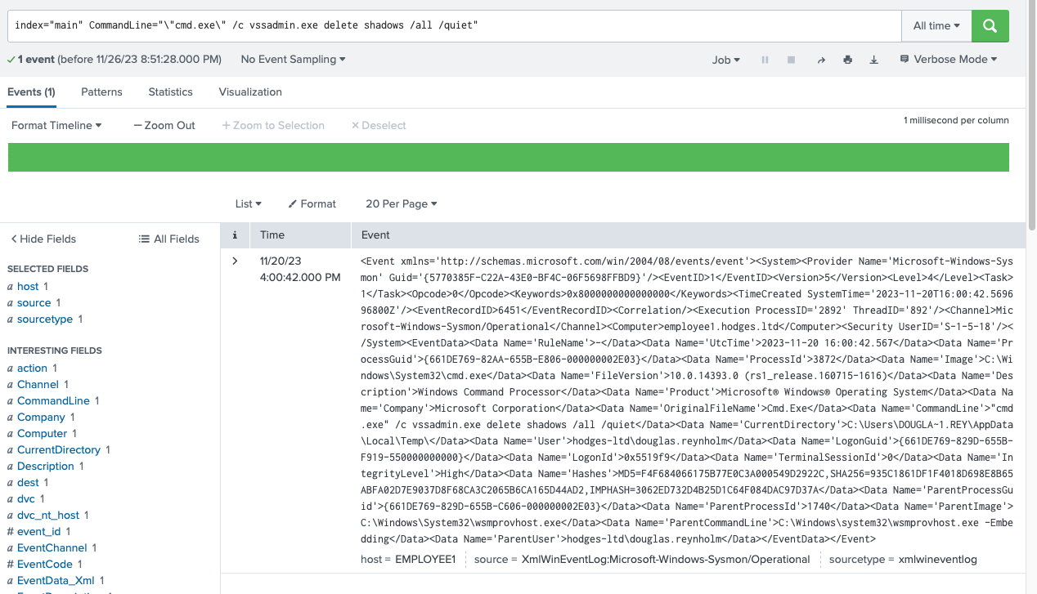

Atomic Test #2 - Windows - Delete Volume Shadow Copies via WMI

|  |
| --- |
| Splunk Sorgusu: |
| index="main" CommandLine="wmic.exe shadowcopy delete" |

Atomic Test #3 - Windows - wbadmin Delete Windows Backup Catalog

|  |
| --- |
| Splunk Sorgusu: |
| index="main" CommandLine="wbadmin delete catalog -quiet" |

Atomic Test #4 - Windows - Disable Windows Recovery Console Repair

|  |
| --- |
| Splunk Sorgusu: |
| index="main" CommandLine="bcdedit.exe /set {default} recoveryenabled no" |
| index="main" CommandLine="bcdedit.exe /set {default} bootstatuspolicy ignoreallfailures" |

Atomic Test #5 - Windows - Delete Volume Shadow Copies via WMI with PowerShell

|  |
| --- |
| Splunk Sorgusu: |
| index="main" CommandLine="\"powershell.exe\" &amp; {Get-WmiObject Win32_Shadowcopy | ForEach-Object {$_.Delete();}}" |

Atomic Test #6 - Windows - Delete Backup Files

|  |
| --- |
| Splunk Sorgusu: |
| index="main" CommandLine="\"cmd.exe\" /c del /s /f /q c:\\*.VHD c:\\*.bac c:\\*.bak c:\\*.wbcat c:\\*.bkf c:\\Backup*.* c:\\backup*.* c:\\*.set c:\\*.win c:\\*.dsk" |

Atomic Test #7 - Windows - wbadmin Delete systemstatebackup

|  |
| --- |
| Splunk Sorgusu: |
| index="main" CommandLine="wbadmin delete systemstatebackup -keepVersions:0" |

Atomic Test #8 - Windows - Disable the SR scheduled task

|  |
| --- |
| Splunk Sorgusu: |
| index="main" CommandLine="schtasks.exe /Change /TN \"\\Microsoft\\Windows\\SystemRestore\\SR\" /disable" |

Atomic Test #9 - Disable System Restore Through Registry

|  |
| --- |
| Splunk Sorgusu: |
| index="main" "reg add" CommandLine="\"cmd.exe\" /c reg add \"HKLM\\SOFTWARE\\Policies\\Microsoft\\Windows NT\\SystemRestore\" /v \"DisableConfig\" /t \"REG_DWORD\" /d \"1\" /f &amp; reg add \"HKLM\\SOFTWARE\\Policies\\Microsoft\\Windows NT\\SystemRestore\" /v \"DisableSR\" /t \"REG_DWORD\" /d \"1\" /f &amp; reg add \"HKLM\\SOFTWARE\\Microsoft\\Windows NT\\CurrentVersion\\SystemRestore\" /v \"DisableConfig\" /t \"REG_DWORD\" /d \"1\" /f &amp; reg add \"HKLM\\SOFTWARE\\Microsoft\\Windows NT\\CurrentVersion\\SystemRestore\" /v \"DisableSR\" /t \"REG_DWORD\" /d \"1\" /f" |

Atomic Test #10 - Windows - vssadmin Resize Shadowstorage Volume

|  |
| --- |
| Splunk Sorgusu: |
| index="main" CommandLine="\"C:\\Windows\\system32\\vssadmin.exe\" resize shadowstorage /For=C: /On=C: /MaxSize=20%%" |

**Task 2:** Impair Defenses: Disable Windows Event Logging | T1562.002-6

<https://github.com/redcanaryco/atomic-red-team/blob/master/atomics/T1562.002/T1562.002.md#atomic-test-6---disable-event-logging-with-wevtutil>

Atomic Test #6 - Disable Event Logging with wevtutil

|  |
| --- |
|  |
| index="main" CommandLine="wevtutil sl \"Microsoft-Windows-IKE/Operational\" /e:false" |

**Task 3:** Modify Registry (Suspicious Registery Modifying) | T1112-3

Atomic Test #3 - Modify registry to store logon credentials

|  |
| --- |
|  |
| index="main" CommandLine="reg add HKLM\\SYSTEM\\CurrentControlSet\\Control\\SecurityProviders\\WDigest /v UseLogonCredential /t REG_DWORD /d 1 /f" |

**Task 4:**Detection OS Credential Dumping : LSASS Memory | T1003.001-2

<https://github.com/redcanaryco/atomic-red-team/blob/master/atomics/T1003.001/T1003.001.md>

Atomic Test #2 - Dump LSASS.exe Memory using comsvcs.dll

|  |
| --- |
|  |
| index="main" CommandLine="\"powershell.exe\" &amp; {C:\\Windows\\System32\\rundll32.exe C:\\windows\\System32\\comsvcs.dll, MiniDump (Get-Process lsass).id $env:TEMP\\lsass-comsvcs.dmp full}" |

**Task 5:**Path Interception by Unquoted Path | T1574.009-1

<https://github.com/redcanaryco/atomic-red-team/blob/master/atomics/T1547.009/T1547.009.md>

Atomic Test #1 - Shortcut Modification

|  |
| --- |
|  |
| index="main" OriginalFileName=* "copy" CommandLine="\"cmd.exe\" /c copy \"C:\\AtomicRedTeam\\atomics\\T1574.009\\bin\\WindowsServiceExample.exe\" \"C:\\Program Files\\windows_service.exe\" &amp; copy \"C:\\AtomicRedTeam\\atomics\\T1574.009\\bin\\WindowsServiceExample.exe\" \"C:\\program.exe\" &amp; sc create \"Example Service\" binpath= \"C:\\Program Files\\windows_service.exe\" Displayname= \"Example Service\" start= auto &amp; sc start \"Example Service\"" |

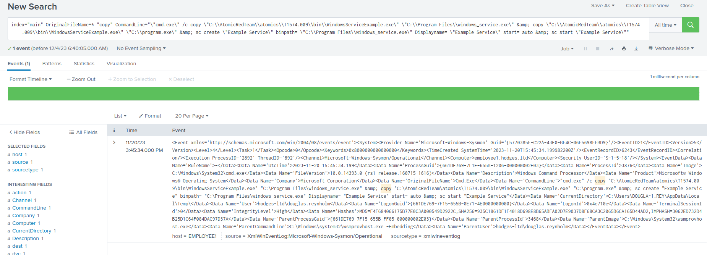

**Task 6:** Process Injection (Shellcode execution via VBA) | T1055-1

https://github.com/redcanaryco/atomic-red-team/blob/master/atomics/T1055/T1055.md

Atomic Test #1 - Shellcode execution via VBA

|  |
| --- |
|  |
| index=* Invoke-Maldoc -macroFile original_file_name="PowerShell.EXE" | table OriginalFileName user CommandLine UtcTime |

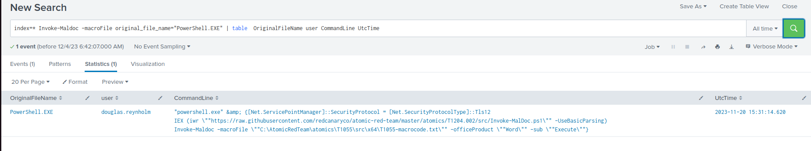

Additionally we don't understand why they were successfully executed in the internal network, so if you let us know how to prevent this from happening, we can re-test and document the results.

Komut satırı üzerinden çalıştırılan komutlar, "admin" yetkisiyle yürütülebilir durumdadır. Bu bağlamda, "cmd.exe"nin Group Policy tarafından kullanımı kısıtlanmalıdır. Douglas.reynholm kullanıcısı, admin yetkisi gerektiren tüm komutları başarıyla çalıştırabilmiştir.

PowerShell'de, ExecutionPolicy ayarı, çalıştırılabilen script türlerini belirler. Bu ayarı değiştirerek PowerShell scriptlerinin çalıştırılması engellenebilirdi.

Örneğin, Set-ExecutionPolicy Restricted komutu ile scriptlerin çalışması durdurulabilir.

PowerShell'de başka bir sıkılaştırma önlemi olarak, belirli komut dosyalarının çalıştırılmasına izin vermek için bir beyaz liste oluşturulabilir. Bu sayede, yalnızca belirli scriptlere izin verilirken, diğer scriptler engellenmiş olur.