

MIDDLE EAST TECHNICAL UNIVERSITY

DEPARTMENT OF ELECTRICAL AND ELECTRONICS ENGINEERING

EE464 Simulation Project-2 Report

Isolated Converters & Controller Design

19/04/2018

Hakan Saraç - 2041838

Mahmut Enes Kara -

Cem Kavuncu - 2030963

Table of Contents

1. Introduction 3

2. Results 3

3. Conclusion 25

1. **Introduction**

In this project, we are required to design an isolated DC-DC converter and a controller, respectively. For DC-DC converter, we are supposed to use the topology that we chose for our hardware project. Therefore, since we have chosen to use flyback converter for our hardware project, firstly we need to design a transformer for our flyback converter. Secondly, we are supposed to observe the voltage-current stress in the switches and decide to use any snubber. Also, we are objected to choose our components for our converter. Moreover, we are supposed to design a converter for our specifications in the hardware project and obtain its bode plot and transfer function. Lastly, we are supposed to design a Type-2 controller.

1. **Results**

**Q1)**

The given constraints of the Flyback converter is 80W of output power rating, input voltage of 24V and output voltage of 12V. To achieve that we have decided upon the following specifications for our converter. Calculation of values (Lm,C) and the choice of the elements are provided in the following sections.

**Table 1: Chosen element list.**

|  |  |  |  |
| --- | --- | --- | --- |
|  | Value | Voltage Rating | Current Rating |
| C | 1000µF | 50V | - |
| Lm | 256µH | - | 8.33Aavg |
| Mosfet | - | 100V | 9.7A |
| Diode | - | 45V | 10A |

In the steady state under full load, we have designed our converter achieve CCM under full load. The switching frequency is chosen as 10kHz in order to achieve greater efficiency. Low switching frequency is compensated by using a bigger core and larger number of turns. Output capacitor is chosen large deliberately in order to achieve low voltage ripple at the output. Since the voltage ratings are low size of the capacitor is not a big issue in this converter. Moreover, there is no limitation in the size as well. The transformer ratio is chosen as N1/N2 = 2.

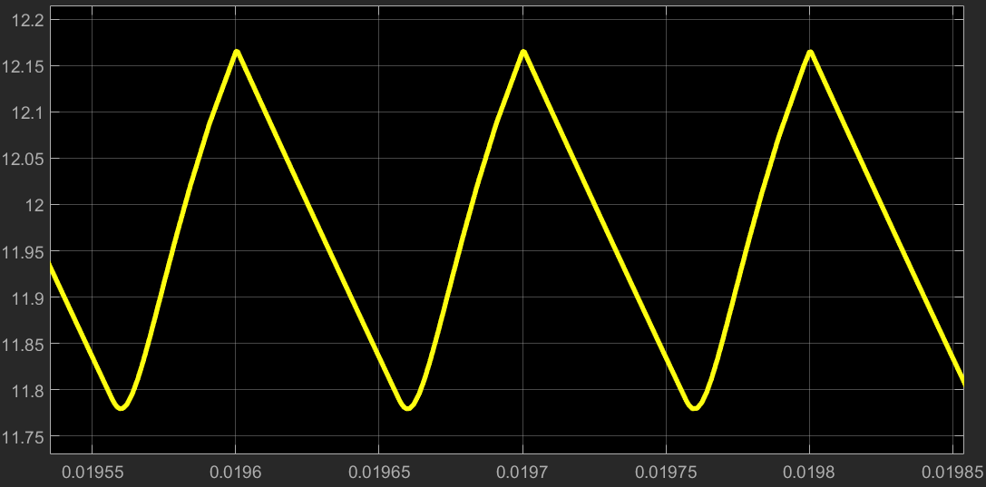

**Figure 1: Output voltage waveform at the steady state.**

1. **Transformer design**

In this part, and most of the parts, the calculation is done using MATLAB. You can reach to the related m file in our Github repository.

Transformer is the key component in a flyback converter. It should be capable of storing and delivering enough energy to the output in a switching cycle. As the switching frequency increases Lm value can be reduced because the ripple current on the Lm is directly related to the switching frequency. Before starting to the transformer design, ripple of the current flowing through the Lm is assumed to have a ripple of 40%. Using this constraint following values are calculated. Moreover, duty cycle is chosen as 0.4, which is a reasonable duty ratio.

Note that, as duty cycle gets too close to 0 or 1, operation of any converter is affected badly since the inductor is charged or discharged for a very short amount of time, proper operation may not be achievable.

$Ripplepercent=0.4;$

$$I_{Lmavg}=\frac{{Vo}^{2}}{Vs*D*Rload}=8.33A$$

$$I_{Lmmax}=I_{Lmavg}+ I_{Lmavg}*\frac{Ripplepercent}{2}=10A$$

$$I_{Lmmin}=I_{Lmavg}- I_{Lmavg}*\frac{Ripplepercent}{2}=6.67A$$

$$L_{m}=\frac{V_{s}*D}{{ΔI}_{Lm}*fsw}=288µH$$

To achieve 288µH, a core with a high AL value should be chosen. Core should be gapped in order to store more energy. To achieve the given specifications, we have chosen the core with the chosen specifications. To reach to the datasheet, you can click [here](https://www.digikey.com/product-detail/en/epcos-tdk/B65887E0160A041/495-5332-ND/3914482).

**Table 2: Specifications of the transformer core**

|  |  |
| --- | --- |
| Flux Density | 0.49T |
| Effective Core Area (Ae) | 200mm2 |
| Effective Length (le) | 70mm |
| Inductance Factor (Al) | 160nH |
| Effective Permeability (µe) | 45 |
| Effective Magnetic Volume (Ve) | 14000mm³ |
| Material | N41 |

Number of turns required for to reach to the calculated Lm value:

$N1= \sqrt{\frac{L_{m}}{Al}}=42$

Based on this calculation, N1 chosen as 40 turns. The current flowing in the primary side is calculated as half of the load current (since N1/N2 = 2 chosen) that is 3.33A. Referring to the table in this [link](https://www.powerstream.com/Wire_Size.htm), AWG 16 cable can carry 3.7A of current which has 1.29mm of diameter. The window area of the core is given as 20.8*7mm2. Fill factor of the core is:

$Fill Factor= \frac{N*CableArea}{Window Area}=0.36$

With the addition of the secondary side cables, FF value will be around 0.7, which is achievable.

The core also should not get saturated the maximum value of the Lm value. Peak value of the flux density of the is calculated as:

$B_{peak}=\frac{N1*I_{Lmmax}}{Effective Core Area*Core Reluctance}=0.32T$

From the datasheet, it can be seen that the loss coefficient at 0.3T and 10khz is around 100kW/m3.

1. DCM occurs when ILmmin reaches zero. Assuming current ripple on the Lm is constant,

then ILm=1.667A at the boundary of the DCM. Also, we know that Is=D*ILm = 0.4*1.667 = 0.667A. Therefore when the load current goes below N1/N2*Is = 2*0.667 = 1.333A, the converter goes into the DCM.

**2)**

**b)**



**Figure 1:** The schematic circuit of the designed Buck Converter

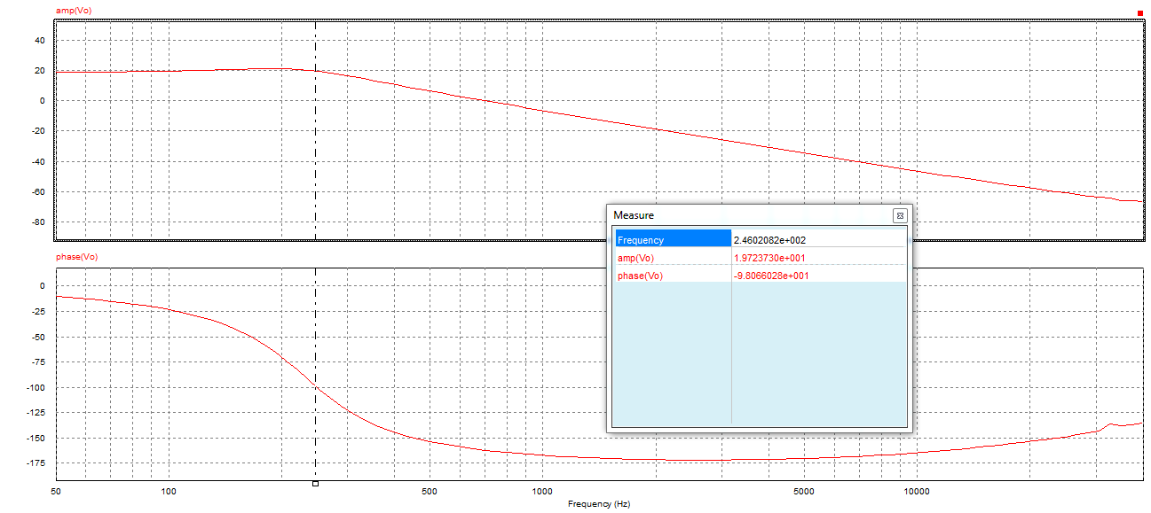

**Figure 2:** The Bode plot of the Buck Converter

We chose to use PSIM for simulating our converter design. Our hardware project specifications are designing a flyback converter with input 24V, output 12V and output power 80W. For this question, we used this specifications; however, we designed Buck Converter according to them. We chose the capacitor value as 470uF and inductor value as 1mH. Also, we considered the equivalent series resistance of the capacitor and inductor as 0.01Ω.

**c)**



**Figure 3:** The schematic circuit of the designed Buck Converter with Type-2 controller

In order to produce enough transient stability for our converter, we designed a Type-2 controller and chose the components of it. It can be seen as follows.



**Figure 4:** The schematic circuit of the Type-2 controller



**Figure 5:** The output voltage of the Buck Converter with Type-2 controller

We chose 2.2nF for the capacitor values, 10Ω for the first resistor and 50Ω for our second resistor. We considered the following equations in order to find a proper values for them.





We firstly decided the 10Ω value for the first resistor and calculate the gain with the following equation:



After that we found the gain, we calculated the capacitor values and the other resistor value, respectively. We tried them on the simulation and changed them with manually for the best operation.

**d)**



**Figure 6:** The change in the output voltage when the load is changed from half load to full load



**Figure 7:** The change in the output voltage when the supply voltage is decreased 10%

**e)**

When we changed the load or supply voltage, we observed some peak values in the output voltage. However, it fixed itself. When we increase the capacitor values in the controller circuit, we observed that firstly, the ripple of the output voltage is increasing and after that we increase the value to mF range and further, we also observe resonancy. However, when we decreased the capacitor value to pF range, we observed that no change occur for the peak value at the step change; however, ripple of output is decreased. For the increase in the first resistor value, we observed that the ripple at the output voltage is increased. Therefore, we chose small resistor value for this component.