

**EE568 – Selected Topics on Electrical Machines**

Project #2: Motor Winding Design & Analysis

by

Hakan Saraç - 2408086

Table of Contents

2. Introduction 2

3. Question 1: Integral-Slot Winding Design 2

3.1. Winding Diagram 2

3.2. Distribution factor, Pitch factor, Winding factor calculation for the fundamental 2

3.3. Distribution factor, Pitch factor, Winding factor calculation for the 3rd and 5th harmonic 2

3.4. Comments 3

4. Fractional-Slot Winding Design 3

# Introduction

# Question 1: Integral-Slot Winding Design

## Winding Diagram

The stator consists of 120 slots, 20 poles and 3 phases. This configuration results in a q value of 2, which states number of slots per pole per phase.

(1)

This slot and pole value results in an electrical angle of 30° degrees between each slot, whose derivation is given in (2).

(2)

Table 1 : Winding Distribution of the 120 Slots 20 Pole Integral Slot Machine

|  |  |  |  |  |  |  |  |  |  |  |  |  |
| --- | --- | --- | --- | --- | --- | --- | --- | --- | --- | --- | --- | --- |
| Slot Number | 1 | 2 | 3 | 4 | 5 | 6 | 7 | 8 | 9 | 10 | 11 | 12 |
| Electrical Angle | 0° | 30° | 60° | 90° | 120° | 150° | 180° | 210° | 240° | 270° | 300° | 330° |
| Coil distribution | A1 | A1 | -C1 | -C1 | B1 | B1 | -A2 | -A2 | C2 | C2 | -B2 | -B2 |
| -C2 | -C2 | B2 | B2 | -A1 | -A1 | C1 | C1 | -B1 | -B1 | A2 | A2 |

## Distribution factor, Pitch factor, Winding factor calculation for the fundamental

The results of distribution factor, pitch factor and winding factor are provided in (3), (4) & (5) respectively for the fundamental frequency.

(3)

(4)

(5)

## Distribution factor, Pitch factor, Winding factor calculation for the 3rd and 5th harmonic

The results of distribution factor, pitch factor and winding factor are provided in (6), (7) & (8) respectively for the 3rd, (9), (10), (11) for the 5th harmonic.

(6)

(7)

(8)

(9)

(10)

(11)

Table 2 : Winding Factor of the 120 Slot 20 Pole 2/3 Pitched Machine

|  |  |  |  |  |
| --- | --- | --- | --- | --- |
|  | 1st | 3rd | 5th | |
| kp | 0.866 | 0 | -0.866 | |
| kd | 0.966 | 0.707 | 0.2588 | |
| kw | 0.8366 | 0 | -0.2241 |

## Comments

On my first attempt, I tried a full pitched configuration for the machine. Full pitched configuration resulted in winding factors of 0.966, -0.707, 0.2588 for the fundamental, third and fifth components respectively. Looking at these winding factor values, the third harmonic component not only considerably high, it is also reverse in direction due to the negative sign. Due to that, third harmonic component will induce even larger voltages on the rotor causing significant amounts of loss, reducing efficiency and increasing the temperature. Therefore, third harmonic component needed to be suppressed. To achieve that, I have chosen pitch factor of 2/3. After changing the pitch factor, the winding factors have become 0.8366, 0, -0.2241 for the fundamental, third and fifth components respectively. This reduced the magnitude of the fundamental component; however completely suppressed the third harmonic.

It is worth to mention that the update on the factor has changed the fifth harmonic components’ sign, this may or may not cause problem, it needs further examination.

# Question 2: Fractional-Slot Winding Design

## Calculations for Machine 1:24 slots 20 poles

In this part, I have chosen a machine which has 24 slots, 20 poles and 3 phases. From [Emetor Winding Design [2]](https://www.emetor.com/windings/) tool, it can be seen that this configuration results in a winding factor of 0.966.

(12)

(13)

Table 3 : Winding Distribution of the 24 Slots 20 Pole Fractional Slot Machine

|  |  |  |  |  |  |  |  |  |  |  |  |  |
| --- | --- | --- | --- | --- | --- | --- | --- | --- | --- | --- | --- | --- |
| Slot Number | 1 | 2 | 3 | 4 | 5 | 6 | 7 | 8 | 9 | 10 | 11 | 12 |
| Fundamental Angle (Normalized) | 0° | 150° | 300° | 90° | 240° | 30° | 180° | 330° | 120° | 270° | 60° | 210° |
| Third Harmonic Angle (Normalized) | 0° | 90° | 180° | 270° | 0° | 90° | 180° | 270° | 0° | 90° | 180° | 270° |
| Fifth Harmonic Angle (Normalized) | 0° | 30° | 60° | 90° | 120° | 150° | 180° | 210° | 240° | 270° | 300° | 330° |
| Coil distribution | A1 | C1 | -C1 | -B1 | B1 | A3 | -A3 | -C3 | C3 | B3 | -B3 | -A2 |
|  |  |  |  |  |  |  |  |  |  |  |  |  |
| Slot Number | 13 | 14 | 15 | 16 | 17 | 18 | 19 | 20 | 21 | 22 | 23 | 24 |
| Electrical Angle (Normalized) | 0° | 150° | 300° | 90° | 240° | 30° | 180° | 330° | 120° | 270° | 60° | 210° |
| Third Harmonic Angle (Normalized) | 0° | 90° | 180° | 270° | 0° | 90° | 120° | 270° | 0° | 90° | 180° | 270° |
| Fifth Harmonic Angle (Normalized) | 0° | 30° | 60° | 90° | 120° | 150° | 180° | 210° | 240° | 270° | 300° | 330° |
| Coil distribution | A2 | C2 | -C2 | -B2 | B2 | A4 | -A4 | -C4 | C4 | B4 | -B4 | -A1 |

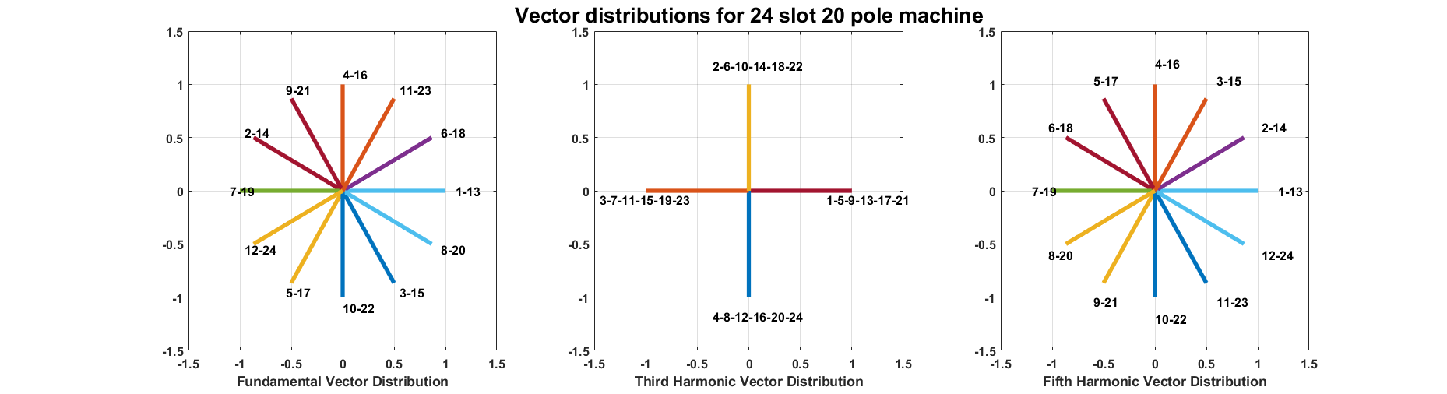

Figure 1 : Voltage Vectors of the 24 Slots 20 Pole Fractional Slot Machine

(14)

* (15)

(16)

(17)

* (18)

(19)

(20)

* (21)

(22)

*\*Distribution factor calculations are taken from the formulas 4,5,6,7 of [1].*

Table 4 : Winding factor of the 24 Slot 20 Pole Machine

|  |  |  |  |
| --- | --- | --- | --- |
|  | 1st | 3rd | 5th |
| kp | 0.966 | -0.707 | 0.2588 |
| kd | 1 | 1 | 1 |
| kw | 0.966 | -0.707 | 0.2588 |

## Calculations for Machine 2:30 slots 20 poles

The pole number kept constant and number of slots is changed to 30 from 24. The resultant winding factors and winding diagrams are provided.

(23)

(24)

Table 5 : Winding Distribution of the 30 Slots 20 Pole Fractional Slot Machine

|  |  |  |  |  |  |  |  |  |  |  |  |  |  |  |  |
| --- | --- | --- | --- | --- | --- | --- | --- | --- | --- | --- | --- | --- | --- | --- | --- |
| Slot Number | 1 | 2 | 3 | 4 | 5 | 6 | 7 | 8 | 9 | 10 | 11 | 12 | 13 | 14 | 15 |
| Fundamental Angle (Normalized) | 0° | 120° | 240° | 0° | 120° | 240° | 0° | 120° | 240° | 0° | 120° | 240° | 0° | 120° | 240° |
| Third Harmonic Angle (Normalized) | 0° | 0° | 0° | 0° | 0° | 0° | 0° | 0° | 0° | 0° | 0° | 0° | 0° | 0° | 0° |
| Fifth Harmonic Angle (Normalized) | 0° | 240° | 120° | 0° | 240° | 120° | 0° | 240° | 120° | 0° | 240° | 120° | 0° | 240° | 120° |
| Coil distribution | A1 | -A1 | C1 | -C1 | B1 | -B1 | A2 | -A2 | C2 | -C2 | B2 | -B2 | A3 | -A3 | C3 |
|  |  |  |  |  |  |  |  |  |  |  |  |  |  |  |  |
| Slot Number | 16 | 17 | 18 | 19 | 20 | 21 | 22 | 23 | 24 | 25 | 26 | 27 | 28 | 29 | 30 |
| Fundamental Angle (Normalized) | 0° | 120° | 240° | 0° | 120° | 240° | 0° | 120° | 240° | 0° | 120° | 240° | 0° | 120° | 240° |
| Third Harmonic Angle (Normalized) | 0° | 0° | 0° | 0° | 0° | 0° | 0° | 0° | 0° | 0° | 0° | 0° | 0° | 0° | 0° |
| Fifth Harmonic Angle (Normalized) | 0° | 240° | 120° | 0° | 240° | 120° | 0° | 240° | 120° | 0° | 240° | 120° | 0° | 240° | 120° |
| Coil distribution | -C3 | B3 | -B3 | A4 | -A4 | C4 | -C4 | B4 | -B4 | A5 | -A5 | C5 | -C5 | B5 | -B5 |

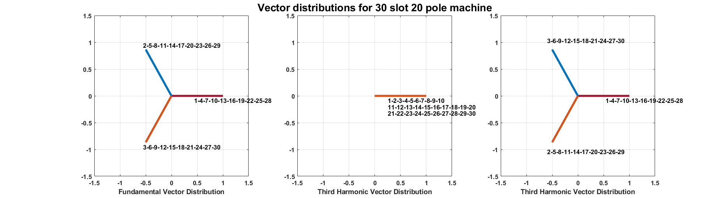

Figure 2: Voltage Vectors of the 30 Slots 20 Pole Fractional Slot Machine

(25)

* (26)

(27)

(28)

* (29)

(30)

(31)

* (32)

(33)

*\*Distribution factor calculations are taken from the formulas 4,5,6,7 of [1].*

Table 6 : Winding factor of the 30 Slot 20 Pole Machine

|  |  |  |  |
| --- | --- | --- | --- |
|  | 1st | 3rd | 5th |
| kp | 0.866 | 0 | -0.866 |
| kd | 1 | 1 | 1 |
| kw | 0.866 | 0 | -0.866 |

## Comments

Properties of Machine 1 has resulted in a winding distribution as shown in Table 3. The winding factor coefficient of the third and fifth harmonic is noticeably high, meaning that the machine 1 will have high harmonics in its airgap MMF waveform. From Figure 1, the voltage vectors for third component are distributed on 0°,90°,180°,270° degrees. Due to the machine winding configuration, the third harmonic component vectors will have an angle of either 45° or 225° degrees, stating that the third harmonic component will have a nonzero comparable coefficient. This is proven by the winding factor coefficients provided in Table 4. The fifth harmonic component for machine 1 has a similar voltage vector distribution when compared to the fundamental component. However, since the angles of the voltages are different, the fifth harmonic component will exist, but its magnitude will be relatively low.

Properties of Machine 2 has led to a winding distribution show in Table 5. All the voltage vectors are provided in Figure 2. For the fundamental component, the resultant voltage vectors will have an angle of 330°, 210° or 90°. All the third harmonic component voltage vectors have 0° angles, meaning that independent of the winding configuration, there will be no third harmonic component on the airgap MMF. This can also be seen Table 6, the winding factor coefficient of the third harmonic is zero. The voltage vector distribution of fifth harmonic is the reverse of the fundamental. This causes a negative fifth harmonic in the airgap MMF, it will rotate in the reverse direction.

# Question 3: 2D FEA Modelling

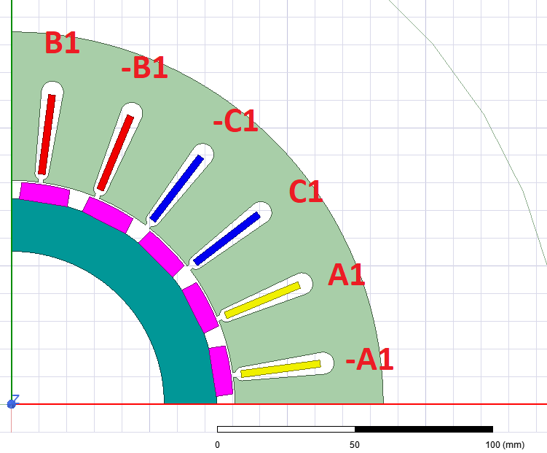

Machine 2 has no third harmonic component but it has

# References

[1] - Li, G. J., Ren, B., & Zhu, Z. Q. (2017). Design guidelines for fractional slot multi-phase modular permanent magnet machines. *IET Electric Power Applications*, *11*(6), 1023–1031. https://doi.org/10.1049/iet-epa.2016.0616

[2] - <https://www.emetor.com/windings/>