# Introduction

In this hand note, the inner structure of Sigma Delta Analog to Digital Converters are investigated.

# Delta Sigma ADCs

The overall structure of a delta-sigma ADC is given in Figure 1. The details of each block will be explained. However, in short, the operation of a delta sigma ADC is as follows:

1. The analog signal is converted to a bit-stream (Delta-Sigma modulator in Figure 1). This conversion usually is around MHz range (larger than the operation frequency).
2. To obtain the real ADC values of the signal, the generated bitstream in the first step is passed through a digital filter (usually a sinc filter). The data out

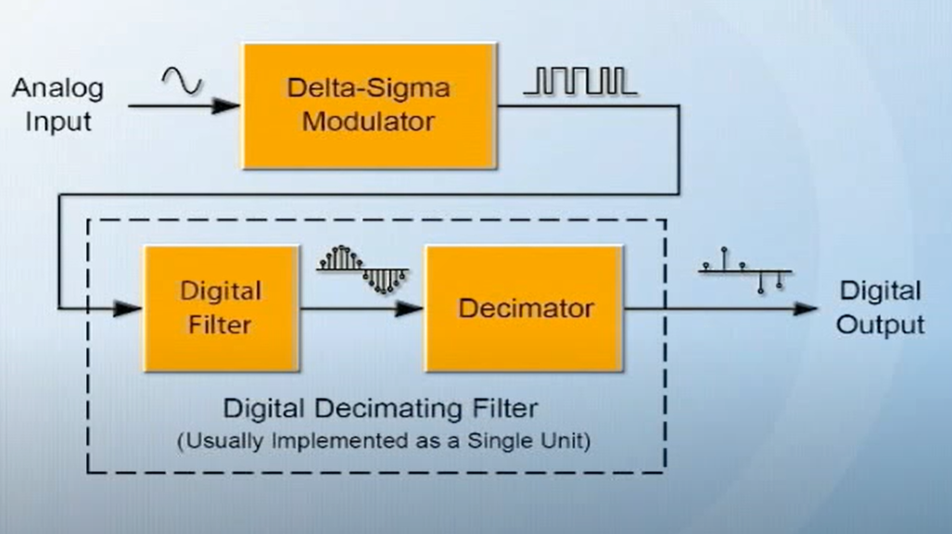

Figure 1 :Delta Sigma ADC structure

# References

[1] [Nuts and Bolts of the Delta-Sigma Converter](https://www.youtube.com/watch?v=oVti3b4rqQA)