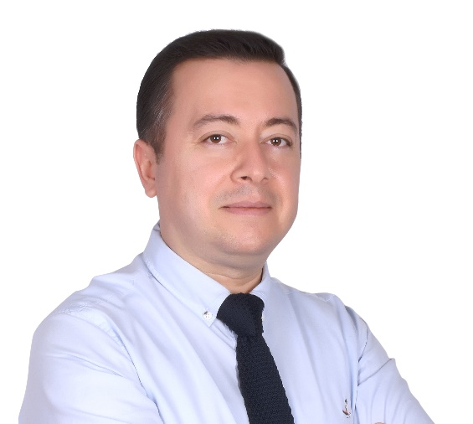 | Hi,  My name is Hakan Taylan. I am a software engineer from Ankara, Turkey. I am working for Ericsson as of 4th April 2022. I have an Electronic Engineering degree from Ankara University, graduated in 2000. Till now, almost my whole career has been in the defense industry. I had been working for Havelsan for 18 years, developing a huge command and control system written in Java. For all those years, I worked in different positions and roles, including Software Developer, Devops Engineer and Team Leader. I have participated in every phase of the software development life cycle many times.  Although I have a Java background, I am a constant learner and open to new technologies. I have a very good understanding of object oriented programming and design, design patterns and testing at all levels. I don't have any hands-on experience but have good theoretical information about microservices and microservice related patterns and best practices.  I am married. I have a son who is 3 years old. He takes most of my time after work. In the time remaining from being a dad, I like reading, watching movies and origami.  I feel excited about putting my experience into practice in project(s) I will participate in and sharpen my knowledge and getting experience on the technologies and techniques which you guys are using in your projects.  I would like to be a part of an organization where people support each other in the right way and where people foster each other with their technical and intellectual knowledge. I hope, with Ericsson, we all will have such a good working environment  I am looking forward to meeting you all.  Kind regards,  Hakan Taylan

