|  |  |  |  |  |  |
| --- | --- | --- | --- | --- | --- |
| **LPF**  **Equalized_data** | SVM Classifier | KNN | SVM with PCA | KNN WITH PCA | Neural net with PCA |
| Sigma=2 | 0.8421 | 0.7894 | 0.618 | 0.7763 | 0.6447 |
| Sigma=5 | 0.828 | 0.7368 | 0.6184 | 0.75 | 0.7105 |
| Sigma=10 | 0.815 | 0.7368 | 0.618 | 0.7368 | 0.7368 |
| Sigma=15 | 0.8157 | 0.73 | 0.618 | 0.776 | 0.644 |

|  |  |  |  |  |  |
| --- | --- | --- | --- | --- | --- |
| **HPF**  **Equalized-data** | SVM Classifier | KNN | SVM with PCA | KNN WITH PCA | Neural net with PCA |
| Sigma=2 | 0.77 | 0.72 | 0.618 | 0.52 | 0.55 |
| Sigma=5 | 0.78 | 0.82 | 0.618 | 0.72 | 0.64 |
| Sigma=10 | 0.815 | 0.75 | 0.618 | 0.75 | 0.7368 |
| Sigma=15 | 0.8289 | 0.72 | 0.618 | 0.7105 | 0.75 |

|  |  |  |  |  |  |
| --- | --- | --- | --- | --- | --- |
| **LPF+HPF**  **Equalized data** | SVM Classifier | KNN | SVM with PCA | KNN WITH PCA | Neural net with PCA |
| Sigma=2 | 0.8289 | 0.802 | 0.618 | 0.539 | 0.697 |
| Sigma=5 | 0.789 | 0.8684 | 0.618 | 0.8289 | 0.7236 |
| Sigma=10 | 0.8421 | 0.815 | 0.618 | 0.828 | 0.6842 |
| Sigma=15 | 0.8421 | 0.881 | 0.618 | 0.8815 | 0.4868 |

|  |  |  |  |  |  |
| --- | --- | --- | --- | --- | --- |
| **LPF**  **Contrast data** | SVM Classifier | KNN | SVM with PCA | KNN WITH PCA | Neural net with PCA |
| Sigma=2 | 0.8157 | 0.6184 | 0 .6447 | 0.6710 | 0.8026 |
| Sigma=5 | 0.815 | 0.67 | 0.618 | 0.684 | 0.6710 |
| Sigma=10 | 0.8421 | 0.7105 | 0.618 | 0.7368 | 0.6315 |
| Sigma=15 | 0.8157 | 0.7763 | 0.618 | 0.7763 | 0.6052 |

|  |  |  |  |  |  |
| --- | --- | --- | --- | --- | --- |
| **HPF**  **Contrast data** | SVM Classifier | KNN | SVM with PCA | KNN WITH PCA | Neural net with PCA |
| Sigma=2 | 0.855 | 0.855 | 0.618 | 0.73 | 0.657 |
| Sigma=5 | 0.815 | 0.789 | 0.618 | 0.776 | 0.631 |
| Sigma=10 | 0.75 | 0.71 | 0.618 | 0.736 | 0.697 |
| Sigma=15 | 0.71 | 0.67 | 0.618 | 0.72 | 0.69 |

|  |  |  |  |  |  |
| --- | --- | --- | --- | --- | --- |
| **LPF+HPF**  **Contrast data** | SVM Classifier | KNN | SVM with PCA | KNN WITH PCA | Neural net with PCA |
| Sigma=2 | 0.855 | 0.8289 | 0.618 | .6710 | 0.828 |
| Sigma=5 | 0.78 | 0.77 | 0.618 | 0.8026 | 0.71 |
| Sigma=10 | 0.73 | 0.75 | 0.618 | 0.75 | 0.59 |
| Sigma=15 | 0.76 | 0.77 | 0.618 | 0.7631 | 0.6184 |

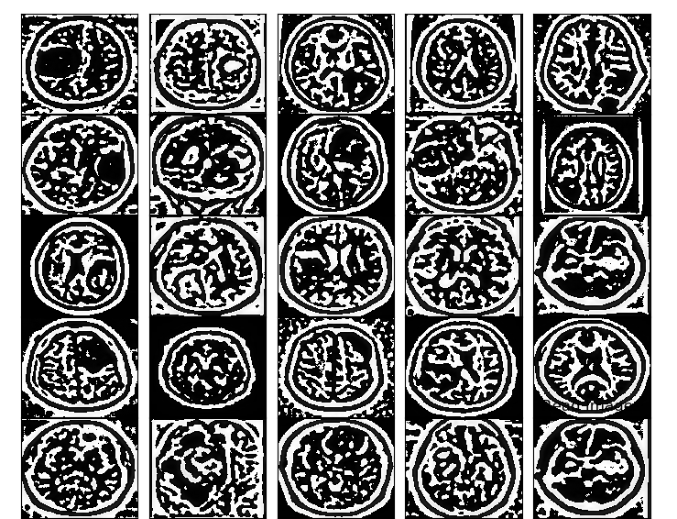lpf+hpf sigma=5 on equalized data

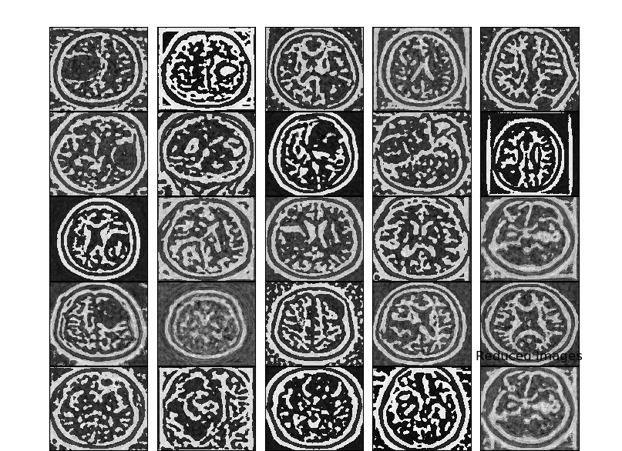pca image

So equalized images improve accuracy of classifiers.

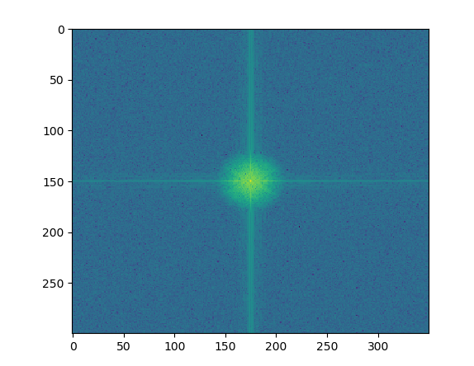fft of yes image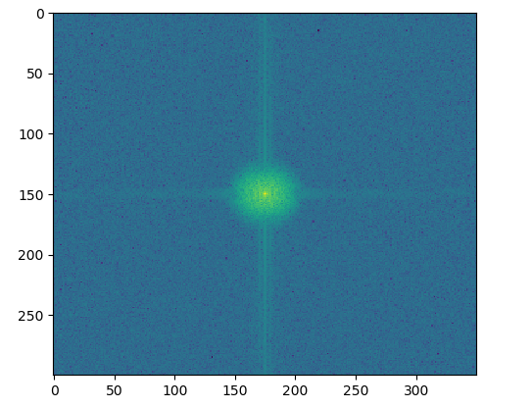fft of no image

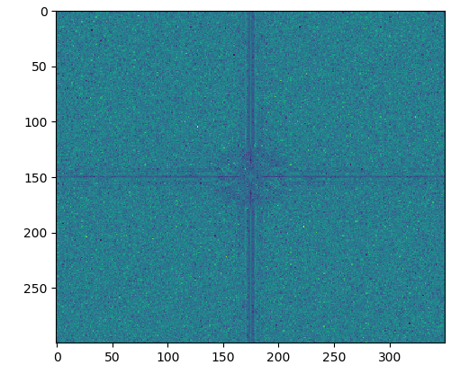difference of above 2 images.

For discrete data klt and pca are no different.