

ANADOLU UNIVERSITY

FACULTY OF ENGINEERING

DUYARLIOL

Hakan Yıldız

Okan Öztaban

A Bachelor of Science Project

Department of Computer Engineering

May 2017

DUYARLIOL

by

Hakan YILDIZ - 30928274948

Okan ÖZTABAN-29122110244

Submitted in partial fulfillment of the requirements for the degree of Bachelor of Science in Computer Engineering is approved by the following scientific committee members.

Date of Approval : May12, 2017

Member (Advisor) : Doç. Dr. Özgür YILMAZEL

Member : Öğr. Gör. Emre KAÇMAZ

Member : Araş. Gör. Emin Talip DEMİRKIRAN

Member : Araş. Gör. Ahmet AYDIN

ABSTRACT

In recent years, the use of computers, smart phones and many electronic devices has increased because of the rapid growth of technology. However, with the widespread use of the internet, the numbers of e-commerce sites are increasing day by day. Users can easily buy any product they want on the internet, and also sell their products at more affordable prices to increase shopping on e-commerce sites. In this era of consumption, the number of consumers is increasing while individual borrowing is increasing at a great pace. The increase in the incentives of state and banks to encourage buying and spending rather than creating awareness and sensitivity to individuals.

The main purpose of the project is a web-awareness project that allows individuals who want to make online purchases to take some basic information and complete a short test before completing their purchases, allowing them to think about how much they need for their product and what they need to buy.

Keywords: Online Shopping, Credit Cards, Sensitivity, Web

ÖZET

Son yıllarda teknolojinin büyük bir hızla gelişmesinden dolayı, bireylerin bilgisayar, akıllı telefon ve birçok elektronik alet kullanımı artmıştır. Bununla beraber internetin yaygınlaşmasıyla e-ticaret sitelerinin sayılarına her geçen gün kat ve kat artmaktadır. Kullanıcıların istedikleri herhangi bir ürünü internet üzerinden kolay bir şekilde alabilmeleri ve ayrıca firmaların ürünlerini daha uygun fiyatlara satmaları e-ticaret sitelerinden alışverişi arttırmaktadır. Tüketim çağı dediğimiz bu çağda, kullanıcıların alışveriş sayıları artar iken bireysel borçlanmaları da büyük bir hızda artış göstermektedir.Devlet ve bankalar,bireyler üzerinde farkındalık ve duyarlılık oluşturmak yerine satın almaya, harcama yapmaya teşvik etmeleri bu artışa da sebep olmaktadır.

Projemizin asıl amacı online alışveris yapmak isteyen bireylerin alışverişlerini tamamlamadan önce bazı temel bilgilerini alıp ,kısa bir teste tabi tutarak, ellerindeki bütçe ile alacak olduğu ürüne ne kadar ihtiyacı olup olmadıgını düşünmesini sağlayan ve tabiki de son kararı kendisine bırakan bir web duyarlılık projesidir.

Anahtar Kelimeler: Online Alışveriş, Kredi Kartı, Duyarlılık, Web

CONTENTS

Page

ABSTRACT i

ÖZET ii

CONTENTS iii

LIST OF FIGURES iv

1. INTRODUCTION 1

1.1. Project Title 1

1.2. Group Members 1

1.3. Project Motivation 1

1.4. Project Definition 1

1.5. Scope of Project 1

1.6. Gantt Chart 2

2. PLATFORM AND TECHNOLOGIES TO BE USED 3

2.1.ASP.NET 3

2.2.CSS 3

2.4. JAVASCRIPT 4

2.5. MS-SQL 4

2.6. POLYMER JS 5

2.7. CHROME EXTENSION 5

3. DESIGN 6

4. CONCLUSION 17

4. REFERENCES 18

LIST OF FIGURES

Page

Figure 1. Login Screen 6

Figure 2. Homepage 7

Figure 3. List of Shopping 8

Figure 4. Profile and Total Income 9

Figure 5. Profile and Total Outcome 10

Figure 6. Profile and Credit Cards Information 11

Figure 7. Application of Duyarlı ol On Shopping Website 12

Figure 8. Application of Duyarlı ol with n11.com 13

Figure 9. Application of Duyarlı ol with gittigidiyor.com 14

Figure 10. Application of Duyarlı ol with mediamarkt.com 15

Figure 11. Events 16

1. INTRODUCTION

1.1. Project Title

DUYARLIOL

1.2. Group Members

Hakan Yıldız

Okan Öztaban

1.3. Project Motivation

The user will be redirected to our website before the user completes the

exchange.Our system will want some information of its own from the user. After the information, the system, based on the information entered, The user will be thought for the second time about the product he will need or not need .

1.4. Project Definition

Online shopping has increased with the increase in the use of credit cards in recent years. This has led to an increase in the individual debts of individuals. Our system is a susceptibility project intended to make people think twice about shopping.

1.5. Scope of Project

Anyone who makes an online purchase can go to our test and evaluate the price for that shopping.

1.6. Gantt Chart

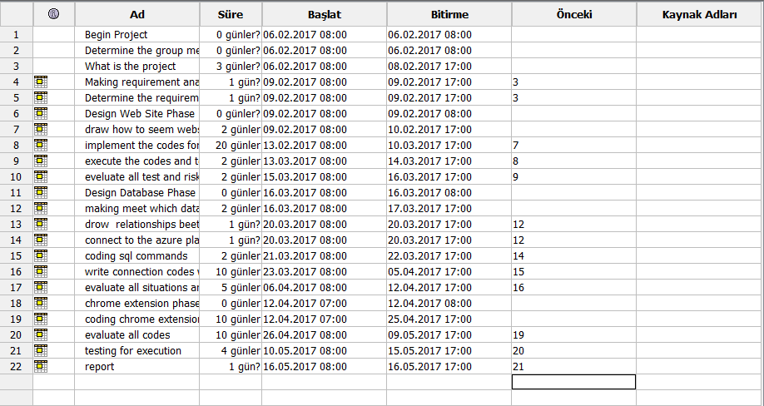

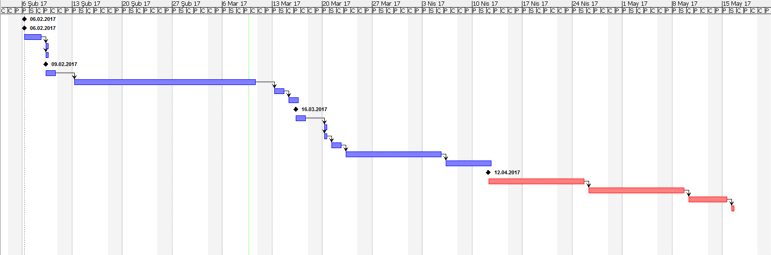

2. Platform and technologies to be used

2.1.ASP.NET

ASP.NET is an open-source server-side web application framework designed for web development to produce dynamic web pages. It was developed by Microsoft to allow programmers to build dynamic web sites, web applications and web services.

It was first released in January 2002 with version 1.0 of the .NET Framework, and is the successor to Microsoft's Active Server Pages (ASP) technology. ASP.NET is built on the Common Language Runtime (CLR), allowing programmers to write ASP.NET code using any supported .NET language. The ASP.NET SOAP extension framework allows ASP.NET components to process SOAP messages.

ASP.NET is in the process of being re-implemented as a modern and modular web framework, together with other frameworks like Entity Framework. The new framework will make use of the new open-source .NET Compiler Platform (code-name "Roslyn") and be cross platform. ASP.NET MVC, ASP.NET Web API, and ASP.NET Web Pages (a platform using only Razor pages) will merge into a unified MVC 6. The project is called ASP.NET Core.

.

2.2.CSS

Cascading Style Sheets (CSS) is a style sheet language used for describing the presentation   of a document written in a markup language. Although most often used to set the visual style of web pages and user interfaces written in HTML and XHTML, the language can be applied to any XML document, including plain XML , SVG and XUL, and is applicable to rendering in speech, or on other media. Along with HTML and JavaScript, CSS is a cornerstone technology used by most websites to create visually engaging webpages, user interfaces for web applications, and user interfaces for many mobile applications.

2.3.HTML

Hypertext Markup Language (HTML) is the standard markup language for creating web pages and web applications. With Cascading Style Sheets (CSS) and JavaScript it forms a triad of cornerstone technologies for the World Wide Web.  Web browsers receive HTML documents from a webserver or from local storage and render them into multimedia web pages. HTML describes the structure of a web page semantically and originally included cues for the appearance of the document.

.

2.4. JAVASCRIPT

JavaScript is a high-level, dynamic, untyped and interpreted programming language. It has been standardized in the ECMAScript language specification. Alongside HTML and CSS, JavaScript is one of the three core technologies of World Wide Web content production; the majority of websites employ it, and all modern Web browsers support it without the need for plug-ins. JavaScript is prototype-based with first class functions, making it a multi-parading language, supporting, object-oriented, imperative, and functional programming styles. It has an API for working with text, arrays, dates and regular expressions, but does not include any I/O, such as networking, storage, or graphics facilities, relying for these upon the host environment in which it is embedded.

2.5. MS-SQL

Microsoft SQL Server is a relational database management system developed by Microsoft. As a database server, it is a software product with the primary function of storing and retrieving data as requested by other software applications—which may run either on the same computer or on another computer across a network (including the Internet).

2.6. POLYMER JS

Polymer is an open-source JavaScript library for building web applications using web components. The library is being developed by Google developers and contributors on Github. Modern design principles are implemented as a separate project using Google’s Material Design principles.

Polymer provides a number of features over vanilla web components:

* Simplified way of creating custom elements
* Both One-way and Two-way data binding
* Computed properties
* Conditional and repeat templates
* Gesture events
* Library of Elements

2.7. CHROME EXTENSION

Google Chrome Extensions are browser extensions that modify the Google Chrome browser. These extensions are written using web technologies like HTML, JavaScript, and CSS. Google Chrome Extensions are downloadable through the Chrome Web Store (formerly the Google Chrome Extensions Gallery).By February 2010, over 2,200 extensions had been published by developers. All users with a Google Account are able to add extensions after developing them.

3. DESIGN

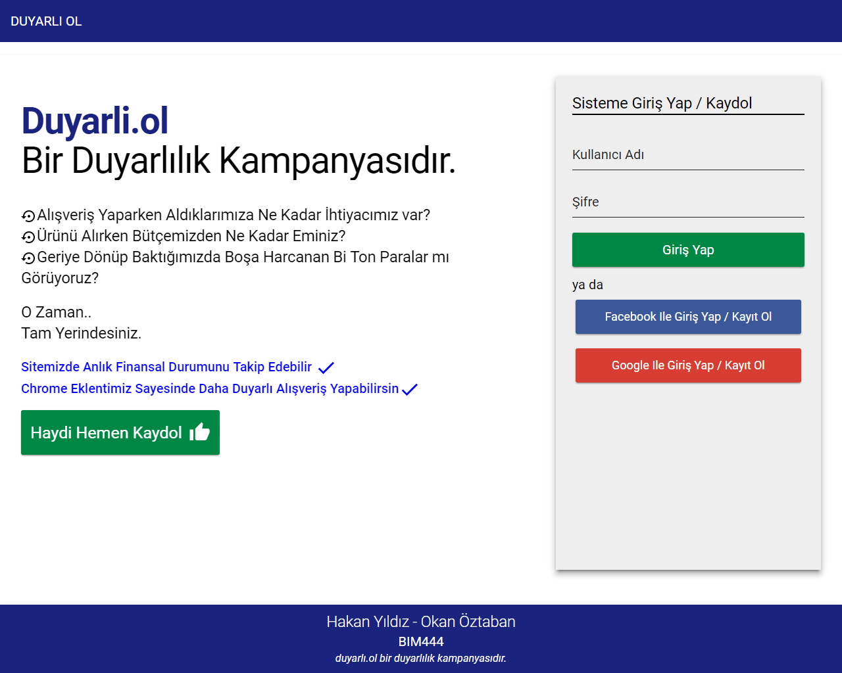

Figure 1. Login Screen

Users can login with their username and password or prefer to connect to homepage with Facebook or Gmail to be easier.

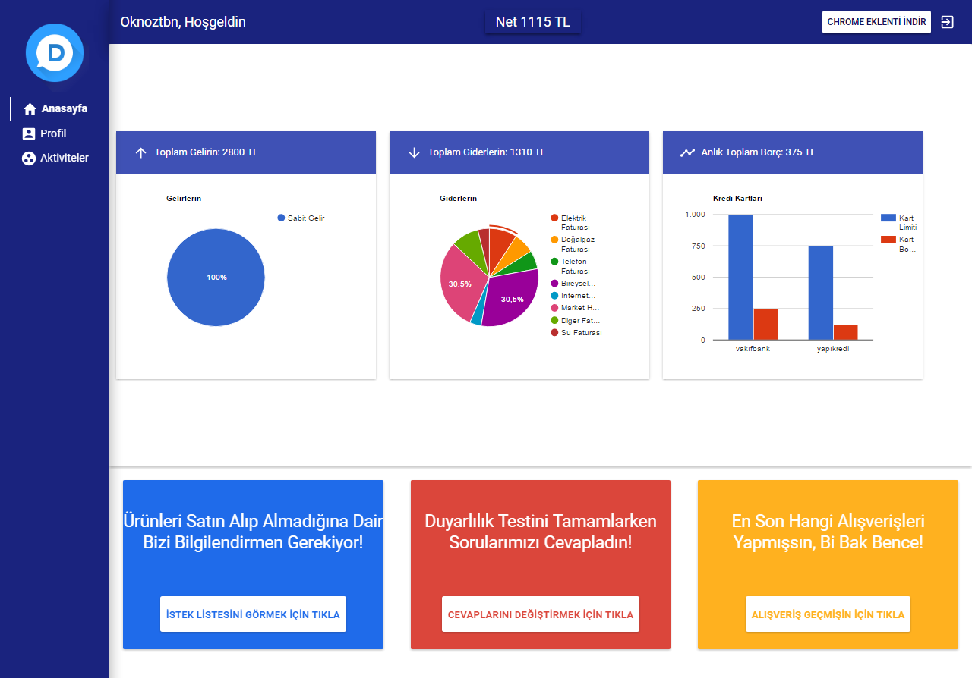

Figure 2. Homepage

Users can see total income, outcome, instant total debt. Also, User get information as a graphically. User should give information about last shopping for taking or not taking last product. If User don’t do the sensivity thesis before completing the shopping, they can do it on homepage. Also, If User doesn’t remember product which buy on the last shopping, they can learn easily.

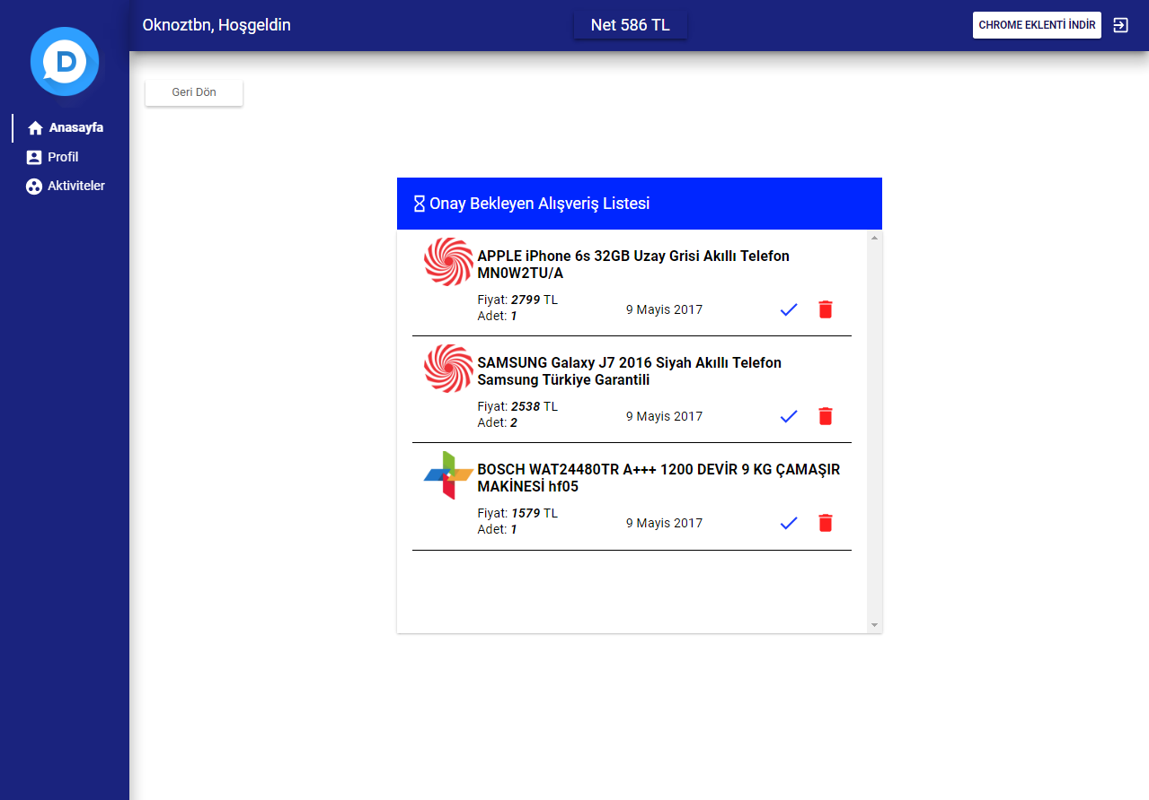

Figure 3. List of Shopping

Users can reach the list of the shopping and if they buy one of products as seen the picture and they click the tick button, after price of the product is reduced from net-income.

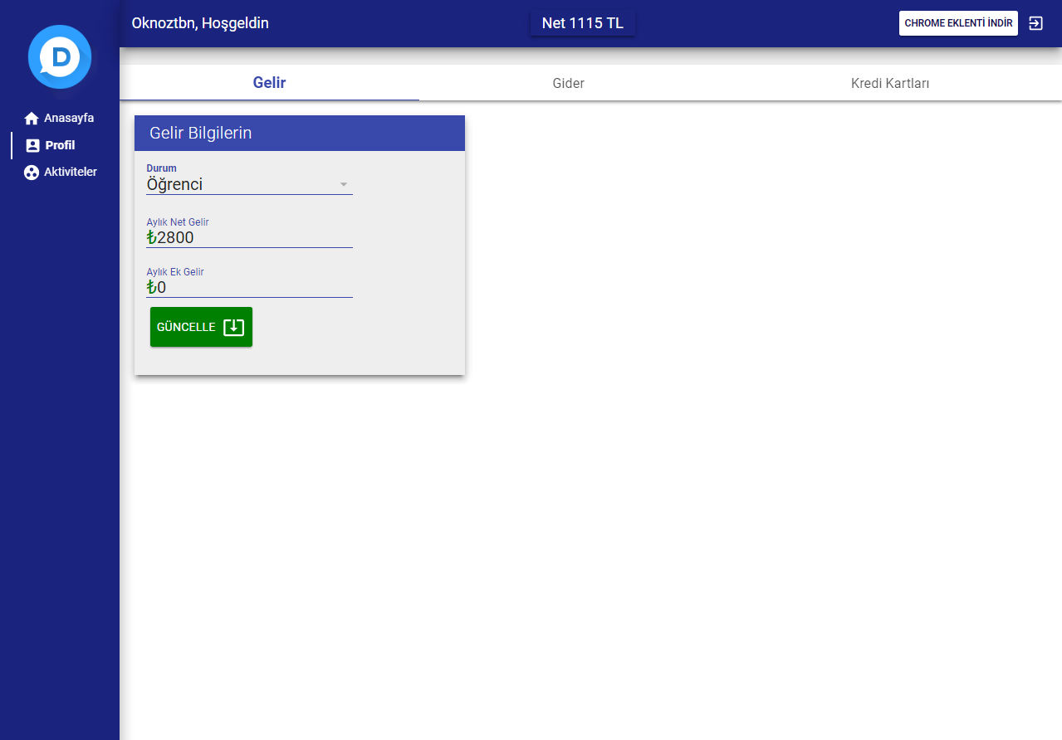

Figure 4. Profile and Total Income

User can see the total income and if there is any change, they can update the total income.

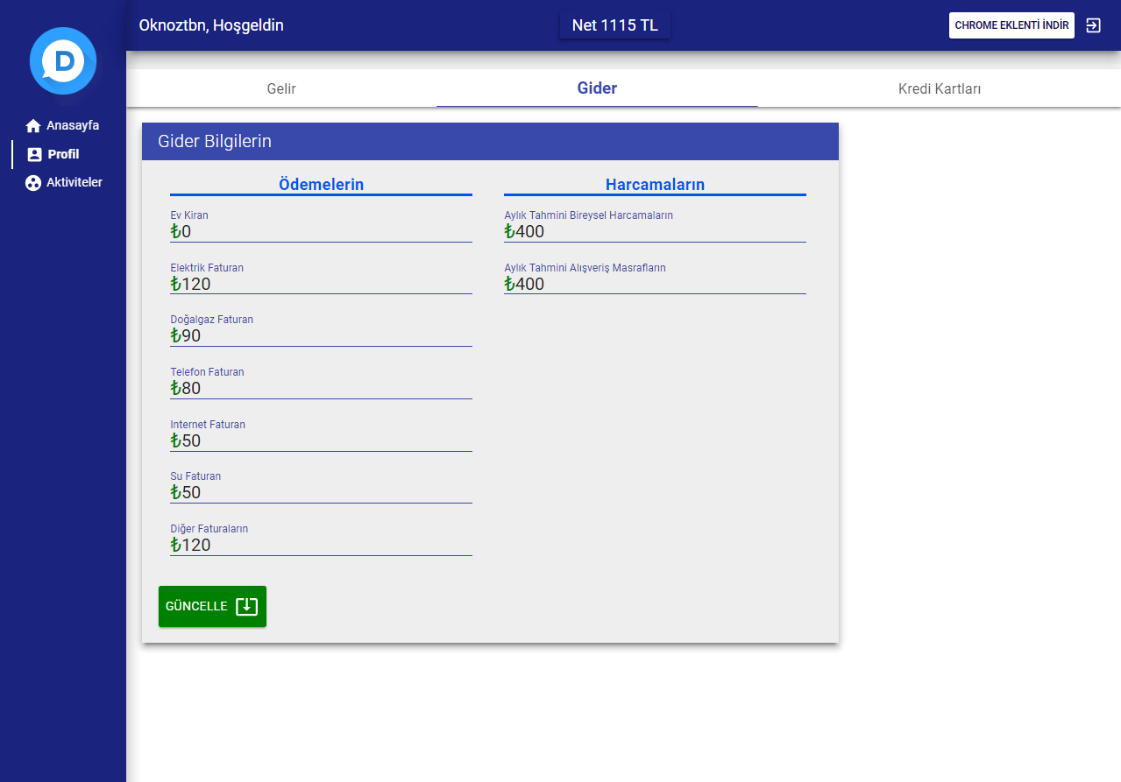

Figure 5. Profile and Total Outcome

We want to enter some outcome such as house rent, telephone bill for users. Also, users have to write monthly individual spending and shopping spending. If there is any change, they can update easily.

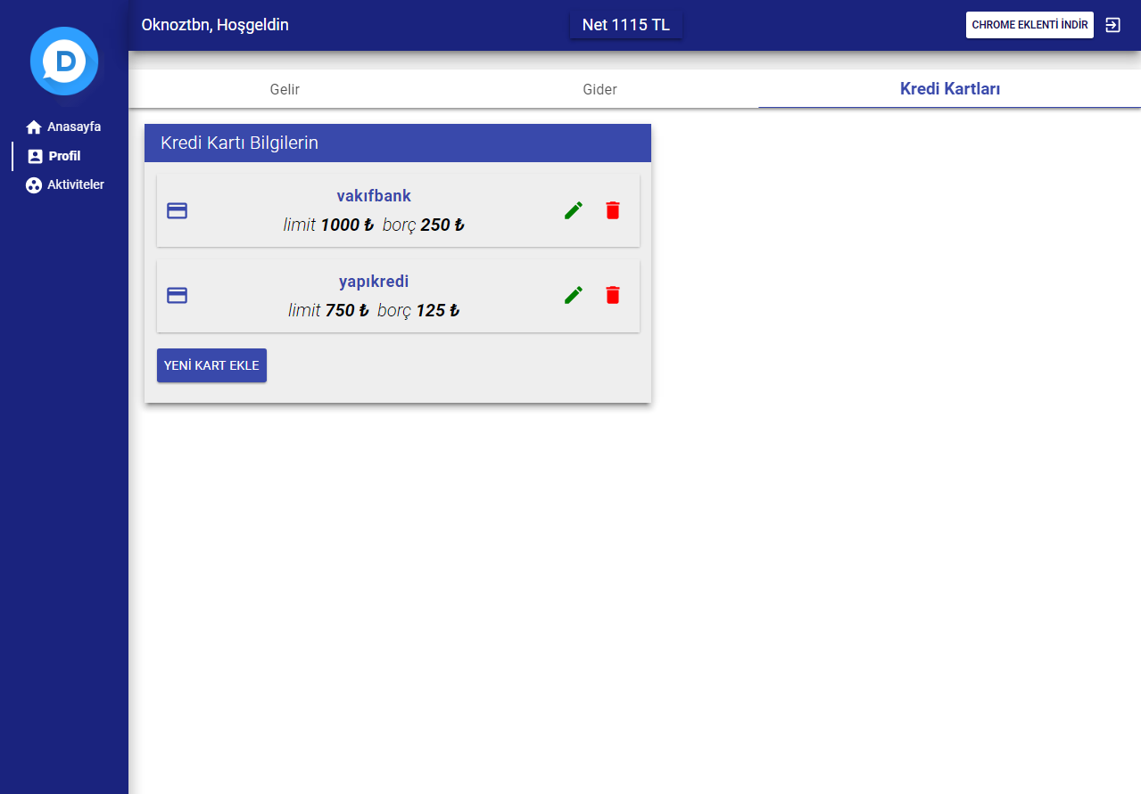

Figure 6. Profile and Credit Cards Information

User must enter their credit cards information. If they have one more than credit cards, they can click the buttons and add new cards. After all, Users can see total limits of credit cards and debt information.

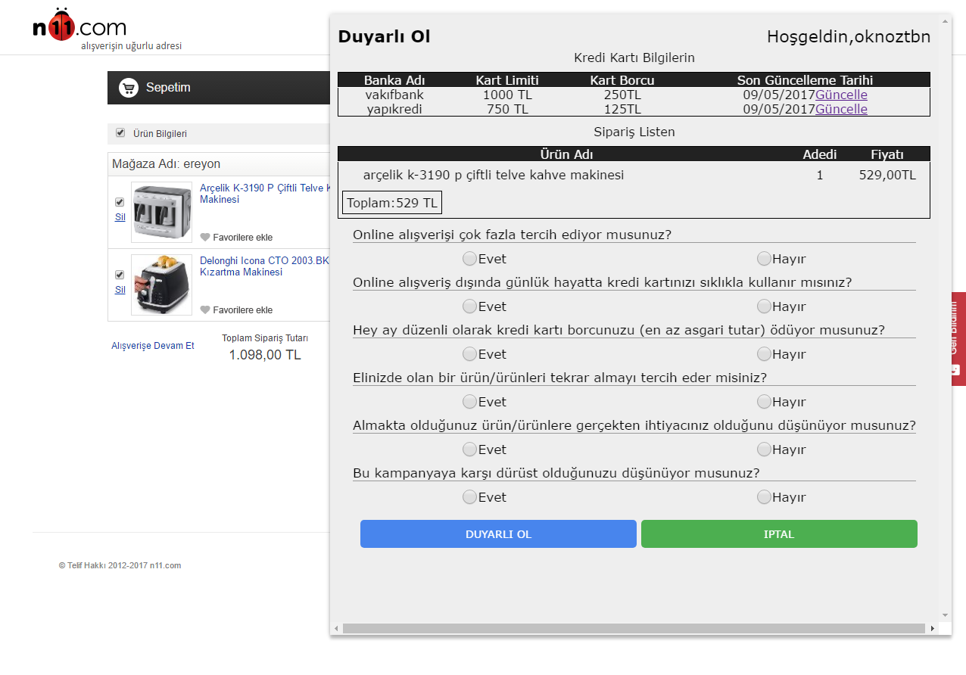

***Figure 7. Application of Duyarlı ol On Shopping Website***

User is directed before they completed the shopping. On the picture users, can see credit cards information and product that they want to buy. And if they don’t answer our applications questions, our questions come to screen.

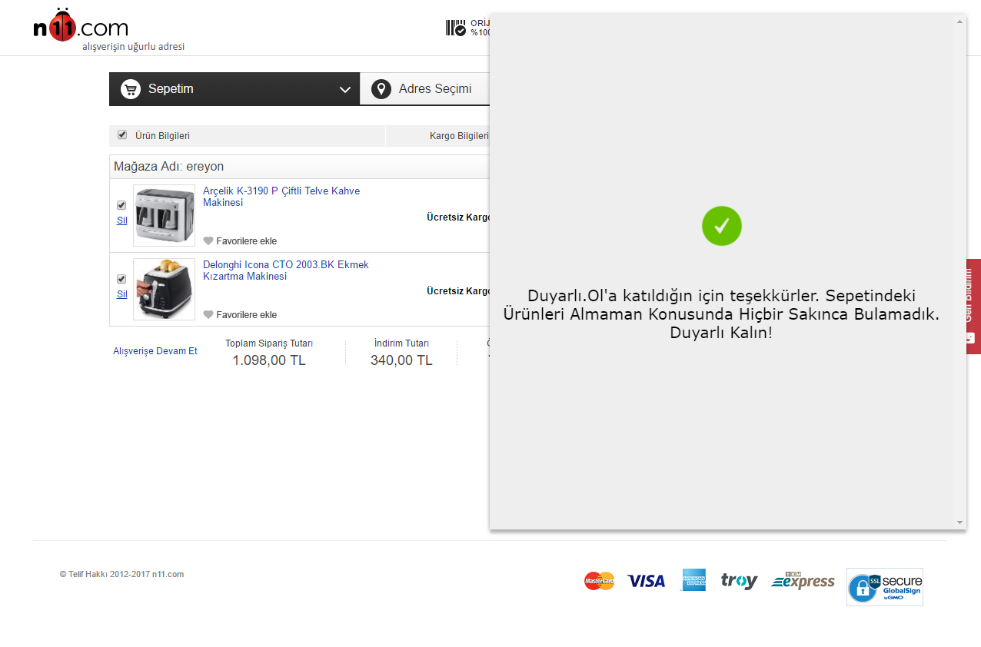

Figure 8. Application of Duyarlı ol with n11.com

Our application calculates the information that the user has entered and returns a result as to whether the product it received is suitable. It works on n11.com shopping site.

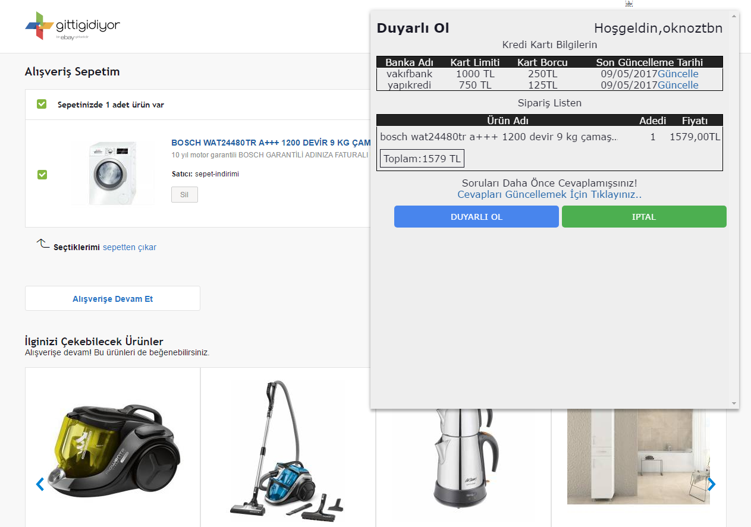

Figure 9. Application of Duyarlı ol with gittigidiyor.com

User is directed before they completed the shopping. On the screenshot, users can see credit cards information and product that they want to buy. Also, because the user has answered our questions previously, there is no reason to have our questions displayed on the screen again. It works on gittigidiyor.com shopping site.

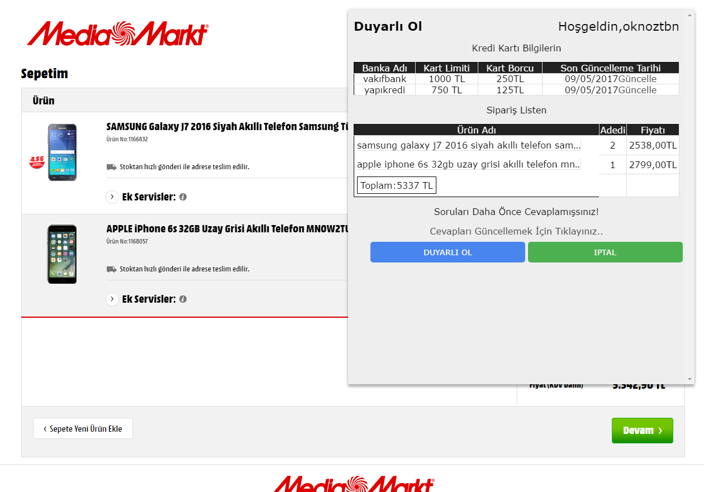

Figure 10. Application of Duyarlı ol with mediamarkt.com

User is directed before they completed the shopping. On the screenshot, users can see credit cards information and product that they want to buy. Also, because the user has answered our questions previously, there is no reason to have our questions displayed on the screen again. It works on mediamarkt.com.tr shopping site.

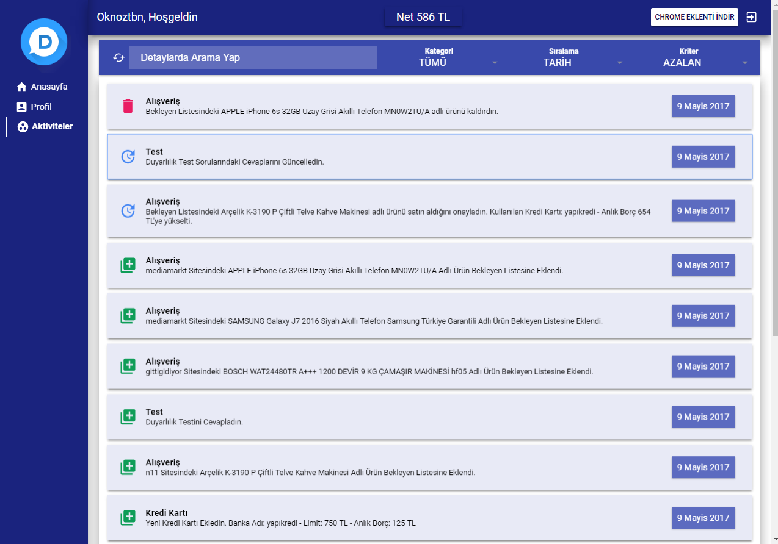

Figure 11. Events

The user can see the events of the shopping. They can also see changes in their income, outcome and credit card information.

4. CoNCLUSION

At the end of the project, we were able to show how much the user needed to shop in his own budget. The user had seen that the product he had bought with the amount of budget he had was in line with his budget. We made a second thought about buying products while shopping for individuals. We did our campaign of sensitivity. **Duyarlı Ol** a sensitivity campaign.

4. REFERENCES

1. https://azure.microsoft.com
2. https://tr.wikipedia.org/wiki/ASP.NET
3. https://tr.wikipedia.org/wiki/HTML
4. https://tr.wikipedia.org/wiki/Cascading_Style_Sheets
5. https://tr.wikipedia.org/wiki/JavaScript
6. https://www.microsoft.com/tr-tr/sql-server/
7. https://www.polymer-project.org/
8. https://developer.chrome.com/extensions