ANADOLU UNIVERSITY

FACULTY OF ENGINEERING

DUYARLIOL

Hakan Yıldız

Okan Öztaban

A Bachelor of Science Project

Department of Computer Engineering

May 2017

DUYARLIOL

by

Hakan Yıldız -

Okan Öztaban -29122110244

Submitted in partial fulfillment of the requirements for the degree of Bachelor of Science in Computer Engineering is approved by the following scientific committee members.

Date of Approval : May 12 , 2017

Member (Advisor) :

Member :

Member :

Member :

ABSTRACT

**Online shopping is more preferred in recent times due to the use of credit cards.   
Nevertheless, the rate of individual borrowing that people have is increasing. State and banks are encouraging instead of creating awareness and awareness on the individual, causing this increase**

**The main purpose of our project is to aim at a web sensitivity project which takes some basic information before completing the shopping to our clients who want to make online shopping and then makes a short test so that they can think about how much they need for the product they are buying and how they need it and leave the final decision to themselves.**

Keywords: Online Shopping, Credit Cards, Sensitivity, Web

ÖZET

Kredi kartı kullanımı nedeniyle son zamanlar online alışveriş daha fazla tercih edilmektedir.Bununla birlikte kişilerin sahip olduğu bireysel borçlanmada hız bir şekilde artış göstermektedir. .Devlet ve bankaların bireyler üzerinde farkındalık ve duyarlılık oluşturmak yerine teşvik etmeleri bu artışa da sebebiyet vermektedir.

Projemizin asıl amacı online alışveris yapmak isteyen müşterilerimize alışverişini tamamlamadan once bazı temel bilgilerini alıp ,kısa bir teste tabi tutarak, elindeki bütçe ile alacak olduğu ürüne ne kadar ihtiyacı olup olmadıgını düşünmesini sağlayan ve tabikide son kararı kendisine bırakan bir web duyarlılık projesi amaçlamaktır.

Anahtar Kelimeler: Online Alışveriş, Kredi Kartı, Duyarlılık, Web

CONTENTS

Page

1. INTRODUCTION v

1.1 Project Title v

1.2 Group Members v

1.3 Project Motivation v

1.4 Project Definition v

1.5 Scope of Project v

1.6 Gantt Chart vi

2. Platform and technologies to be used vii

2.1 ASP.NET vii

2.2 HTML vii

2.3 CSS vii

2.4 JAVASCRİPT vii

2.5 MySQL vii

2.6 POLYMER vii

3. CONCLUSIONS x

# 1. INTRODUCTION

## 1.1 Project Title

DUYARLIOL

## 1.2 Group Members

Hakan Yıldız

Okan Öztaban

## 1.3 Project Motivation

**The user will be redirected to our website before the user completes the exchange.Our system will enter some information of its own from the user. After the information, the system, based on the information entered, The user will be thought for the second time about the product he will buy.**

## 1.4 Project Definition

**Online shopping has increased with the increase in the use of credit cards in recent years. This has led to an increase in the individual debts of individuals. Our system is a susceptibility project intended to make people think twice about shopping.**

## 1.5 Scope of Project

**Anyone who makes an online purchase can go to our test and evaluate the price for that shopping.**

## 1.6 Gantt Chart

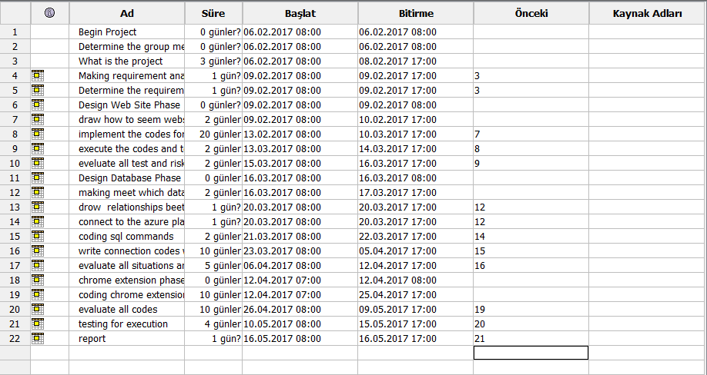

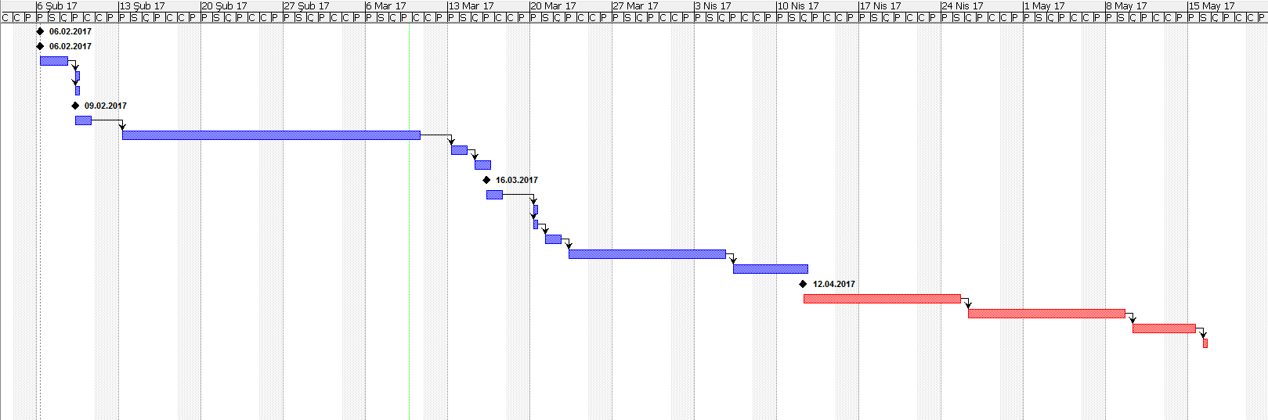

# 2. Platform and technologies to be used

## 2.1 ASP.NET

ASP.NET is an open-source server-side web application framework designed for web development to produce dynamic web pages. It was developed by Microsoft to allow programmers to build dynamic web sites, web applications and web services.

It was first released in January 2002 with version 1.0 of the .NET Framework, and is the successor to Microsoft's Active Server Pages (ASP) technology. ASP.NET is built on the Common Language Runtime (CLR), allowing programmers to write ASP.NET code using any supported .NET language. The ASP.NET SOAP extension framework allows ASP.NET components to process SOAP messages.

ASP.NET is in the process of being re-implemented as a modern and modular web framework, together with other frameworks like Entity Framework. The new framework will make use of the new open-source .NET Compiler Platform (code-name "Roslyn") and be cross platform. ASP.NET MVC, ASP.NET Web API, and ASP.NET Web Pages (a platform using only Razor pages) will merge into a unified MVC 6. The project is called ASP.NET Core.

.

## 2.2 CSS

Cascading Style Sheets (CSS) is a  style sheet language  used for describing the presentation   of a document written in a markup language. Although most often used to set the visual style of  web pages and user interfaces written in HTMl and XHTML, the language can be applied to any XML document, including plain XML , SVG and XUL, and is applicable to rendering in speech, or on other media. Along with HTML and JavaScript, CSS is a cornerstone technology used by most websites to create visually engaging webpages, user interfaces for web applications, and user interfaces for many mobile applications.

.

## 2.3 HTML

HyperText Markup Language (HTML) is the standard markup language for creating web pages and web applications. With Cascading Style Sheets (CSS) and JavaScript  it forms a triad of cornerstone technologies for the World Wide Web.  Web browsers receive HTML documents from a webserver or from local storage and render them into multimedia web pages. HTML describes the structure of a web page semantically and originally included cues for the appearance of the document.

.

## 2.4 JAVASCPRİPT

JavaScript is a high-level , dynamic, untyped and interpreted programming language .It has been standardized in the ECMAScript  language specification.Alongside HTML and CSS, JavaScript is one of the three core technologies of World Wide Web content production; the majority of websites employ it, and all modern Web browsers support it without the need for plug-ins.JavaScript is prototype-baseed with first class functions, making it a multi-paradign language, supporting,object-oriented ,imperative , and functional programming styles. It has an API for working with text,arrays , dates and reguşar expressions, but does not include anyI/O, such as networking, storage, or graphics facilities, relying for these upon the host environment in which it is embedded

## 2.5 MySQL

MySQL (officially pronounced as  is an open-source relational database management system .Its name is a combination of "My", the name of co-founder Michael Widenius' daughter, and “SQL”, the abbreviation for Structured Query Language. The MySQL development project has made its source code available under the terms of the GNU General Public License, as well as under a variety of proprietary agreements. MySQL was owned and sponsored by a single for-profit firm, the Swedish company MySQLAB, now owned by Oracle Corporation .For proprietary use, several paid editions are available, and offer additional functionality.

## 2.6 POLYMER

**In this period where internet usage is intensive and widespread, the need for modern web and mobile applications is increasing day by day, and various frameworks are being developed in order to develop faster and practical applications accordingly. However, these frameworks are also encountered;**

**Html codes not conforming to W3C standards**

**Can not reuse code written**

**Are an important problem in terms of implementation. In case of such problems, Polymer comes into commission as a savior, W3C conforms to its standards and re-usability. Polymer is a Google-developed framework that allows you to quickly and easily reusable components in modern web and mobile applications. While creating these components, they do so by taking web component standard (W3C) into account. In addition to these features, it also increases the readability of the code thanks to the custom elements it creates.**

# 3. CONCLUSIONS

**At the end of our project, we intend to think twice about this person and to create this awareness for everybody.**

REFERENCES

1. <https://nicolargo.github.io/glances/>
2. <http://linuxcommand.org/man_pages/vmstat8.html>
3. [https://www.vim.org](https://www.vim.org/)
4. <https://www.jetbrains.com/clion/>
5. <https://lemp.io/>
6. [http://www.lkd.org.tr](http://www.lkd.org.tr/)
7. <http://man7.org/linux/man-pages/man2/socket.2.html>