*Table of Contents:*

1. **Introduction**
2. **Simulation Design**
   * Locations and Entities
   * Path Network and Interfaces
   * Resources and Processes
   * Arrivals and Frequencies
3. **Entity Status Analysis**
4. **Resource Status Analysis**
   * Machinist Status
5. **Process Analysis**
6. **Simulation Outputs and Analysis**
   * Total Exit Part Count
   * Average Time in System
   * Average Processing Time
7. **Improvement of Simulation**
8. **Conclusion**

**1.Introduction**

This report presents a comprehensive analysis of a factory part production simulation created using the ProModel simulation software. The primary objective of this simulation is to evaluate the production processes and identify potential areas for improvement.

**2. Simulation Design**

* **Locations and Entities:** The simulation involves six distinct locations: queue, saw, production_machine1, production_machine2, polishing_machine1, and polishing_machine2. The main entity in the system, represented by "Product," follow designated paths between these locations.
* **Path Network and Interfaces:** The simulation employs a path network named Net1, enabling the movement of entities through different locations. Each location has a specific interface assigned to it.
* **Resources and Processes:** The "Machinist" resource is responsible for managing production processes. Processes include "saw-wait," "production_machine1-wait," "production_machine2-wait," "polishing_machine1-wait," and "polishing_machine2-wait."
* **Arrivals and Frequencies:** "Product" entities arrive at the "queue" location at intervals of 10 minutes.

**Design of Simulation:**

**Locations:**

**Paths: Interfaces:**

**3. Entity Status Analysis**

* Approximately 17.92% of entities are in motion logic, while the remaining 82.08% are engaged in operational phases.

**4. Resource Status Analysis**

The main resource in the system, "Machinist," exhibits the following utilization distribution:

* **Machinist Status:** The Machinist resource is allocated as follows:
  + In Use: 23.83% of the time, indicating instances where the Machinist is actively engaged in overseeing processes.
  + Travel to Use: 34.97% of the time, representing periods when the Machinist is moving between different locations for resource utilization.
  + Idle: 41.20% of the time, signifying instances where the Machinist is available but not actively involved in any operation.

These utilization percentages reflect the distribution of the main resource's activities within the simulated production process.

**5. Process Analysis**

The simulation entails the following sequential processes, each contributing to the entities' overall production journey:

1. **Product Arrival to Queue:** Entities initially arrive at the "queue" location, awaiting further processing.
2. **Product Processing at Saw:** Entities move to the "saw" location and undergo a 5-minute waiting process, simulating material preparation or initial processing.
3. **Product Processing at Production Machine 1:** After departing from the "saw" location, entities enter "production_machine1" and wait for 13 minutes. The extended wait time accounts for potential variations in machine performance due to factors like wear and tear.
4. **Product Processing at Production Machine 2:** Entities subsequently proceed to "production_machine2" and wait for 12 minutes. Similar to the previous step, the extended wait time accommodates potential differences in machine capabilities and performance.
5. **Product Processing at Polishing Machine 1:** Entities are directed to "polishing_machine1" and wait for 10 minutes. This stage represents the polishing process, which may necessitate different requirements compared to prior operations.
6. **Product Processing at Polishing Machine 2:** Finally, entities reach "polishing_machine2" and wait for 11 minutes. The distinct wait time underscores variations in machine efficiency, factoring in potential differences in wear and tear. The allocation to "polishing_machine2" is determined by its availability.

**6. Simulation Outputs and Analysis**

* **Total Exit Part Count:** The simulation yields a total of 45 output parts during its runtime.
* **Average Time in System:** On average, entities spend 34.87 minutes within the system.
* **Average Processing Time:** The average time entities spend in processing is 28.62 minutes.
* **The Machinist resource utilization is as follows:** 23.83% in use, 34.97% in travel to use, and 41.20% idle.
* **The status of single capacity locations:**
  + Saw: 50% in operation, 35.97% idle, 14.03% waiting.
  + production_machine1: 64.39% in operation, 32.46% idle, 3.05% waiting.
  + production_machine2: 57.52% in operation, 35.51% idle, 6.97% waiting.
  + polishing_machine1: 47.92% in operation, 52.08% idle.
  + polishing_machine2: 51.55% in operation, 48.45% idle.
* **The status of multiple capacity locations:**
  + **Occupancy:** The "queue" is occupied 20.04% of the time and remains empty 79.96% of the time. This indicates the utilization and waiting times of the queue during the simulation.

These resource and location status analyses provide insights into the operational efficiency and utilization patterns of various elements within the simulation.

**7. Improvement of Simulation**

**Adding an operator for saw:** Firstly, I placed a resource named "saw_operator" at the helm of the saw in the simulation. The purpose of this resource was to fulfill the request of my laboratory professor during the presentation, which was to carry out the operation of machines using "use" command with resources. In the simulation, I used the following operation in the relevant process: "USE saw_operator FOR 5." This way, thanks to the operator I added, the saw gave the impression of being controlled not in an automated manner but rather as if it were being operated by a human. However, I intentionally did not apply this to all machines in the factory simulation because, as you are aware, there are already numerous machines in today's world that operate autonomously, without the need for operators.

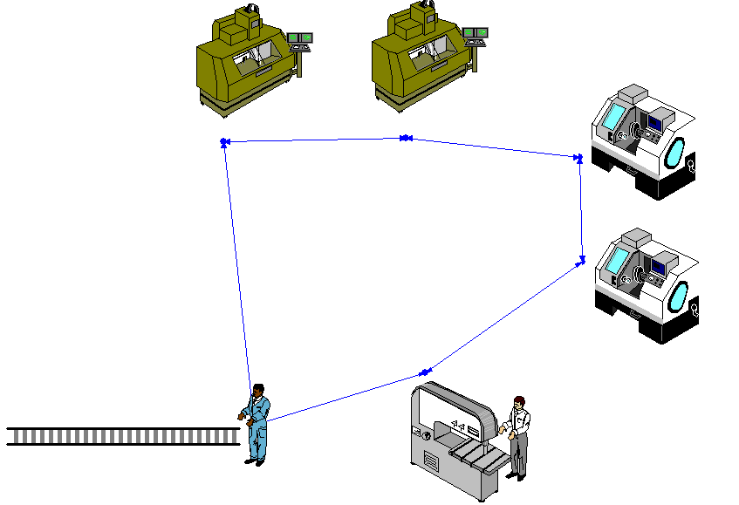

**Doubling the number of machinists and the results:** Subsequently, I doubled the number of machinists in the system. As a result, with the increased number of machinists and reduced workload in the queue, I was able to boost the frequency of product arrivals in the arrival section. This led to the system avoiding any bottlenecks, and as a result of simulating an 8-hour production shift, we were able to produce a greater quantity of parts. Additionally, the waiting times were reduced to almost zero. I have attached the final output image below, where you can view the relevant statistics.

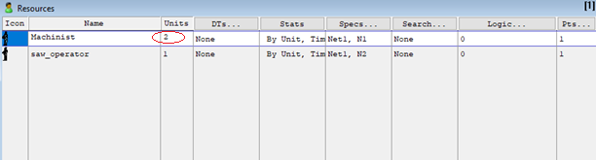



**8. Conclusion**

This comprehensive report delves into the analysis of a factory part production simulation executed via ProModel software. By pinpointing improvement prospects and suggesting strategies for bolstering productivity, the report aspires to bolster decision-making and optimization endeavours within the realm of manufacturing.