# Small Problem 2: Disease Diagnosis

## Introduction

The file “problem-2-generator.R” contains R code to generate random bipartite networks relating diseases to findings inspired by the famous QMR-DT medical diagnosis system (Shwe, Middleton, Heckerman, Henrion, Horvitz, Lehmann, Cooper, 1991. “Probabilistic diagnosis using a reformulation of the INTERNIST-1/QMR knowledge base: I. The probabilistic model and inference algorithms.” *Methods of Information in Medicine*, Schattauer).

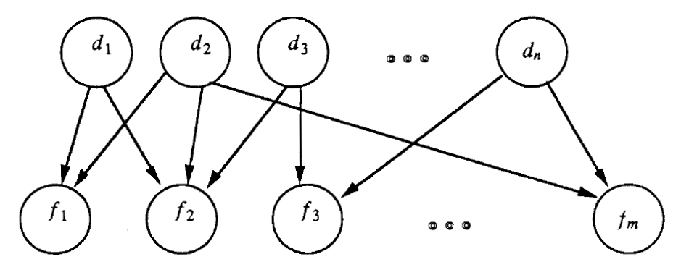

The conditional probability of is parameterized as a Noisy-OR. In the published work, a leakage probability (corresponding to a species disease node that is always observed to be true) was included. However, our code does not include this.

The following files are provided:

|  |  |
| --- | --- |
| *Name* | *Description* |
| problem-2-disease-priors.csv | Prior probability of occurrence of each disease |
| problem-2-edges.csv | Weights on each edge. A 0 weight means no edge |
| problem-2-cases-findings.csv | Findings for four cases |
| problem-2-cases-ground-truth.csv | Ground truth for the four cases |
| problem-2-treatment-costs.csv | Cost of treating each disease |
| problem-2-observation-costs.csv | Cost of observing each finding |
| problem-2-cases-partial-findings.csv | Partial findings for query 3 |

For this network, we have manually tweaked the model to ensure that the rarest disease is the most expensive to treat. But we have not adjusted observation costs to reflect the informativeness of the findings.

## Queries and Metrics:

**Query 1:**

Posterior distribution over the disease state variables.

**Metric 1:**

Total variation distance between the true posterior and the posterior output by the probabilistic program.

**Query 2:**

Joint MAP value of the disease state variables.

**Metric 2:**

Hamming distance between the true disease states and the predicted MAP disease states.

**Query 3:**

For each case, for each unobserved finding, compute the one-step expected value of information for observing that finding. To do this, we must model the cost to the patient of having the disease versus not having the disease and the cost of treatment. Let index the diseases and let equal 1 if the patient has the disease and 0 otherwise. Let equal 1 if we decide to treat disease and 0 otherwise. Then is a cost matrix of the following form:

|  |  |  |
| --- | --- | --- |
|  |  |  |
|  |  |  |
|  |  |  |

In words, if the patient does not have the disease and we do not treat it, then there is zero cost. If the patient has the disease and we do not treat it, there is a cost (“misery”) for an untreated case. If we treat the disease, then the cost is regardless of whether the patient had the disease (i.e., when , the treatment works perfectly and there is no misery).

Let be the given set of partial findings and their values, and let be the revised set of findings after observing finding . Let be the cost of observing finding . Let be the vector of treatment decisions. Then

is the expected cost of the vector of treatments that minimizes the total cost.

Then the value of information is the expected cost of treating the disease(s) without observing less the cost of observing plus the expected cost of treating the disease(s) after observing .

**Metric 3:**

**Submission:**

The metric value should be computed for each elapsed time step (by calling the provided code or by implementing yourself). The metric value should be reported for several elapsed time steps. The number of elapsed time steps should be sufficient to establish an “informative profile”.

For further details regarding submission of the metric and your code, please refer to the main CP4 problem description document, e.g. PPAML-Challenge-Problem-4.pdf.

Sample output for this problem has been provided in the “sampleoutput” folder:

problem-2-query-1-metric-1.csv

problem-2-query-2-metric-2.csv

problem-2-query-3-metric-3.csv

**Notes:**

Further details on this problem can be found in the provided sample solution, e.g.

ppaml-cp4/solutions/problem2