## **Problem 6: Network Analysis Expressiveness Challenge**

This is an expressiveness challenge. The challenge is to represent a probabilistic model that generates an undirected graph. Nodes are added sequentially to the graph, and edges are added according to a mixture of two approaches: random attachment (each new node is randomly attached to existing nodes) and preferential attachment (where each new node is attached to existing nodes according to a “rich-get-richer” preference). Full details of the model are provided on the CP4 web page.

The challenge is to express the model in such a way that constraints can be placed on such properties as the clustering coefficient and the number of edges while still permitting reasonably efficient inference.

# Motivation

Graphs are ubiquitous in many “Big Data” applications. Hence, many machine learning algorithms and methods must incorporate and learn on graphical data. This often requires modeling the generative process of a graph, and applying evidence to the model in the form of properties of the final graph.

# Model

This task uses a simple generative model of a mixed preferential/uniform attachment graph, as shown in Figure 1.

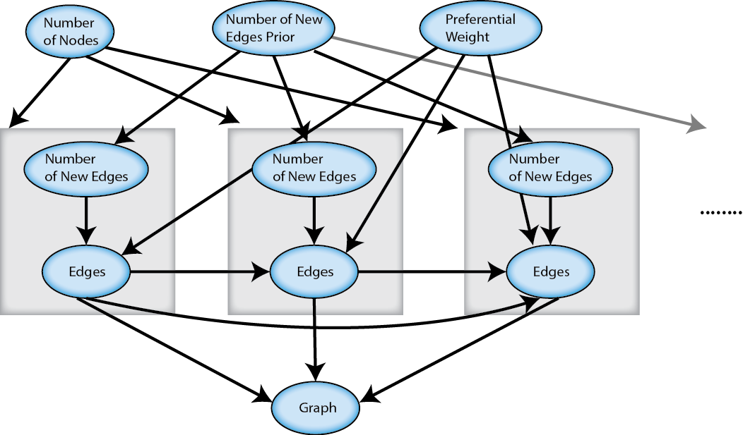

Figure 1: Preferential Attachment Graph Generative Model

The *Number of Nodes* variable determines how many nodes are in the graph. The nodes are generated in succession, and each newly generated node has a distribution over the number of new edges it will create, in the *Number of New Edges* variable. The *Edges* variable for a node represents a set of new edges (whose size depends on *Number of New Edges*). As this is a mixed preferential/uniform attachment model, the *Edges* variable for a node also depends on all of the *Edges* variables for previously created nodes. The variable *Preferential Weight* models the weight of the preferential attachment model for edge creation; values closer to one indicate more weight to a preferential attachment policy of creating new edges, whereas values close zero give more weight to a uniform attachment policy. The probability that a newly created node *i* creates an edge to node *j* is:

$$P\left(i connects to j\right)= Weight*\frac{\left|j.Edges\right|+1}{\left|Nodes\right|+\left|Edges\right|}+(1-Weight)*\frac{1}{|Nodes|}$$

Where $\left|j.Edges\right|$ is the number of edges connecting to node *j* and $\left|Nodes\right|$ and $|Edges|$ are the current total number of nodes and edges in the graph, respectively.

Finally, the *Graph* variable represents the final graph representation of the generative process. All edges are treated as undirected.

# Challenge Task and Metrics

The task on this problem is to design and implement the graph generative model in such a way that arbitrary hard or soft constraints can be applied to the final, observed graph and used to infer properties of the graph, such as the number of new edges prior or the edge attachment mixing weight.

Performers will be judged on the expressiveness and conciseness of the constraints and efficiency in reasoning with the constraints. Performers may optionally produce performance profile curves (accuracy of answer versus amount of CPU time).

Performers are free to define their own distributions for the model parameters, such as the number of nodes and the number of new edges, as long as they are able to demonstrate reasoning about the posterior distribution given evidence (outlined in the Appendix).

# Submission

This problem is an expressiveness challenge. The primary requirement is to demonstrate a probabilistic program and show that it runs and computes the right answer. Teams should submit their source code as file “problem-6-solution.tar”. Teams may optionally produce performance profiles for a metric of their choice. Please define the metric in a file named “problem-6-query-q-metric.pdf”.

# Appendix

* 1. **Constraint and Query 1**

|  |  |
| --- | --- |
| **Constraint** | **Relative Weights** |
| 1 | *0.4 <= CC <= 0.6 -> 3.0*  *0.2 <= CC < 0.4 -> 2.0*  *0.6 < CC <= 0.8 -> 2.0*  *0.0 <= CC < 0.2 -> 1.0*  *0.8 < CC <= 1.0 -> 1.0* |

|  |  |
| --- | --- |
| **Query** | **Value** |
|  | ? |
|  | ? |

* 1. **Constraint and Query 2**

|  |  |
| --- | --- |
| 1. **Constraint** | **Relative Weights** |
| 2 |  |

|  |  |
| --- | --- |
| **Query** | **Value** |
| $$Distribution of Preferential Weight$$ | ? |
| $$Distribution of Number of New Edges Prior$$ | ? |

1. The Clustering Coefficient of a graph is defined as the average clustering coefficient of a node. The Clustering Coefficient of a node $C_{i}$ is defined as:

$$C_{i}= \frac{2|e_{i}∈N_{i}|}{\left|N_{i}\right||N_{i}-1|}$$

Where $N_{i}$ is the set of nodes directly connected to node $i$ and $e_{i}$ is an existing edge between any two nodes in $N_{i}$.

1. This constraint is really on the cumulative degree distribution of the network. That is, the fraction of nodes in the graph with at least one edge should be 1.0, with at least two edges 1/4, etc. This assumes that the minimum number of edges that at node has is one. Performers may restrict the constraint to a reasonable finite range of node degrees.