

**ACADEMIC TASK - 2 CSE307**

(Internetworking Essentials)

Name: Adnan Mushtaq

Registration No.: 12313158

Section: K23UP, G2

Roll No.: 52

Submitted to:

**Mr. Simarjit Singh Malhi**

**Acknowledgment**

I would like to express my sincere gratitude to all those who contributed to the successful completion of this CA on Internetworking Essentials.

First and foremost, extend my heartfelt thanks to **Simarjit Singh Malhi,** our esteemed professor, for his invaluable guidance, encouragement, and continuous support throughout this project. His deep knowledge and insightful feedback have greatly enriched understanding of computer networking concepts and their practical applications. Thank you to everyone who played role in making this project a success.

Adnan Mushtaq

12313158

Lovely Professional University

29/04/2025

**SIX FLOOR BUILDING NETWORKING**

**LAYOUT:**

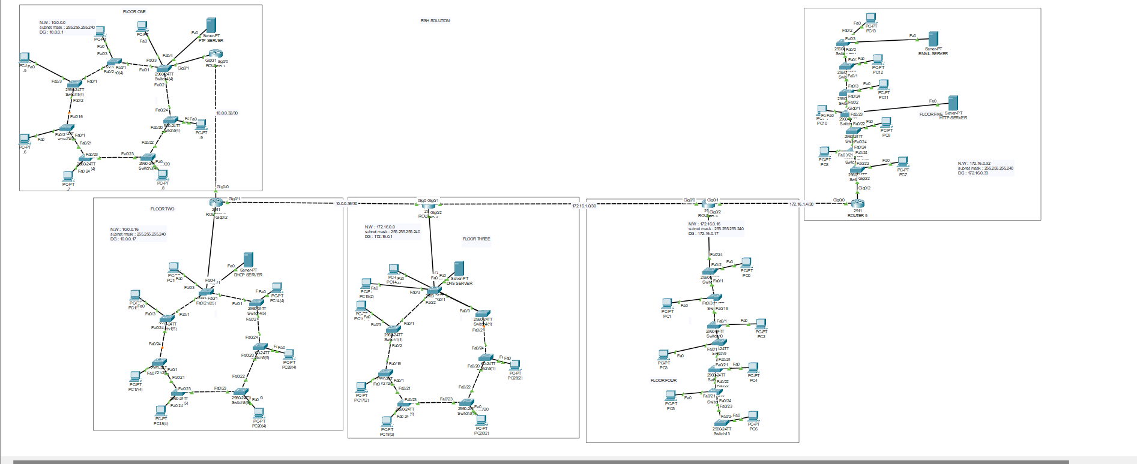

Total number of networks: 9

Total number of LANs: 5

Total number of default gateways: 5

**Network addresses** of LANs are:

**10.0.0.0/28** (Private ClassA)

**10.0.0.16/28** (Private Class A)

**172.16.0.0/28** (Private Class B)

**172.16.0.16/28**(private Class B)

**172.16.0.32 /28** (Private Class B)

**NETWORKS ADDRESS IN BETWEEN ROUTERS**

**FLOOR1-FLOOR2 HAS 10.0.0.32/30 NETWORK**(Private Class A)

**FLOOR2-FLOOR3 HAS 10.0.0.36/30 NETWORK**(Private Class A)

**FLOOR3-FLOOR4 HAS 172.16.1.0/30 NETWORK**(Private Class B)

**FLOOR4-FLOOR5 HAS 172.16.1.4/30 NETWORK(**private Class B**)**

**FLOOR 1:**

**network 10.0.0.0/28**

**subnet 255.255.255.240**

**gateway 10.0.0.1**

**FLOOR 2:**

**Network 10.0.0.16/28**

**Subnet 255.255.255.240**

**Gateway 10.0.0.17**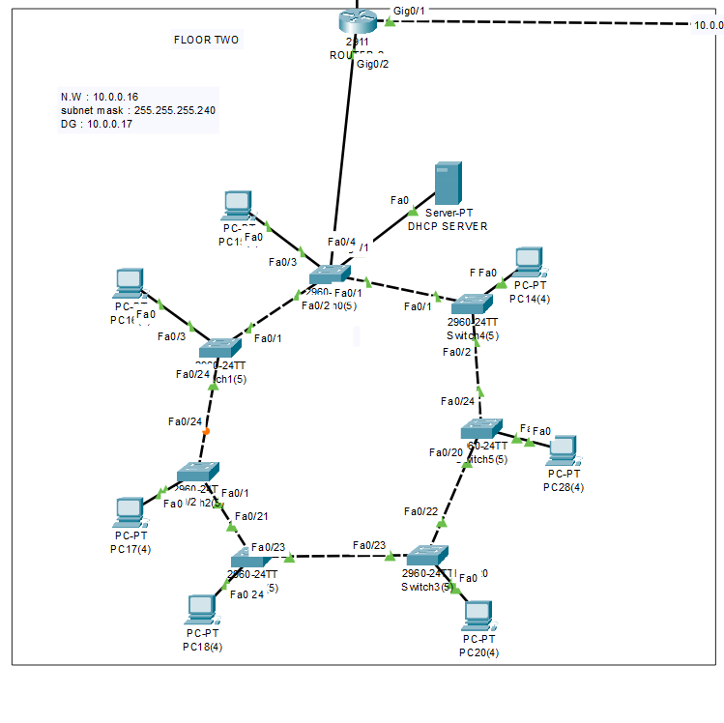

**FLOOR 3:**

**Network 172.16.0.0/28**

**Subnet 255.255.255.240**

**Gateway 172.16.0.1**

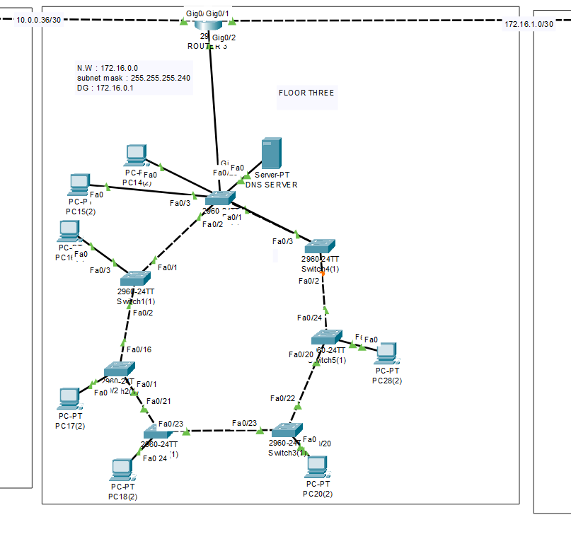

**FLOOR 4:**

**Network 172.16.0.16/28**

**Subnet 255.255.255.240**

**Gateway 172.16.0.17**

**FLOOR 5:**

**Network 172.16.0.32/28**

**Subnet 255.255.255.240**

**Gateway 172.16.0.33**

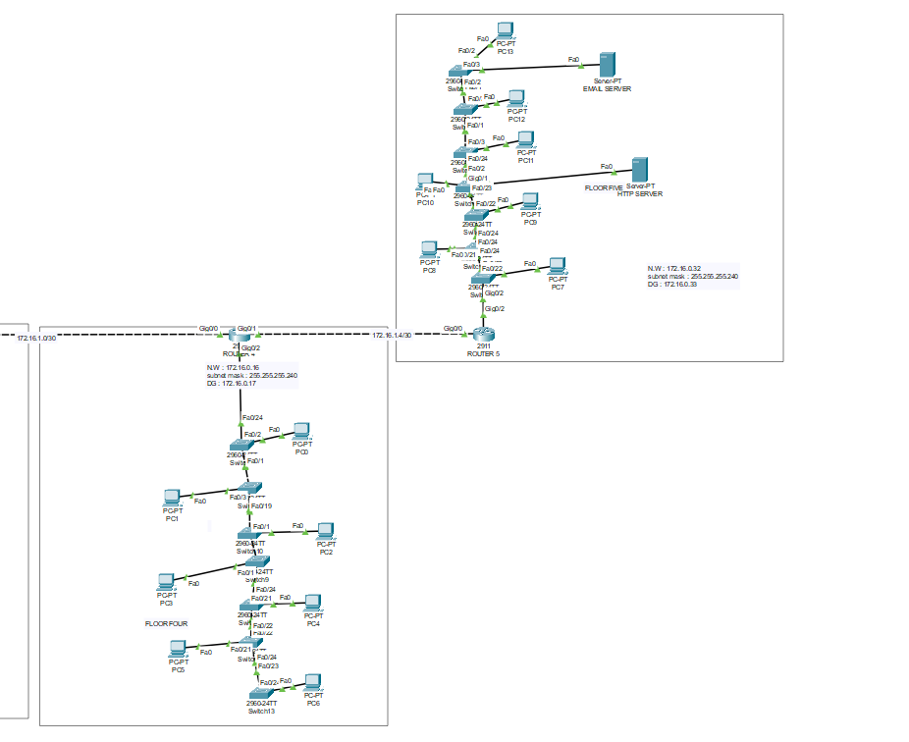

**PINGING THE PCS**

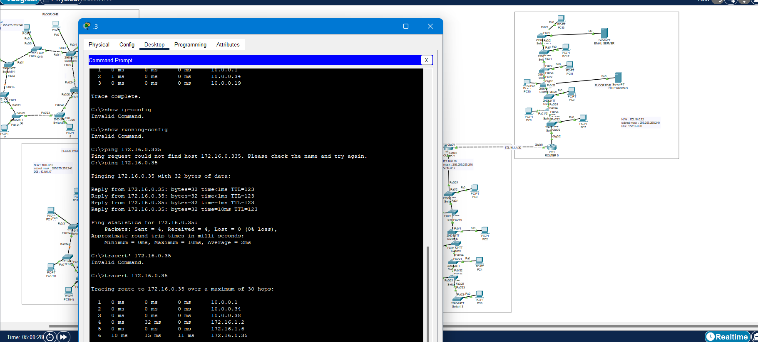

Figure 1 FLOORPC1 – FLOOR5

MAIL SERVICES

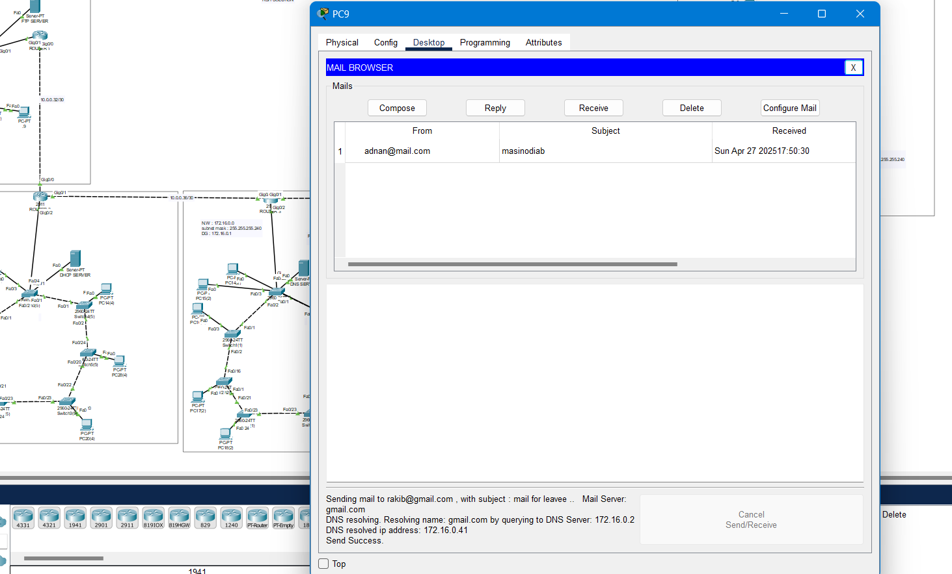

DHCP SERVICES

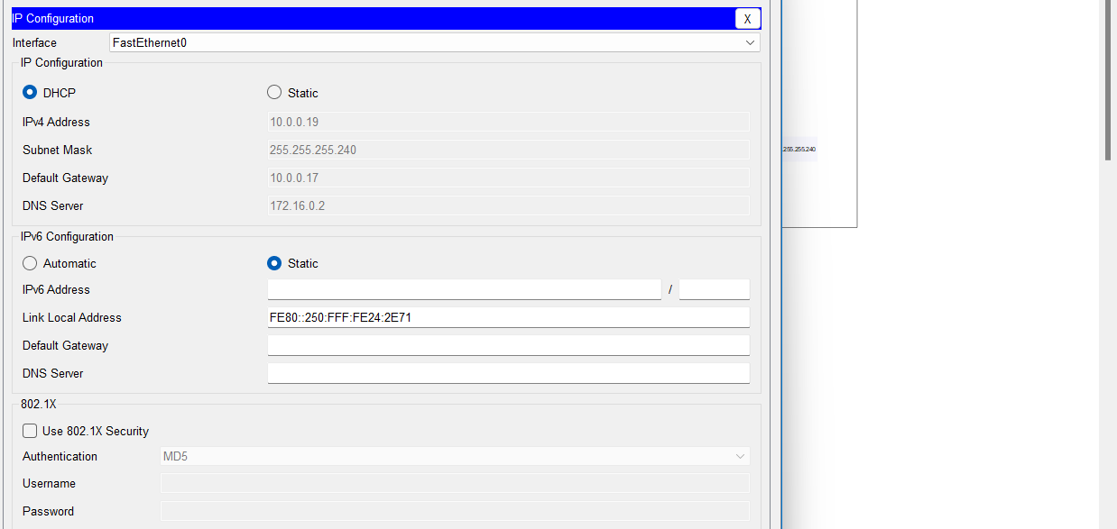

Github link : <https://github.com/hakeemadnan/NETWORKING>CA2