**Acknowledgment**

I would like to express my sincere gratitude to all those who contributed to the successful completion of this CA on Internetworking Essentials.

First and foremost, extend my heartfelt thanks to **Simarjit Singh Malhi,** our esteemed professor, for his invaluable guidance, encouragement, and continuous support throughout this project. His deep knowledge and insightful feedback have greatly enriched understanding of computer networking concepts and their practical applications. Thank you to everyone who played role in making this project a success.

Adnan Mushtaq

12313158

Lovely Professional University

28/02/2025

**SIX FLOOR BUILDING NETWORKING**

**LAYOUT:**

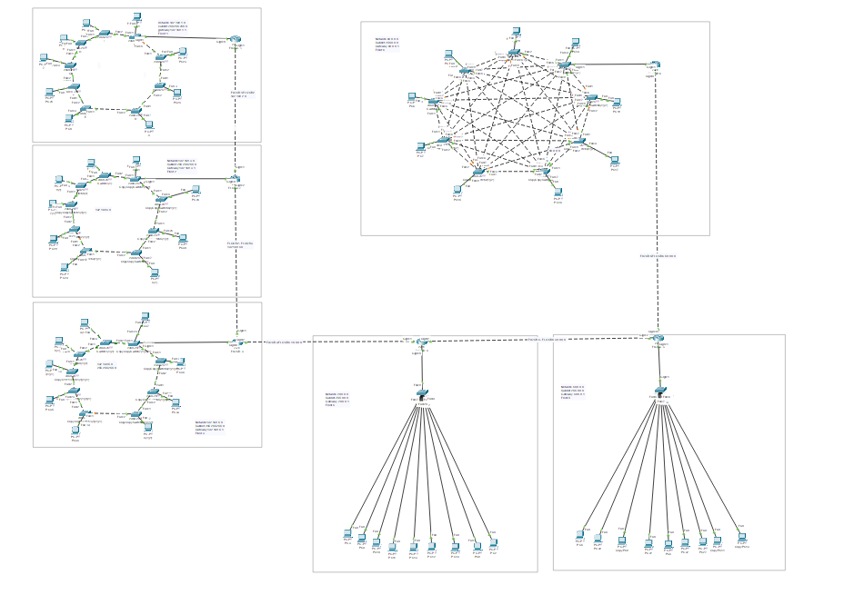

Total number of networks: 11

Total number of LANs: 6

Total number of default gateways: 6

**Network addresses** of LANs are:

**192.168.1.0** (Private ClassC)

**192.168.3.0** (Private Class C)

**192.168.5.0** (Private Class C)

**20.0.0.0** (Public Class A)

**40.0.0.0**  (Public Class A)

**60.0.0.0**  (Public Class A)

**NETWORKS ADDRESS IN BETWEEN ROUTERS**

**FLOOR1-FLOOR2 HAS 192.168.2.0 NETWORK**(Private Class C)

**FLOOR2-FLOOR3 HAS 192.168.4.0 NETWORK**(Private Class C)

**FLOOR3-FLOOR4 HAS 10.0.0.0 NETWORK**(Private Class A)

**FLOOR4-FLOOR5 HAS 30.0.0.0 NETWORK(**Public Class A**)**

**FLOOR5 -FLOOR6 HAS 50.0.0.0 NETWORK(**Public Class A)

**FLOOR 1:**

**network 192.168.1.0**

**subnet 255.255.255.0**

**gateway 192.168.1.1**

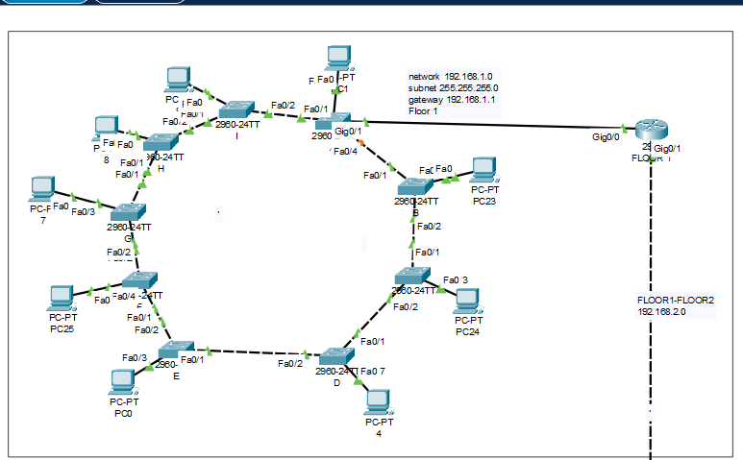

**FLOOR 2:**

**Network 192.168.3.0**

**Subnet 255.255.255.0**

**Gateway 192.168.3.1**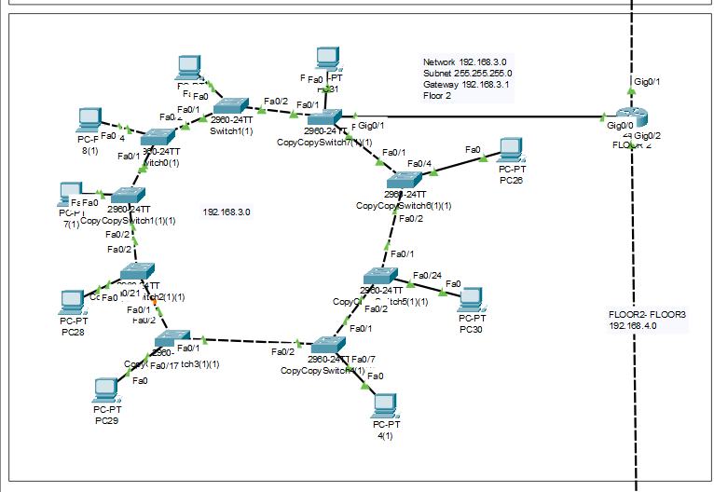

**FLOOR 3:**

**Network 192.168.5.0**

**Subnet 255.255.255.0**

**Gateway 192.168.5.1**

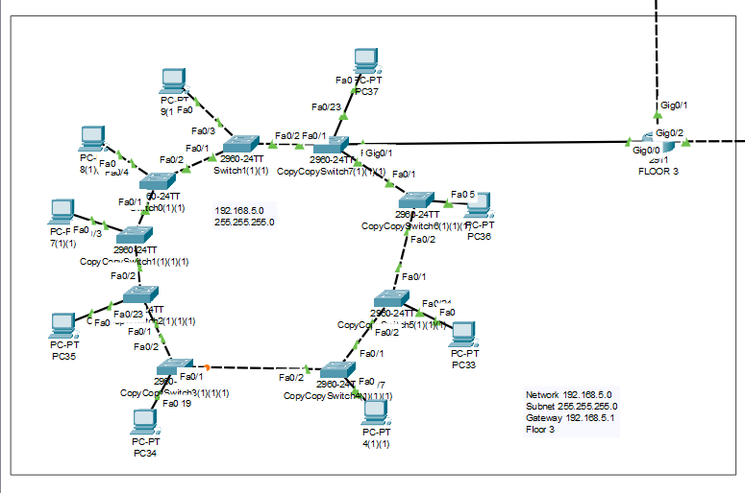

**FLOOR 4:**

**Network 20.0.0.0**

**Subnet 255.0.0.0**

**Gateway 20.0.0.1**

**FLOOR 5:**

**Network 40.0.0.0**

**Subnet 255.0.0.0**

**

**FLOOR 6**:

**Network 60.0.0.0**

**Subnet 255.0.0.0**

**Gateway 60.0.0.1**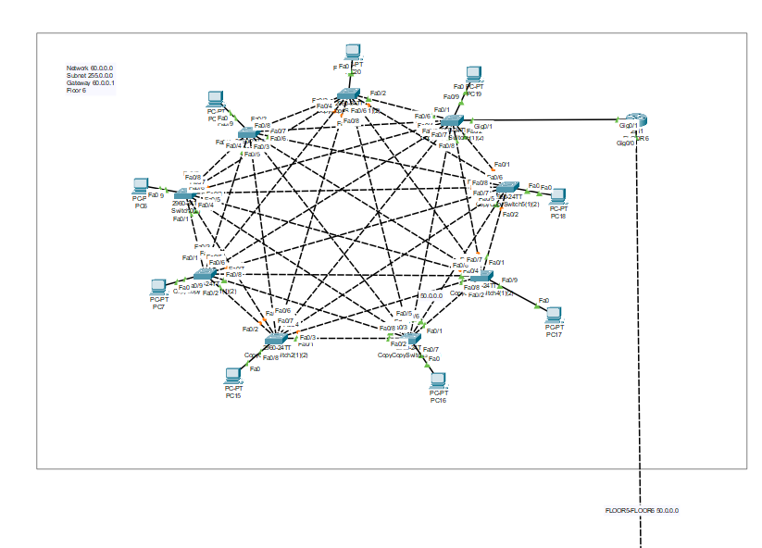

**NETWORKS IN BETWEEN ROUTERS**

**FLOOR1-FLOOR2 HAS 192.168.2.0 NETWORK**

**FLOOR2-FLOOR3 HAS 192.168.4.0 NETWORK**

**FLOOR3-FLOOR4 HAS 10.0.0.0 NETWORK**

**FLOOR4-FLOOR5 HAS 30.0.0.0 NETWORK**

**FLOOR5 -FLOOR6 HAS 50.0.0.0 NETWORK**

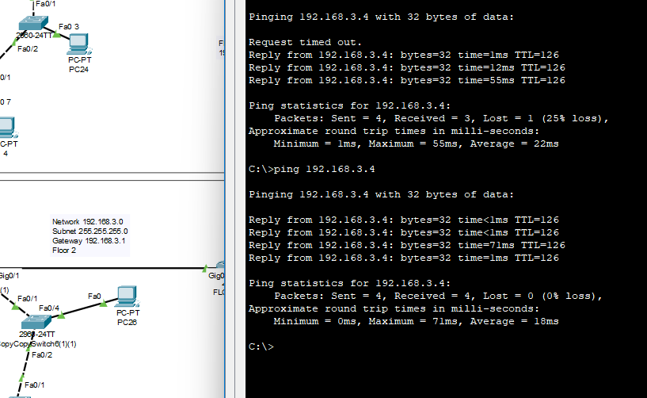

Figure FLOORPC1 - FLOOR2PC

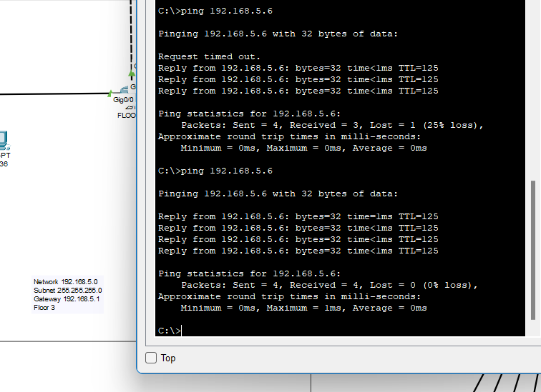

Figure FLOOR1PC-FLOOR3PC

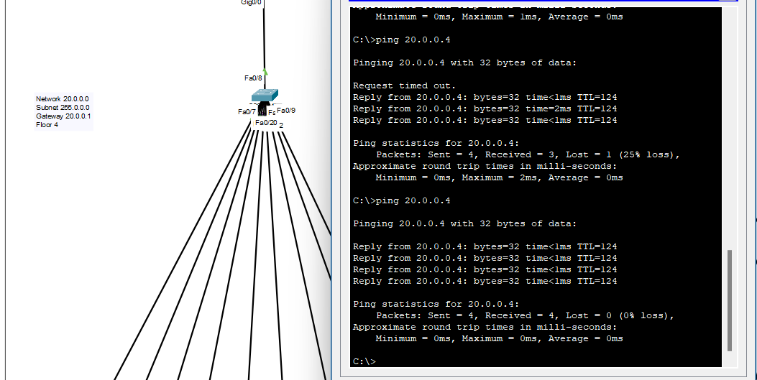

Figure :- FLOOR1PC-FLOOR4PC

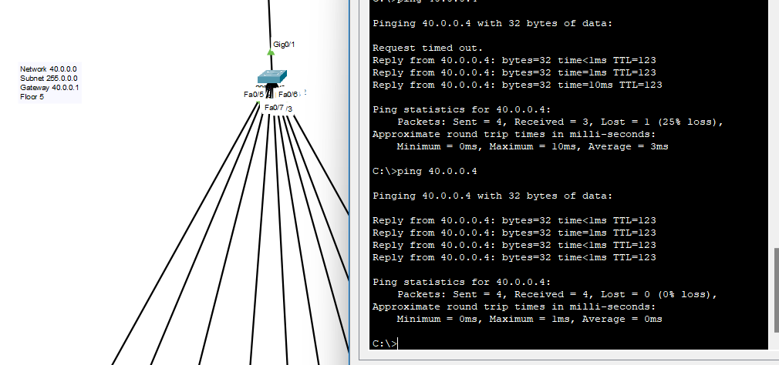

Figure : - FLOOR1PC -FLOOR5PC

Figure FLOOR1PC - FLOOR6PC

