**Farm**

**Dokumentáció**

Hoffmann Ákos

S8F9EN

**Felhasználói kézikönyv**

A Farm egy farm menedzsment játék, ahol a játékosnak egy kertet kell gondoznia, abba növényeket ültetnie, valamint azokat le kell aratnia.

A játékos a programot megnyitva a főmenüben kezd, ahonnan közvetlen ki tud lépni, be tudja tölteni egy korábbi játékállását, abban az esetben, ha már játszott a játékkal, vagy kezdhet egy újat.

Új játék kezdése:

Új játék kezdésekor a játékosnak meg kell adnia a nevét, valamint, hogy milyen nehézségen akar játszani. A nehézség függvényében változik a kert nagysága.

Játék mentése-betöltése:

A játék automatikusan elmenti az adott játékállást minden kilépéskor, és a játék indításakor van lehetősége ennek betöltésére a főmenüből. Ha a játékos egy új játékot kezd, akkor a korábbi játékállását nem tudja betölteni, mivel a program az új játékot menti el.

A játék menete:

A kertben egy-egy parcellára kattintva jobb klikkel lehetséges az ültetés, valamint aratás.

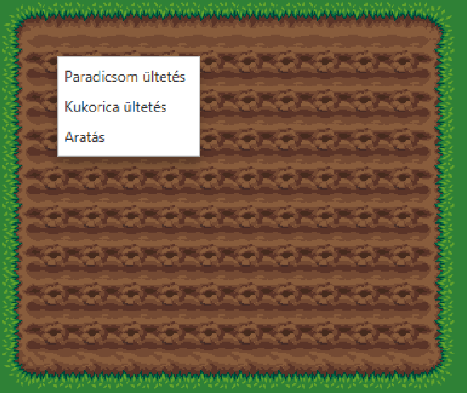

A növényt elültetve az növésnek indul és a paradicsom esetében 5 másodpercenként nő egy-egy fázist, míg el nem éri a végső (4.-ik) fázist amikor már teljesen megnőtt és le lehet aratni. Minden növénynek különböző növési ideje van, a paradicsom nő a leggyorsabban.  
Miután megnőtt, ugyanígy a növényre jobb klikkelve lehet learatni a növényt.

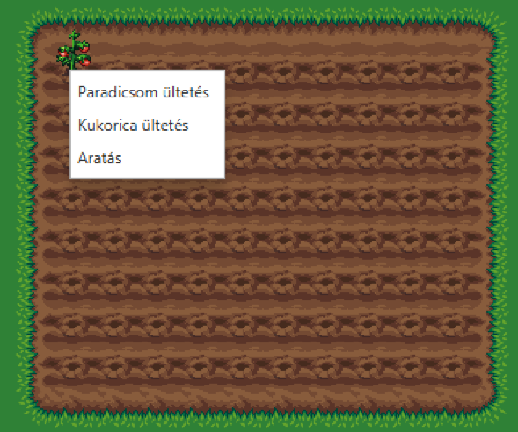

**Class Diagram**

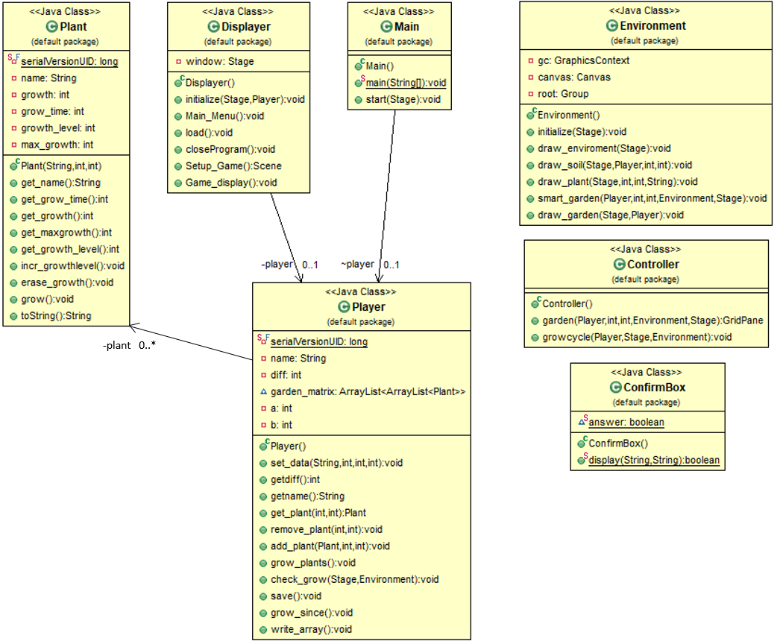

**Hierarchical Index**

**Class Hierarchy**

This inheritance list is sorted roughly, but not completely, alphabetically:

ConfirmBox ......................................................................................................................................... 6

Controller .................................................................................................................................... 7

Displayer ..................................................................................................................................... 9

Environment ................................................................................................................................ 11

Application

Main ..................................................................................................................................... 14

Serializable

Plant ..................................................................................................................................... 16

Player ................................................................................................................................... 18

**Class Documentation**

**ConfirmBox Class Reference**

**Static Public Member Functions**

static boolean display (String title, String message)

*Create a* *ConfirmBox* *to close the program.*

**Detailed Description**

**Author**

Hofi

**Version**

1.0

**Since**

2019-11-06

Definition at line 15 of file ConfirmBox.java.

**Member Function Documentation**

**static boolean ConfirmBox.display (String *title*, String *message*)[STATIC]**

Create a ConfirmBox to close the program.

**Parameters**

|  |  |  |
| --- | --- | --- |
|  | *title* | the title of the Box |
|  | *message* | the message which appears inside the box |
| **Returns** | |  |
|  | return itself |  |

Definition at line 24 of file ConfirmBox.java.

**The documentation for this class was generated from the following file:**

D:/STORE/Egyetem/Java programs/Farm_gradle/src/main/java/ConfirmBox.java

**Controller Class Reference**

**Public Member Functions**

GridPane garden (Player player, int x, int y, Environment environment, Stage window)

*Makes the garden clickable, and sets the ContextMenu for the player.*

void growcycle (Player player, Stage window, Environment e)

*The cycle which grows the plants and increase their growth level.*

**Detailed Description**

**Author**

Hofi

**Version**

1.0

**Since**

2019-11-06

Definition at line 19 of file Controller.java.

**Member Function Documentation**

**GridPane Controller.garden** **(Player** ***player*, int *x*, int *y*,** **Environment** ***environment*, Stage *window*)**

Makes the garden clickable, and sets the ContextMenu for the player.

The player with this can plant and harvest.

**Parameters**

|  |  |
| --- | --- |
| *player* | to use the players data |
| *x* | the first tiles position |
| *y* | the first tiles position |
| *environment* | with this can the function draw elements |
| *window* | the actual used window |

**Returns**

returns the gridpane which is drawed to the screen

Definition at line 29 of file Controller.java.

**void Controller.growcycle** **(Player** ***player*, Stage *window*,** **Environment** ***e*)**

The cycle which grows the plants and increase their growth level.

**Parameters**

*player* to use the players data

|  |  |
| --- | --- |
| *window* | the actual window |
| *e* | the used environment |

Definition at line 124 of file Controller.java.

**The documentation for this class was generated from the following file:**

D:/STORE/Egyetem/Java programs/Farm_gradle/src/main/java/Controller.java

**Displayer Class Reference**

**Public Member Functions**

void initialize (Stage PrimaryStage, Player p)

*Initialize and creates the window.*

void Main_Menu ()

*Draws the main menu's background and add 3 button to it.*

void load ()

*In case of load, it loads the players data from the 'farm_save' named file.*

void closeProgram ()

*It closes the program, and shuts down the javafx.*

Scene Setup_Game ()

*Draws the setup game menu, and add an observable list to it to set the difficulty of the game, a text field to write the players name and 2 button.*

void Game_display ()

*Calls the environment class to draw the ingame textures.*

**Detailed Description**

**Author**

Hofi

**Version**

1.0

**Since**

2019-11-06

Definition at line 26 of file Displayer.java.

**Member Function Documentation**

**void Displayer.closeProgram ()**

It closes the program, and shuts down the javafx.

Definition at line 158 of file Displayer.java.

**void Displayer.Game_display ()**

Calls the environment class to draw the ingame textures.

Definition at line 230 of file Displayer.java.

**void Displayer.initialize (Stage *PrimaryStage*,** **Player** ***p*)**

Initialize and creates the window.

Add title, icon to it and sets the size and align of the window.

On close request calls the closeProgram function

**Parameters**

|  |  |
| --- | --- |
| *PrimaryStage* | gets the actual stage |
| *p* | the player |

Definition at line 39 of file Displayer.java.

**void Displayer.load ()**

In case of load, it loads the players data from the 'farm_save' named file.

Definition at line 113 of file Displayer.java.

**void Displayer.Main_Menu ()**

Draws the main menu's background and add 3 button to it.

Sets the actions of the buttons.

Definition at line 62 of file Displayer.java.

**Scene Displayer.Setup_Game ()**

Draws the setup game menu, and add an observable list to it to set the difficulty of the game, a text field to write the players name and 2 button.

**Returns**

Scene

Definition at line 170 of file Displayer.java.

**The documentation for this class was generated from the following file:**

D:/STORE/Egyetem/Java programs/Farm_gradle/src/main/java/Displayer.java

**Environment Class Reference**

**Public Member Functions**

void initialize (Stage window)

*Initialize the environment and sets the drawing canvas and graphichs context.*

void draw_enviroment (Stage window)

*Loads the picture and draws the statics on the screen.*

void draw_soil (Stage window, Player player, int x, int y)

*Draws the garden which size is depends on the players difficulty choice.*

void draw_plant (Stage window, int a, int b, String type)

*Draw a selected plant in the given position.*

void smart_garden (Player player, int x, int y, Environment environment, Stage window)

*This function calls the controller class functions.*

void draw_garden (Stage window, Player player)

*Redraw the garden by the players stored data.*

**Detailed Description**

**Author**

Hofi

**Version**

1.0

**Since**

2019-11-06

Definition at line 17 of file Environment.java.

**Member Function Documentation**

**void Environment.draw_enviroment (Stage *window*)**

Loads the picture and draws the statics on the screen.

**Parameters**

|  |  |
| --- | --- |
| *window* | get the actual window to draw on it |

Definition at line 41 of file Environment.java.

**void Environment.draw_garden (Stage *window*,** **Player** ***player*)**

Redraw the garden by the players stored data.

**Parameters**

|  |  |
| --- | --- |
| *window* | get the actual window to draw on it |
| *player* | to use the players data |

Definition at line 326 of file Environment.java.

**void Environment.draw_plant (Stage *window*, int *a*, int *b*, String *type*)**

Draw a selected plant in the given position.

**Parameters**

|  |  |
| --- | --- |
| *window* | get the actual window to draw on it |
| *a* | the x pos for the plant |
| *b* | the y pos for the plant |
| *type* | what type of plant to draw |

Definition at line 279 of file Environment.java.

**void Environment.draw_soil (Stage *window*,** **Player** ***player*, int *x*, int *y*)**

Draws the garden which size is depends on the players difficulty choice.

**Parameters**

|  |  |
| --- | --- |
| *window* | get the actual window to draw on it |
| *player* | gets the player to use its data for the gardens size |
| *x* | the top left x pos |
| *y* | the top left y pos |

Definition at line 223 of file Environment.java.

**void Environment.initialize (Stage *window*)**

Initialize the environment and sets the drawing canvas and graphichs context.

**Parameters**

|  |  |
| --- | --- |
| *window* | get the actual window to draw on it |

Definition at line 26 of file Environment.java.

**void Environment.smart_garden (Player *player*, int *x*, int *y*,** **Environment** ***environment*, Stage *window*)**

This function calls the controller class functions.

**Parameters**

|  |  |
| --- | --- |
| *player* | to use the players data |
| *x* | the position of the first tile |

|  |  |
| --- | --- |
| *y* | the position of the first tile |
| *environment* | with this can the controller class call to draw |
| *window* | get the actual window to draw on it |

Definition at line 313 of file Environment.java.

**The documentation for this class was generated from the following file:**

D:/STORE/Egyetem/Java programs/Farm_gradle/src/main/java/Environment.java

**Main Class Reference**

**Public Member Functions**

void start (Stage PrimaryStage)

*Starts the main program, and opens the main menu.*

**Static Public Member Functions**

static void main (String[] args)

*Initialize and starts the JavaFX.*

**Detailed Description**

**Author**

Hofi

**Version**

1.0

**Since**

2019-11-06

Definition at line 10 of file Main.java.

**Member Function Documentation**

**static void Main.main (String[] *args*)[STATIC]**

Initialize and starts the JavaFX.

**Parameters**

|  |  |  |
| --- | --- | --- |
|  | *args* | JavaFX args |
| Definition at line 19 of file Main.java. | | |
| **void Main.start (Stage** | | ***PrimaryStage*)** |

Starts the main program, and opens the main menu.

Definition at line 27 of file Main.java.

**The documentation for this class was generated from the following file:**

D:/STORE/Egyetem/Java programs/Farm_gradle/src/main/java/Main.java

**Plant Class Reference**

**Public Member Functions**

Plant (String n, int t, int u)

String get_name ()

int get_grow_time ()

int get_growth ()

int get_maxgrowth ()

int get_growth_level ()

void incr_growthlevel ()

void erase_growth ()

void grow ()

String toString ()

**Detailed Description**

Definition at line 3 of file Plant.java.

**Constructor & Destructor Documentation**

**Plant.Plant (String *n*, int *t*, int *u*)**

Definition at line 15 of file Plant.java.

**Member Function Documentation**

**void Plant.erase_growth ()**

Definition at line 47 of file Plant.java.

**int Plant.get_grow_time ()**

Definition at line 27 of file Plant.java.

**int Plant.get_growth ()**

Definition at line 31 of file Plant.java.

**int Plant.get_growth_level ()**

Definition at line 39 of file Plant.java.

**int Plant.get_maxgrowth ()**

Definition at line 35 of file Plant.java.

**String Plant.get_name ()**

Definition at line 23 of file Plant.java.

**void Plant.grow ()**

Definition at line 51 of file Plant.java.

**void Plant.incr_growthlevel ()**

Definition at line 43 of file Plant.java.

**String Plant.toString ()**

Definition at line 56 of file Plant.java.

**The documentation for this class was generated from the following file:**

D:/STORE/Egyetem/Java programs/Farm_gradle/src/main/java/Plant.java

**Player Class Reference**

**Public Member Functions**

void set_data (String n, int d, int x, int y)

*Sets the datas of the player.*

int getdiff ()

*Returns the chosen difficulty.*

String getname ()

*Returns the player's name.*

Plant get_plant (int i, int j)

*gets the plant from the given cell*

void remove_plant (int i, int j)

*Removes the plant from the given position.*

void add_plant (Plant p, int i, int j)

*Adds a plant to the given cell.*

void grow_plants ()

*Grows the planted plants in the garden.*

void check_grow (Stage window, Environment e)

*Checks if the plant is growed enough, if yes then draw the next stage on it.*

void save ()

*Serialize the player class.*

void grow_since ()

void write_array ()

*Write out the player class ArrayList for test purposes.*

**Detailed Description**

**Author**

Hofi

**Version**

1.0

**Since**

2019-11-06

Definition at line 12 of file Player.java.

**Member Function Documentation**

**void Player.add_plant** **(Plant** ***p*, int *i*, int *j*)**

Adds a plant to the given cell.

**Parameters**

|  |  |
| --- | --- |
| *p* | the plant |
| *i* | the position |
| *j* | the position |

Definition at line 84 of file Player.java.

**void Player.check_grow (Stage *window*,** **Environment** ***e*)**

Checks if the plant is growed enough, if yes then draw the next stage on it.

|  |  |  |
| --- | --- | --- |
| **Parameters** | |  |
|  |  |  |
|  | *window* | the actual used window |
|  | *e* | the enviroment to draw |

Definition at line 108 of file Player.java.

**Plant** **Player.get_plant (int *i*, int *j*)**

gets the plant from the given cell

**Parameters**

|  |  |
| --- | --- |
| *i* | coordinate of the cell |
| *j* | coordinate of the cell |

**Returns**

returns the plant

Definition at line 65 of file Player.java.

**int Player.getdiff ()**

Returns the chosen difficulty.

**Returns**

the chosen difficulty

Definition at line 47 of file Player.java.

**String Player.getname ()**

Returns the player's name.

**Returns**

the player's name

Definition at line 55 of file Player.java.

**void Player.grow_plants ()**

Grows the planted plants in the garden.

Definition at line 91 of file Player.java.

**void Player.grow_since ()**

Definition at line 164 of file Player.java.

**void Player.remove_plant (int *i*, int *j*)**

Removes the plant from the given position.

**Parameters**

|  |  |
| --- | --- |
| *i* | the position fo the plant |
| *j* | the position fo the plant |

Definition at line 74 of file Player.java.

**void Player.save ()**

Serialize the player class.

Definition at line 148 of file Player.java.

**void Player.set_data (String *n*, int *d*, int *x*, int *y*)**

Sets the datas of the player.

**Parameters**

|  |  |
| --- | --- |
| *n* | name of the player |
| *d* | the chosen difficulty |
| *x* | the size of the garden |
| *y* | the size of the garden |

Definition at line 28 of file Player.java.

**void Player.write_array ()**

Write out the player class ArrayList for test purposes.

Definition at line 188 of file Player.java.

**The documentation for this class was generated from the following file:**

D:/STORE/Egyetem/Java programs/Farm_gradle/src/main/java/Player.java