DevOps Engineer Intern – Tahapan Seleksi MagangHub | SEVIMA
Nama : Mohammad Khusai Hakiki

- SOAL NOMOR 1 - Infrastructure Provisioning
- Topologi Keseluruhan
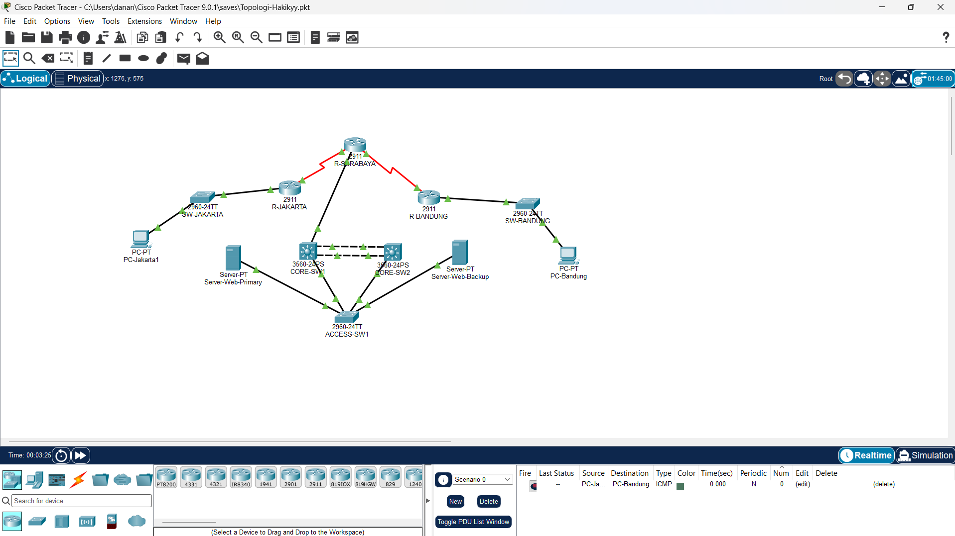
- Bukti Konfigurasi per Device (CLI)
Device | Command | Hasil
CORE-SW1 | show etherchannel summary | 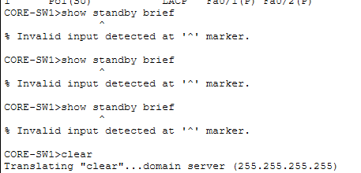
CORE-SW1 | show standby brief | 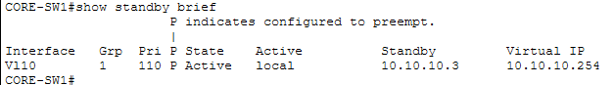
CORE-SW2 | show standby brief | 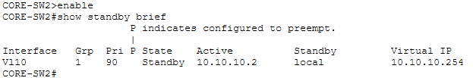
CORE-SW1 & CORE-SW2 | show vlan brief | 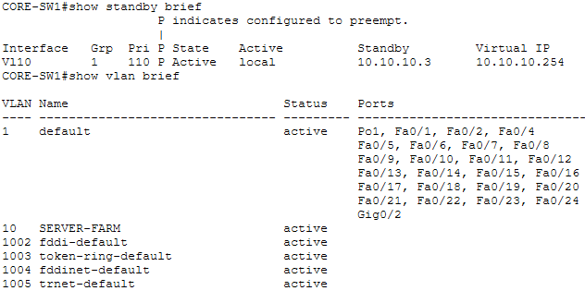  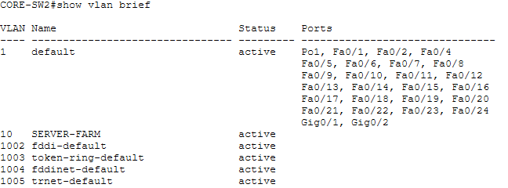
ACCESS-SW1 | show interfaces trunk | 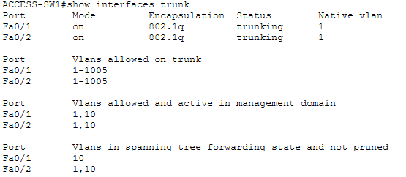
R-SURABAYA | show ip interface brief | 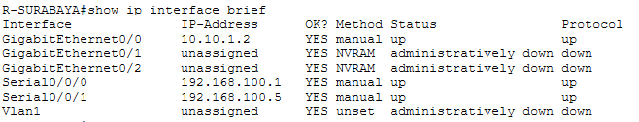
R-SURABAYA | show ip ospf neighbor | 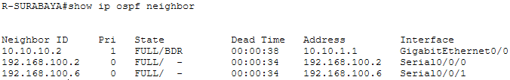
R-SURABAYA | show ip route | 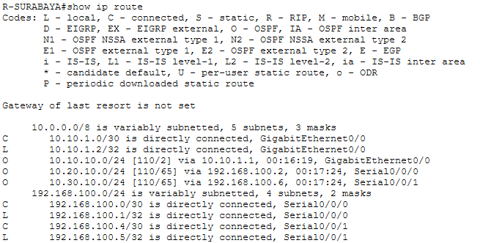
R-JAKARTA | show ip route | 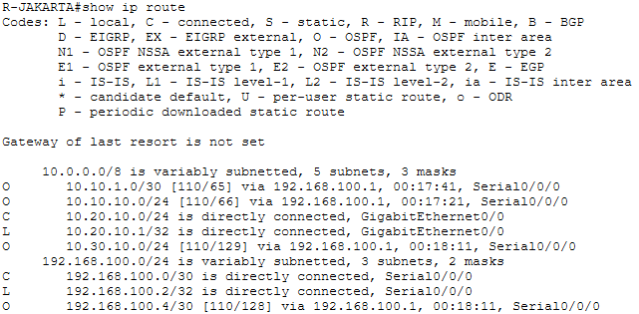
R-BANDUNG | show ip route | 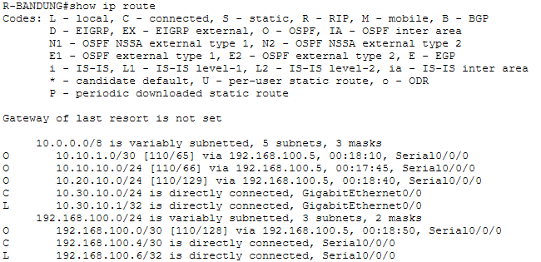
- Bukti Konektivitas End-to-End
PC-Jakarta1 Ke Server-Web-Primary | 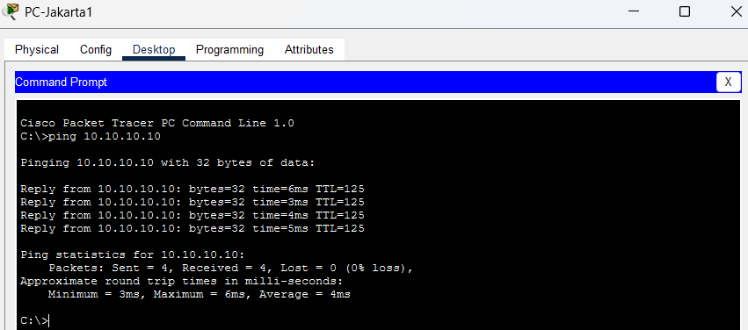
PC-Bandung Ke Server-Web-Backup | 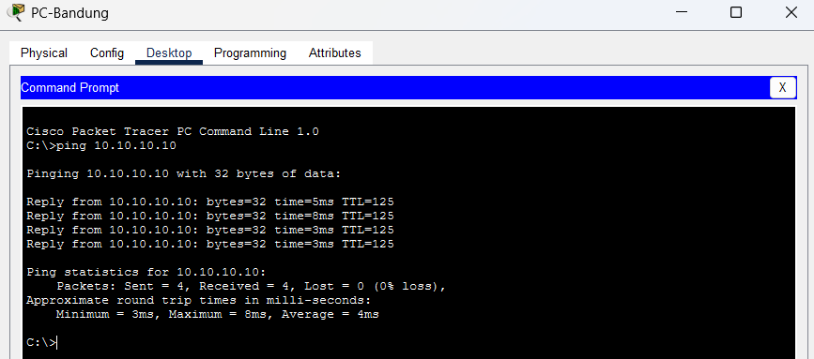
PC-Jakarta1 Ke PC-Bandung | 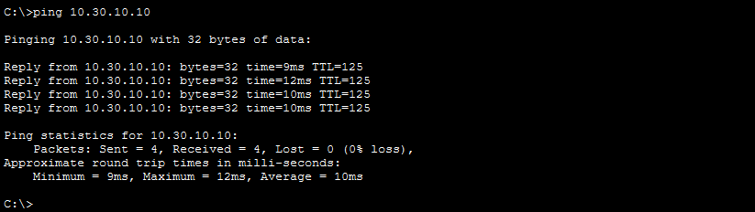
- SOAL NOMOR 2: Make Your Web Great Again
- Task A. Linux Hardening
No | Langkah | Command
1 | Melakukan identifikasi sistem operasi | cat /etc/os-release
2 | Mengetahui user aktif | whoami
3 | Mengetahui konfigurasi IP | ip a
4 | Menginstall paket keamanan | apt update && apt install rsyslog auditd acct apache2 nginx haproxy openssl socat -y
5 | Mengaktifkan service logging | systemctl enable --now rsyslog
6 | Mengaktifkan audit daemon | systemctl enable --now auditd
7 | Mengaktifkan process accounting | systemctl enable --now acct
8 | Verifikasi service | systemctl status rsyslog auditd acct
9 | Membuat user administrator | useradd -m -s /bin/bash sevima-adm1
10 | Mengatur password user | passwd sevima-adm1
11 | Mengatur limit resource | nano /etc/security/limits.conf
12 | Verifikasi PAM Limits | grep pam_limits /etc/pam.d/common-session
13 | Login sebagai user | su - sevima-adm1
14 | Verifikasi limit | ulimit -a
- Task B. Certificate Authority (CA)
- B.1 Membuat Struktur CA
No | Langkah | Command
1 | Membuat direktori CA | mkdir -p /root/ca/{certs,private,newcerts,crl,csr}
2 | Membuat database CA | touch /root/ca/index.txt
3 | Membuat serial number | echo 1000 > /root/ca/serial
4 | Verifikasi direktori | find /root/ca -maxdepth 1
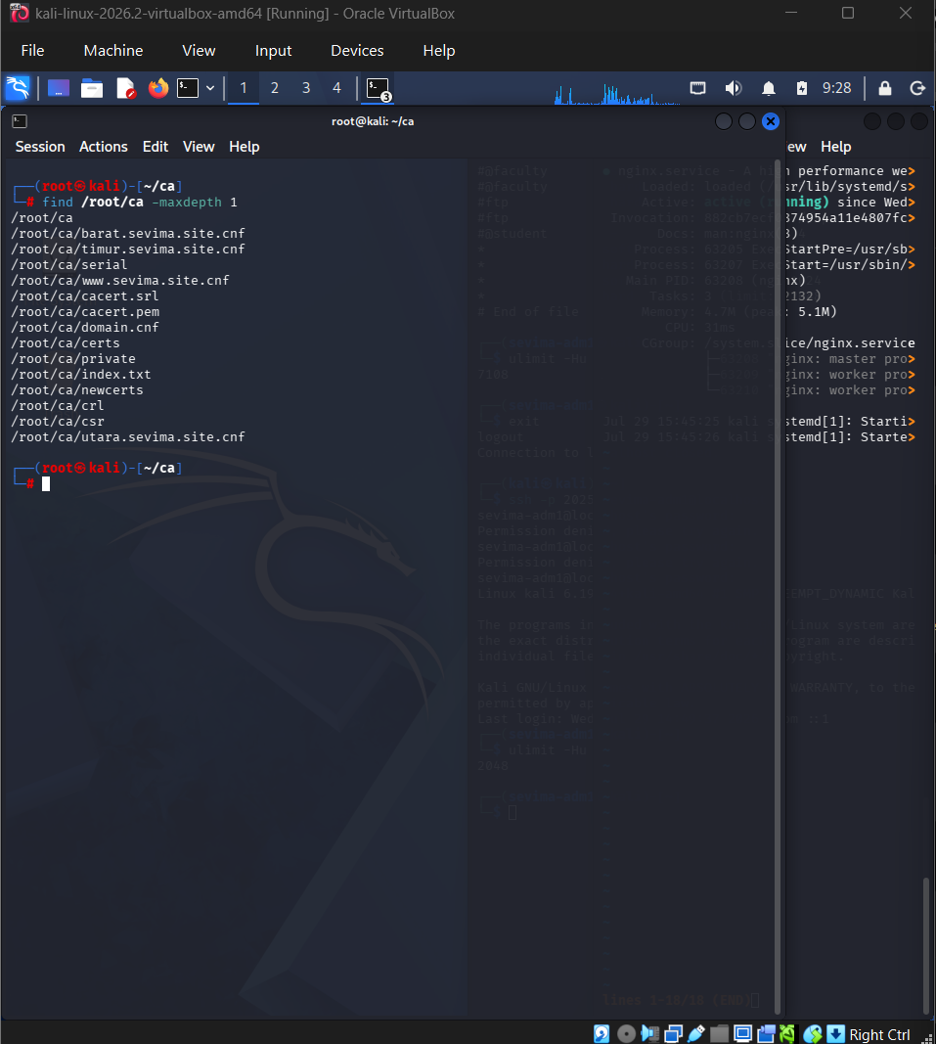
- B.2 Membuat Root CA
No | Langkah | Command
1 | Generate Root Private Key | openssl genrsa -aes256 -out private/cacert.key 4096
2 | Generate Root Certificate | openssl req -x509 -new -key private/cacert.key -sha256 -days 3650 -out cacert.pem
3 | Verifikasi Root CA | openssl x509 -in cacert.pem -noout -subject -issuer
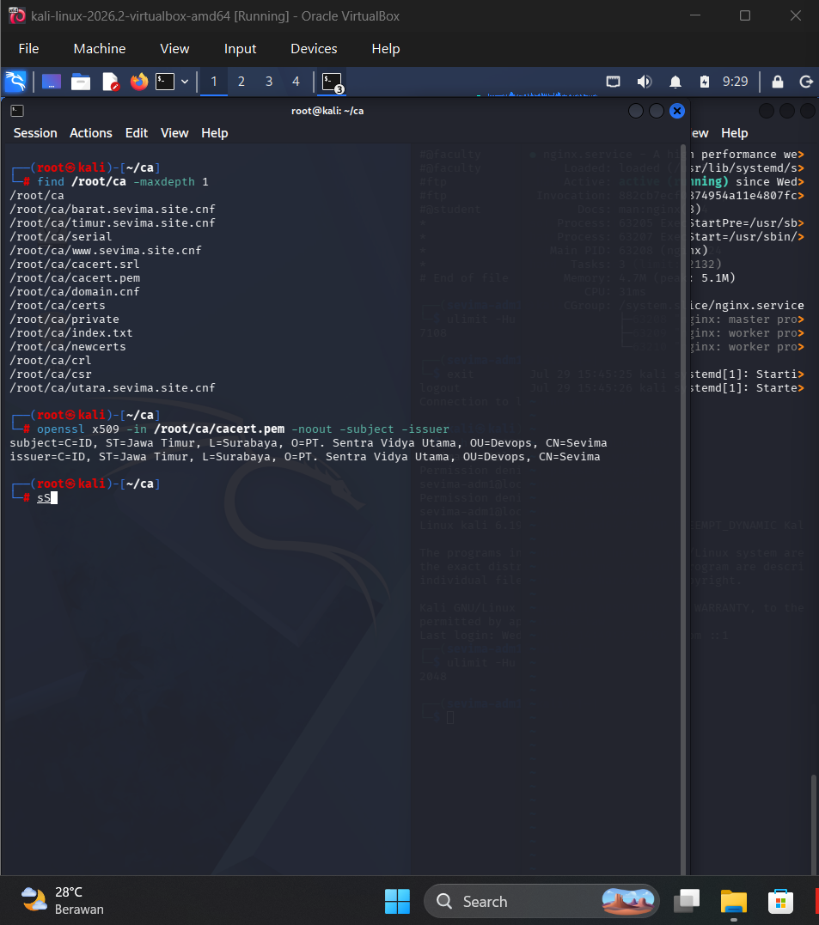
- B.3 Membuat Sertifikat Domain
No | Langkah | Command
1 | Membuat file konfigurasi CSR | nano /root/ca/domain.cnf
2 | Generate Private Key seluruh domain | openssl genrsa
3 | Generate CSR | openssl req -new
4 | Sign Certificate menggunakan Root CA | openssl x509 -req ...
5 | Melakukan seluruh proses otomatis | for DOMAIN in ... do ... done
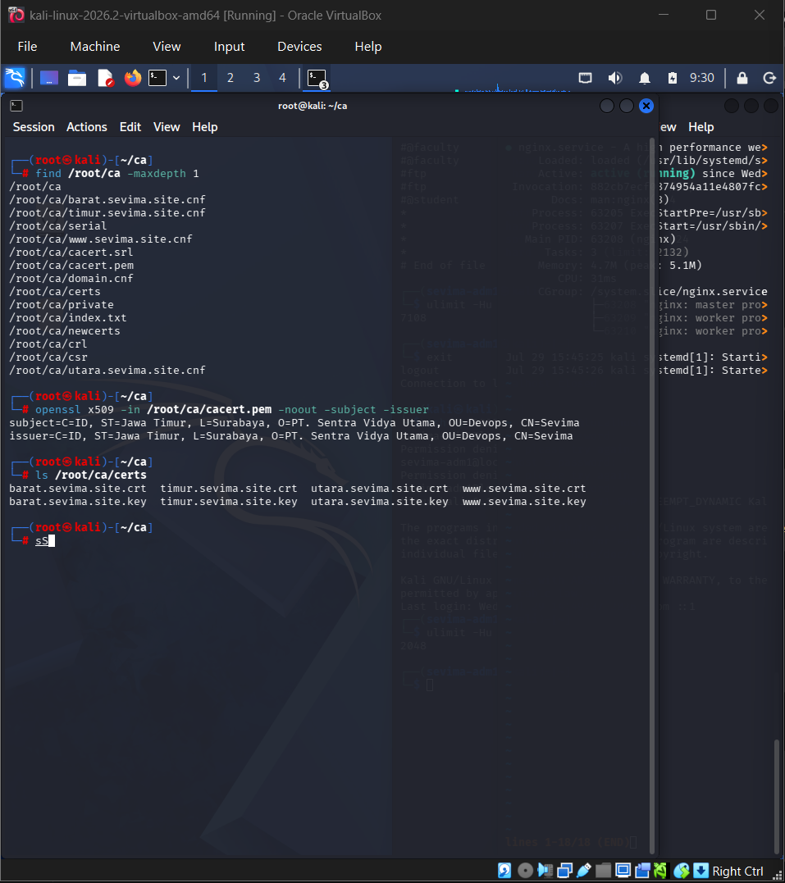
- B.4 Verifikasi Certificate
No | Langkah | Command
1 | Melihat hasil sertifikat | ls /root/ca/certs
2 | Verifikasi Certificate | openssl verify -CAfile /root/ca/cacert.pem /root/ca/certs/*.crt
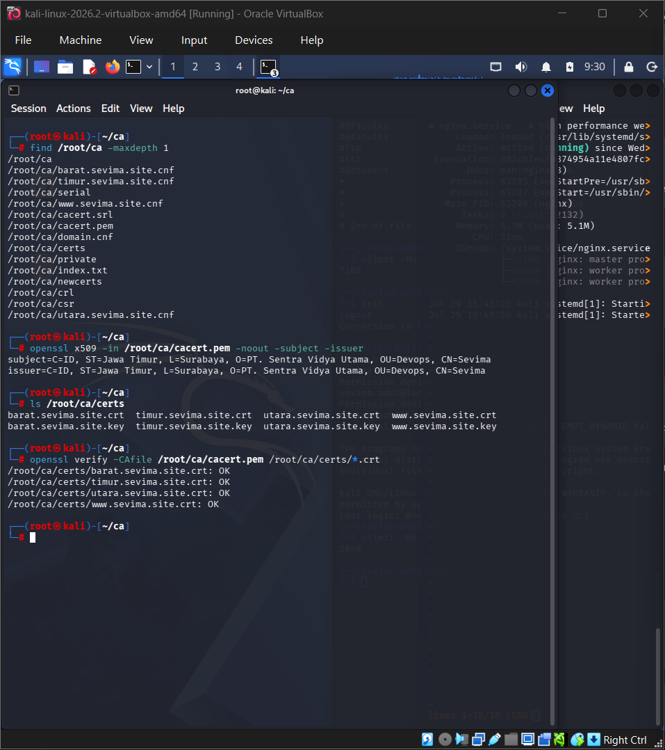
- Task C. Apache Web Server
No | Langkah | Command
1 | Menonaktifkan VirtualHost default | a2dissite 000-default.conf
2 | Mengaktifkan module headers | a2enmod headers
3 | Membuat Document Root | mkdir -p /var/www/utara
4 | Membuat halaman web | nano /var/www/utara/index.html
5 | Menambahkan port Apache | nano /etc/apache2/ports.conf
6 | Membuat VirtualHost | nano /etc/apache2/sites-available/utara.conf
7 | Mengaktifkan VirtualHost | a2ensite utara.conf
8 | Restart Apache | systemctl restart apache2
9 | Menambahkan hosts | nano /etc/hosts
10 | Pengujian | curl -I http://utara.sevima.site:8023
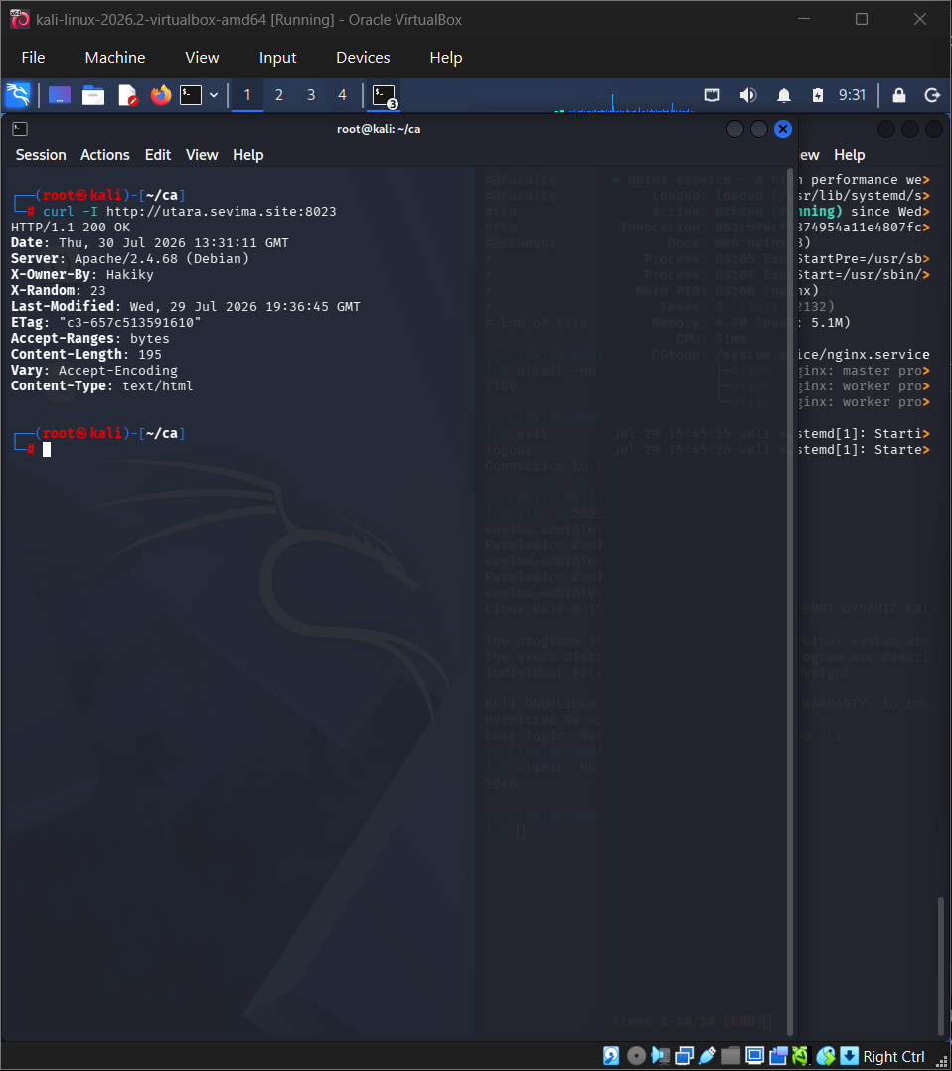

- Task C. Nginx Web Server
No | Langkah | Command
1 | Membuat Document Root | mkdir -p /var/www/timur
2 | Membuat halaman web | nano /var/www/timur/index.html
3 | Membuat VirtualHost | nano /etc/nginx/sites-available/timur
4 | Mengaktifkan site | ln -s /etc/nginx/sites-available/timur /etc/nginx/sites-enabled/
5 | Verifikasi konfigurasi | nginx -t
6 | Restart Nginx | systemctl restart nginx
7 | Menambahkan hosts | nano /etc/hosts
8 | Pengujian | curl -I http://timur.sevima.site:8123
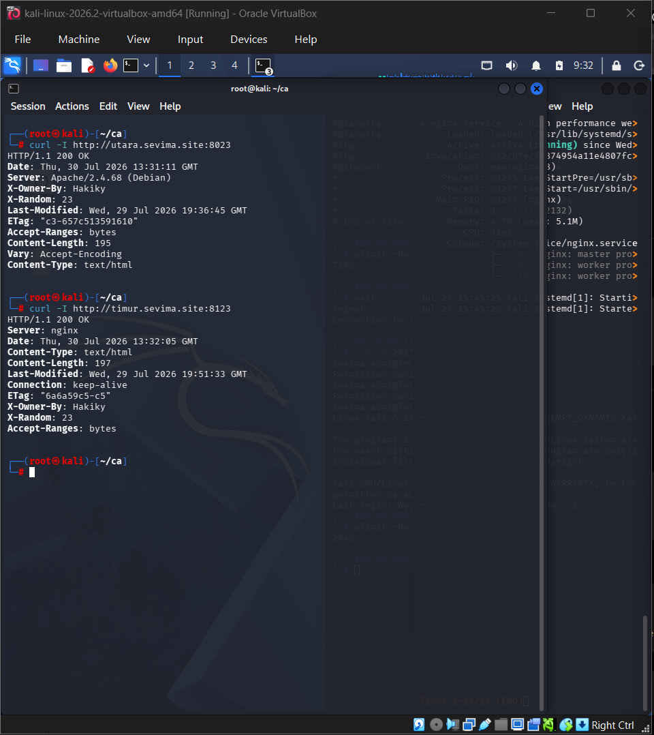

- Task C. HTTPS Server
No | Langkah | Command
1 | Membuat Document Root | mkdir -p /var/www/barat
2 | Membuat halaman web | nano /var/www/barat/index.html
3 | Membuat HTTPS VirtualHost | nano /etc/nginx/sites-available/barat
4 | Mengaktifkan site | ln -s /etc/nginx/sites-available/barat /etc/nginx/sites-enabled/
5 | Verifikasi konfigurasi | nginx -t
6 | Restart Nginx | systemctl restart nginx
7 | Pengujian HTTPS | curl -I https://barat.sevima.site:4435
8 | Verifikasi Certificate | openssl s_client -connect barat.sevima.site:4435 -showcerts

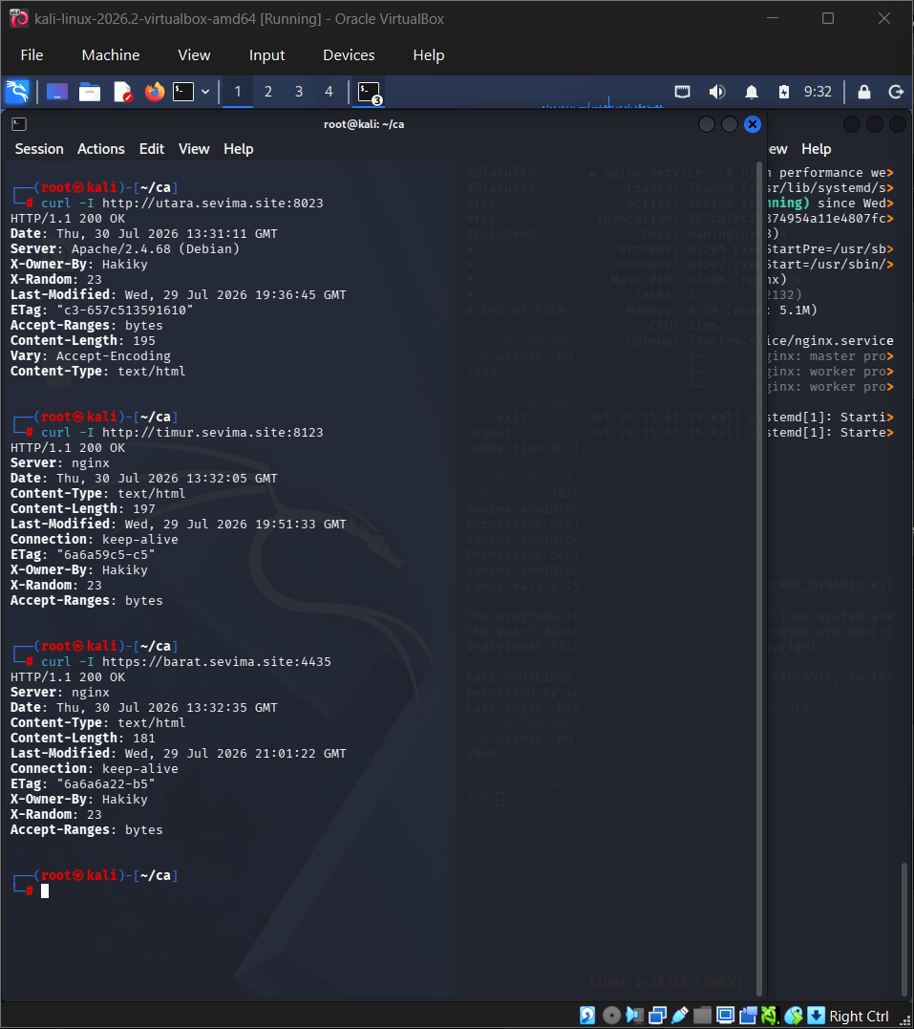
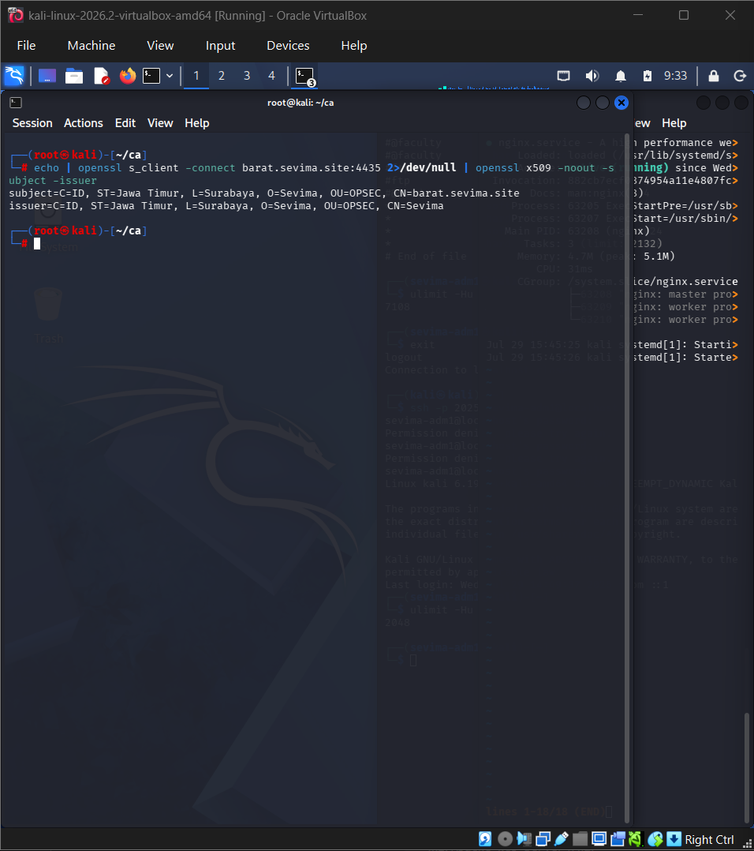
- Task D. HAProxy Load Balancer
No | Langkah | Command
1 | Install HAProxy | apt install haproxy -y
2 | Membuat file PEM | cat www.sevima.site.crt www.sevima.site.key > /etc/haproxy/certs/www.sevima.site.pem
3 | Backup konfigurasi | cp /etc/haproxy/haproxy.cfg /etc/haproxy/haproxy.cfg.bak
4 | Mengubah konfigurasi HAProxy | nano /etc/haproxy/haproxy.cfg
5 | Validasi konfigurasi | haproxy -c -V -f /etc/haproxy/haproxy.cfg
6 | Restart HAProxy | systemctl restart haproxy
7 | Enable HAProxy | systemctl enable haproxy
8 | Pengujian HTTP | curl -I http://www.sevima.site
9 | Pengujian HTTPS | curl -I https://www.sevima.site
10 | Pengujian Round Robin | for i in {1..10}; do curl -sk https://www.sevima.site | grep -E "Apache|Nginx"; done
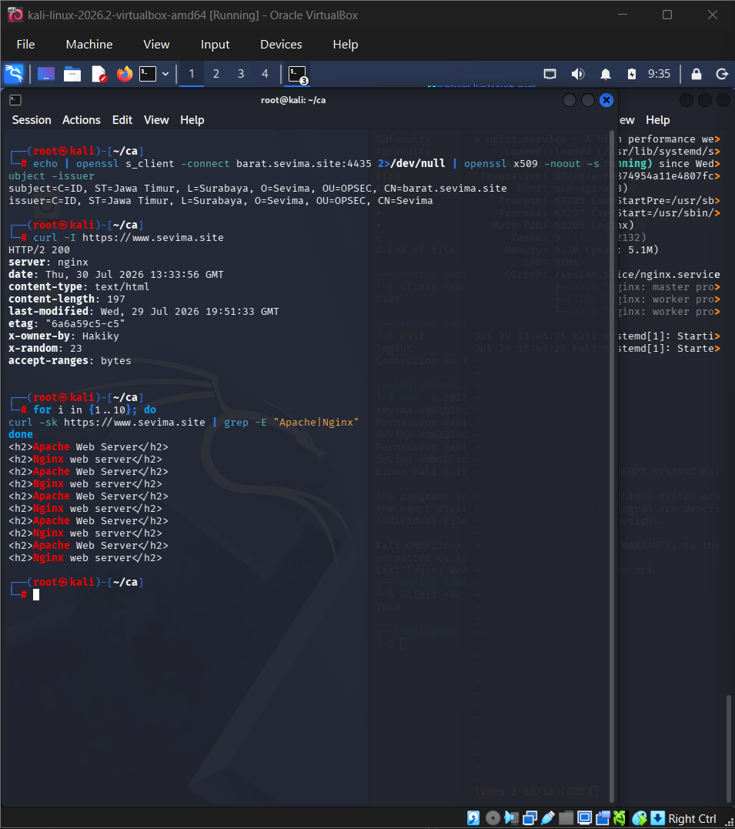
- Pengujian Akhir
No | Tujuan | Command
1 | Verifikasi Root CA | openssl x509 -in cacert.pem -noout -subject -issuer
2 | Verifikasi seluruh Certificate | openssl verify -CAfile cacert.pem certs/*.crt
3 | Apache | curl -I http://utara.sevima.site:8023
4 | Nginx | curl -I http://timur.sevima.site:8123
5 | HTTPS | curl -I https://barat.sevima.site:4435
6 | HAProxy HTTPS | curl -I https://www.sevima.site
7 | Round Robin | for i in {1..10}; do curl -sk https://www.sevima.site | grep -E "Apache|Nginx"; done

