Assignment 1 Report – CSCI251

Name: Fayyah Hakim Bin Jumat

Tutorial: T05F

UOW ID: 8575848

**(Interpreted) Requirements of the program**

• Gain proficiency in using the Ubuntu terminal to display various types of graphs.

• Learn to open and read files directly from the Ubuntu terminal.

• Understand the use of dynamic arrays and manage their memory allocation effectively.

• Implement features designed to enhance the user experience.

• Utilize characters to create illustrative representations.

• Properly deallocate pointers to prevent memory leaks during runtime.

**Diagram/ Illustrations of program design**

**Option1:**

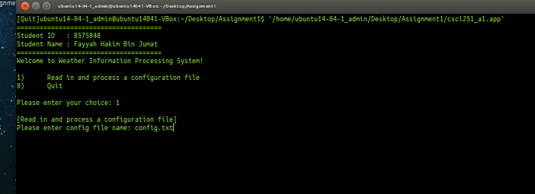

Before file is read, options 2-7 are not shown.

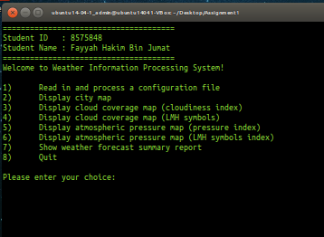

**Option2:**

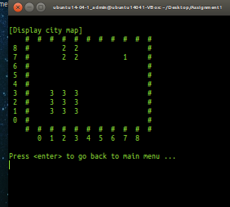

**Option3:**

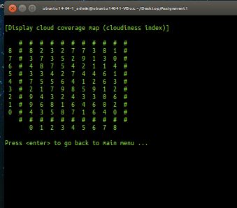

**Option4:**

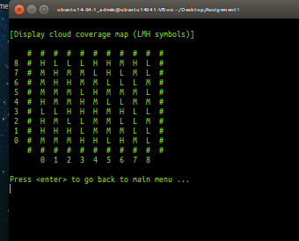

**Option5:**

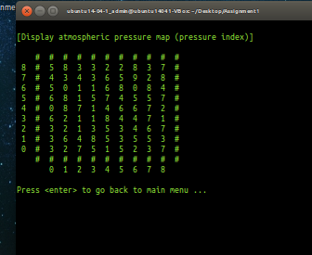

**Option6:**

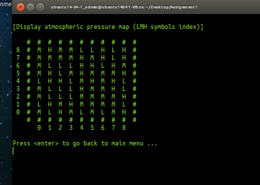

**Option7:**

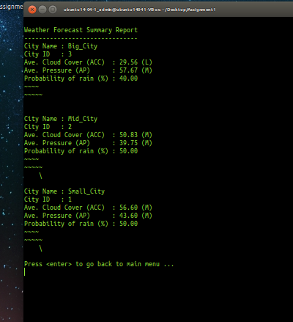

**Option8:**

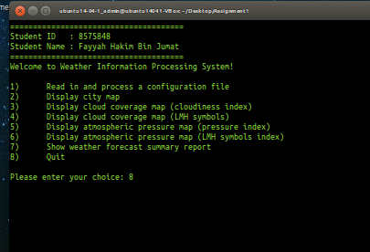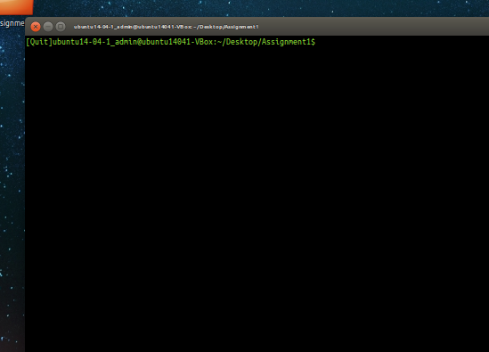

Inputting 8 exits the program.