1. create folder learn_git  
     
     
   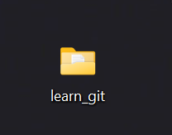
2. open learn-git  
   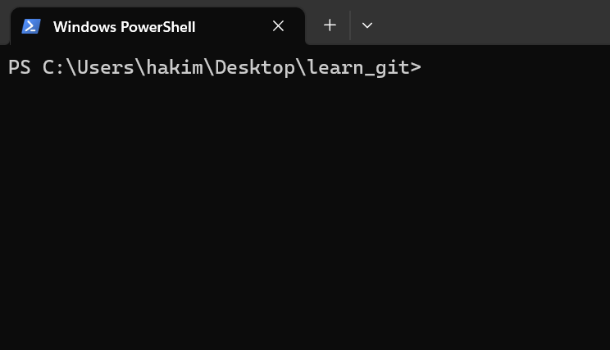
3. create file three.txt  
   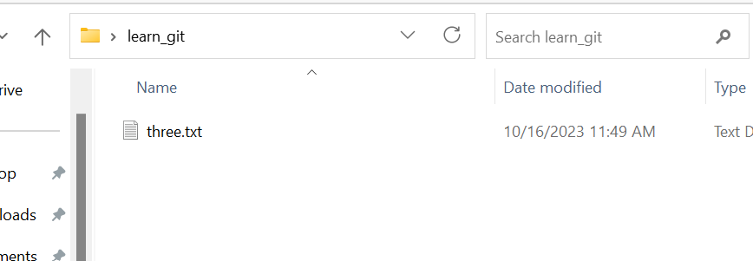

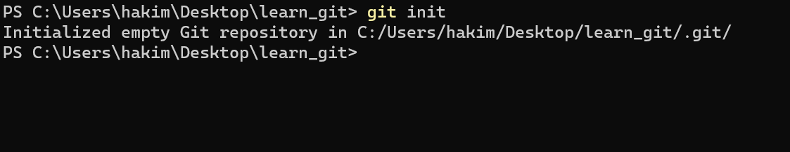

1. 6) 7) adding three.txt and commit with the message "three.txt added".and checking

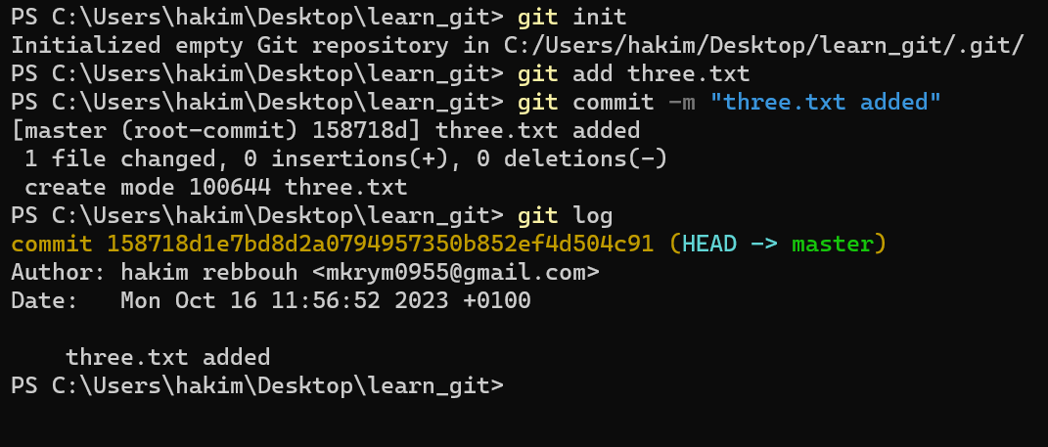

8) create file four.txt   
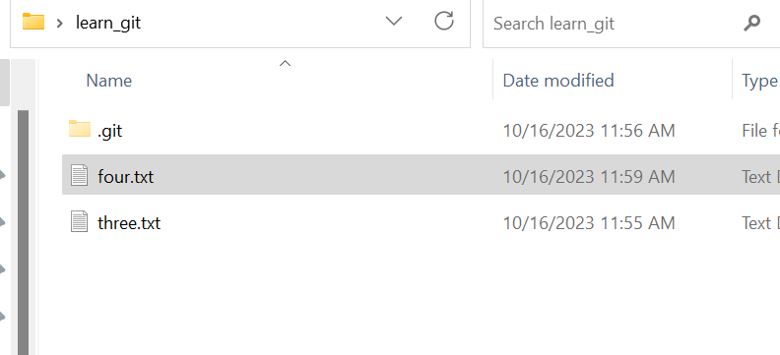

9) 10) add four.txt and commit with message "added four.txt".

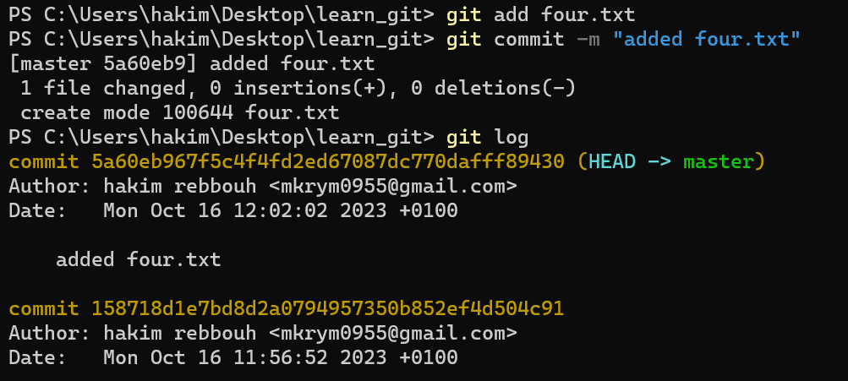

11) 12) 13) 14)Delete the file ‘three.txt’ ,Add this change to the staging area.,Commit this action with the message "delete three.txt",Check the commit with git log.