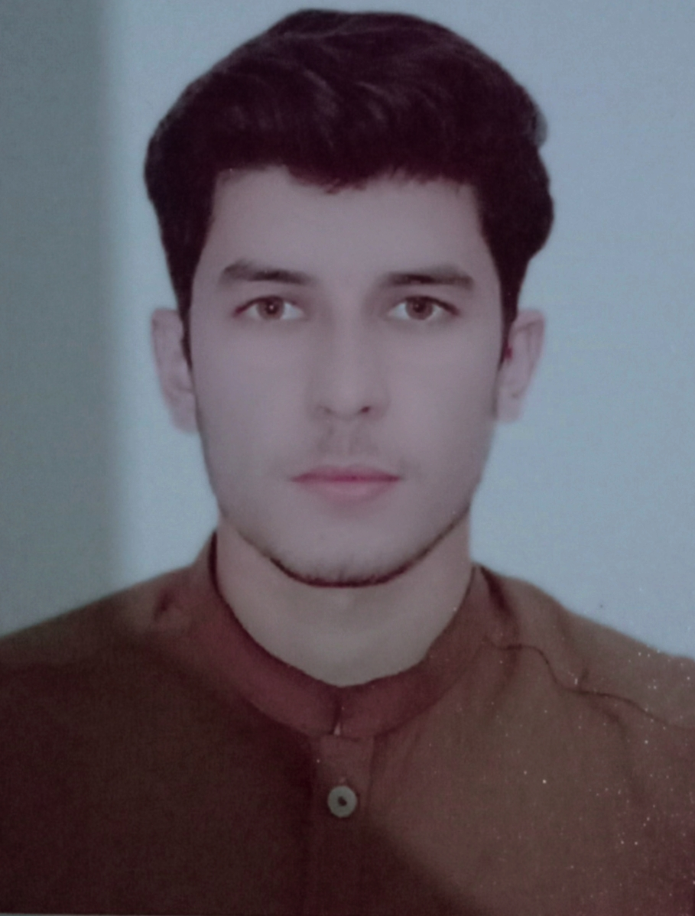

Personal Data

Name | HAKIM ULLAH
Father name | ABDYL SHAKOOR
Nationality | PAKISTANI
Religion | ISLAM
Date of birth | 21 OCT 2000
Domicile | Peshawar
Permanent address | Village Naguman P/O Nahaqi Dab Tehsil shahalam & district Peshawar
Present address | As above
Mobile No | 03164889003
Email Addresses | Hakimullah851@gmail.com

Academic Record

 | Board/university |  | year | division | marks | %age
MATRIC  science |  | B.I.S.E Peshawar | 2017 | 1st | 800/1100
FSC pre Eng |  | B.I.S.E Peshawar | 2019 | 1st | 698/1100 | 60.54%
Major subjects:
- Urdu
- Maths
- Physics
- Biology
- Pak study
- Islamiyat
- English

Curriculum vitae

69.09

Objectives

- To become a part of professional and well equipped organization.
- To utilize and explore my knowledge (skill in abilities and contribute in organization development accordingly).
- To work in challenging environment with the view of refining my knowledge through practical experience of what I have learned and seeking a long term career oriented relationship with the organization.

Languages / Communication Skills

Language | Speaking | Writing | Reading
English | Good | Excellent | Excellent
Urdu | Excellent | Excellent | Excellent
Pashto | Excellent | Excellent | Excellent

Experience:
- One year Security in Fc(Frontier Corps)

Skills:
- Sports Man

Hobbies:
- Running
- Climbing
- Problem Solver

