**Part 1 - design specification**

**Agree on the purpose of the web site**

* Book entrance ticket in advance
* Boost views and increase number of visitors
* Earn money for advertising
* Offer your own park’s hotel

**Research theme park web sites**

1. <https://www.rwsentosa.com/en/attractions/universal-studios-singapore>
2. <https://disneyland.disney.go.com/es-us/>
3. <https://www.europapark.de/en> best design
4. <https://www.visithersheyharrisburg.org/things-to-do/family-fun/hersheypark/>
5. <https://www.cedarpoint.com/>

|  |  |
| --- | --- |
| **Good aspects** | **Bad aspects** |
| Easy navigation menu | Difficult navigation |
| Dining/rides/shows/events/shopping | Slow load times |
| Help (navigation/medical) | Lack of updated information |
| Possibility to change language | Limited accessibility features for visitors with disabilities |
| Interactive maps with location markers for attractions, dining options, restrooms, and more |  |
| Easy access on smartphones and tablets |  |
| Online ticket purchasing |  |

**Agree on the content for the web site**

The main theme of the park will be about cartoons: princess, castle, monsters and so on. Every girl dreams about being special, smart and beautiful as princess. This park will be based on cartoon that we produce.

Additionally, our theme park will have a variety of attractions to cater to different types of visitors. For families with young children, we will have a kiddie section with gentle rides and meet-and-greet opportunities with popular cartoon characters. For thrill-seekers, we will have roller coasters and other adrenaline-pumping rides. We will also have shown and live entertainment featuring our cartoon characters.

In terms of services, we will provide a variety of food options (especially, I want to add cuisine of the different countries), ranging from quick and easy snacks to sit-down restaurants. We will have ATMs on site for visitors to easily access money, and we will also have a medical center with trained staff in case of any emergencies.

On our website, we will make sure to include information about ticket prices, park hours, directions, parking, and any special events or promotions happening at the park. We will also have a FAQ section to address common visitor questions. Overall, our goal is to provide a fun and memorable experience for all visitors to our cartoon-themed theme park.

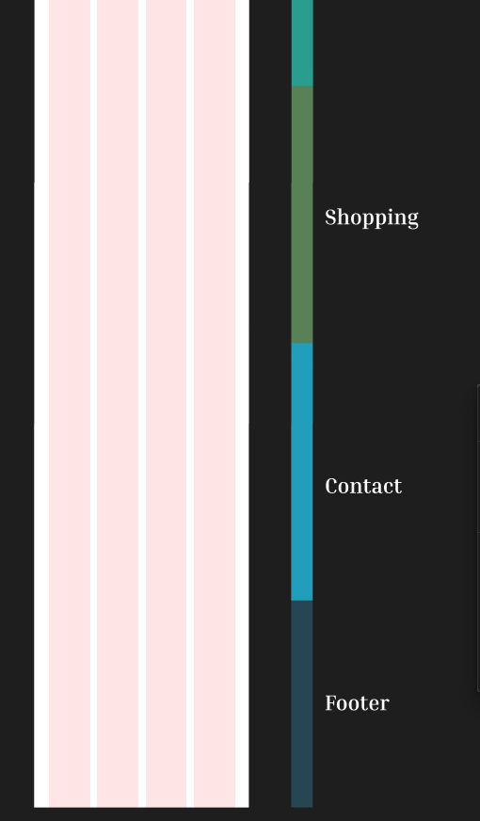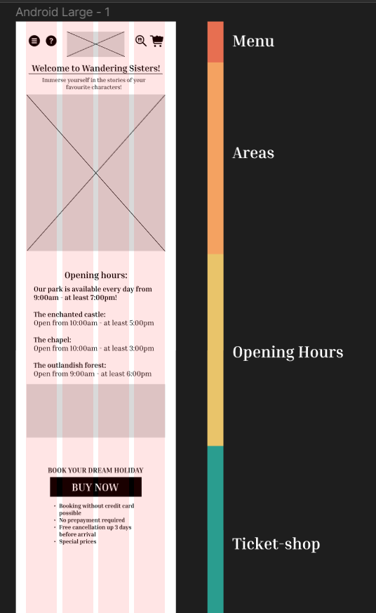**Agree on the structure of the web site / Design the wireframes for the web site**

Picture 1. Android-version