ASSIGNMENT 1

1. Define artificial intelligence (AI). Find at least 3 definitions of AI that are not covered in the lecture.

* “The capability of a machine to imitate intelligent human behavior.” -Merriam-Webster
* “The theory and development of computer systems able to perform tasks normally requiring human intelligence, such as visual perception, speech recognition, decision-making, and translation between languages.” - The English Oxford Living Dictionary.
* “artificial intelligence (AI), the ability of a digital computer or computer-controlled robot to perform tasks commonly associated with intelligent beings.” - The Encyclopedia Britannica.

1. What is the Turing test, and how it is conducted?

The turning test is a test that was conducted with a human interrogator and two responders, one human and one machine. The interrogator would ask the responders equivalent questions and the goal was to distinguish between the human’s answer and the machine’s answer. If the interrogator chooses the machine’s answer as the human’s answer then the AI would have passed the test.

1. What is the relationship between thinking rationally and acting rationally?

Thinking rationally means following the laws of thought, which is often favored by people, however, it can be hard to represent these laws of thought as code. Acting rationally means that it ‘Acts to achieve the best outcome, if uncertainty the best-expected output Is achieved’, in other words, logical thinking.

Is rational thinking an absolute condition for acting rationally?

rational acting is often a reflection of rational thinking. However, it is not always an absolute condition. i.e if you put your hand into a flame, one would usually react by removing your hand as a rational act before thinking rationally.

1. What is Tarski’s “theory of reference” about?

The theory of reference shows how to link objects in a logic manner to objects in the real world.

1. Describe rationality. How is it defined?

Rationality can be found in actions or in beliefs and are based on reasoning or logic. A rational decision should also be the optimal solution/choice for the issue/task.

1. Consider a robot whose task it is to cross the road. Its action portfolio looks like this: look-back, lookforward, look-left-look-right, go-forward, go-back, go-left, and go-right.
   1. While crossing the road, a helicopter falls down on the robot and smashes it. Is the robot rational?

Yes, because it took a choice based on what it knew at the time.

* 1. While crossing the road on a green light, a passing car crashes into the robot, preventing it from crossing. Is the robot rational?

Yes, one could argue that this is a rational decision if the green light is a green walking man, however, the robot should also be able to be cautious as humans would be when crossing the road. If the green light is for the car. It is not a rational decision.

1. Consider the vacuum cleaner world described in Chapter 2.2.1 of the textbook. Let us modify this vacuum environment so that the agent is penalized 1 point for each movement.
   1. Can a simple reflex agent be rational for this environment? Explain your answer.

For the environment given, it would be rational, however, the robot will go into an infinite loop when the environment is clean.

* 1. Can a reflex agent with state be rational in this environment? Explain your answer.

An agent that tracks state would be rational. Both partially observable and fully observable would allow the vacuum cleaner to make rational decisions based on what it knows of the environment and sensor input.

* 1. Assume now that the simple reflex agent (i.e., no internal state) can perceive the clean/dirty status of both locations at the same time. Can this agent be rational? Explain your answer. In case it can be rational, design the agent function.

Yes, an agent that can detect the status of the environment will be rational. It will avoid going into an infinite loop because will only decide to move when it senses that a tile is dirty.

Example code:

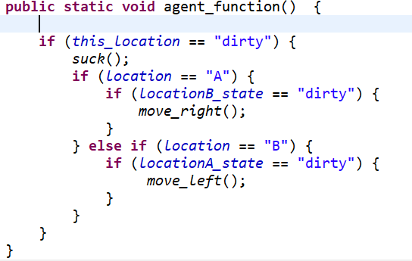

1. Consider the vacuum cleaner environment shown in Figure 2.3 in the textbook. Describe the environment using properties from Chapter 2.3.2, e.g. episodic/sequential, deterministic/stochastic, etc. Explain selected values for properties in regard to the vacuum cleaner environment.

The environment in figure 2.3 is …:

* Single-agent
* Episodic, because the actions are divided into atomic episodes, and does not rely on the previous status of the other location other.
* Deterministic, because the state of the other location in the environment is determined by the state of the current location and then the actions are executed by the agent.
* Partially observant, because the vacuum only senses the status of the current location and not the entire environment.
* Dynamic, as it moves within the environment.
* Discrete, as the status of the locations changes over time(not relying on each other’s status), gives the vacuum cleaner a discrete set of actions.

1. Discuss the advantages and limitations of these four basic kinds of agents:
   1. Simple reflex agents

Are usually not too complex, and have an easy implementation. However, they are often dumb. i.e. Vacuum cleaner example of an infinite loop.

* 1. Model-based reflex agents

Maps and stores its perception of the world. i.e. a modern robot vacuum cleaner that maps obstacles. However, the real environment can change, and the agents guess will not always be accurate.

* 1. Goal-based agents

Are more complex and often less efficient than other agents because the agent may have to consider long sequences of twists and turns in order to find a way to achieve the goal. However, the solution is often better than the other because it applies searching and planning to find the optimal goal.

* 1. Utility-based agents

Also uses searching and planning, but tries to find the most optimal set of actions for reaching its goal(typical lowest cost, etc.). The many options are rated by a utility function and the most desirable output are used.