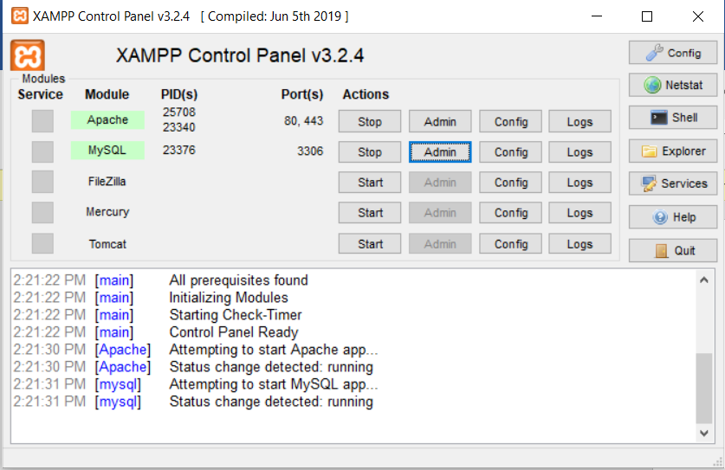

Open XAMPP and click start for apache and MySQL

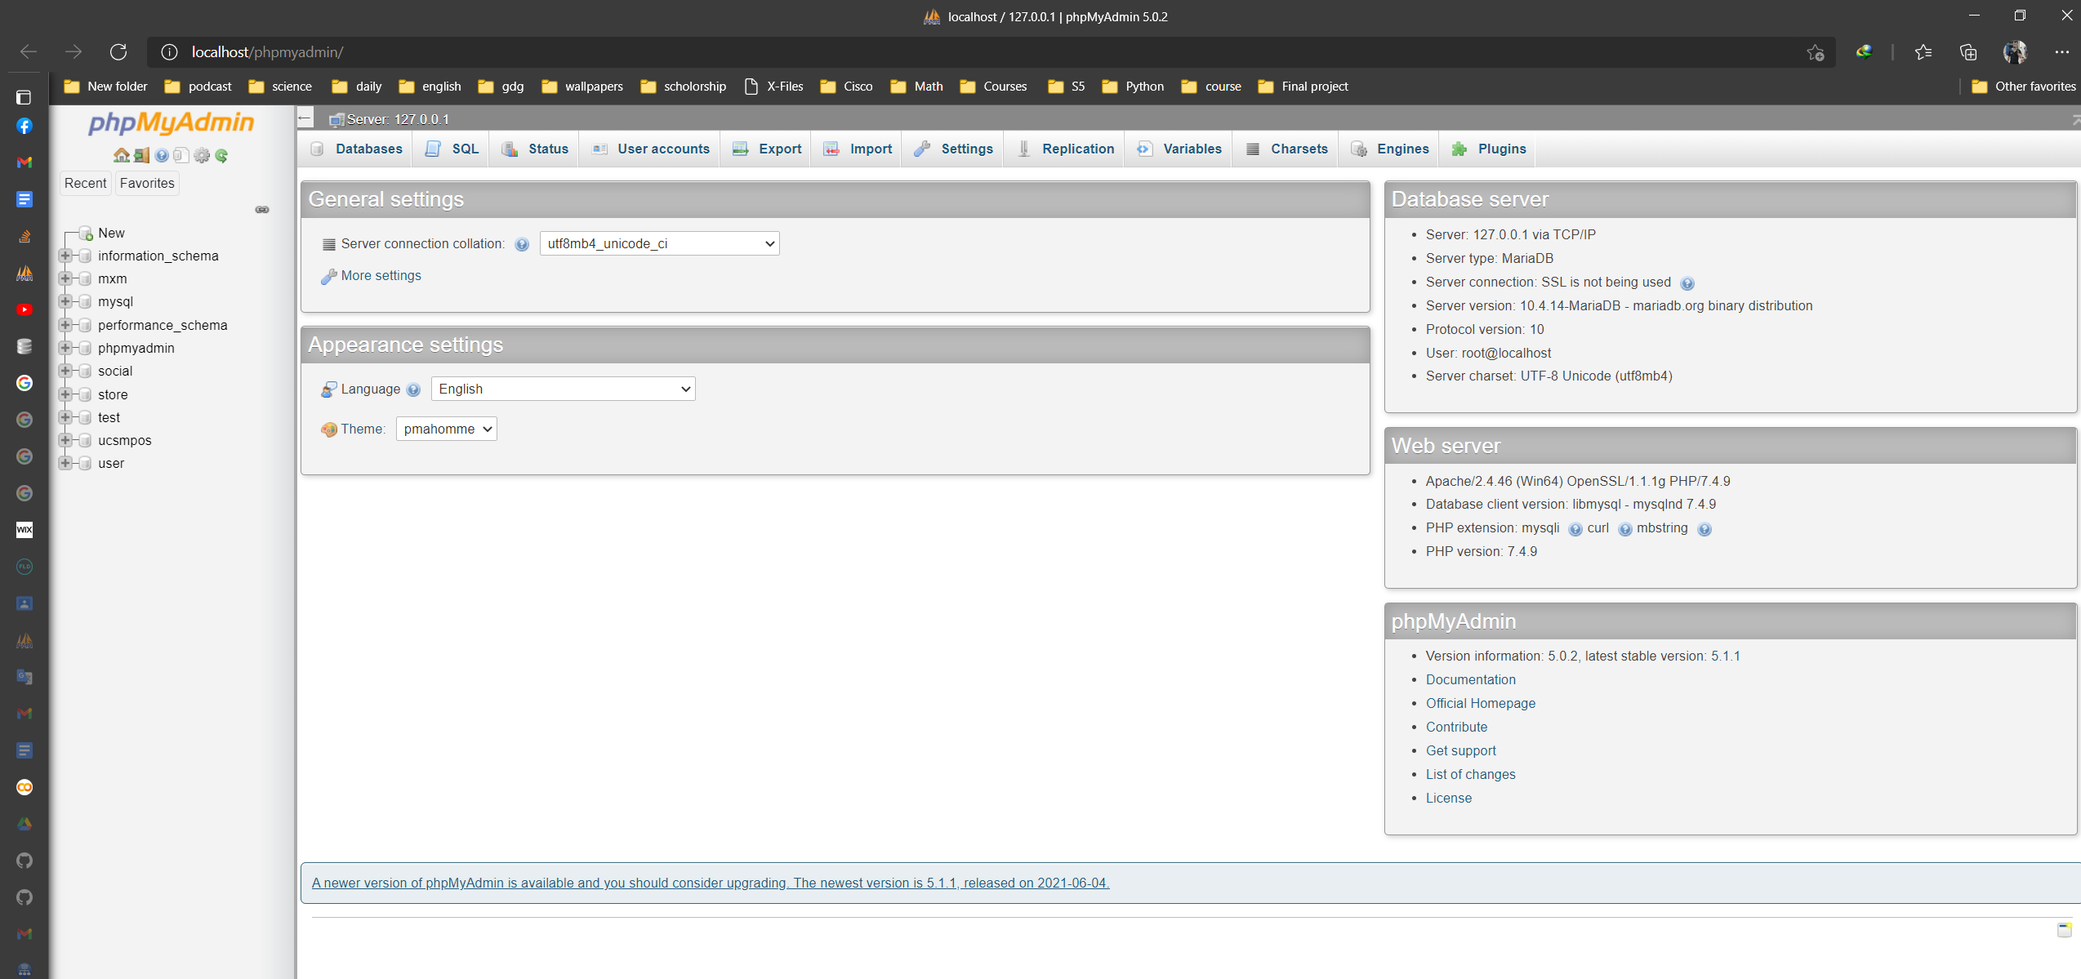

Open localhost/phpMyAdmin

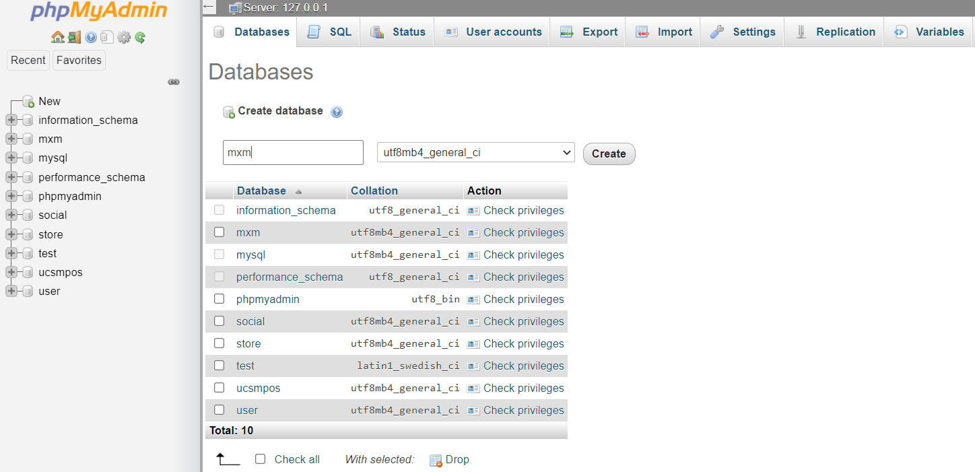

Create a database with name mxm

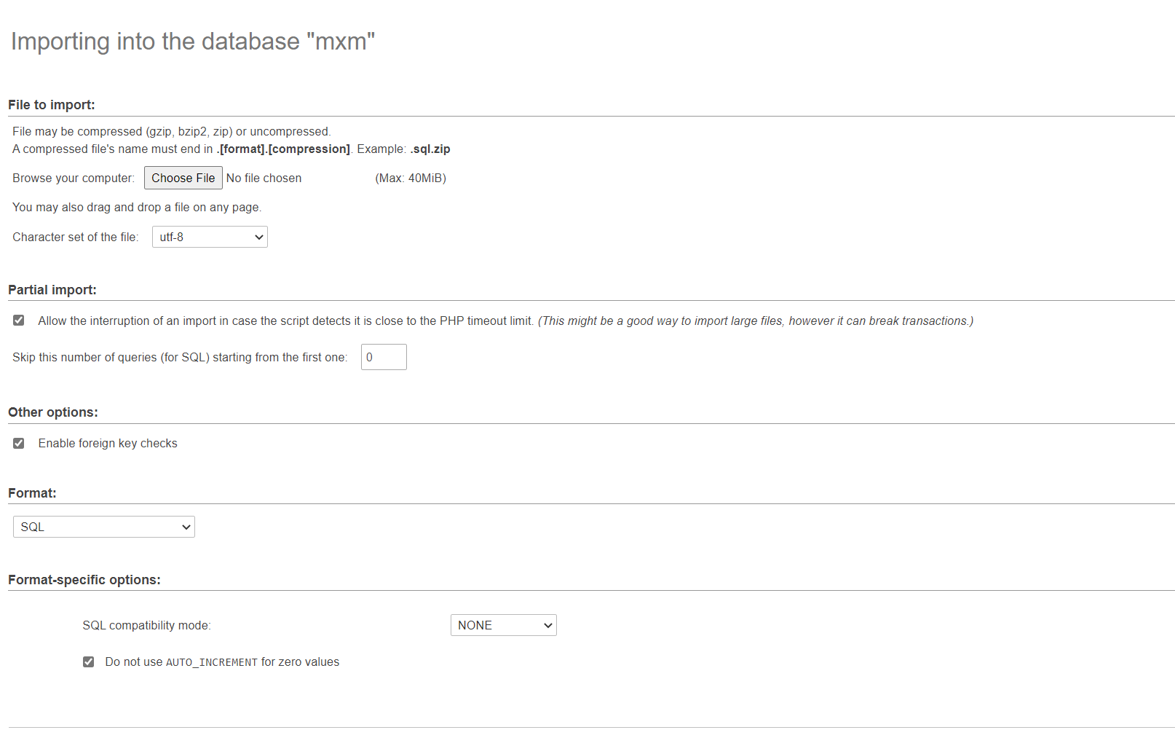

Then export mxm.sql attached with this file

And now click on your jar file and the application it’s running