Diagnosis from ECG data using Neural Networks

Paul An  
Shiv Prathik

# Abstract

During our class, we have covered the Feed-Forward Neural Network. These networks have been identified as good candidate for classifying patterns as well as predicting time-series. Our homework covered classifying patterns from images. We wanted to explore the ways in which we can adapt the Neural Network to make viable predictions on time-series. A well-trained doctor or nurse can look at an ECG, and identify immediately whether there is something wrong with the patient’s heart or not. Our goal is to see if a machine can be trained to identify various problems with a patient from their ECG data. To this effect, we explore different ways in which an Electrocardiogram (ECG) can be fed into various Neural Network architectures, and compare the success rate of eat trained network.

# Introduction

Electrocardiogram (ECG) is a process in which voltage reading is measured from multiple leads on a human body to analyze his heartbeat. Such mechanism is used in hospitals to monitor heart rate and activity. It can also be used to identify and diagnose some heart problems such as myocardial infarction, and dysrhythmia. Fortunately, the medical community is very active in data collection, and research, so anonymized ECG data can be easily obtained. Our data is pulled from the PhysioNet’s PhysioBank, which provides free web access to large collections of recorded physiologic signals. This database gives us access to close to 200 patients, and over 400 records.

## Informal Research

Upon an informal conversation with medical residence acquaintances, I gathered that for her to make her decision, she can’t just data from a single lead, as each lead tells her a different information about the heart. Additionally, she mentioned that several heartbeats must been examined to be sure. Some of the main things she looks for are inversions of P and T waves. Their inversion in certain leads (but not others) are indicative of something wrong with the heart.

The following figure taken from Wikipedia identifies the different phases of an ECG.

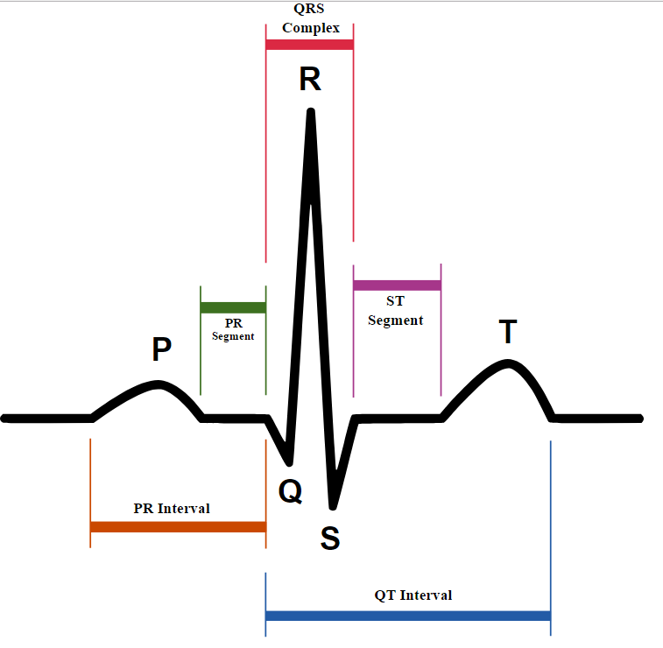

# ECG Data

Each record contains a header file, which describes the patient’s conditions as well as diagnoses. Such information includes: Primary Diagnosis, Additional Diagnosis, Sex, Age, Smoker, Blood Pressure, etc. We first analyzed all headers to obtain a list of all possible diagnosis. We included secondary diagnoses to the search, but found that it yielded many irrelevant diagnoses that did not have any connection to heart-disease or ECG (such as tinnitus). Doing the analysis on only the primary diagnosis gave us the list: Myocardial Infarction, Healthy, Valvular heart disease, Dysrhythmia, Heart failure (NYHA 2, NYHA 3, NYHA 4), Palpitation, Cardiomyopathy, Stable angina, Hypertrophy, Bundle branch block, Unstable angina, and Myocarditis (edit later if list changes).

The signals graph for each record include 15 linear data, representing 12 leads connected to the patient, as well as 3 Frank Leads, discussed later. These leads are named: *i, ii, iii, avr, avl, avf, v1, v2, v3, v4, v5, v6,* and Frank Leads *vx, vy, vz*. The length of the dataset varies, but are around the order of magnitude of 100,000.

FIGURE HERE

# naïve Feed-Forward Network

Our first attempt is to use the feed-forward neural network (FFN) created for a class work, and adapt the input to fit that neural net. The FFN would consist of an input layer with as much nodes as there are input signals, a hidden layer of appropriate size, and an output of each of the 15 diagnosis.

FIGURE HERE

## Data Input

As described in the previous section, each sample consists of 15 graphs, each consisting of over 200,000 data points. An FFN connects each node from layer n to every node in layer n+1. In this case, if we do not do something about the input data, we will have an input size of 1,500,000, and a very long training time (including network construction itself)

To mitigate this, we attempt to understand the data, and separate parts of the data for consumption.

## Dimensionality reduction

In a normal ECG, 12 leads are connected to the body at various locations. Ernest Frank, Ph.D. proposed a method in 1956 called vectorcardiography, which aggregates the electrical signals along each orthogonal axis (sagittal, frontal, and transverse) of the heart by via specific combination of leads. This can be achieved both via resistors in the hardware during the capture process, or via post-capture calculations

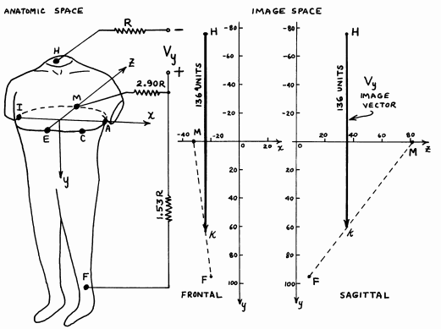

We propose, then, to simply use these 3 leads’ data (*vx, vy, vz*) for the purpose of our learning and prediction.

## Standardizing Input Data

Another problem we encounter is that the graphs contain too much data altogether. These graphs are taken at 1000 samples per second, for up to 100 seconds. This gives us well over 100 heartbeats. Another problem arises because a person’s pulse might change depending on situation. We attempt to mitigate this by attempting to only extract a few heartbeats per record, and normalize the data such that the data is the same length (around 800 sample points).

To do this, we first find a way to computationally find each heartbeat. We use a small sliding window, and find the variance within that window for every data point.

FIGURE HERE

This exploits the flat area between each heartbeat, and uses it as a break point between two beats. Using these variance windows, we can define thresholds, and count heartbeats computationally. Once we located the number of heartbeats we want, we can simply down-sample the data into the required resolution. While doing so, we also use a moving average along each sample point to smooth out any noise and loss occurred during the down-sample process.

FIGURE

## Results

Finally, these standardized Frank Lead data are fed as inputs into our neural network.

Architecture FIGURE

The entire patient database is separated such that training sample make up 70% of the entire database, and the rest 30%. At the end of each epoch, the network predictions and square-meant-errors are tested. They are plotted below.

# Convolutional Neural Network with Tensorflow

## References

Goldberger AL, Amaral LAN, Glass L, Hausdorff JM, Ivanov PCh, Mark RG, Mietus JE, Moody GB, Peng C-K, Stanley HE. PhysioBank, PhysioToolkit, and PhysioNet: Components of a New Research Resource for Complex Physiologic Signals. Circulation 101(23):e215-e220 [Circulation Electronic Pages; <http://circ.ahajournals.org/content/101/23/e215.full>]; 2000 (June 13).

ECG Data. Retrieved from <https://www.physionet.org/physiobank/database/ptbdb/>

Frank, E.(1956). "An Accurate, Clinically Practical System For Spatial Vectorcardiography". Circulation. 13:737-749. Originally published May 1, 1956

Electrocardiography, (n.d.) In *Wikipedia.* Retrieved from <https://en.wikipedia.org/wiki/Electrocardiography>