DESIGN NOTE

SOFTWARE DEVELOPMENT I

By Hoàng Trung Hiếu – 1801040081

7.1. What is the purpose of using the two interfaces Comparable and Document?

- The purpose of using the two interfaces is to add new classes that implement the two interfaces without having to update the core functions, sorting object with Comparable interface method and read objects as HTML documents with Document interface method. For example, currently in the assignment, the two classes that implementing the two interfaces is Customer and its subclass HighEarner. In the future we can add new classes to the software just by letting them implement the two interfaces without having to update the core functions of the software.

- There is not another way of designing the same functionality and flexibility as the two interfaces Comparable and Document because in the future, when trying to add more new classes, it is require to change to core functions to add those class to use the same methods. Meanwhile when using those two interfaces, new classes just have to implement the interfaces and the core functions can still work.

The benefits of this design are showing the hierarchy of the software where which class implements/extends other. Example for this is the HighEarner is a subclass of Customer that implement Comparable and Document interface.

7.3: What is the purpose of using the SortedSet class in the software?

- The purpose of using the SortedSet is to store Comparable object and sort them ascending order.

- It is possible to develop the same software functionality by using other list like LinkedList, ArrayList but it is required to sort the list every time add a new object, which is required to update the core functions with a sort method that is invoked every time add a new Comparable object and future code that use the Set/List. Therefore, using the SortedSet class is more optimal way.

7.4: What makes the original KEngine library possible to seach for Customer objects using keywords?

- With method toHtmlDoc that Customer class implement from Document, the KEngine can read the Customer class information as a normal Html Document.

7.5: Complete UML design class diagram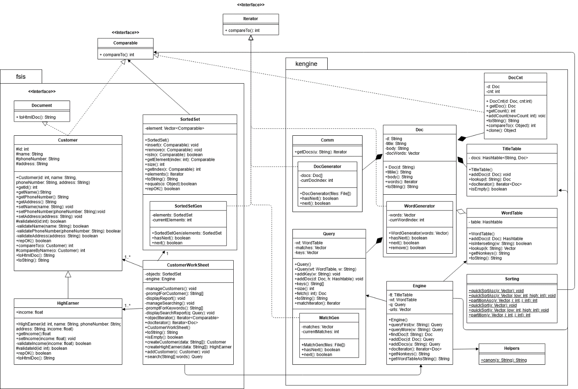

7.6: The implementation strategy that was used to build the software is hybrid implementation. With the KEngine package, components are built with many versions, by writing stubs class or complete one first than expand and complete with next iteration. While the fsis package, components are implemented in bottom-up, with the design is fully completed. Therefore, each component while built requires more testing to suit the design.