Emojis as Visual Language: Evolution, Social Emotion, and Cross-Cultural Ambiguity in Digital Communication
Anonymous full-paper draft for VINCI 2026
Paper type: Full paper; suggested track: Cultural Computing Special Track / Technical Paper Track
Abstract
Emojis have moved from platform-specific pictograms into a standardized visual language that mediates emotion, identity, and cultural meaning in everyday digital communication. This paper presents a visual-information-communication study of emojis as visual information artifacts. We ask how the emoji system has expanded through Unicode standardization, how emoji use reflects collective and generational social emotion, and why the same emoji can support divergent meanings across cultures, platforms, and communities. The analysis synthesizes Unicode and Emojipedia records, social-media trend visualizations, selected public events, and updated data covering Emoji 17.0, the draft Emoji 18.0 list, Gen Z platform use, and emerging applications such as Genmoji and spatial avatars. We argue that emoji meaning is produced through three interacting layers: pictorial abstraction, affective signaling, and cultural indexing. The paper contributes a concise analytical framework and design implications for inclusive, context-aware visual communication systems.
CCS Concepts
Human-centered computing -> Human computer interaction (HCI); Human-centered computing -> Visualization; Applied computing -> Arts and humanities; Social and professional topics -> Cultural characteristics.
Keywords
emoji, visual language, visual communication, social emotion, cross-cultural communication, digital culture, Unicode, cultural computing
ACM Reference Format
Anonymous Author(s). 2026. Emojis as Visual Language: Evolution, Social Emotion, and Cross-Cultural Ambiguity in Digital Communication. In Proceedings of the 19th International Symposium on Visual Information Communication and Interaction (VINCI 2026), November 1-4, 2026, Hangzhou, China. ACM, New York, NY, USA, 8 pages.

1 INTRODUCTION
In 2015, Oxford Dictionaries selected the Face with Tears of Joy emoji as its Word of the Year, turning a small yellow pictograph into a visible marker of a broader cultural change [1]. The decision was controversial because an emoji is not a word in the ordinary lexical sense. Yet the controversy clarified why emojis matter to visual information communication: they compress affect, stance, social identity, and situational context into graphic forms that can be inserted into ordinary text streams.
This paper treats emojis as a visual language operating inside computer-mediated communication. Emojis compensate for the absence of facial expression, gesture, and tone in short digital messages, but they also do more than decorate text. They can frame sarcasm, soften disagreement, signal belonging, mobilize public sentiment, and create cross-platform visual conventions. Their circulation across messaging systems, social networks, operating-system keyboards, reactions, stickers, and AI-assisted interfaces makes them an everyday interface between writing and image.
Emoji research requires both historical breadth and attention to current interface practice. This paper therefore examines how small visual signs become standardized, used, contested, and redesigned across platforms. It incorporates updated data on Emoji 17.0, the draft Emoji 18.0 candidate list, 2025-2026 phone and teen-platform-use indicators, and new interface cases such as Apple Genmoji and Vision Pro Persona.
The paper addresses three research questions. RQ1 asks how the emoji visual system has expanded, stabilized, and shifted from growth to refinement. RQ2 asks how emoji use reflects collective and generational social emotion in online communication. RQ3 asks why the same emoji can support divergent meanings across cultures, platforms, and communities. Together these questions connect visual-system evolution with use, interpretation, and design.
The contribution is a compact analytical framework for studying emojis as visual information artifacts. The framework distinguishes three layers of meaning: pictorial abstraction, affective signaling, and cultural indexing. We apply this framework to historical development, Unicode standardization, inclusive design, viral social cases, usage-frequency visualizations, and emerging AI/spatial-computing uses.
2 BACKGROUND: FROM EMOTICON TO EMOJI SYSTEM
Emoji research sits at the intersection of semiotics, HCI, visual design, linguistics, social computing, and cultural studies. Danesi argues that emojis indicate a shift in writing and literacy because they reintroduce pictorial and affective cues into typed communication [3]. Systematic reviews similarly show that emoji studies have moved beyond simple sentiment analysis toward questions of interpretation, pragmatics, platform variation, and social meaning [2].
The lineage of emojis begins before the Unicode emoji system. Harvey Ball’s 1963 yellow smiley popularized a simplified face as a mass-circulating affective sign. ASCII emoticons such as :-) later adapted typographic characters into sideways facial expressions for early networked communication. Japanese kaomoji, including forms such as ^_^ and T_T, extended the expressive range of character-based faces by using horizontal layouts and more varied symbolic components. These predecessors share a common design logic: reducing the face to a few recognizable visual cues so that emotion can be transmitted quickly.
This study distinguishes emoticons, kaomoji, and emojis because the terms are often conflated. Emoticons are text or graphic arrangements used to convey emotion; kaomoji are face-like text arrangements rooted in Japanese character conventions; emojis are encoded pictographic characters used in electronic communication. This distinction matters for visual communication because each form solves a visual communication problem differently. Emoticons exploit existing typography, kaomoji exploit culturally specific character composition, and emojis depend on a standardized code point rendered as a platform image.
The mobile emoji system emerged through Japanese carriers in the late 1990s. SoftBank and NTT DoCoMo introduced compact pictographic sets for mobile messaging, while Shigetaka Kurita’s 176-pictogram i-mode set became especially influential in later histories of emoji design [8]. These early sets were not only smileys. They also included weather, transport, objects, activities, and social signals, establishing the principle that emoji communication could refer to things, actions, places, and emotions at once.
Unicode standardization transformed emojis from proprietary images into interoperable code points. Standardization solved a practical communication problem: sender and receiver on different devices needed a shared encoded symbol. At the same time, Unicode did not erase visual difference. The same code point can still appear differently on Apple, Google, Samsung, Microsoft, or X/Twitter, which means that semantic interpretation is partly shaped by platform rendering. This platform layer is central to emoji meaning and to visual communication design.
3 MATERIALS AND ANALYTICAL FRAMEWORK
This paper uses a qualitative synthesis supported by descriptive visualizations and curated case data. The materials include Unicode emoji charts and proposal criteria [4,5,10], Emojipedia version records [6,7], public reports on emoji use and platform use [17-19], and selected cases in which emoji meanings became visible through social events. The trend visualizations include long-term Twitter/X emoji use and top-emoji rankings from 2020 to 2023.
The dataset adds a second layer of material by organizing the topic into four areas: the Unicode evolution path, proposal criteria and cultural origins, Gen Z “always on” communication, and cases beyond the keyboard. This organization provides updated evidence and a design context for presenting emoji history as visual information.
The analytical framework has three layers. First, pictorial abstraction refers to how a small visual form selects and simplifies features from a face, object, activity, or social symbol. A smiley face depends on a few high-salience components: circular contour, eyes, mouth curvature, color, and sometimes tears, sweat, or gesture marks. Second, affective signaling refers to how emojis modulate the emotional tone of surrounding text. They can intensify, soften, contradict, or reframe a written message. Third, cultural indexing refers to how emojis point to communities, events, identities, and social meanings outside the immediate graphic form.
The three layers help avoid two simplifications. The first is treating emojis as decorative images. The second is treating them as fixed words with stable dictionary definitions. In practice, emoji communication depends on visual form, textual co-occurrence, platform rendering, community convention, and timing. A raised fist, snake, red flag, or folded hands emoji can carry different meanings depending on the community and event in which it appears.
The paper therefore reads emoji visualizations and cases as evidence of communication dynamics rather than as exhaustive statistical proof. This scope is appropriate for a visual-information-communication paper: the emphasis is on how graphic symbols are designed, standardized, circulated, interpreted, and recontextualized in social interaction.
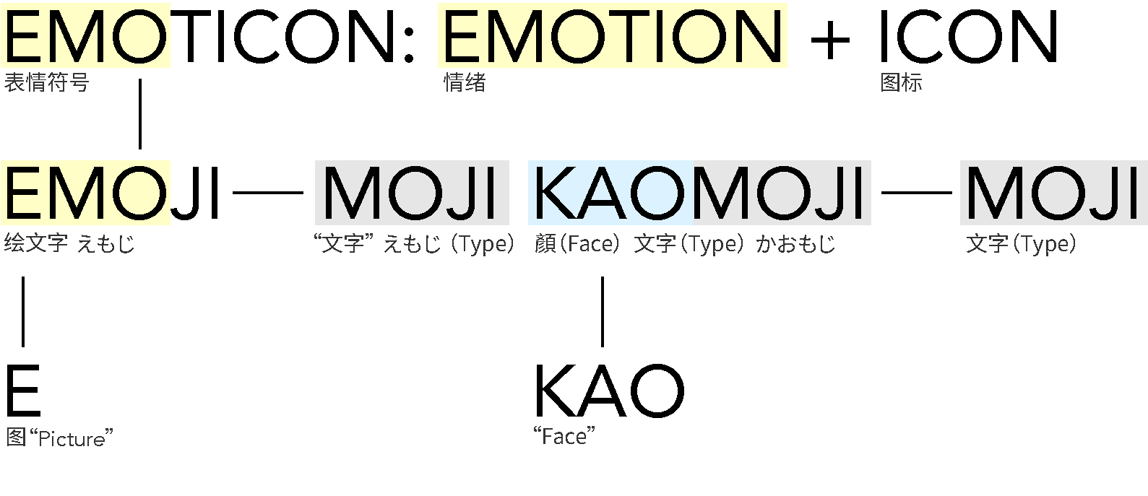
Figure 1: Conceptual relation among emoticons, emojis, and kaomoji. Author diagram.
4 EVOLUTION AND STANDARDIZATION OF THE EMOJI VISUAL SYSTEM
The emoji system evolved from small sets of platform-specific pictograms into a large, categorized, and continuously revised visual system. This growth can be understood through three connected processes: expansion, categorization, and adaptation.
Expansion is visible in the increasing number of encoded emoji characters and sequences. Unicode updates have added new smileys, people, animals, foods, activities, objects, symbols, and flags. The latest stable Unicode emoji count page for v17.0 lists 3,953 total recommended-for-general-interchange emojis when skin-tone and gender variations are included [5]. Emojipedia reports that Emoji 17.0 added 163 new emojis and that implementation on user devices is expected to roll out through 2026 [6]. The draft Emoji 18.0 list contains 19 provisional candidates, including a cracking face, leftward and rightward thumb signs with skin-tone variants, monarch butterfly, pickle, lighthouse, meteor, eraser, and net with handle; if unchanged, it would raise the total to 3,972 [7].
Emoji 18.0 is marked as draft because Unicode’s proposed UTS #51 document states that draft material may be updated, replaced, or superseded and should not be cited as stable [4]. This distinction is important for visual communication research. A draft emoji is already part of public imagination and interface planning, but it is not yet a stable communicative resource. The draft status also explains why interface mockups may need stand-in glyphs when system fonts do not yet support the new code points.
Categorization provides navigational structure. Contemporary emoji keyboards group symbols into smileys and emotion, people and body, animals and nature, food and drink, travel and places, activities, objects, symbols, and flags. These categories make the system usable as an interface, but they also encode assumptions about what kinds of things deserve visual representation. A category system is therefore not neutral; it shapes what users can easily find and express.
Unicode proposal criteria reveal another layer of governance. A successful proposal must demonstrate expected frequency, multiple use cases, visual distinctiveness, compatibility or representational need, and durability beyond short-term trends. The guidelines also exclude brands, deities, named people, and concepts that are too specific or transient [10]. Accepted cases such as dumpling, woman with headscarf, and mate drink show how cultural representativeness can justify new symbols when communities lack a visible place in the standard.
Adaptation appears when emoji designs are revised in response to social conditions. Examples include the gun emoji’s shift from a realistic firearm to a toy water pistol, and the Face with Medical Mask redesign during COVID-19, which made the face appear more positive and socially responsible. These examples show that emoji design is not fixed illustration. It is ongoing visual governance shaped by safety, public mood, platform policy, and cultural sensitivity.
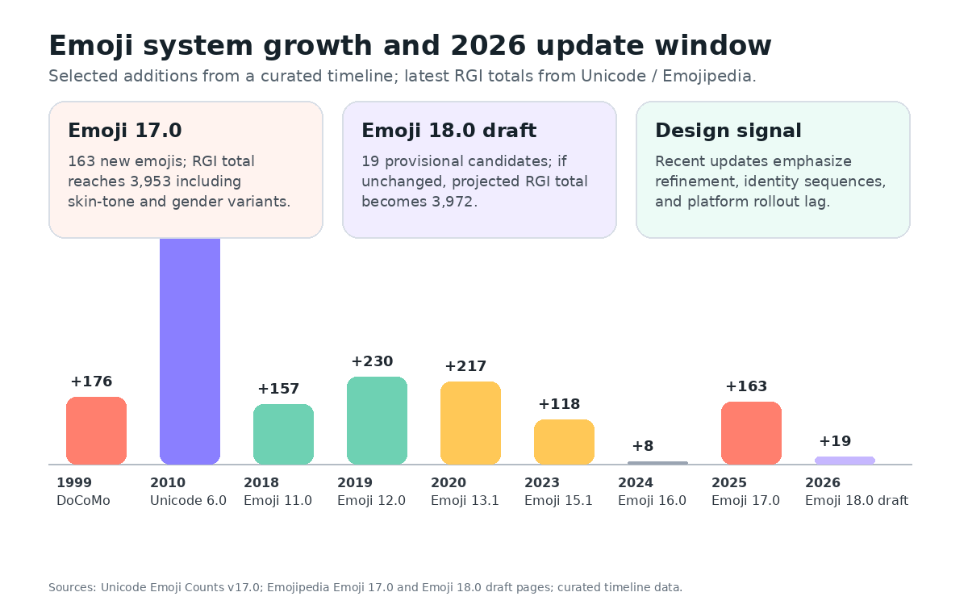
Figure 2: Updated growth window for the emoji system, combining curated timeline milestones with Unicode/Emojipedia 2025-2026 counts.
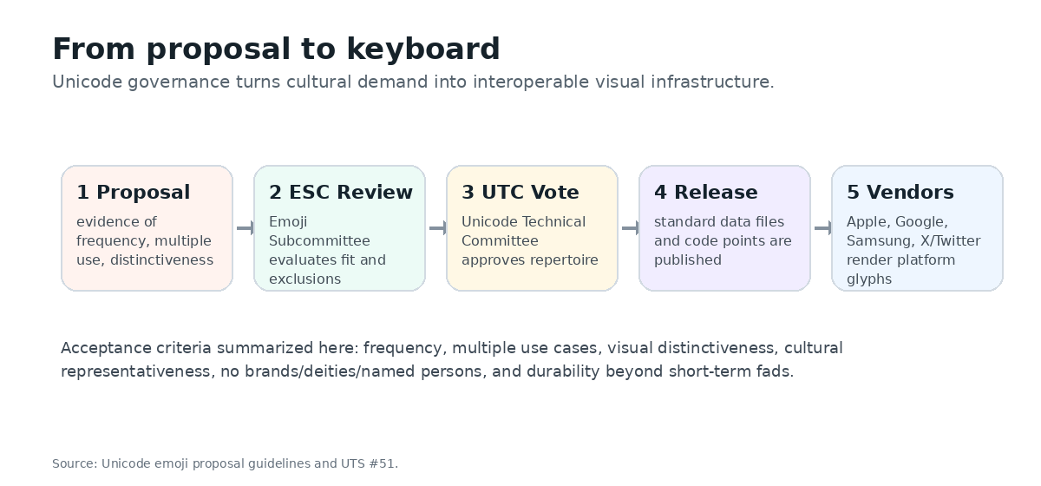
Figure 3: Unicode proposal-to-keyboard process summarized from Unicode proposal guidelines.
5 VISUAL DESIGN PRINCIPLES: ABSTRACTION, CONSISTENCY, AND INCLUSION
Several visual characteristics remain central to visual-information-communication analysis. Emojis are pictorial: they convey meaning through stylized images rather than alphabetic description. They are punctuational: users insert them into text streams to mark tone, turn-taking, or emotional stance. They are combinatorial: users can place several emojis in sequence or combine them with text, hashtags, stickers, and reactions. They are also platform-rendered: the encoded identity of an emoji is shared, but its image is drawn differently by each vendor.
Pictorial abstraction is clearest in smileys. A yellow circular face with two eyes and a mouth can express a wide emotional range because small visual changes carry high semiotic weight. Tears convert laughter into relief, embarrassment, or grief depending on context. A sweat drop can signal anxiety, exertion, awkwardness, or comic panic. A tilted mouth can transform politeness into irony. This economy of detail explains why small emoji images remain legible at keyboard size, but it also explains why slight rendering differences can shift interpretation.
Consistency matters because emoji are used in fast, low-friction communication. Users expect a symbol to remain recognizable across screen sizes, light and dark modes, and platforms. However, perfect uniformity is not the goal. Vendor styles are part of brand identity and local aesthetic culture. The practical design challenge is therefore controlled variation: an Apple, Google, or Samsung version may look different, but the emotion, object identity, and social risk should remain within an acceptable interpretive range.
Inclusion has become a defining design pressure. Skin-tone modifiers, gender-neutral figures, disability-related emojis, and culturally specific foods or objects show attempts to make the system more representative. Yet inclusion creates technical and semantic complexity. Family emojis, handshake combinations, and multi-person sequences demonstrate how quickly combinations multiply. The design problem is both ethical and infrastructural: represent more people without creating an unusable keyboard or implying that identity can be fully captured by a finite set of icons.
Cultural-origin cases make this tension visible. Dumpling, taco, pretzel, mooncake, sari, matryoshka, headscarf, and mate are not just decorative additions. They show how cultural symbols enter a global visual vocabulary through evidence, advocacy, and committee review. Once encoded, however, these symbols can be used by people outside the originating culture, acquiring additional meanings in tourism, food discourse, nationalism, humor, and everyday chat.
6 EMOJIS IN ONLINE SOCIAL EXPRESSION
Emoji use on social platforms demonstrates how visual symbols participate in collective emotion. Trend data from Twitter/X between 2012 and 2023 show a steady rise in tweets containing at least one emoji, reaching more than one quarter of tweets in early 2023 according to the visualization in Figure 4. This growth suggests that emojis have become a normalized part of public written communication rather than a niche youth practice.
The most popular emojis reveal changes in affective style. Face with Tears of Joy dominated for years because it supports a hybrid emotional register: amusement, exaggeration, embarrassment, and sometimes helpless laughter. During the COVID-19 period, however, Loudly Crying Face gained prominence and challenged or surpassed Face with Tears of Joy in some rankings [16]. This does not prove a direct causal relationship between pandemic mood and emoji frequency, but it does indicate a shift in the visual vocabulary of public emotion.
Heart emojis, folded hands, crying faces, and laughing faces also show that high-frequency emojis are semantically flexible. A red heart can express love, support, appreciation, or decorative warmth. Folded hands can mean prayer, thanks, apology, pleading, or respect depending on cultural context. Loudly Crying Face can indicate grief, cuteness, gratitude, dramatic humor, or being emotionally overwhelmed. Popularity is therefore linked not only to emotional intensity but also to semantic versatility.
Viral emoji events make cultural indexing especially visible. During Black Lives Matter protests, raised-fist emojis with different skin tones became symbols of solidarity and anti-racist resistance [14]. In Taylor Swift’s public-image controversy, the snake emoji was used for harassment and then reappropriated as an image of empowerment. In the red-flag trend, users repeated the triangular flag emoji to mark social warning signs and critique toxic behavior [15]. In each case, the emoji became a compact visual container for social narratives larger than the sign itself.
These cases show that emoji communication is not merely individual expression. It is collective visual coordination. A repeated emoji can align users around an event, create a meme-like shorthand, or transform a private symbol into a public discourse marker. For visual communication research, this means emojis should be studied as networked signs: their meaning changes as they circulate.
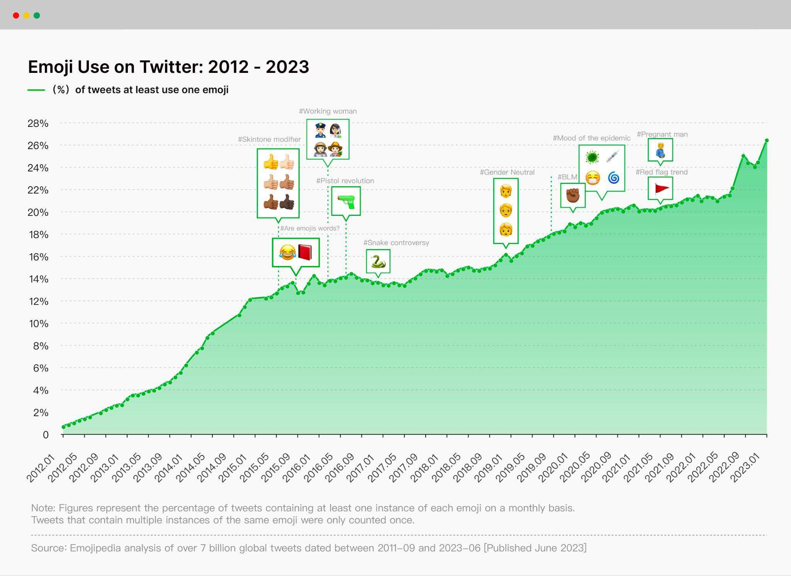
Figure 4: Emoji use on Twitter/X from 2012 to 2023. Visualization based on Emojipedia trend data.
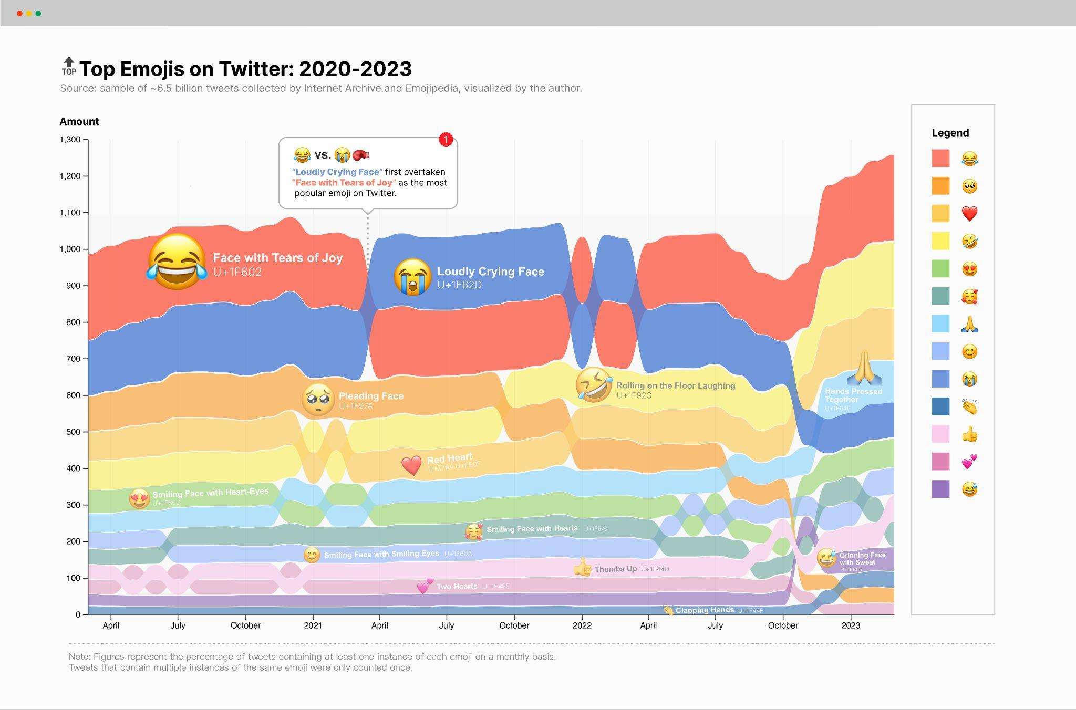
Figure 5: Top emojis on Twitter/X from 2020 to 2023, showing shifts among laughing, crying, heart, and gesture emojis.
7 CROSS-CULTURAL AMBIGUITY AND GENERATIONAL DRIFT
The idea that emojis are universal is useful but incomplete. Emojis often cross language barriers because their pictorial forms are quickly recognizable, but recognition is not the same as shared interpretation. An emoji can be visually legible while still pragmatically ambiguous.
The nail-polish emoji illustrates this ambiguity. A Preply survey updated in 2025 identifies nail polish, dashing away, and upside-down face as especially confusing emojis; respondents interpreted nail polish as classiness, nail care, self-care, or a stance like “do not involve me” [27]. The folded-hands emoji is another case: it can signal prayer, gratitude, apology, pleading, or respectful greeting. The eggplant, upside-down face, dashing-away symbol, and raised-hands emoji likewise accumulate community-specific meanings. Such cases show that emoji meanings are not stored entirely inside the image. They are negotiated through repeated use.
Platform rendering can intensify ambiguity. Minor differences in mouth shape, eye direction, color, shading, or gesture detail can alter perceived emotion. A face that looks embarrassed on one platform may look playful on another. A hand gesture may seem celebratory in one culture and inappropriate in another. Because users often do not see the sender’s platform rendering, cross-platform communication can produce mismatched interpretations even when the Unicode code point is identical.
Semantic drift is also generational. Recent reporting suggests that thumbs-up can be read by older users as agreement but by some younger users as dismissive; Face with Tears of Joy can signal literal laughter to one group but feel dated or cringe to another; the simple smiley can read as friendly, fake, or passive-aggressive depending on community convention. These are not merely slang changes. They show how a visual sign gains social age, and how users manage identity by adopting or avoiding particular emojis.
Recent platform-use data strengthen this point. Pew’s 2025 report finds that 97% of U.S. teens use the internet daily, four in ten say they are online almost constantly, 36% are almost constantly on at least one of five major social platforms, and 64% use AI chatbots [18]. Reviews.org’s 2026 survey reports that U.S. adults check phones 186 times per day on average [19]. These figures do not measure emoji use directly, but they update the communication environment in which emoji meaning is learned: the visual vocabulary is encountered through always-on phones, platform feeds, chatbot interfaces, and reaction systems.
For design research, ambiguity should not be treated only as a failure. Ambiguity is part of why emojis are useful. A single symbol can support humor, intimacy, irony, and indirectness precisely because it is not fully explicit. The design challenge is to preserve expressive flexibility while minimizing harmful ambiguity in high-stakes contexts such as harassment, identity representation, health communication, and public safety.
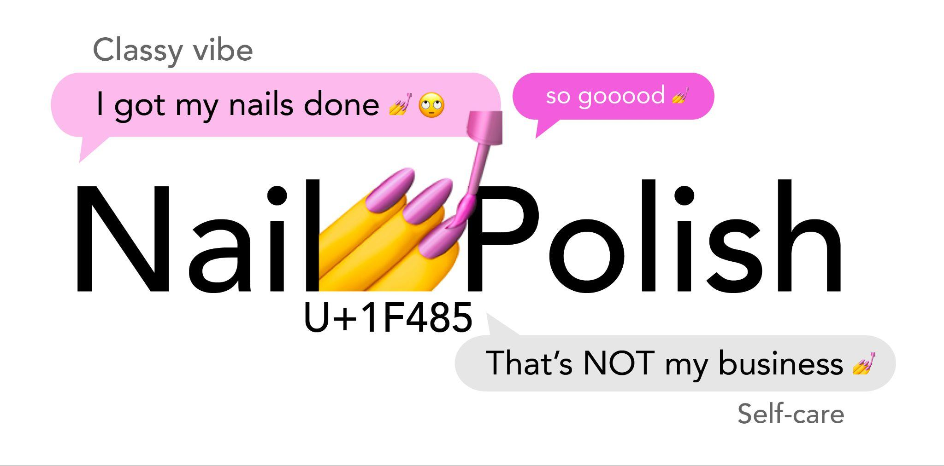
Figure 6: Pragmatic ambiguity of the nail-polish emoji, one of the confusing emojis highlighted in recent survey reporting.
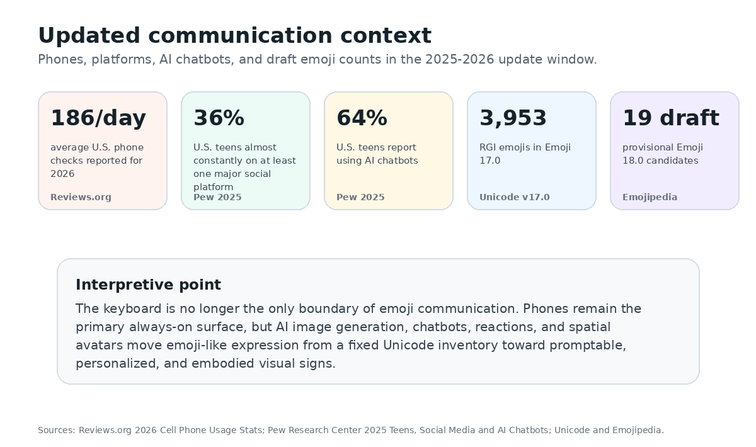
Figure 7: Updated 2025-2026 communication context for emoji use: phones, teen platforms, AI chatbots, and draft emoji counts.
8 BEYOND THE KEYBOARD: AI, SPATIAL AVATARS, AND REACTION INTERFACES
Future-oriented cases show emoji-like expression moving beyond the fixed keyboard. Earlier examples include emojis as visual metaphor and sentiment labels, such as Emoji Dick, Xu Bing’s Book from the Ground, mood-tracking applications, and music recommendation by emoji. Newer cases extend this trajectory into generative AI, spatial avatars, and reaction-based workflows.
Apple’s Genmoji is the most direct shift. Apple describes Genmoji as allowing users to create original emoji by typing a description, with results that can be inserted inline in messages, shared as stickers, or used as Tapback reactions [20]. This changes the ontology of emoji communication. Traditional emojis are standardized signs selected from a common inventory. Genmoji are prompt-generated, personalized signs that imitate the social role of emojis while weakening the boundary between a shared code and an individual image.
Spatial computing pushes the same issue into embodiment. Apple Vision Pro Persona is described as a dynamic representation of a user’s face and hand movements for FaceTime and other apps [21]. Although Persona is not an emoji, it extends the same communication problem: how can a system capture, stylize, transmit, and render affective presence? Emoji began as a small face in a text line; spatial avatars turn face, hands, gaze, and posture into interface-mediated signs.
Bitmoji and AR lenses provide a third direction. Bitmoji personalizes the visual sign into a user’s cartoon likeness and places it into stickers, feeds, and augmented scenes [22]. Slack and GitHub reactions show a more infrastructural direction: emoji-like icons become lightweight workflow signals for agreement, acknowledgment, review, celebration, or triage [23,24]. Google Noto Emoji shows the opposite end of the stack, providing open-source font infrastructure that reduces missing-glyph problems and supports Unicode coverage [25].
Together these cases show that emoji communication is splitting into three forms. The first is standardized emoji: stable, encoded, interoperable, and governed. The second is personalized emoji-like imagery: promptable, avatar-based, and user-specific. The third is interface reaction systems: small signs used less as words than as operational states. Visual information communication research can connect these forms by asking how visual signs remain understandable when they become more personalized, dynamic, and embedded in workflows.
9 DESIGN IMPLICATIONS
The analysis suggests five implications for designers of emoji systems, messaging interfaces, and visual communication tools.
First, emoji design should account for layered meaning. A successful emoji must remain recognizable at small sizes, but it must also tolerate metaphorical use. Designers should evaluate not only whether a symbol depicts an object accurately but also how it may be used affectively, socially, or politically. The red flag, snake, and raised fist show that metaphorical uptake can become more important than literal depiction.
Second, platform consistency should be treated as communication risk management. Complete visual uniformity across vendors is unlikely and may not be desirable, but large differences in emotional expression can create misunderstanding. For faces, gestures, and socially sensitive objects, cross-platform testing should include perceived emotion, intensity, politeness, and possible threat.
Third, inclusion requires both representation and usability. Adding identity options can make users feel visible, but an expanding set of modifiers and sequences can also make the keyboard harder to navigate. Future emoji interfaces may need better search, recommendation, grouping, and context-sensitive display so that inclusive symbols are findable without overwhelming users.
Fourth, designers should disclose uncertainty for draft or unsupported symbols. Interfaces can use dashed markers, provisional labels, and stand-in glyph notes for draft or unsupported emoji releases. This is a useful pattern: when a sign is provisional or not widely renderable, the interface should communicate that status rather than pretending the visual system is stable.
Fifth, emoji-like systems should support annotation and repair. Mood trackers, music recommenders, reactions, and AI-generated emoji tools benefit from low-friction icons, but they should not assume one emoji equals one stable emotion. Interfaces should allow combination, text annotation, undo, and clarification, especially when symbols are used in professional, educational, or cross-cultural contexts.
10 LIMITATIONS AND CONCLUSION
This paper is a qualitative synthesis rather than a controlled user study. Its empirical basis comes from public datasets, published reports, curated case data, and visual trend analysis. The Twitter/X trend visualizations are useful for observing broad patterns, but they do not represent all platforms, languages, or private messaging contexts. Future work should compare multiple platforms, including WeChat, Instagram, TikTok, WhatsApp, Slack, and region-specific messaging services.
The analysis also relies on examples whose public visibility may overrepresent English-language and Western social-media discourse. Cross-cultural emoji interpretation should be tested through multilingual surveys and interaction studies. Such studies could measure how users interpret the same emoji in different textual contexts, across platform renderings, and under different relationship conditions.
Despite these limitations, emojis offer a compact case study of contemporary visual language. They began as compact pictorial aids for mobile messaging, but they have become a standardized, platform-rendered, and culturally dynamic system for expressing emotion and social meaning. Their significance lies in the way they bridge writing and image: emojis turn text into a multimodal exchange where tone, identity, and stance can be signaled visually.
The proposed three-layer framework, consisting of pictorial abstraction, affective signaling, and cultural indexing, explains why emojis can be simultaneously simple and complex. They are easy to insert into a message, yet their meanings depend on platforms, communities, social events, and time. For visual information communication, understanding emojis helps us understand a broader shift in digital culture: communication is increasingly written with images, and images increasingly behave like language.
REFERENCES
[1] Oxford Languages. 2015. Word of the Year 2015. Retrieved from https://languages.oup.com/word-of-the-year/2015/
[2] Qiyu Bai, Qi Dan, Zhe Mu, and Maokun Yang. 2019. A systematic review of emoji: Current research and future perspectives. Frontiers in Psychology 10, Article 2221. https://doi.org/10.3389/fpsyg.2019.02221
[3] Marcel Danesi. 2017. The Semiotics of Emoji: The Rise of Visual Language in the Age of the Internet. Bloomsbury Academic, London.
[4] Unicode Consortium. 2026. Unicode Emoji, Proposed Update Unicode Technical Standard #51, Version 18.0 draft 1. Retrieved from https://www.unicode.org/reports/tr51/proposed.html
[5] Unicode Consortium. 2025. Emoji Counts, v17.0. Retrieved from https://unicode.org/emoji/charts/emoji-counts.html
[6] Emojipedia. 2025. Emoji Version 17.0. Retrieved from https://emojipedia.org/emoji-17.0
[7] Emojipedia. 2026. Emoji Version 18.0 / Latest Draft Emojis. Retrieved from https://emojipedia.org/emoji-18.0
[8] Museum of Modern Art. 2016. NTT DOCOMO Emoji. Retrieved from https://www.moma.org/collection/works/196070
[9] Paola Antonelli. 2023. The Original Emoji, by Shigetaka Kurita. MoMA Magazine. Retrieved from https://www.moma.org/magazine/articles/998
[10] Unicode Consortium. 2024. Submitting Emoji Proposals / Emoji Selection Factors. Retrieved from https://unicode.org/emoji/proposals.html
[11] Francesco Barbieri, German Kruszewski, Francesco Ronzano, and Horacio Saggion. 2016. How cosmopolitan are emojis? Exploring emojis usage and meaning over different languages with distributional semantics. In Proceedings of the 24th ACM International Conference on Multimedia, 531-535. https://doi.org/10.1145/2964284.2967278
[12] Kate M. Miltner. 2021. One part politics, one part technology, one part history: Racial representation in the Unicode 7.0 emoji set. New Media & Society 23, 3, 515-534. https://doi.org/10.1177/1461444819899623
[13] Steven Coats. 2018. Skin tone emoji and sentiment on Twitter. arXiv:1805.00444.
[14] Emojipedia. 2020. Emojis of Black Lives Matter. Retrieved from https://blog.emojipedia.org/emojis-of-blacklivesmatter/
[15] Esquire. 2021. The red flag meme, explained. Retrieved from https://www.esquire.com/entertainment/a37960180/red-flag-meme-explained/
[16] Emojipedia. 2021. Loudly Crying becomes top-tier emoji. Retrieved from https://blog.emojipedia.org/loudly-crying-becomes-top-tier-emoji/
[17] Adobe. 2022. Future of Creativity: 2022 U.S. Emoji Trend Report. Retrieved from https://blog.adobe.com/en/publish/2022/09/13/emoji-trend-report-2022
[18] Pew Research Center. 2025. Teens, Social Media and AI Chatbots 2025. Retrieved from https://www.pewresearch.org/internet/2025/12/09/teens-social-media-and-ai-chatbots-2025/
[19] Reviews.org. 2026. Cell Phone Usage Stats 2026. Retrieved from https://www.reviews.org/mobile/cell-phone-addiction/
[20] Apple. 2024. Introducing Apple Intelligence for iPhone, iPad, and Mac. Retrieved from https://www.apple.com/newsroom/2024/06/introducing-apple-intelligence-for-iphone-ipad-and-mac/
[21] Apple Support. 2026. Capture and edit your Persona on Apple Vision Pro. Retrieved from https://support.apple.com/guide/apple-vision-pro/capture-your-persona-dev934d40a17/visionos
[22] Snap Inc. 2026. Bitmoji: Your Personal Emoji. Retrieved from https://www.bitmoji.com/
[23] Slack. 2026. Use emoji and reactions. Retrieved from https://slack.com/help/articles/202931348-Use-emoji-and-reactions
[24] GitHub Docs. 2026. REST API endpoints for reactions. Retrieved from https://docs.github.com/en/rest/reactions/reactions
[25] Google Fonts. 2026. Noto Emoji. Retrieved from https://github.com/googlefonts/noto-emoji
[26] Emojipedia. 2020. On families and equality. Retrieved from https://blog.emojipedia.org/on-families-and-equality/
[27] Preply. 2025. Study: The most confusing emojis in every state in 2025. Retrieved from https://preply.com/en/blog/most-confusing-emojis-2024/
[28] Francesco Barbieri and Jose Camacho-Collados. 2018. How gender and skin tone modifiers affect emoji semantics in Twitter. In Proceedings of the Seventh Joint Conference on Lexical and Computational Semantics.
[29] Zhao Shuangying and Yao Wang. 2013. Expression, emotion, plot: The development and evolution of online emoticons. Press Circles 20, 29-33. https://doi.org/10.15897/j.cnki.cn51-1046/g2.2013.20.007
[30] Zhang Huiming. 2011. A study on semiotic applications in modern online emoticon design. Zhuangshi 6, 110-111. https://doi.org/10.16272/j.cnki.cn11-1392/j.2011.06.021

