Emoji as Visual Language: History, Selection Standards, Generational Use, and Creative Futures
Anonymous full-paper draft for VINCI 2026
Paper type: Full paper; suggested track: Cultural Computing Special Track / Technical Paper Track
Abstract
Emoji have become a standardized but culturally dynamic visual language for everyday digital communication. This paper organizes emoji research around four connected questions: how emoticons and emoji developed historically, how contemporary emoji are selected and governed, how usage habits are changing under mobile-first and Gen Z communication patterns, and how emoji-like expression is expanding into creative future applications. Drawing on Unicode and Emojipedia records, public platform-use reports, social-media trend visualizations, and selected cultural cases, the paper argues that emoji meaning emerges from the interaction of visual abstraction, affective signaling, and cultural indexing. The analysis shows that emoji are not merely decorative icons. They are standardized signs, cultural artifacts, interface controls, and increasingly personalized visual media shaped by AI generation, spatial avatars, and reaction-based workflows. The paper contributes a structured synthesis and design implications for inclusive, context-aware visual communication systems.
CCS Concepts
Human-centered computing -> Human computer interaction (HCI); Human-centered computing -> Visualization; Applied computing -> Arts and humanities; Social and professional topics -> Cultural characteristics.
Keywords
emoji, emoticon, visual language, visual communication, Unicode, Gen Z, mobile communication, cultural computing
ACM Reference Format
Anonymous Author(s). 2026. Emoji as Visual Language: History, Selection Standards, Generational Use, and Creative Futures. In Proceedings of the 19th International Symposium on Visual Information Communication and Interaction (VINCI 2026), November 1-4, 2026, Hangzhou, China. ACM, New York, NY, USA, 8 pages.

1 INTRODUCTION
Emoji have become one of the most recognizable visual systems in contemporary digital communication. They appear in private messaging, public social-media posts, workplace reactions, brand campaigns, mood-tracking tools, and emerging AI-generated media. Their scale is small, but their communicative role is large: a single emoji can soften a message, intensify emotion, signal irony, mark identity, or connect a user to a shared cultural event. This makes emoji a useful object of study for visual information communication, because they sit at the boundary between image, writing, interface, and social practice.
The central problem is that emoji are often described as a universal language, yet their actual use is neither fully universal nor fully stable. Unicode standardization gives emoji a shared encoded identity, but platform rendering, cultural context, user community, and historical moment all shape interpretation. A folded-hands emoji can mean prayer, thanks, apology, pleading, or greeting. A crying face can signal grief, cuteness, comedy, or emotional overload. A thumbs-up can be read as agreement by some users and as dismissive by others. Emoji therefore require analysis as context-sensitive visual signs rather than as simple pictorial substitutes for words.
This paper examines emoji through four connected dimensions. First, it reviews the historical development from emoticons and kaomoji to mobile emoji and Unicode standardization. Second, it analyzes contemporary emoji selection standards, with particular attention to cultural factors, representational gaps, and Unicode governance. Third, it discusses changes in usage habits under mobile-first communication, especially Gen Z phone dependence, reaction culture, and semantic drift. Fourth, it considers future creative applications, including AI-generated emoji-like images, spatial avatars, AR identity systems, and workflow reactions.
The contribution is a structured synthesis for visual communication research. Rather than treating emoji only as decorative icons or only as linguistic tokens, the paper argues that emoji meaning emerges from three interacting layers: pictorial abstraction, affective signaling, and cultural indexing. This framework explains why emoji can be easy to recognize yet difficult to interpret, why platform consistency matters, and why cultural representation cannot be separated from interface design.
2 HISTORICAL REVIEW OF EMOTICONS AND EMOJI
Emoji are often treated as a recent social-media phenomenon, but their logic belongs to a longer history of visual expression. Before digital networks, simplified faces and symbolic marks already helped people transmit affect through compact visual forms. Harvey Ball’s 1963 yellow smiley is an important precursor because it reduced happiness to a small number of high-salience features: a circular yellow field, two eyes, and a curved mouth. This reduction made the image easy to reproduce, easy to recognize, and easy to circulate as a sign of positive emotion.
This early history matters because it shows that emoji did not appear as isolated graphic novelties. They inherit a recurring design problem: how to make emotion visible when communication becomes compressed, distant, or mediated. A postcard, a badge, a bulletin-board message, a mobile SMS, and a social-media post all reduce embodied interaction. Visual signs compensate for that reduction by restoring some of the expressive cues normally carried by face, voice, and gesture. Emoji are therefore part of a longer effort to make writing behave more like interaction.
Computer-mediated communication introduced a new constraint: users needed emotional cues inside plain text. ASCII emoticons such as :-) and :-( solved this problem by turning typographic characters into sideways faces. They were visually simple, technically cheap, and compatible with early networked systems. Japanese kaomoji, including forms such as ^_^ and T_T, extended the expressive range of text-based faces by using horizontal arrangements and a wider set of characters. These forms show that emotional communication online did not begin with colorful icons. It began with users adapting available visual resources to replace missing facial expression, gesture, and tone.
This study distinguishes emoticons, kaomoji, and emoji because the terms describe different visual systems. Emoticons are text or graphic arrangements used to convey emotion. Kaomoji are face-like text arrangements rooted in Japanese character conventions. Emoji are encoded pictographic characters used in electronic communication. This distinction matters because each form solves a communication problem differently. Emoticons exploit typography, kaomoji exploit character composition, and emoji depend on standardized code points rendered as platform images.
The mobile emoji system emerged through Japanese carriers in the late 1990s. SoftBank released an early emoji set in 1997, while Shigetaka Kurita’s 176-pictogram i-mode set for NTT DoCoMo in 1999 became especially influential in later histories of emoji design [8,9]. These early sets were not only smileys. They included weather, transportation, objects, activities, and social cues, which established a key principle of emoji communication: one visual vocabulary can refer to emotion, things, places, and actions at the same time.
The spread of smartphones changed the social scale of emoji. Apple’s integration of emoji input into iOS and Android’s later support made emoji available to users far beyond the Japanese carrier environment. Once emoji became part of default keyboards, they no longer required special technical knowledge. Their use became habitual: a user could search, tap, repeat, and combine symbols in the same interface used for ordinary text. This integration explains why emoji became a cross-platform literacy practice rather than a decorative sticker set.
Unicode standardization transformed emoji from platform-specific images into interoperable signs. A sender and receiver on different devices needed a shared encoded symbol, and Unicode supplied that infrastructure. However, standardization did not eliminate visual difference. The same code point may still be drawn differently by Apple, Google, Samsung, Microsoft, or X/Twitter. Emoji therefore sit between code and image: their encoded identity is standardized, but their perceived tone depends on rendering style, screen context, surrounding text, and community convention.
The Oxford Dictionaries Word of the Year decision in 2015 made this shift publicly visible [1]. Selecting Face with Tears of Joy as a “word” was controversial because the symbol does not behave like an ordinary lexical item. Yet the decision was useful precisely because it exposed a change in writing practice: users were already treating small images as grammatical, emotional, and social elements inside written messages. For visual communication research, the event shows how a symbol can become culturally legible not only through official standardization but also through mass repetition.
Recent version data show how quickly this visual system has grown. Unicode Emoji v17.0 lists 3,953 recommended-for-general-interchange emoji when skin-tone and gender variations are included [5]. Emojipedia reports that Emoji 17.0 added 163 new emoji, while the draft Emoji 18.0 list contains 19 provisional candidates, including a cracking face, thumb-sign variants, monarch butterfly, pickle, lighthouse, meteor, eraser, and net with handle [6,7]. This growth indicates that emoji have become not only a keyboard feature but a managed visual vocabulary with cultural, technical, and social consequences.
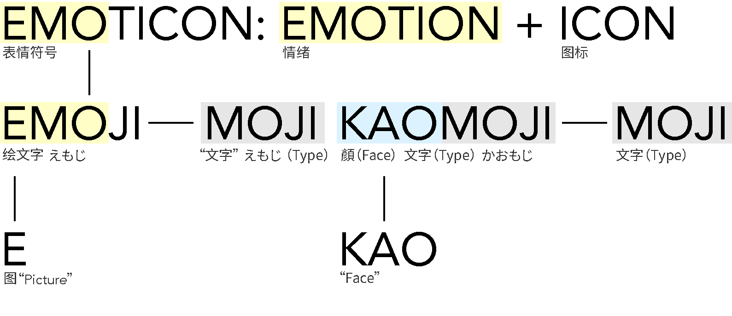
Figure 1: Conceptual relation among emoticons, emoji, and kaomoji. Author diagram.
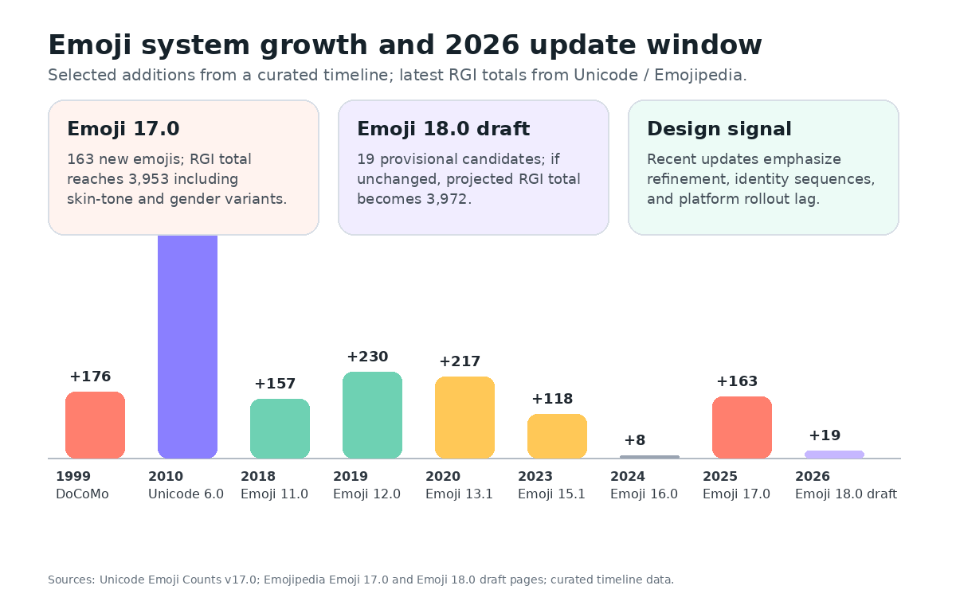
Figure 2: Updated growth window for the emoji system, combining curated timeline milestones with Unicode/Emojipedia 2025-2026 counts.
3 CONTEMPORARY EMOJI SELECTION STANDARDS: CULTURAL FACTORS AND GOVERNANCE
Contemporary emoji are not added simply because a symbol is popular or attractive. Unicode proposal guidelines define an evaluation process that treats emoji as part of a global communication standard. A successful proposal must demonstrate expected frequency, multiple use cases, visual distinctiveness, compatibility or representational need, and likely durability beyond short-term trends [10]. The same guidelines also exclude brands, logos, deities, named people, and overly specific or transient concepts. These rules show that emoji are governed as shared infrastructure rather than casual illustrations.
Frequency is important, but it is not sufficient. A proposed emoji must show that people would actually use the concept, yet the committee also asks whether the symbol can support multiple meanings. A visually literal object becomes more valuable when it can also work metaphorically. A rocket can suggest space travel, ambition, speed, launch, or excitement. A fire can describe heat, danger, attractiveness, or excellence. This preference for multiple use cases reveals that the standard values semantic flexibility, not only pictorial accuracy.
The selection process can be understood as a pipeline from cultural demand to platform rendering. A proposal first gathers evidence, including search frequency, social-media use, metaphorical range, and visual need. The Emoji Subcommittee reviews the proposal, the Unicode Technical Committee votes on repertoire changes, approved emoji enter the standard, and vendors then design platform-specific glyphs. This pipeline is important for visual communication because it separates three decisions: whether a concept deserves encoding, how it is represented in the standard, and how each platform visually renders it.
Cultural factors are central to this process. Emoji have often been criticized as universal symbols, but the selection system increasingly recognizes that universality must be built through representation. Dumpling, woman with headscarf, and mate drink are useful cases. Dumpling filled a gap for foods shared across several Asian and Eastern-European food cultures. Woman with headscarf responded to a representational gap for Muslim women and other communities in which head coverings carry identity and religious meaning. Mate drink represented a South American social practice that no existing beverage emoji captured. These cases show that cultural specificity can strengthen, rather than weaken, the global value of a symbol.
Visual distinctiveness is another selection standard with cultural consequences. Emoji must remain recognizable at small keyboard and message sizes, often near 18 x 18 pixels. This requirement favors forms with strong silhouettes, clear internal contrast, and minimal reliance on fine detail. It also means that some culturally meaningful objects are difficult to encode because their identity depends on texture, inscription, ritual use, or regional variation. The selection process therefore converts cultural richness into simplified visual form, and that conversion can be both enabling and reductive.
The cultural logic of emoji selection also explains why some proposed symbols are rejected. A symbol may be visually clear but unsuitable if it primarily represents a brand, deity, celebrity, or temporary internet fad. The exclusion of deities, for example, is not a technical limitation but a governance decision: encoding a deity could imply unequal endorsement, trigger irreversible controversy, or require the standard to adjudicate religious representation in ways that exceed its role. The standard must balance expressive demand with neutrality, durability, and cross-cultural risk.
Selection is therefore a form of visual governance. Once an emoji is encoded, it becomes available for uses beyond the proposing community. A taco can signify Mexican food, casual dining, identity, tourism, humor, or a brand campaign. A headscarf can signify religious identity, modesty, cultural pride, discrimination, or solidarity depending on context. A red flag can be a literal marker, a warning sign, a meme, or social critique. The selection standard authorizes a form, but users and communities continue to negotiate meaning after release.
Inclusivity intensifies this governance problem. Skin-tone modifiers, gender-neutral figures, disability-related emoji, and multi-person sequences respond to real representational gaps. At the same time, each addition changes the interface burden. Handshake combinations, family variants, and person-role sequences show how quickly identity representation multiplies into technical and navigational complexity. A standard that includes more people must also remain searchable, learnable, and renderable across devices. Inclusion is therefore not only an ethical question; it is also an information-architecture problem.
Draft status further complicates governance. Unicode’s proposed UTS #51 states that draft material may be updated, replaced, or superseded and should not be cited as stable [4]. Yet draft emoji already circulate through media coverage, design speculation, and interface mockups. Designers therefore need methods for communicating uncertainty, such as draft labels, dashed markers, and stand-in glyph notes when system fonts do not yet support new code points. This is a practical issue for any visual system that evolves faster than device rendering support.
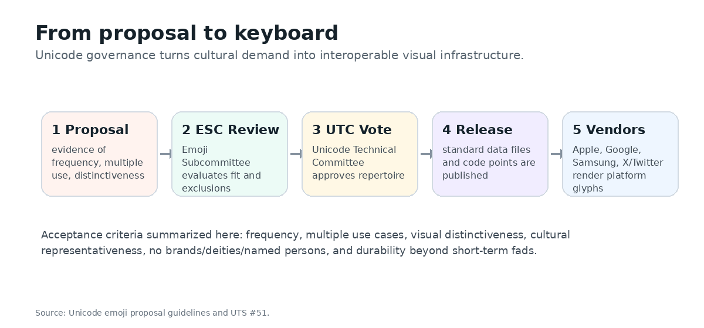
Figure 3: Unicode proposal-to-keyboard process summarized from Unicode proposal guidelines.
4 CHANGING USAGE HABITS: GEN Z, PHONE DEPENDENCE, AND SEMANTIC DRIFT
Emoji use has changed because the communication environment has changed. In early mobile messaging, emoji helped users add emotional cues to short text. In contemporary platform communication, emoji function as punctuation, reactions, social identity markers, and meme-like signals. The shift from occasional text messaging to always-on mobile platforms has made emoji part of a continuous visual grammar.
The term “phone addiction” is often used colloquially to describe this always-on condition, but the design issue is broader than clinical addiction. Smartphones make communication persistent, interruptible, and visually dense. Users encounter emoji not only in private messages but also in notifications, live comments, reaction bars, algorithmic feeds, avatars, stickers, and push alerts. The same symbol can move from intimate chat to public performance within seconds. This rapid circulation helps explain why emoji meanings can change quickly across communities.
Mobile dependence is especially visible in younger users. Pew’s 2025 report finds that 97% of U.S. teens use the internet daily, four in ten say they are online almost constantly, 36% are almost constantly on at least one of five major social platforms, and 64% report using AI chatbots [18]. Reviews.org’s 2026 survey reports that U.S. adults check phones 186 times per day on average [19]. These figures do not measure emoji use directly, but they describe the communication condition in which emoji meanings are learned, repeated, and transformed: frequent phone checking, platform feeds, reaction buttons, short-form messaging, and AI-mediated interaction.
For Gen Z users, emoji often work less like literal pictures and more like stance markers. A skull can mean “I am laughing,” a crying face can mark exaggeration rather than sadness, and sparkles can create a tone of irony, emphasis, or playful glamor. This is different from older usage patterns that often attach emoji more directly to the depicted emotion or object. The generational difference is not that one group understands emoji correctly and another incorrectly; rather, different groups learn different pragmatic conventions from their platform environments.
Trend data from Twitter/X between 2012 and 2023 show a steady rise in tweets containing at least one emoji, reaching more than one quarter of tweets in early 2023 according to the visualization in Figure 4. This suggests that emoji have become a normalized part of public written communication rather than a niche youth practice. They are not separate from text; they help structure tone, emphasis, and stance within text-based streams.
High-frequency emoji are often semantically flexible. Face with Tears of Joy dominated for years because it supports a hybrid emotional register: amusement, exaggeration, embarrassment, and helpless laughter. During the COVID-19 period, Loudly Crying Face gained prominence and challenged or surpassed Face with Tears of Joy in some rankings [16]. This does not prove that pandemic mood directly caused a ranking change, but it indicates a visible shift in the public vocabulary of emotion. Likewise, red hearts, folded hands, crying faces, and laughing faces remain popular because they can adapt to gratitude, grief, humor, support, apology, and decorative warmth.
This flexibility is why simple popularity rankings must be interpreted carefully. A high-frequency emoji does not map neatly onto a single feeling. For example, folded hands may indicate prayer, thanks, apology, pleading, or respect; a red heart may indicate love, support, agreement, or decorative friendliness; Loudly Crying Face may indicate grief, cuteness, comic overreaction, or emotional intensity. Emoji frequency therefore reveals the prevalence of visual forms, but qualitative interpretation is needed to understand the social meanings those forms carry.
Gen Z communication highlights semantic drift. A thumbs-up emoji can be read by older users as agreement but by some younger users as dismissive. Face with Tears of Joy can signal literal laughter to one group but feel dated or cringe to another. The simple smiley can read as friendly, fake, or passive-aggressive depending on the community. These changes are not merely slang. They show that a visual sign can gain social age, and that users manage identity by adopting or avoiding particular emoji.
Cross-cultural ambiguity remains equally important. Nail polish can literally refer to nail care, but users also interpret it as classiness, self-care, indifference, or a stance similar to “do not involve me.” Folded hands can signify prayer, gratitude, apology, pleading, or respectful greeting. Upside-down face, dashing away, eggplant, and raised hands similarly accumulate community-specific meanings. The result is a paradox: emoji cross language barriers because their images are recognizable, but recognition does not guarantee shared interpretation.
Platform rendering compounds this ambiguity. A face that appears shy on one platform may appear anxious or sarcastic on another. A gesture may look celebratory in one rendering and ambiguous in another. Users usually do not see the sender’s original rendering if they are on a different platform, so the receiver may interpret a slightly different image from the one the sender selected. This is especially important for smileys, gestures, and socially sensitive objects, where small changes in eyes, mouth shape, angle, or color can alter perceived tone.
Viral emoji events make the social layer visible. During Black Lives Matter protests, raised-fist emoji with different skin tones became symbols of solidarity and anti-racist resistance [14]. In Taylor Swift’s public-image controversy, the snake emoji was used for harassment and then reappropriated as an image of empowerment. In the red-flag trend, users repeated the triangular flag emoji to mark social warning signs and critique toxic behavior [15]. These examples show that emoji are not only individual affective markers. They can become collective visual coordination devices in public discourse.
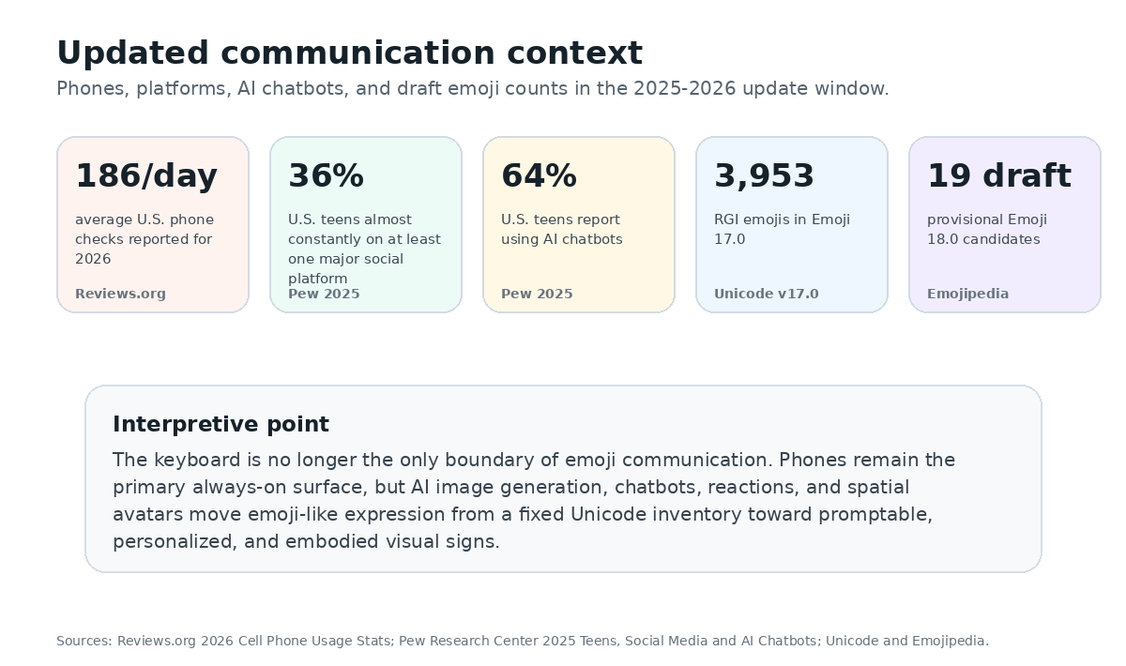
Figure 4: Updated 2025-2026 communication context: phones, teen platform use, AI chatbots, and draft emoji counts.
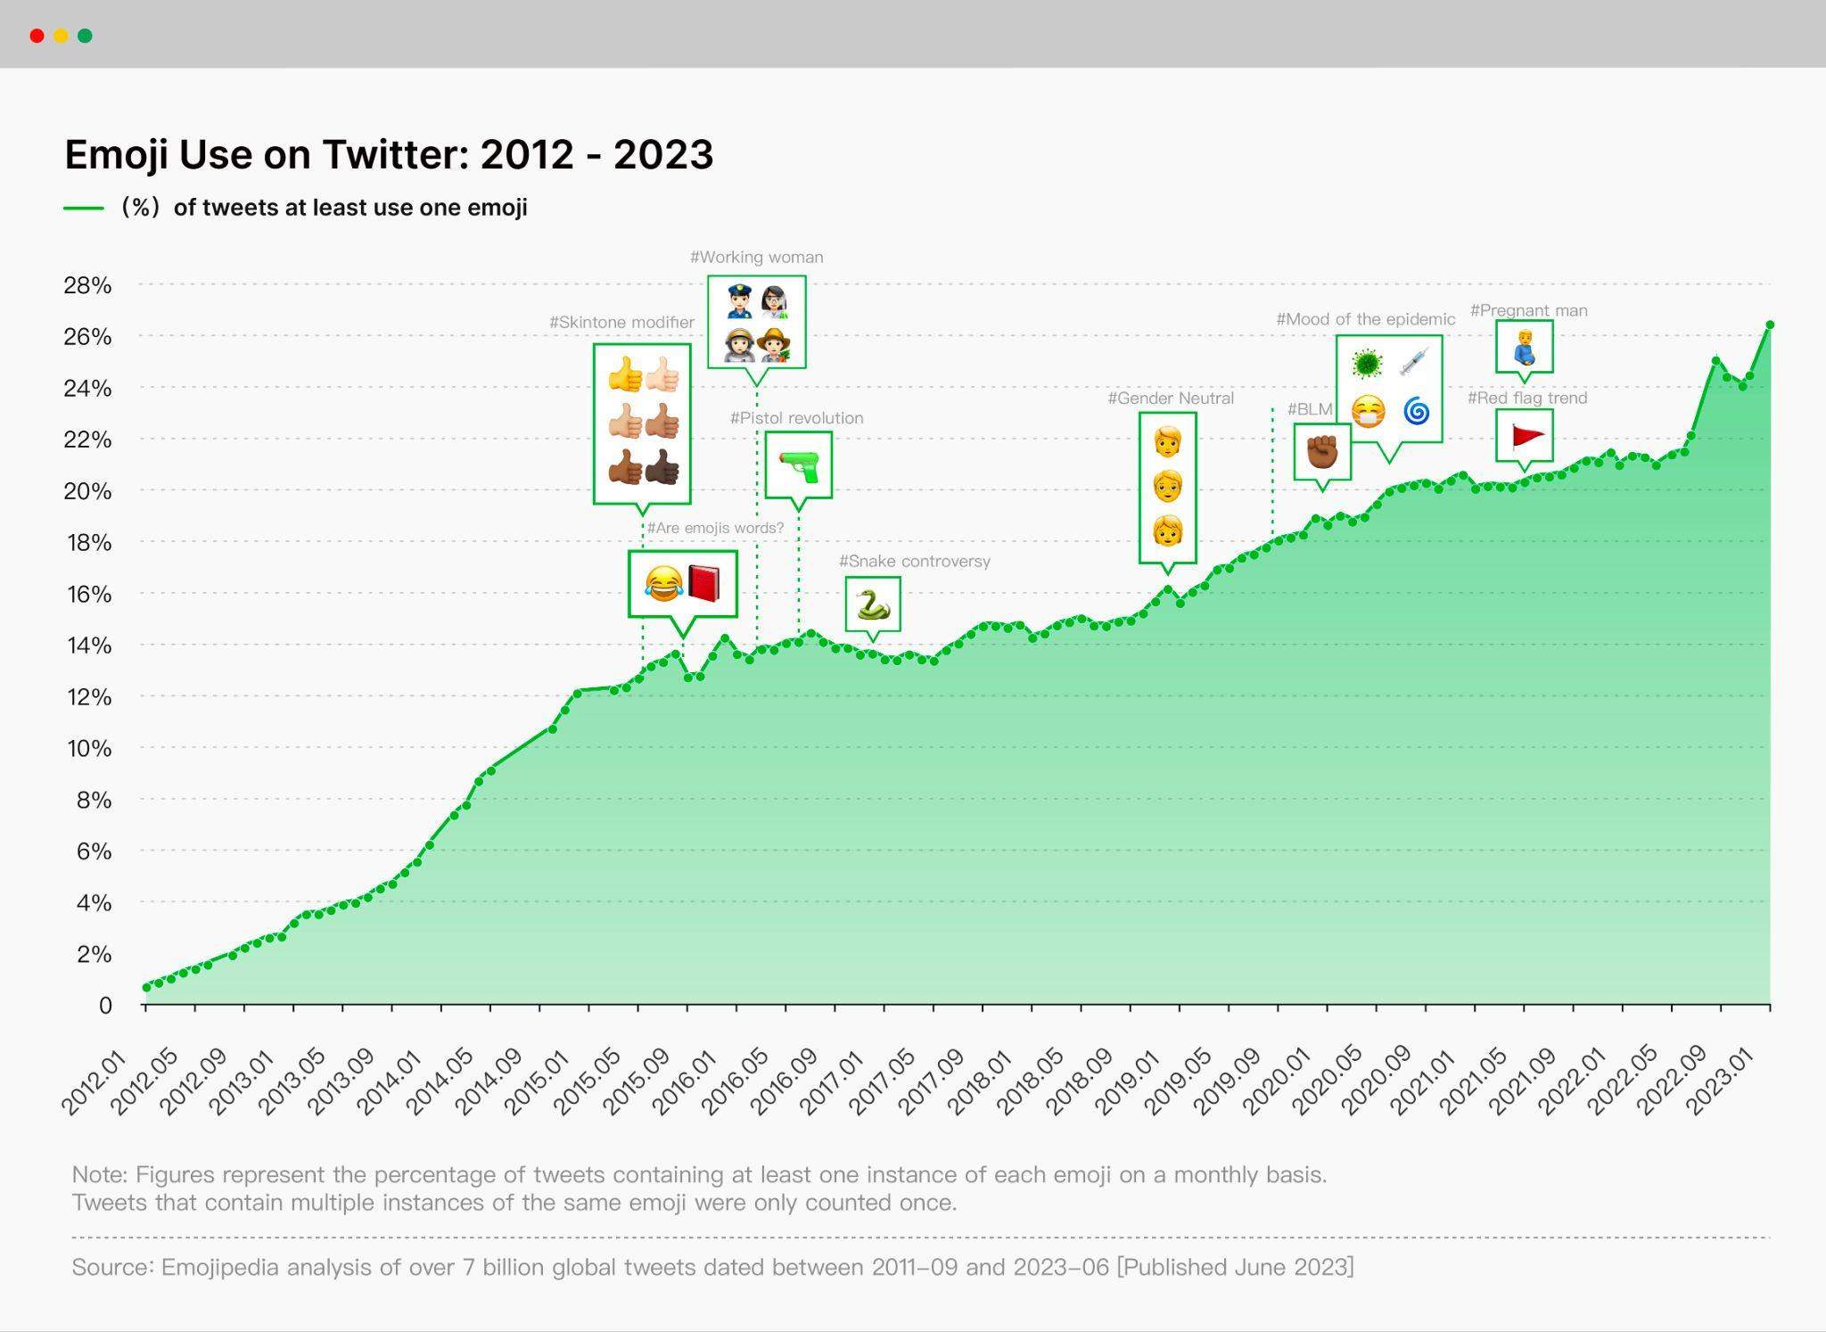
Figure 5: Emoji use on Twitter/X from 2012 to 2023. Visualization based on Emojipedia trend data.
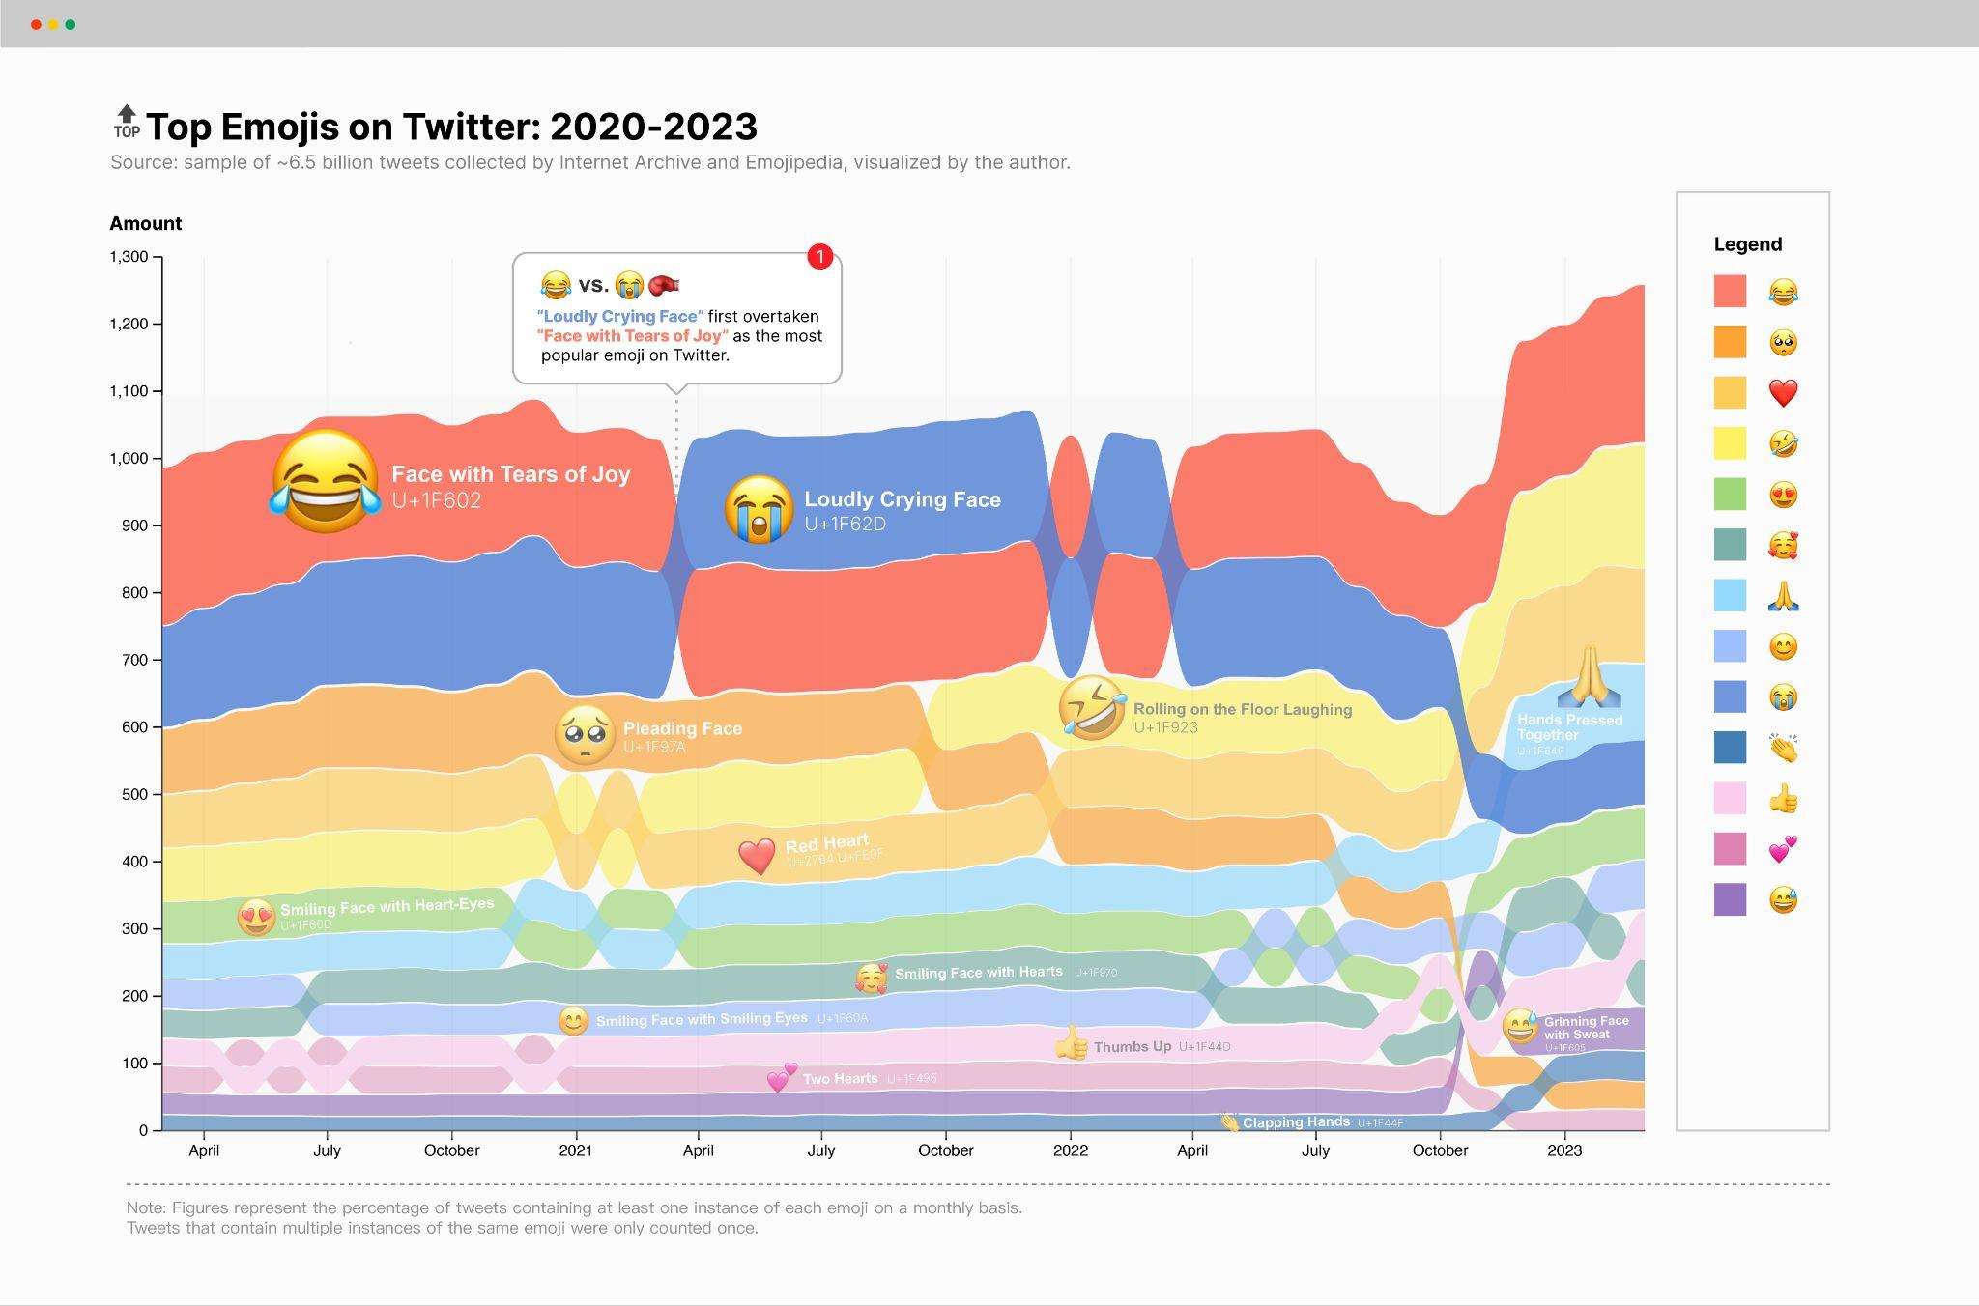
Figure 6: Top emoji on Twitter/X from 2020 to 2023, showing shifts among laughing, crying, heart, and gesture emoji.
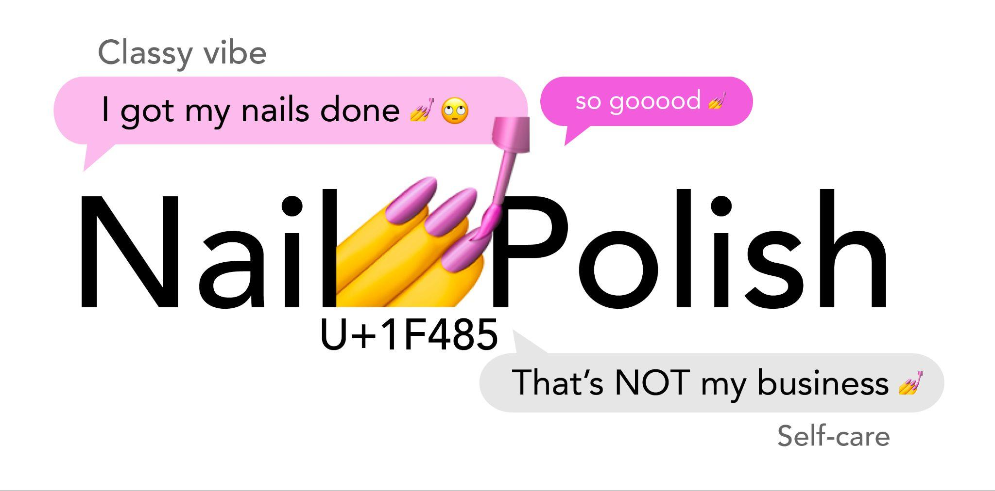
Figure 7: Pragmatic ambiguity of the nail-polish emoji, one of the confusing emoji highlighted in recent survey reporting.
5 CREATIVE APPLICATIONS AND FUTURES OF EMOJI
Emoji already operate beyond ordinary chat. Creative works such as Emoji Dick and Xu Bing’s Book from the Ground show how pictographic symbols can be arranged into extended narratives. Mood-tracking applications use emoji-like stickers as sentiment labels. Music recommendation systems can use emoji as affective tags. These examples extend emoji from punctuation into visual metaphor, classification, and interface input.
These creative uses challenge the assumption that emoji are too simple for complex communication. Emoji Dick translated a canonical literary work into a crowdsourced pictographic register, while Book from the Ground explored a broader symbol-based narrative system. Neither project proves that emoji can replace language. Instead, they show how pictorial signs can expose the boundaries between reading, seeing, translating, and interpreting. Emoji become experimental material for testing how much narrative or emotion can be carried by shared visual experience.
The next phase is shaped by personalization and generation. Apple’s Genmoji allows users to create original emoji-like images by typing a description, with results that can be inserted inline in messages, shared as stickers, or used as Tapback reactions [20]. This shifts the ontology of emoji communication. Traditional emoji are standardized signs selected from a common inventory. Genmoji are prompt-generated, personalized signs that imitate the social role of emoji while weakening the boundary between shared code and individual image.
This shift creates a tension between expressiveness and interoperability. Standard emoji work because everyone has access to the same encoded repertoire. Prompt-generated emoji-like images may be more personal and emotionally precise, but they are less stable as shared signs. A generated image can communicate strongly in one conversation while lacking broader cultural recognizability. Future systems will need to decide whether generated emoji are treated as stickers, as message attachments, as reactions, or as a new class of semi-standard visual tokens.
Spatial computing extends the same problem into embodiment. Apple Vision Pro Persona is described as a dynamic representation of a user’s face and hand movements for FaceTime and other apps [21]. Although Persona is not an emoji, it addresses a related communication problem: how can a system capture, stylize, transmit, and render affective presence? Emoji began as a small face in a text line; spatial avatars turn face, hands, gaze, and posture into interface-mediated signs.
Bitmoji and AR lenses provide another direction. Bitmoji personalizes visual expression into a user’s cartoon likeness and places it into stickers, feeds, and augmented scenes [22]. In this model, emoji-like communication is no longer limited to a small icon. It becomes a portable identity object that can be inserted into social, spatial, and branded environments. This movement from icon to avatar is important because it changes the scale of expression from a discrete symbol to a persistent visual self.
Reaction interfaces show a more infrastructural future. Slack and GitHub reactions use emoji-like signs as lightweight workflow signals for agreement, acknowledgment, review, celebration, or triage [23,24]. In these settings, emoji function less as words than as operational states. A reaction can close a loop, approve a change, mark a task, or reduce the need for another message. This suggests that emoji-like symbols are becoming part of interface logic, not only interpersonal expression.
In professional settings, the ambiguity of emoji can be both useful and risky. A check mark reaction can efficiently acknowledge a task, but a smiling face, thumbs-up, or eyes reaction may be interpreted differently across teams. The advantage of reaction systems is speed; the weakness is that they compress intent. Designers of workplace tools should therefore consider whether reaction vocabularies need local norms, tooltips, audit trails, or configurable meanings when emoji-like signs carry workflow consequences.
Open-source fonts and platform infrastructure also shape the future. Google Noto Emoji aims to reduce missing-character “tofu” problems by providing broad Unicode emoji coverage [25]. This matters because visual communication depends on reliable rendering. A symbol that cannot display becomes a broken communication channel. As emoji expand into AI-generated media and spatial interfaces, designers must preserve legibility, disclosure, and repair mechanisms: users should know when a sign is standardized, when it is generated, when it is provisional, and how to clarify meaning when interpretation fails.
The future of emoji is therefore not only a question of adding more symbols. It is a question of how visual communication systems manage shared standards, personal expression, cultural representation, and machine-generated variation at the same time. A useful future emoji system must support both common understanding and creative difference. That balance will require clearer status markers, better search, cross-platform rendering checks, and user controls for explaining or revising visual intent.
These future applications suggest three design implications. First, emoji systems should preserve layered meaning: a symbol must be recognizable at small size while allowing metaphorical and affective use. Second, inclusion requires both representation and usability; adding identity options helps users feel visible but also creates keyboard complexity. Third, emoji-like systems should support annotation and repair. Mood trackers, reactions, and AI-generated emoji tools should not assume that one icon equals one stable emotion. Interfaces should allow combination, text annotation, undo, and clarification in cross-cultural or professional contexts.
6 CONCLUSION
This paper has reorganized emoji research around four linked areas: history, selection standards, changing use habits, and future creative applications. The historical review shows that emoji belong to a longer effort to reinsert face, gesture, and affect into written communication. The selection-standard discussion shows that emoji are governed as global visual infrastructure. The usage section shows that always-on mobile life and Gen Z communication practices accelerate semantic drift. The future-application section shows that emoji-like expression is moving into AI generation, spatial avatars, AR identity, and workflow systems.
Across these areas, emoji meaning emerges from the interaction of pictorial abstraction, affective signaling, and cultural indexing. Emoji are simple enough to be inserted into a sentence with one tap, yet complex enough to reflect platform rendering, identity politics, cultural ambiguity, public events, and generational style. For visual information communication, emoji provide a compact but powerful case study of how images become language-like, and how language becomes increasingly visual.
REFERENCES
[1] Oxford Languages. 2015. Word of the Year 2015. Retrieved from https://languages.oup.com/word-of-the-year/2015/
[2] Qiyu Bai, Qi Dan, Zhe Mu, and Maokun Yang. 2019. A systematic review of emoji: Current research and future perspectives. Frontiers in Psychology 10, Article 2221. https://doi.org/10.3389/fpsyg.2019.02221
[3] Marcel Danesi. 2017. The Semiotics of Emoji: The Rise of Visual Language in the Age of the Internet. Bloomsbury Academic, London.
[4] Unicode Consortium. 2026. Unicode Emoji, Proposed Update Unicode Technical Standard #51, Version 18.0 draft 1. Retrieved from https://www.unicode.org/reports/tr51/proposed.html
[5] Unicode Consortium. 2025. Emoji Counts, v17.0. Retrieved from https://unicode.org/emoji/charts/emoji-counts.html
[6] Emojipedia. 2025. Emoji Version 17.0. Retrieved from https://emojipedia.org/emoji-17.0
[7] Emojipedia. 2026. Emoji Version 18.0 / Latest Draft Emojis. Retrieved from https://emojipedia.org/emoji-18.0
[8] Museum of Modern Art. 2016. NTT DOCOMO Emoji. Retrieved from https://www.moma.org/collection/works/196070
[9] Paola Antonelli. 2023. The Original Emoji, by Shigetaka Kurita. MoMA Magazine. Retrieved from https://www.moma.org/magazine/articles/998
[10] Unicode Consortium. 2024. Submitting Emoji Proposals / Emoji Selection Factors. Retrieved from https://unicode.org/emoji/proposals.html
[11] Francesco Barbieri, German Kruszewski, Francesco Ronzano, and Horacio Saggion. 2016. How cosmopolitan are emojis? Exploring emojis usage and meaning over different languages with distributional semantics. In Proceedings of the 24th ACM International Conference on Multimedia, 531-535. https://doi.org/10.1145/2964284.2967278
[12] Kate M. Miltner. 2021. One part politics, one part technology, one part history: Racial representation in the Unicode 7.0 emoji set. New Media & Society 23, 3, 515-534. https://doi.org/10.1177/1461444819899623
[13] Steven Coats. 2018. Skin tone emoji and sentiment on Twitter. arXiv:1805.00444.
[14] Emojipedia. 2020. Emojis of Black Lives Matter. Retrieved from https://blog.emojipedia.org/emojis-of-blacklivesmatter/
[15] Esquire. 2021. The red flag meme, explained. Retrieved from https://www.esquire.com/entertainment/a37960180/red-flag-meme-explained/
[16] Emojipedia. 2021. Loudly Crying becomes top-tier emoji. Retrieved from https://blog.emojipedia.org/loudly-crying-becomes-top-tier-emoji/
[17] Adobe. 2022. Future of Creativity: 2022 U.S. Emoji Trend Report. Retrieved from https://blog.adobe.com/en/publish/2022/09/13/emoji-trend-report-2022
[18] Pew Research Center. 2025. Teens, Social Media and AI Chatbots 2025. Retrieved from https://www.pewresearch.org/internet/2025/12/09/teens-social-media-and-ai-chatbots-2025/
[19] Reviews.org. 2026. Cell Phone Usage Stats 2026. Retrieved from https://www.reviews.org/mobile/cell-phone-addiction/
[20] Apple. 2024. Introducing Apple Intelligence for iPhone, iPad, and Mac. Retrieved from https://www.apple.com/newsroom/2024/06/introducing-apple-intelligence-for-iphone-ipad-and-mac/
[21] Apple Support. 2026. Capture and edit your Persona on Apple Vision Pro. Retrieved from https://support.apple.com/guide/apple-vision-pro/capture-your-persona-dev934d40a17/visionos
[22] Snap Inc. 2026. Bitmoji: Your Personal Emoji. Retrieved from https://www.bitmoji.com/
[23] Slack. 2026. Use emoji and reactions. Retrieved from https://slack.com/help/articles/202931348-Use-emoji-and-reactions
[24] GitHub Docs. 2026. REST API endpoints for reactions. Retrieved from https://docs.github.com/en/rest/reactions/reactions
[25] Google Fonts. 2026. Noto Emoji. Retrieved from https://github.com/googlefonts/noto-emoji
[26] Emojipedia. 2020. On families and equality. Retrieved from https://blog.emojipedia.org/on-families-and-equality/
[27] Preply. 2025. Study: The most confusing emojis in every state in 2025. Retrieved from https://preply.com/en/blog/most-confusing-emojis-2024/
[28] Francesco Barbieri and Jose Camacho-Collados. 2018. How gender and skin tone modifiers affect emoji semantics in Twitter. In Proceedings of the Seventh Joint Conference on Lexical and Computational Semantics.
[29] Zhao Shuangying and Yao Wang. 2013. Expression, emotion, plot: The development and evolution of online emoticons. Press Circles 20, 29-33. https://doi.org/10.15897/j.cnki.cn51-1046/g2.2013.20.007
[30] Zhang Huiming. 2011. A study on semiotic applications in modern online emoticon design. Zhuangshi 6, 110-111. https://doi.org/10.16272/j.cnki.cn11-1392/j.2011.06.021

