İSTANBUL TECHNICAL UNIVERSITY
FACULTY OF COMPUTER AND INFORMATICS

MOTION PREDICTION OF
PUSH MANIPULATION
WITH MACHINE LEARNING

Graduation Project Report

Pelin Hakverir
150140031

Department: Computer Engineering
Division: Computer Engineering

Advisor : Dr. Damien Jade Duff

May 2019
Statement of Authenticity

I/we hereby declare that in this study

- all the content influenced from external references are cited clearly and in detail,
- and all the remaining sections, especially the theoretical studies and implemented software/hardware that constitute the fundamental essence of this study is originated by my/our individual authenticity.

İstanbul, May 2019

Pelin Hakverir

MOTION PREDICTION OF PUSH MANIPULATION WITH MACHINE LEARNING

( SUMMARY )

Today, it is expected from robots to act perfectly under all conditions. For example, everyone admired Boston Dynamics’ Spot when it was announced and it was talked about for weeks [1]. It is resistant to exterior attacks and has an amazing balance. It is a basic sample for what the robots could encounter during their tasks. The exterior factors might prevent the robot from reaching its goal. If the factor can be eliminated, this should be performed. In the case of this factor is an obstacle, elimination would be moving the obstacle out of the robot’s way. To understand what exactly should be done to the obstacle, motion prediction can be used. Motion prediction is one of the important properties for a robot to move around almost perfectly. It calculates the robot’s actions and their results, or what needs to be done for a specific task.

In this project, a robot and objects with different shapes, masses, and volumes are created in a simulation. Random push manipulation to the objects are observed and results are stored in a file. With this data, two neural networks are trained: one for predicting the necessary speed for the robot to move the object to a specific location, and one for predicting the last location of an object knowing the robot’s initial speed. Then this trained models’ prediction functions are called before the push manipulation. In result, after an object and a robot are created, it is possible to know where the object will end up at which speed.

To create the dataset, a motor babbling code is written. It creates objects with different shapes, masses, and volumes. It assigns the robot a random velocity and makes it move towards the object. All the data is collected from the simulation including time passed after the collision occurred, object’s and robot’s initial positions, object’s and robot’s final positions, object’s mass, volume and shape, and robot’s velocity. These form the dataset.

Programming language of the project is Python 2.7 for both the motor babbling code and modeling the machine learning algorithm. Motor babbling code is developed with Visual Studio Code Editor and machine learning algorithms are modeled with PyCharm IDE. The robot and the objects are simulated on Gazebo. TurtleBot is used to interact with objects and ROS is the communication tool to the TurtleBot.

For prediction, a neural network with four dense layers, different activation functions, weight decay, and glorot normal initializer is used. While there are two neurons in the last layer of the neural network for predicting the last location, there is one neuron for predicting the speed of the robot.

This project can be adapted to any mobile robot to help the robot to be aware of its surroundings and be able to overcome the challenge of facing an obstacle during its tasks.

MAKİNE ÖĞRENMESİ İLE İTME MANİPÜLASYONUNUN HAREKET TAHMİNİ

( ÖZET )

Contents

1 Introduction and Project Summary 5

2 Comparative Literatre Survey 6

3 Developed Approach and System Model 6
3.1 Data Model 6
3.2 Structural Model 6
3.3 Dynamic Model 6

4 Experimentation Environment and Experiment Design 7

5 Comparative Evaluation and Discussion 7

6 Conclusion and Future Work 7

7 References 7

1 Introduction and Project Summary

When the robots that have been developed is observed, it can be noticed that each one has a specific goal. They are created for a certain reason, even if that reason is for fun or for performing crucial tasks. While doing these tasks, robots may have to interact with their surroundings. Especially for mobile robots, it is important to know or predict the actions of the objects around while reaching for the goal. For example, an object might be in between the robot and the goal, and there is no way around. In that case, moving the object is a part of the mission from that moment. Motion prediction can help to determine what the robot has to do for moving that object from its place to a certain location. It can also be used in areas like self-driving cars when it comes across to a situation where it has no other option to hit an object and has to know which action causes less damage by detecting how the objects going to react to the impact. In general, motion prediction helps the robot to interact with its surroundings logically and is essential for mobile robots.

When motion prediction is considered, it is mostly developed with the help of image processing. So, the first idea when starting this project was to create multiple objects in the same space, take objects’ and robot’s pictures before and after the collision, analyze the pictures with Convolutional Neural Networks and complete the prediction. However, the project is started to being developed with Gazebo Simulator, and the Robot Operating System (ROS) has services which can extract data from Gazebo. Thus, all the necessary data for prediction can be extracted from Gazebo and no need for taking images and processing them or using CNNs. However, when carrying the experiment to the real world, there is no simulator to extract data from. Thus, image processing will be necessary outside the simulation. But still, the training can be done with the simulation for a better prediction result.

The dataset is collected from the simulation that is executed on Gazebo. The motor babbling code creates different objects and makes the robot move towards them. The action’s data is extracted from Gazebo with ROS services, and stored in a CSV (Comma Separated Value) file. Robot’s initial speed, robot’s initial and final locations, object’s initial and final locations, shape, mass, and volume are the information which are stored. In this project, it is important to collect several varying samples. The robot’s speed, the object’s mass, volume, shape and final location are considered to achieve this diversion and assigned randomly.

There are two neural networks that are trained for two different prediction purposes. Both neural networks extract the data from the CSV file created at the end of the motor babbling.

First neural network is for predicting the necessary speed for the robot to move the object to a specific location. It takes object’s shape, robot’s and object’s initial positions, robot’s final position, object’s desired last location, and object’s mass and velocity as the input data and robot’s speed as output data. This neural network consists of four dense layers, has activation functions tanh, relu, linear and leaky_relu, with a weight decay of 0.0001 and glorot normal initializer in the first layer. The neuron counts are 64, 32, 16 and 1 in order for the layers. The model is trained with Adam optimizer, mean squared error loss, 20% validation split, 500 epochs and 10 as batch size. After the training, it is saved to be used later.

The second neural network is for predicting the last location of an object after a push manipulation. It takes object’s shape, robot’s speed, robot’s and object’s initial positions, robot’s final position, and object’s mass and velocity as the input data and object’s last location as output data. It has the same features with the neural network mentioned above, with a difference of having 2 neurons in the last layer. This is for predicting both x and y axis coordinates.

When the models are trained, motor babbling code with the prediction can be run. In this code, the robot and an object are created in the beginning. Then, with their initial data, desired information is predicted from neural networks’ prediction functions. The results are visualized in a coordinate system.

The results that are obtained are promising, especially for prediction of the last location. Though, there are several improvements that can be implemented. These will be mentioned under the “Conclusion and Future Work” title.

1.1 Robot Operating System (ROS)

1.2 Gazebo Simulation

#Creating a project from start

1.3 Machine Learning

This should contain dynamic models (both overall and component based) based on

1.3.1 Supervised Learning

1.3.2 Neural Networks

This section should contain dynamic models (both overall and component based) based on

2 Comparative Literature Survey

3 Developed Approach and System Model

For constructing the project, 3 main parts were developed. First part is creating the environment and the objects, second part is motor babbling with push manipulation and gathering necessary data for supervised learning, and final part is modelling and training the neural networks.

3.1 Creating the Environment

Necessary assets for this project are a robot and an object. Thus, there are no other objects added to the simulation.

As robot, TurtleBot is used. To create TurtleBot in the simulation, necessary files, arguments and parameters are added into the launch file. The Gazebo Simulator is also launched from this file. It creates the robot at location (x=0, y=0, z=0) in the beginning. Then, its location is changed to (x=-0.75, y=0, z=0) via SetModelState service proxy of ROS. First creation of robot can be seen in Figure 1.

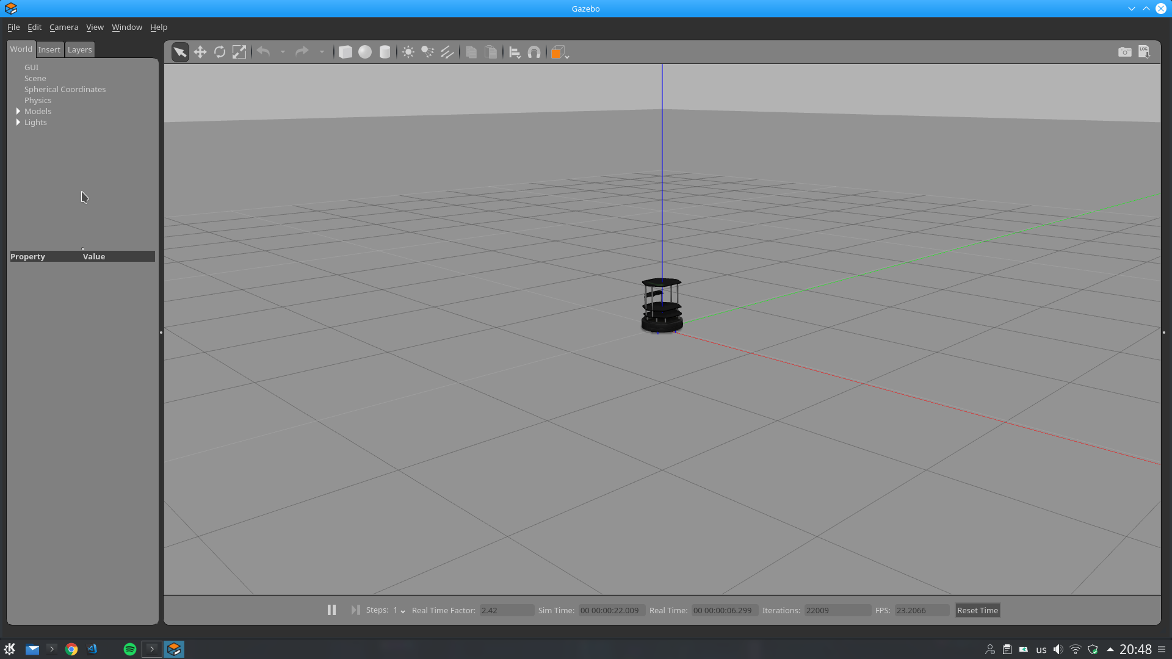
Figure 1 TurtleBot in Gazebo Simulator after first creation

There are three main objects in this project; sphere (Figure 2), cylinder (Figure 3), and quadrangular (Figure 4). However, many different objects are created throughout the experiments with different masses and volumes besides their shapes. Shapes of the objects are assigned randomly as integer values; ‘0’ describing sphere, ‘1’ describing quadrangular, and ‘2’ describing cylinder. The masses of the objects are assigned as random float numbers with the minimum of 0.1 and maximum of 10. The radiuses, edges and heights of the object (features vary from shape to shape), are also assigned randomly, with the minimum value of 0.1 and maximum value of 0.7. These parameters are passed to a function which edits an SDF file (Simulator Description Format: A file format which allows the objects and environments to be explained to the robot simulators, control and visualization [2]). The mass and shape features are edited and stored with the other necessary information in this file. Then, an object is created with SpawnModel service proxy. The initial location is set as the object’s closest point to the robot will be on location (x=0, y=0, z=0) and locate in the area of (+x, +y, +z). The model’s xml characteristics are set with the information from the previously mentioned SDF file. Then, the object is created with SpawnModel rospy service proxy.

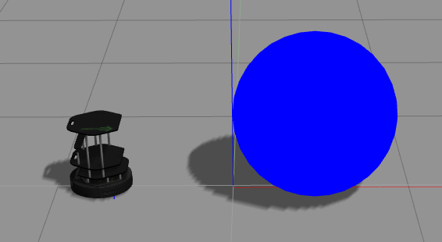
Figure 2 A sphere object after creation

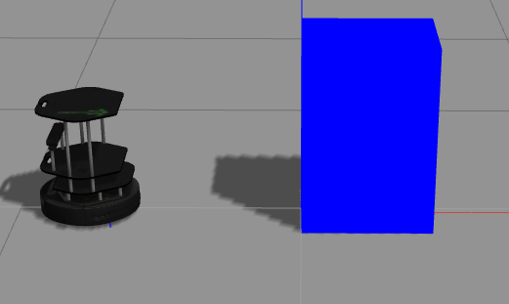
Figure 3 A quadrangular object after creation

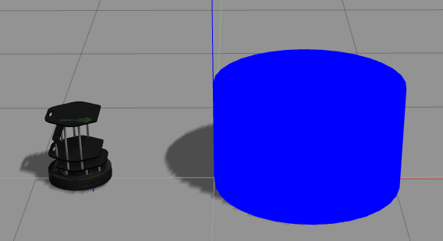
Figure 4 A cylinder object after creation

After an object’s movement is finished, the object is deleted from the environment with passing its name to DeleteModel rospy service proxy.
3.1 Motor Babbling

Motor babbling is described as irregular behaviors done by the robot to discover its surroundings [1]. In this project, it is used to represent the push manipulation action of the robot. Push manipulation is orienting a target through the action of pushing. To gather the necessary data, push manipulation is done randomly, in other words, push manipulation is applied with motor babbling.

To achieve the randomness in the action; shape, mass and radius/height/edge sizes of the object are assigned randomly in each execution. Also, the speed of the robot is assigned randomly between 1.8 and 2.2. Speed of the robot is sent to Gazebo with Twist function of the rospy publisher and push manipulation is actualized. Robot stops after the push and this part of execution is stopped after the object stops its movement. Movement of the object is determined with its twist linear position in x axis, and this information is gathered with GetModelState service proxy. Finally, the object is deleted with DeleteModel service proxy. Sample images of objects after push manipulation and just before deletion can be seen in Figures 5, 6 and 7.

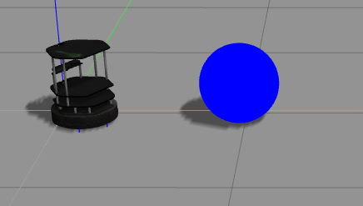
Figure 5 A sphere object after push manipulation

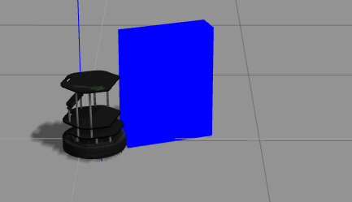
Figure 6 A quadrangular object after push manipulation

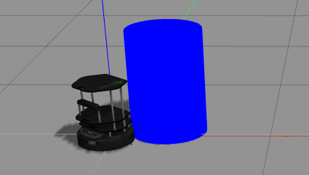
Figure 7 A cylinder object after push manipulation

This process is performed over and over, until the execution of the script is stopped.

3.2 Creating Dataset

The dataset is created with the values assigned to the variables during the execution, and the data extracted from gazebo with several service proxies.

There are two datasets which are created. One of them is for training purposes, the other is for testing. Each data in the datasets are real values that are gathered from executed simulation.

A dataset has 10 columns. First column has the value which describes the shape of the object (‘0’ for sphere, ‘1’ for quadrangular, and ‘2’ for cylinder, as mentioned before). Second and third columns have the robot’s initial location, x and y coordinates respectively. Fourth column has the robot’s speed which is assigned randomly. Fifth column has the volume, sixth column has the mass of the object. While seventh and eighth columns have the initial location of the object, ninth and tenth columns have the last location of the object, x and y coordinates respectively. Robot and object’s location data are extracted from gazebo with GetModelState service proxy.

Datasets are saved as CSV (Comma Separated Value) files to the system.

3.3 Models of Neural Networks

There

4 Experimentation Environment and Experiment Design

Two neural networks are trained to achieve this goal
5 Comparative Evaluation and Discussion

You should evaluate your system design in this section. How does your system compare with the approaches in the literature in terms of quantitative measurement. Evaluation criteria might change according to your system characteristics but you should present some kind of evaluation based on quantitative results. You should reference the goals and evaluation criteria presented in your interim report, discuss if your system is able meet them.

6 Conclusion and Future Work

You should summarize your project and present final remarks. It is also crucial that you include future work and possibilities to extend your design in the future.

7 References

IEEE style references should be used as follows. Please pay attention that books, articles, proceedings and web sites have specific styles.

[1] A. M. Turing, “On computable numbers, with an application to the
entscheidungsproblem,” Proceedings of the London Mathematical Society, vol.
s2-42, no. 1, pp. 230{265, 1937. [Online]. Available: http://dx.doi.org/10.1112/
plms/s2-42.1.230
[2] E. Adalı, Mikroişlemciler Mikrobilgisayarlar, Birsen Yay. 1998.
[3] M.Gökmen, A.K. Jain, "λτ-Space Representation of Images and Generalized Edge Detection," IEEE Trans.on Pattern Analysis and Machine Intelligence, vol.19, No. 6, June 1997, pp.545-563.
[4] O.Aliefendioğlu, R.Çölkesen, E.Harmancı, B.Örencik, "V42 bis Compression Performance", Proc. of 7th Int'l Symp. on Computer and Information Sciences (ISCIS VII), Kemer, Antalya, Nov. 2-4, 1992, pp. 549-552.
[5] Feza Buzluca, “Lecture Notes of Object Oriented Programming”, 2005,
http://www.buzluca.info/oop/slides.html

