

Nmap

1. Nmap Usage Demonstration

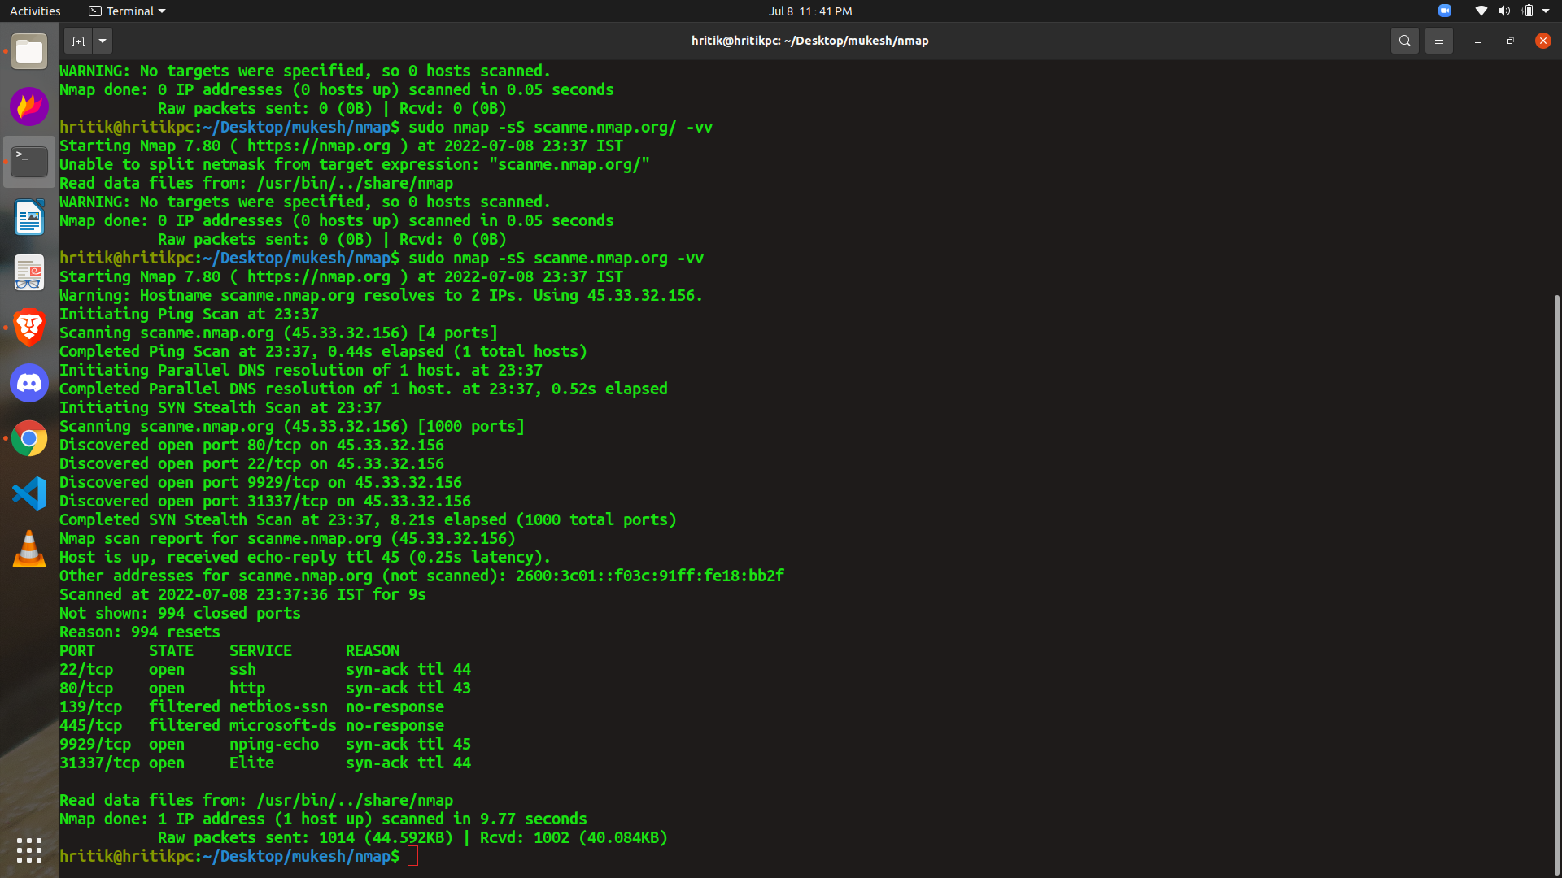

Typescript for nmap is attached with assignment