

Documentation

of version 1.0

Copyright (c) Creative Commons Attribution-Non-Commercial-Share Alike 3.0
info@bimserver.org
Changelog
Date | Description | Author
'2009-10-25 | Fresh start for 0.8 version | Léon van Berlo
'2009-12-21 | Updated screenshots | Léon van Berlo
'2010-03-05 | Changed version to 0.8.1 | Léon van Berlo
'2010-09-12 | Update to 1.0 | Léon van Berlo

WARNING NOTICE:
As the developers of the open source BIMserver we are very happy to develop this wonderful product for you and give it away for free. We do not like to write documentation for software. On the one hand because software should be intuitive, on the onther hand its just not fun.

When you would like to invest (a really small bit) in good documentation, please contact documentation@bimserver.org
Thank you!
Table of Contents
1 Introduction 7
1.1 First 7
2 Updating 9
2.1 From 0.1 9
2.2 from 0.8 9
2.3 from 0.8.1 9
3 Installation 11
3.1 standalone version 11
3.1.1 Requirements 11
3.1.2 Starting 11
3.1.3 Testing the installation 12
3.2 WAR file 14
3.2.1 Requirements 14
3.2.2 Starting 14
3.2.3 Testing the installation 15
3.3 Installation-issues 15
4 Getting started 17
4.1 Changing password 17
4.2 Starting a project 18
4.3 Uploading your first model 19
4.4 Download and/or Checkout 21
4.5 Authorize other users on your project 21
5 Advanced features 23
5.1 Querying a model 23
5.2 Using XML-Link and IFC-Link 23
5.3 Using your BIMserver as a product catalog 23
5.4 How to use ChangeSets 23
6 Configuring your server 25
6.1 Adding or deleting download formats 25
6.2 Configuring the registration settings 25
6.3 Configuring Query settings (ignore file) 25
7 Architecture 27
8 Advanced use 31
8.1 Using the SOAP client 31
8.2 Using the IFC Engine viewer 31
8.3 Using the Clash detection tool 31
9 What doesn't work 33

Introduction
This is the introduction.

First
Find introduction about the open source BIMserver on www.bimserver.org

Updating

From 0.1
Updating is impossible. Contact support@bimserver.org

from 0.8
Updating is impossible. Contact support@bimserver.org

from 0.8.1
Updating is impossible. Contact support@bimserver.org

Installation
There are two possibilities to install the bimserver: stand alone (with a build-in Jetty server) or deploy the WAR file (for example on a tomcat server).
This chapter will describe both options.

standalone version

Requirements
Download and install the latest Java version 6 on http://java.com/
Download the latest JAR file on http://download.bimserver.org/

Starting
Open the JAR file in a Java virtual machine (for most PC's the means that you just double click on it).
At some point in this process, you might be warned with a firewall message. Of course you should choose 'do not block'.
You get a small window called 'BIM Server Starter'.
When your computer has a lot of RAM memory (internal memory) you might want to change the memory settings for a better performance. We recommend a heap size of 1600m and a stack size of 1024k.
Choose your options (if you don't know what to do, don't change them) and click start.
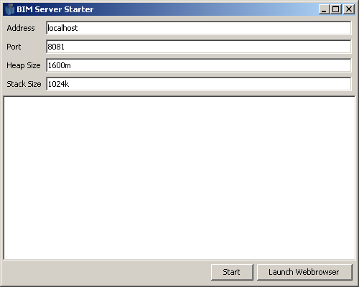Illustration 1: The stand-alone (JAR file) starter

The server will start the deployment and during this you will see some messages. There will be a database-directory deployed. At the end you will see 'org.bimserver.Server - Server started succesfully'. You are now running your own bimserver!
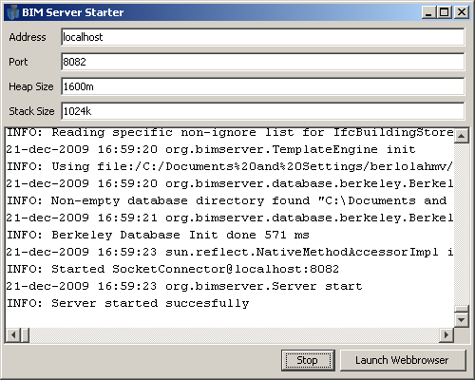Illustration 2: your server is running!

Testing the installation
Click on the 'Launch Webbrowser' button (next to the 'Start' button that is now showing 'Stop'). You will get the loginscreen. You can login as the administrator using admin/admin as the username/password.

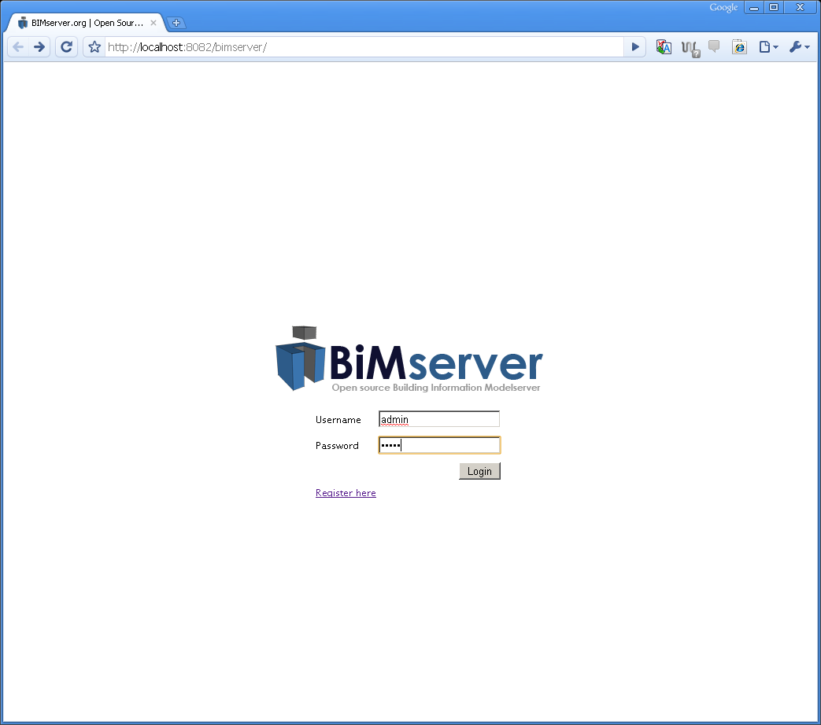Illustration 3: The login screen
You are now logged into your own BIMserver. It will look something like this:

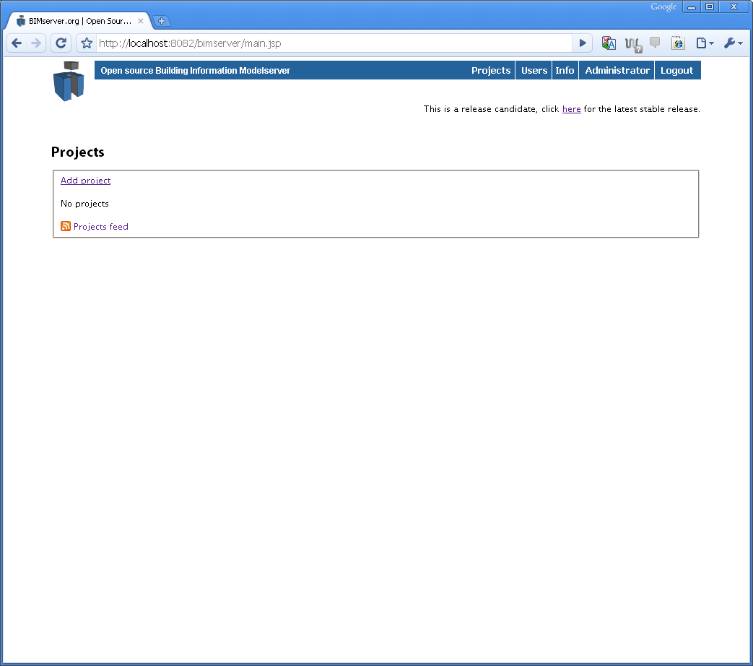Illustration 4: first time login

After your first login, make sure to change the default password into something else!

WAR file

Requirements
Download and install the latest Java version 6 on http://java.com/
Download and install the latest Tomcat on http://tomcat.apache.org/
Download the latest BIMserver WAR file on http://download.bimserver.org/

Starting
Make sure your tomcat JVM has enough memory to run BIMserver. We recommend a heap size of 1600m and a stack size of 1024k.
Deploy the WAR file in tomcat (if you don't know howto, read the tomcat instructions).
The starting of the bimserver takes about 20 seconds. There will be a directory deployed called 'database'.

Testing the installation
Open your favorite webbrowser and go to http://localhost:8080/bimserver-0.8/
Attention: when you run tomcat on a different port you should go to the other port. When you deploy a different filename (like bimserver-x.xxx) you should also use a different URL depending on the filename you deployed.
You will get the loginscreen. The loginscreen looks like Illustration 3. You can login as the administrator using admin/admin as the username/password.
You are now logged into your own BIMserver. It will look something like Illustration 4.
After your first login, make sure to change the default password into something else!

Installation-issues
My standalone server won't start (testing the installation doesn't give results). What's wrong?
When you are using windows (try ubuntu and/or) make sure the firewall isn't blocking the bimserver software and the port you run the software.
I get some strange errors when I try this new version. How about that?
You should delete the database of the old version, before deploying (starting) the new one.
There are some other strange errors... What's this all about?
Make sure you have enough memory available for your JVM. We recommend a minimum heap size of 1600m and a stack size of 1024k.

Getting started
Now that you are running your own BIMserver, you can get start using it. In this chapter we will guide you through the first steps of using it.

Changing password
First of all, you should change the administrator password to something not so default.
After login you should click on 'Administrator' in the top right corner of the screen. You will get the userdetails for the 'Administrator'-user. It will look like Illustration 5.

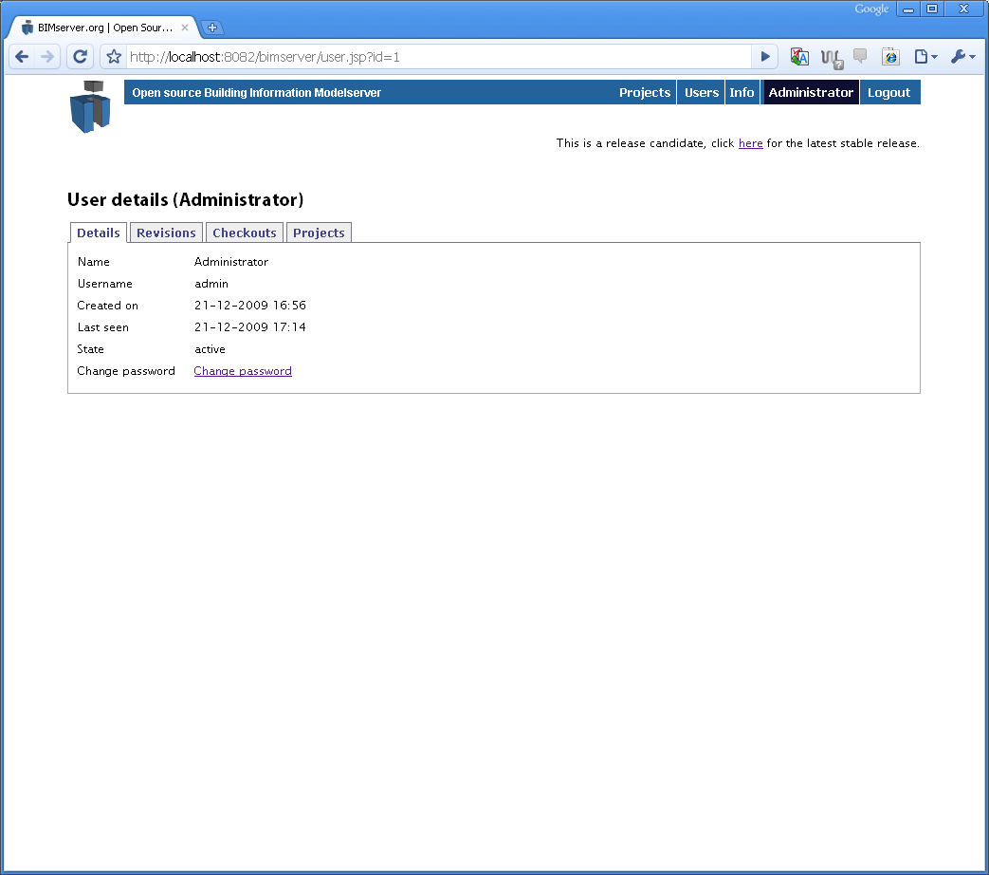Illustration 5: User details for 'Administrator'
Now click on 'Change password' and you will get another screen with 3 boxes. Fill in the old password ('admin') and your own chosen new password twice (to make sure you don't mistype) .
After this you will return to the Userdetails page again, and you will see a message
“Password succesfully changed”
After doing this, click on the BIMserver logo on the topleft and you will return to the main page (looking like Illustration 4).

Starting a project
As you can see, there are no projects in your BIMserver so far. You can start a new project by clicking 'Add project'. After clicking this you will be asked a project name. Give your project a name (for example 'first use').

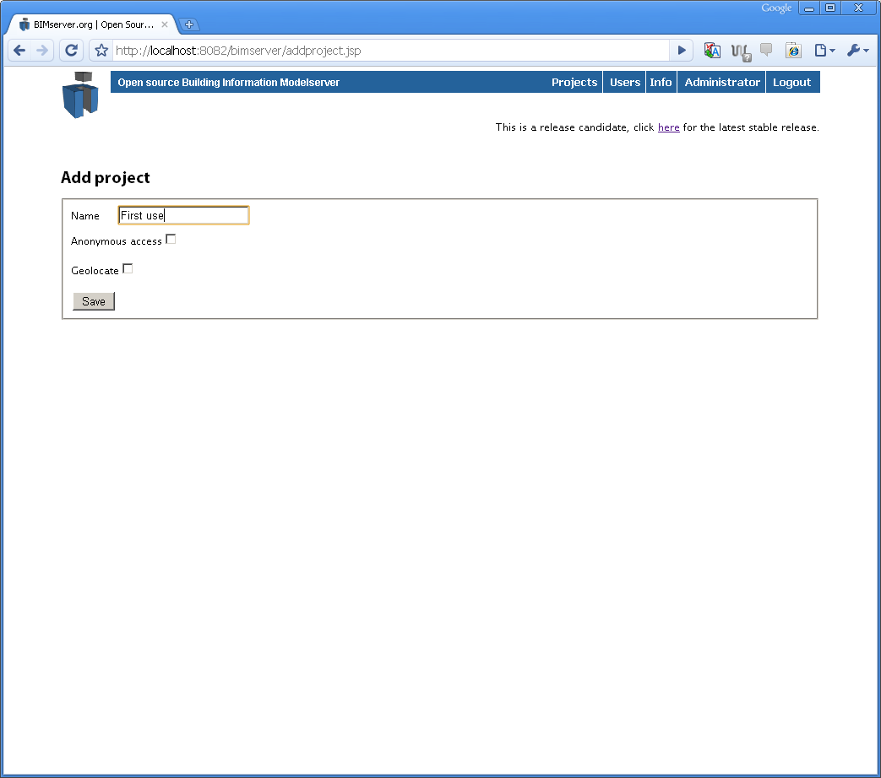Illustration 6: starting a project
Furthermore you can give your project 'anonymous access' and 'geolocate'.
When you check 'anonymous access' you give anonymous users the ability to view (parts of) your model. This can be handy to give people the Google-Earth-networklink for example to view the latest status of your project on Google Earth (without having to login). Advanced users can use the BIMserver as an object library by giving anonymous access.
When you click on 'Geolocate' some x,y,z fields appear. To geolocate your project, fill in in the x,y,z fields. These numbers are the real world placement coordinates of the building you are modeling. But just forget about them for a moment.
Click 'Save' to send your data.
The project is now being created in the database. After this is done you will get a screen that looks like Illustration 7.
Your can see the name, the date and time it was created, the user that created it, it's status (active), whether your project has anonymous access and a description.
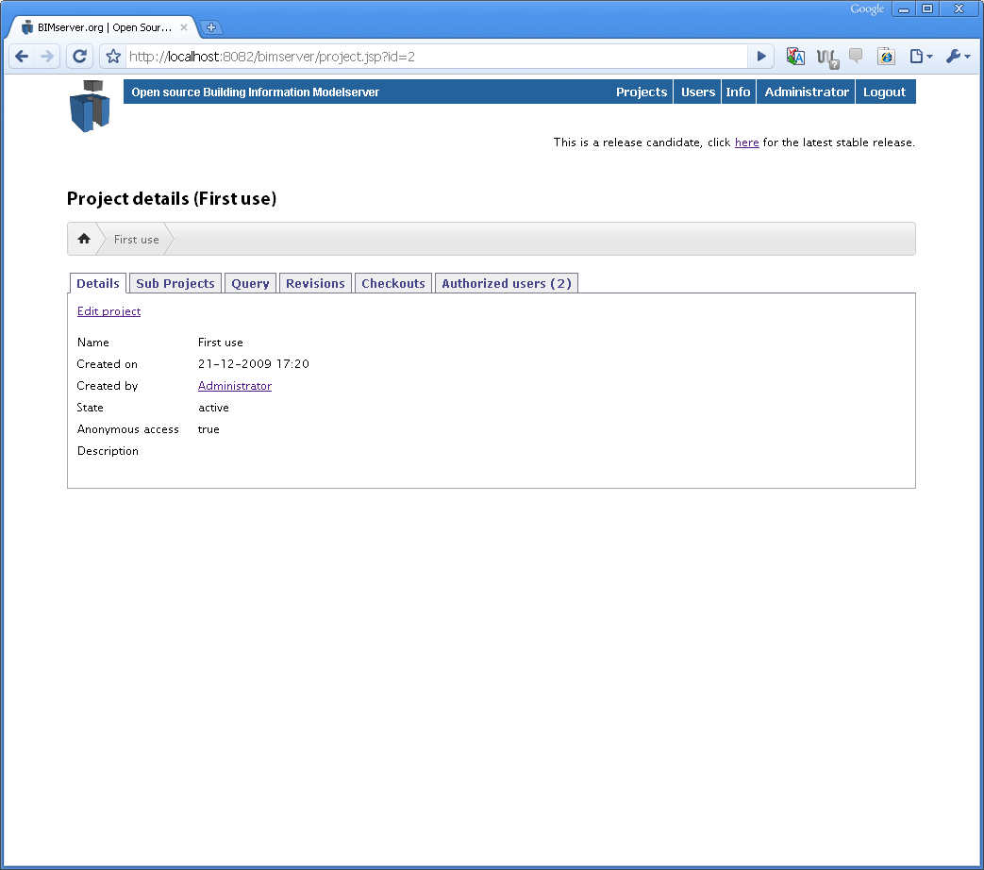Illustration 7: First project created
To change this data, click on 'Edit project'.
This screen has six tabs. You can explore the tabs by clicking on them. When you click on 'Revisions' you will see that there are no revision, same goes for 'Checkouts'. In the tab 'Authorized users' you can find the list of users that have authorization on this project. For now this is only one (the Administrator).

Uploading your first model
Your project is still empty. You have to make an initial upload of a model first. The most common way to do this is to upload an IFC file.
Do this by clicking on the 'Revisions' tab.

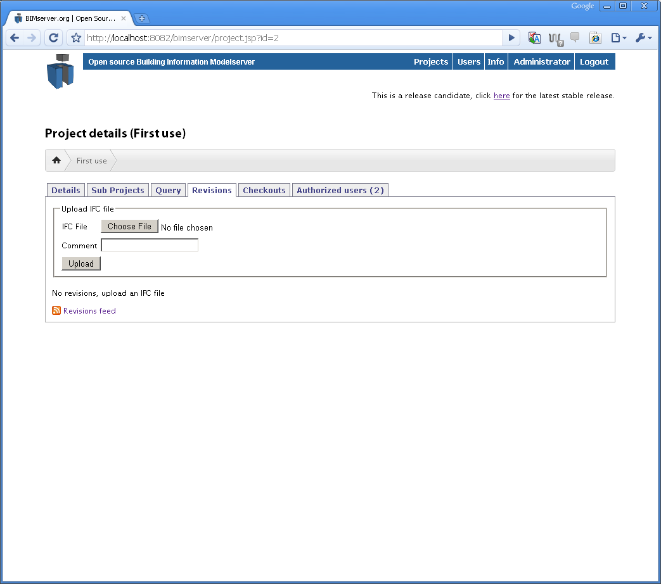Illustration 8: The revisions tab of a project.
Click on 'Choose File' after the 'IFC File' attribute. Now find a STEP file of an IFC model (normally recognizable by the .ifc extension). If you don't have such a file you can download some on www.ifcwiki.org or on download.bimserver.org.
Optionally you may fill in a comment in the 'Comment'-field. For example the text 'initial upload'.
After this click on 'Upload'. This may take a while, and your browser will give the notice that it is 'working' or 'in progress'.
After this is done your BIMserver will return a screen that looks like Illustration 9.
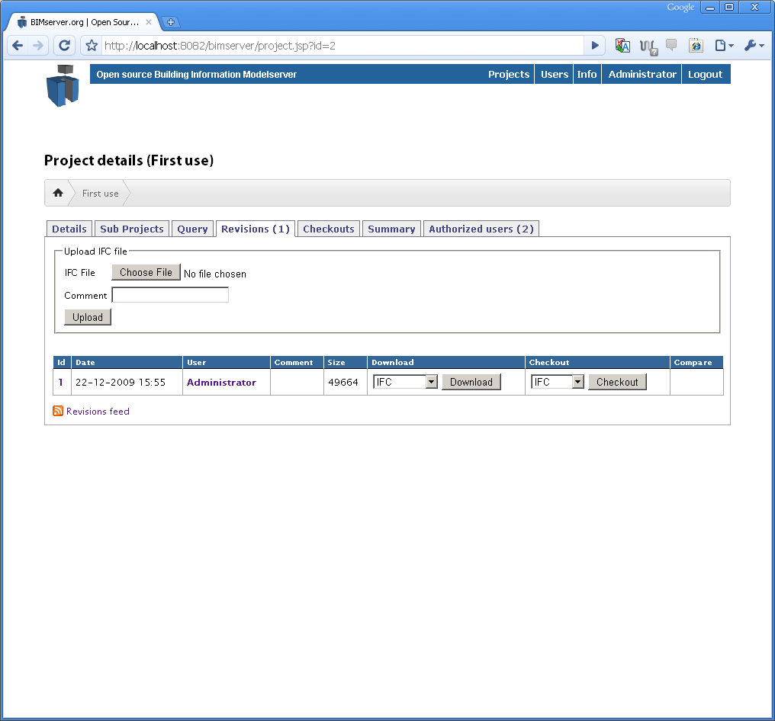Illustration 9: Project revisions (after first upload of an IFC file)

This screen shows you the revisions (which is only one for the moment) of the project. You see the revision ID, the date and time of the creation, the user that created it, the comment, the size (in Kb) and possibilities to download and checkout the revision.
Your first model is now in the database of your BIMserver!

Download and/or Checkout
You can now 'download' or 'checkout' your model in the format of your choice (IFC, or ifcXML for example).

Authorize other users on your project
To authorize other users on your project......

Advanced features

Querying a model
This is cool....

Using XML-Link and IFC-Link
This is cool....

Using your BIMserver as a product catalog
This is cool....

How to use ChangeSets
This is difficult....

Configuring your server

Adding or deleting download formats
This can be done by....

Configuring the registration settings
This can be done by....

Configuring Query settings (ignore file)
This can be done by...

Architecture
This chapter will describe the global architecture..
The global architecture looks something like this:
BerkeleyDB
Other CODB's
(Hbase, SimpleDB, BigTable)
Column Oriented Database
Service Layer
SOAP Stack
Other Database Types
Other Database
(IFC-File Based, OODB)
Interface (ColumnDatabase)
Interface (BimServerStore)
Has yet to be made
Interface (ServiceInterface)
Part of BIMServer.org
Clients
Programmatic Interfaces
Clients (see below)
UserInterface (web, ifc, rest-ish)

There are some different clients to interface with the bimserver:
BIM Server
Client
Web Browsers
IFC clients
(CAD Vendors, etc)
Other clients
(CAD Vendors, etc)
SOAP Stack
UserInterface
(webpages and/or REST)

A different view on the architecture (but basically the same):

Advanced use
Extra stuff for advanced users.

Using the SOAP client
Besides the Web-user interface, the BIMserver software also has a SOAP interface. You can explore this SOAP interface by using the special client.
Download the client from http://download.bimserver.org/
It will be a .jar file.

Using the IFC Engine viewer
tbc

Using the Clash detection tool
tbc

What doesn't work

The stuff that doesn't work is listed on the bugtracker at http://dev.bimserver.org

