**Design pattern in figure 7** This travel plan generator follows a **Builder + Strategy Pattern** approach:

* **User Input** is first collected, specifying preferences and requirements.
* The **TravelPlanDirector** orchestrates the plan creation process by managing the flow based on input.
* It **selects the appropriate TravelPlanBuilder**, which knows how to construct different types of travel plans (e.g., budget-friendly, luxury, adventure).
* The selected builder **applies a specific PlanStrategy** that defines how the travel plan is structured (e.g., fastest trip, most scenic route).
* Finally, the system **generates a complete TravelPlan** tailored to the user's needs.

This pattern promotes **flexibility**, **modularity**, and **easy extensibility** for supporting new types of plans or strategies in the future.

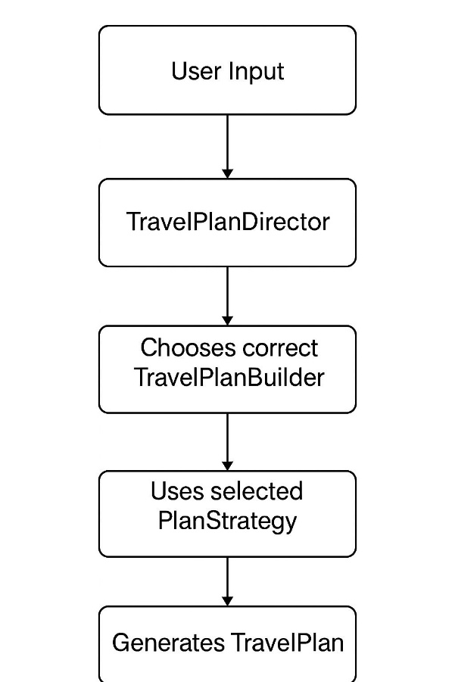

**Figure 7:** design pattern for Personalized Travel Plan Generator.