**The Entity-Relationship Diagram (ERD**)

**figure 4** represents the structure of the Personalized Travel Plan Generator system.  
It defines four main entities: **User**, **TravelPlan**, **Activities**, and **Destination**.

* A user can create multiple travel plans.
* Each travel plan is linked to a destination and can include various activities.
* Activities can be related to multiple destinations.

The ERD illustrates the relationships and essential attributes required to manage users, travel plans, destinations, and activities effectively.

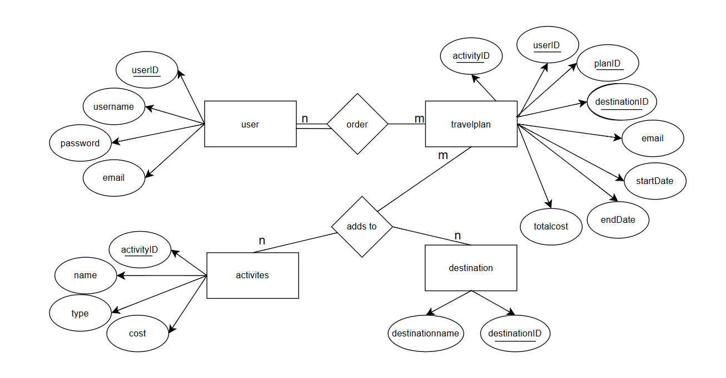

**Figure 4:** ERD for Personalized Travel Plan Generator.