**UML Class Diagram in figure5** models structure of the Personalized Travel Plan Generator system  
It includes five main classes:

* **User**: Manages user information and can create travel plans.
* **TravelPlan**: Links users, activities, and destinations with details like start and end dates and total cost.
* **Destination**: Represents travel destinations available for users to choose.
* **Activity**: Defines activities that users can add to their travel plans.
* **ServiceAPI**: Handles fetching real-time data for flights, activities, and destinations.

The relationships show how a user orders travel plans, and travel plans aggregate activities and destinations, while ServiceAPI supports the system with external data.

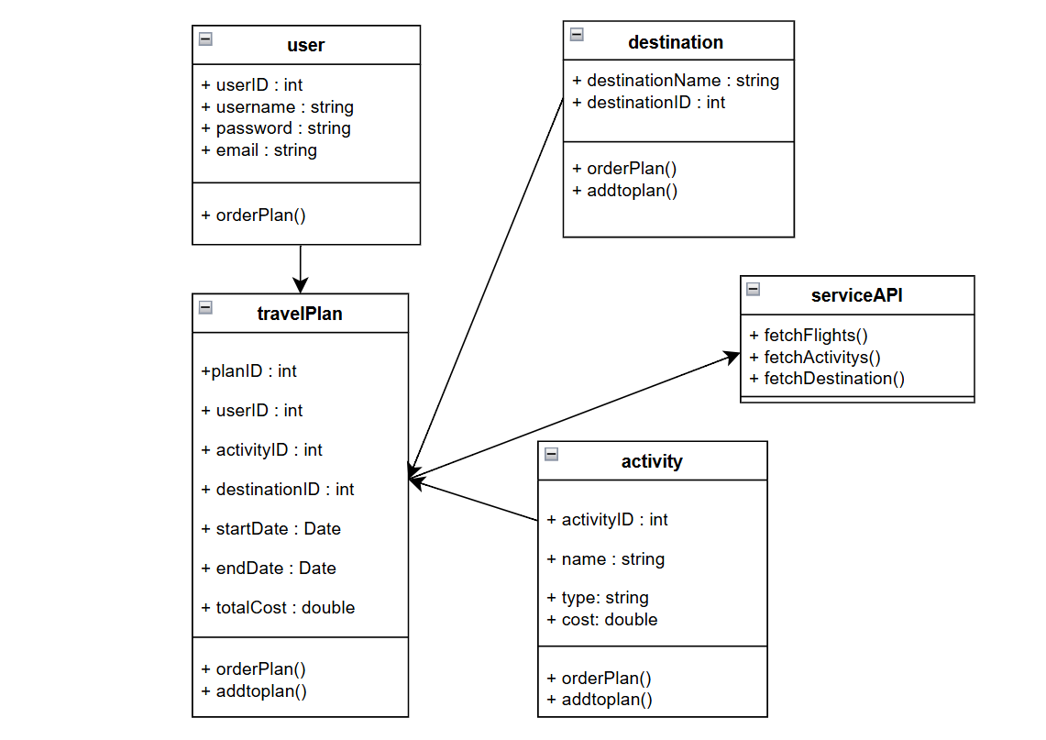

**Figure 5:** UML diagram for Personalized Travel Plan Generator.