**system architecture in figure 6** Personalized Travel Plan Generator consists of a frontend that captures user preferences and a backend that processes requests.

The backend interacts with a **Travel Plan Engine** responsible for generating customized itineraries based on user input. The engine accesses a **database** containing hotels, activities, and external data via web APIs.

Authentication is managed securely using **JWT (JSON Web Tokens)**. The architecture ensures modularity, scalability, and secure user interactions.

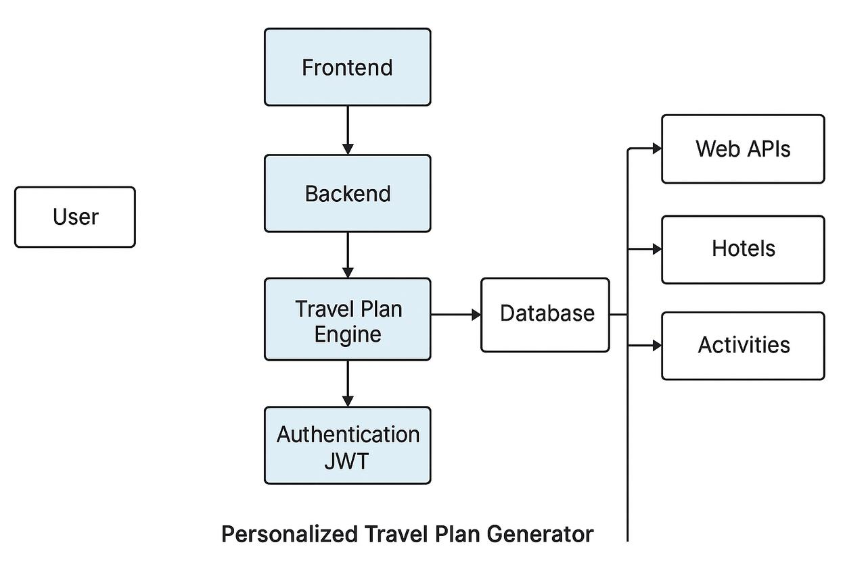

**Figure 6:** system architecturefor Personalized Travel Plan Generator.