问题说明：
1:
给server挂载volume的时候出问题了。
状态为in_use
但是无法查看卷的信息也无法删除卷。
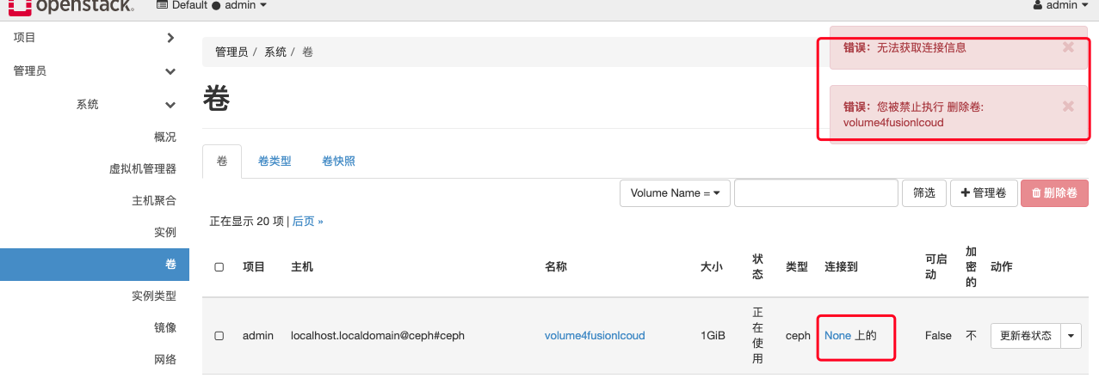

尝试删除server再处理删除卷失败。
此时查看卷的状态仍然为in_use

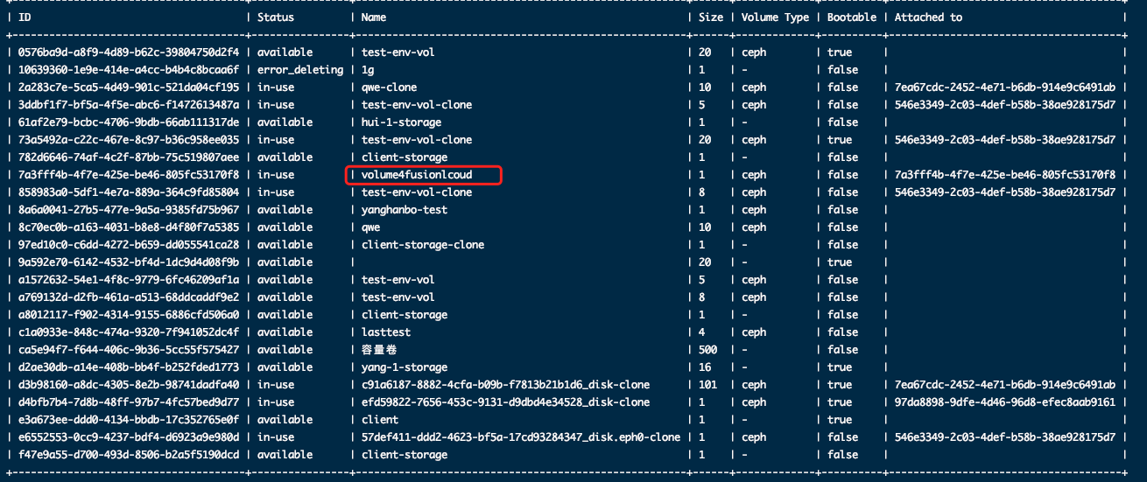
7a3fff4b-4f7e-425e-be46-805fc53170f8 | in-use | volume4fusionlcoud | 1 | ceph | false | 7a3fff4b-4f7e-425e-be46-805fc53170f8 |

https://www.jianshu.com/p/027f650bd79a?from=singlemessage

openstack volume delete volume4fusionlcoud

Failed to delete volume with name or ID 'volume4fusionlcoud': Invalid volume: Volume status must be available or error or error_restoring or error_extending or error_managing and must not be migrating, attached, belong to a group or have snapshots. (HTTP 400) (Request-ID: req-1597d062-0977-4f58-b20e-b30a2653b03d)
1 of 1 volumes failed to delete.

cinder reset-state 7a3fff4b-4f7e-425e-be46-805fc53170f8 --state available

cinder delete 7a3fff4b-4f7e-425e-be46-805fc53170f8

cinder reset-state 86645f-1b48-480d-9a32-ccf4c0dcd1 --state available
https://blog.csdn.net/weixin_34245082/article/details/92650015

