Distributed Honeypot Network with Tamper-Proof Blockchain Logging for Cyber Threat Intelligence
Hala Fouad, Fatma Mohamed, Marwan Khaled, Seif Sherbiny
Department of Cybersecurity
AASTMT
Cairo,Egypt
Abstract—Traditional honeypot systems operate in isolation, failing to provide a global view of cyber threats while remaining vulnerable to log tampering by sophisticated attackers or malicious insiders. This research presents a distributed honeypot network utilizing Docker containers running Cowrie SSH honeypots across multiple nodes. Attack data is collected via Filebeat and aggregated in an ELK Stack (Elasticsearch, Logstash, Kibana) for centralized analysis and visualization. A lightweight Python-based blockchain logger employing SHA-256 hash chaining creates tamper-evident records of attack events including source IPs, timestamps, and executed commands. The hash-chain verification mechanism ensures data integrity by detecting any unauthorized modification to stored threat intelligence. Results demonstrate successful deployment of three distributed honeypot nodes, real-time attack visualization through Kibana dashboards, and verified immutability of blockchain-secured threat records.
Keywords—Honeypot, Blockchain, Threat Intelligence, ELK Stack, Docker, Data Integrity, SHA-256, Cybersecurity

I. INTRODUCTION
Cyber threats continue to evolve in sophistication, making traditional security measures insufficient for early threat detection. Honeypots have emerged as valuable deception technology, deliberately exposing vulnerable services to attract attackers and study their behavior. However, conventional honeypot deployments face two critical limitations: they typically operate in isolation, failing to provide a comprehensive view of distributed attack patterns, and collected attack logs remain vulnerable to tampering by sophisticated adversaries or malicious insiders seeking to cover their tracks.
This research addresses both limitations by developing a distributed honeypot network with tamper-proof blockchain logging. The system deploys multiple Cowrie SSH honeypots as Docker containers, creating a distributed sensor network for attack data collection. The ELK Stack provides centralized log aggregation and visualization. Critically, a lightweight Python blockchain logger cryptographically secures threat intelligence records using SHA-256 hash chaining, ensuring data integrity and enabling detection of any unauthorized modifications.

II. METHODOLOGY

A. System Architecture
The proposed architecture consists of three integrated layers. The first layer comprises three distributed Cowrie SSH honeypot nodes deployed as Docker containers, each emulating SSH services on different ports to capture attack traffic. The second layer provides centralized log collection through Filebeat, which ships honeypot logs to Logstash for parsing and normalization, with structured data stored in Elasticsearch. The third layer implements a Python-based blockchain logger that creates immutable, cryptographically-linked records of attack events using SHA-256 hash chaining.
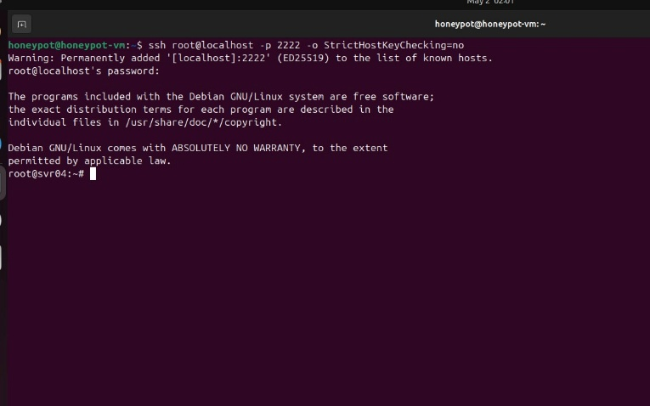Fig. 1. SSH connection test to honeypot node on port 2222.
Fig. 2. Complete system status showing all Docker containers running.

B. Honeypot Deployment
Three Cowrie honeypot containers were deployed using Docker Compose orchestration. Each honeypot emulates an SSH service with full logging of connection attempts, authentication requests, and executed commands. The containers are configured on ports 2222, 2223, and 2224, creating a distributed attack surface for threat data collection. The honeypots log all interactions including timestamps, source IP addresses, usernames, passwords, and shell commands, providing rich data for threat intelligence analysis.
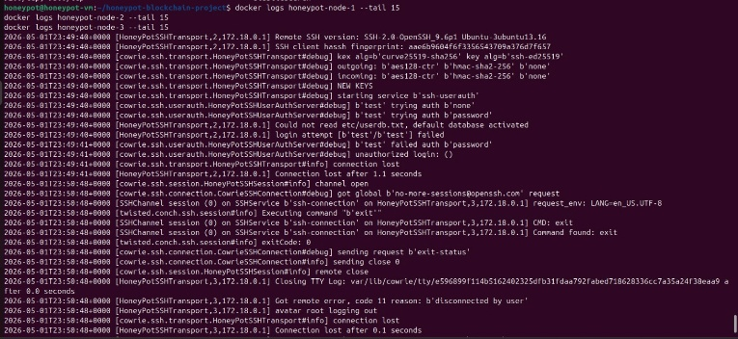Fig. 3. Honeypot logs showing captured SSH connection and login attempts.

C. Blockchain Logger Implementation
The blockchain logger implements a lightweight, tamper-evident data structure using SHA-256 cryptographic hashing. Each block in the chain contains an index, timestamp, attack event data, the previous block's hash, and its own computed hash. The genesis block initializes the chain, and each subsequent block is cryptographically linked to its predecessor through the previous hash field. Any modification to a block's data changes its hash, breaking the chain and enabling immediate detection of tampering. The implementation uses only the Python standard library (hashlib, json, datetime), requiring no external dependencies.
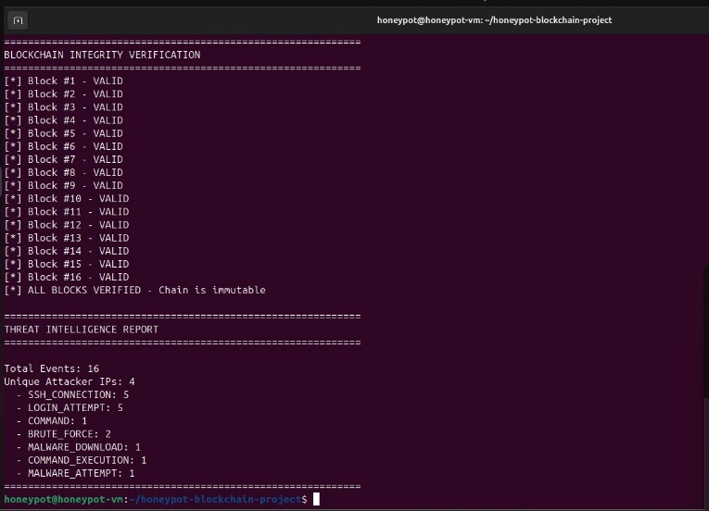Fig. 4. Blockchain logger output showing all blocks with SHA-256 hashes and verification status.

D. ELK Stack Integration
The ELK Stack provides centralized log analysis and visualization. Filebeat monitors Cowrie log directories and ships log entries to Logstash on port 5044. Logstash parses raw logs using grok patterns, extracting structured fields including timestamps, source IPs, usernames, passwords, and commands. Parsed data is indexed in Elasticsearch with daily index rotation (honeypot-logs-YYYY.MM.DD). Kibana connects to Elasticsearch for data exploration and dashboard creation, enabling security analysts to visualize attack patterns in real-time.
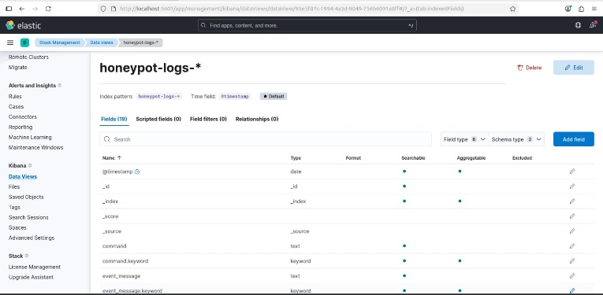Fig. 5. Kibana data view configured for honeypot log analysis.
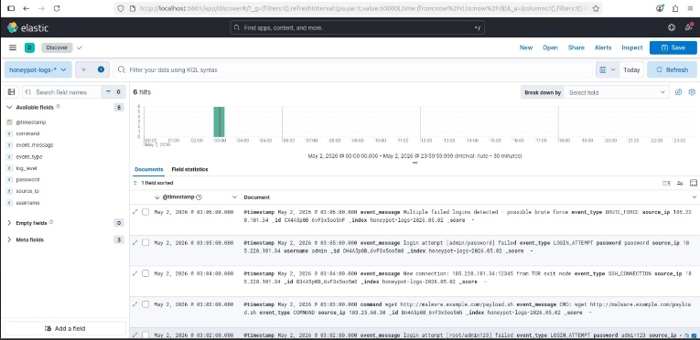Fig. 6. Kibana Discover showing attack event data from distributed honeypots.

III. RESULTS AND DISCUSSION

A. Attack Detection and Data Collection
The distributed honeypot network successfully captured simulated attack traffic during the testing phase. A total of 16 attack events were recorded from 4 unique IP addresses. The captured events included SSH connections, authentication attempts with various credential combinations, brute force attacks with multiple rapid login attempts, and attempted malware downloads. The ELK Stack successfully indexed 6 attack documents for visualization in Kibana, demonstrating the complete data pipeline from honeypot capture through centralized analysis.

B. Blockchain Integrity Verification
The blockchain integrity verification process confirmed that all 17 blocks in the chain were cryptographically valid and immutable under normal operation. To demonstrate tamper detection capability, specific blocks were artificially modified—changing attack details and source IP addresses. The verification algorithm immediately detected hash mismatches in the tampered blocks, confirming that any unauthorized modification of stored threat intelligence is reliably identified. This demonstrates the practical effectiveness of hash chaining for ensuring data integrity in distributed security systems.
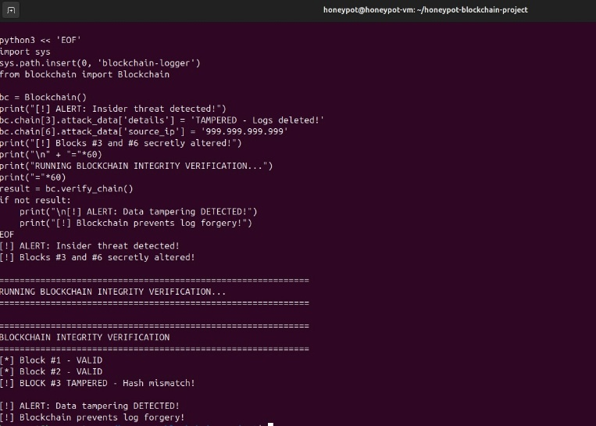Fig. 7. Tamper detection demonstration showing identification of modified blocks.

C. Threat Intelligence Capabilities
The integrated system provides multiple threat intelligence capabilities. The distributed honeypot architecture enables broader attack surface coverage compared to single-node deployments. Centralized log analysis through ELK Stack allows security analysts to correlate attack patterns across nodes. The blockchain logger ensures that threat intelligence records remain trustworthy and admissible for incident response and potential legal proceedings. The event distribution analysis revealed SSH connections and login attempts as the most common attack types, consistent with widespread SSH brute force scanning activity.

IV. CONCLUSION
This research successfully demonstrated a distributed honeypot network with tamper-proof blockchain logging for cyber threat intelligence. The system achieved three key contributions: distributed attack surface coverage using Docker-based Cowrie honeypots across multiple nodes, centralized log collection and analysis through the ELK Stack, and cryptographically verified data integrity through SHA-256 blockchain hash chaining. The tamper detection mechanism effectively identifies any unauthorized modification to stored threat records, ensuring the trustworthiness of collected intelligence. Future work could extend the system to include additional honeypot types (HTTP, database), implement a distributed consensus mechanism across multiple blockchain nodes for enhanced resilience, and integrate machine learning techniques for automated attack classification and threat actor profiling.

ACKNOWLEDGMENT
The authors acknowledge the open-source communities behind Cowrie honeypot, Elastic Stack, and Docker for providing the foundational tools that made this research possible.

REFERENCES
[1] Cowrie SSH/Telnet Honeypot. [Online]. Available: https://github.com/cowrie/cowrie
[2] Elastic Stack Documentation. [Online]. Available: https://www.elastic.co/elastic-stack
[3] S. Nakamoto, "Bitcoin: A Peer-to-Peer Electronic Cash System," 2008. [Online]. Available: https://bitcoin.org/bitcoin.pdf
[4] Docker Documentation. [Online]. Available: https://docs.docker.com/
[5] Python hashlib Documentation. [Online]. Available: https://docs.python.org/3/library/hashlib.html
[6] M. Young, The Technical Writer's Handbook. Mill Valley, CA: University Science, 1989.

