AI-Powered Procurement and Spare Parts
Document Intelligence System
Aligned with UAE Industrial Strategy 2030

Assessment | NLP Solution Design
Student Name | Hala Sarhan
Student ID | 5080307
Course | MAAI 902: Natural Language Processing and Large Language Models
Lecturer | Dr. Pallavi Ranjan
Code Repository | https://github.com/halakhalid8991/MAAI902_Assessment2_NLP_Solution_Design_Hala_Sarhan

- Abstract
This report presents an NLP system for procurement and spare parts management, designed in line with the UAE Industrial Strategy 2030 and Operation 300bn. Procurement teams handle purchase orders, supplier emails, maintenance reports and general correspondence by hand, which is slow, inconsistent and error prone. To address this, a pipeline was built in Google Colab on a Tesla T4 GPU and tested on a synthetic corpus of 550 documents across four document types, 137 of which carry OCR-style noise. Five classifiers were compared on TF-IDF features, and a Linear Support Vector Machine performed best, scoring 100% in cross-validation but 91.7% on templates it had never seen, which is the more realistic figure. A named entity recognition module combining regular expressions with gazetteer lookup extracts six entity types and reached an F1 score of 0.916 on noisy text. For retrieval, TF-IDF, MiniLM embeddings with FAISS and a hybrid Reciprocal Rank Fusion method were compared, and the hybrid gave the best Mean Reciprocal Rank of 0.681 over 30 queries. On top of this, a Qwen2.5-3B-Instruct model answers questions with source citations and refused all 15 off-topic or unanswerable test questions. Because the data are synthetic, the results show that the approach is feasible, not how accurate it would be on real documents, and this limitation is stated throughout the report.
- Introduction and Problem Definition
Procurement and spare parts management are central to industrial companies across the Gulf. Every day, procurement teams handle purchase orders, supplier emails, maintenance reports and general correspondence, and each one carries details that matter: costs, part numbers, delivery dates and supplier terms. The UAE’s industrial and logistics sector is growing quickly, supported by programmes such as Operation 300bn and the UAE Strategy for the Fourth Industrial Revolution, and the volume of documents is reaching the point where staff cannot review them all by hand. The result can be misclassified documents, missed reorder points, duplicate purchase orders and slow decisions, which in turn lead to production downtime and extra cost.
Enterprise resource planning systems work well with structured data, but they cannot understand the meaning of free text. Take an email that reads: “URGENT: gearbox GB 300 stock at the Jebel Ali Free Zone site is critically low; please raise an emergency PO." A person can quickly see the part, the location, the urgency, the action needed and the likely supplier. Doing this by hand for every document is slow, prone to error and dependent on what individual staff happen to know.
Natural language processing can take over much of this work. By combining document classification, named entity recognition (NER), sentiment and urgency analysis, and retrieval-augmented generation, procurement documents can be sorted, understood and searched automatically. This project builds such a pipeline and tests it on a reproducible synthetic dataset of 550 procurement documents. It is aligned with the UAE’s digital transformation goals: Operation 300bn aims to raise industrial GDP from AED 133 billion to AED 300 billion by 2031, and the Fourth Industrial Revolution Strategy prioritises AI-driven automation (UAE Government, 2021).
- Literature Review
The review discusses four topics that the project builds on. The first three are the NLP tasks in the pipeline: document classification, named entity recognition (NER) and retrieval-augmented generation (RAG). The fourth considers the procurement setting, including preprocessing and responsible use.

2.1 Document Classification in Domain-Specific Contexts
Text classification has undergone significant changes during the past decade. Early systems used bag-of-words features and support vector machines, while current ones use transformer models that take the meaning of the word itself into account. A review of various deep learning approaches for text classification and their comparison on more than 40 popular datasets is provided by Minaee et al. (2021). Such models do best on large corpora and require a lot of labelled data, which procurement documents tend not to have. Kowsari et al. (2019) survey the main classifiers and feature representations and outline their strengths and weaknesses. TF-IDF with a linear SVM is still a good choice for small, specialised datasets, as it is fast and its decisions are easy to explain, which is important when they need to be audited. The other side is also shown in the results of this project. Cross-validation accuracy was almost perfect, but it dropped on templates the model had not seen (Section 6.1), so a high score alone says little. With more data, pre-trained language models are the better path. Vaswani et al. (2017) proposed the transformer, based on self-attention. Then Sun et al. (2019) demonstrated how BERT can be fine-tuned for text classification, with state-of-the-art results on eight benchmark datasets. Wang et al. (2023) review how pre-trained models have evolved and where they are used. A classical model was kept here because the dataset is small. The obvious next thing to try would be to fine-tune a pre-trained model on real documents.

2.2 Named Entity Recognition for Technical and Procurement Domains
NER began with hand-written rules and statistical models like conditional random fields, and then moved to neural networks that learn entity boundaries from context. Li et al. (2022) trace this development in IEEE Transactions on Knowledge and Data Engineering, from BiLSTM-CRF models to BERT-based token classification and point out that external knowledge such as lookup lists (gazetteers) can be added to neural taggers. The architecture of Lample et al. (2016), a bidirectional LSTM with CRF decoding and character-level embeddings, is quite influential and should be able to deal reasonably well with part numbers and model codes. Neural taggers do require annotated training data, however, and none was available for this project. Rules and gazetteers are precise and easy to explain for items with a clear format, such as part numbers, dates and quantities, but break down when the text is corrupted, as the noisy text results in Section 6.2 show. The NER module is therefore built of regular expressions, gazetteers and keyword rules, each used for the entity types they are most suitable for and scored against gold labels.

2.3 Retrieval-Augmented Generation
Lewis et al. (2020) proposed retrieval-augmented generation, where a language model answers from passages retrieved from an external knowledge base instead of relying on its memory alone. They combined a dense passage retriever with a sequence-to-sequence generator and obtained state-of-the-art results on open-domain question answering, with more factual answers. This project follows the same idea. Three retrievers (sparse TF-IDF, dense MiniLM embeddings searched with FAISS, and a hybrid of the two) pass their results to the Qwen2.5-3B-Instruct model (Qwen Team, 2024), which generates the final answer.
Gao et al. (2023) survey the field and differentiate naive, advanced and modular RAG. They take retrieval quality as central and measure it with metrics such as hit rate and Mean Reciprocal Rank, both of which are used in Section 6.3. Dense retrieval is shown to outperform BM25 for open-domain question answering by Karpukhin et al. (2020). For many procurement questions, the queries are keyword-rich and the vocabulary is stable, so sparse techniques such as TF-IDF can still do well. For that reason, the two types of retrievers were compared, and neither was assumed to be better than the other. Sentence embeddings (Reimers and Gurevych, 2019; Wang et al., 2020), Reciprocal Rank Fusion (Cormack et al., 2009) and FAISS (Johnson et al., 2019) make this workable on a small corpus. Language models can also produce fluent statements not supported by any source (Ji et al., 2023), so the system includes a refusal gate and grounding checks, described in Section 5.4.

2.4 Procurement Context, Preprocessing and Responsible Use
Unlike normal text, procurement documents have a lot of meaning embedded in brief codes and abbreviations. Part names, model codes and terms like PO, ETA and MOQ tell the buyer what is needed, so the prototype expands abbreviations and leaves behind part codes intact before modelling. The survey of text classification methods by Kowsari et al. (2019) informed the choice of TF-IDF features with linear models as the baseline for document typing. Decisions on suppliers, inventory and payments must also be available for audit. Barredo Arrieta et al. (2020) survey explainable AI, including post-hoc methods such as LIME and SHAP, and this project favours transparent methods and answers that cite their source documents for the same reason. The survey of sentiment analysis methods by Wankhade, Rao and Kulkarni (2022) provides background for the keyword-based urgency and sentiment checks on supplier emails. To summarise, the studies above cover document classification, entity recognition, retrieval-augmented generation, and the background for explainability and sentiment analysis. This project brings them together in one pipeline for procurement documents and evaluates it at prototype scale on synthetic data.

3. Input Data Description
The pipeline implemented in this project used a synthetic dataset of 550 procurement records, generated using Python with a fixed random seed (42), ensuring that every execution of the notebook produces the same data. Synthetic documents were used because the publicly available procurement datasets reviewed from Kaggle contain structured records (item, supplier, quantity, price) and not the running text that classification, extraction, sentiment and retrieval require. The records also provided gold labels for each task, keeping the evaluation free of confidential supplier and company data. The vocabulary nonetheless reflects industrial spare parts work, with 15-part types (for example, hydraulic pump HP 200 and gearbox GB 300), nine suppliers, six items of equipment and five UAE sites, including Dubai Logistics Hub and Jebel Ali Free Zone. Table 1 presents the composition of the corpus and the gold labels stored with each document.
Document Type | Records | Share | Typical Content | Gold Labels Stored
Purchase Order | 150 | 27.3% | Part, quantity, supplier, delivery date, priority tag | Entities, urgency level
Supplier Communication | 150 | 27.3% | Order status updates: confirmed, delayed, on hold | Entities, true sentiment
Maintenance Report | 150 | 27.3% | Equipment failure at a site and replacement part | Entities
General Correspondence | 100 | 18.2% | Mixed notes mentioning parts and suppliers | Entities
Total | 550 | 100% | 137 documents (about 25%) carry OCR-style noise | 4 document types
Table 1: Synthetic Procurement Corpus — Composition and Gold Labels
Each document type has nine templates (sentence structure), and these templates are designed to use overlapping vocabularies. Parts, suppliers and purchase order references are common to many document types, so it is not possible to rely on a single keyword to identify a document type. Purchase orders include part, quantity, supplier, delivery date, and priority tag. Supplier communications record the order status (confirmed, delayed, or on hold). Maintenance reports detail an equipment failure at a site and the replacement part. General correspondence mentions suppliers, parts or procurement topics without requesting or confirming a transaction. All documents are tagged with gold labels: type, entity values, urgency level for purchase orders, and true sentiment for supplier communications. Inspection is replaced by the ability to score each module using precision, recall and accuracy.
Three features of the data were included to make the evaluation more difficult and honest. First, each document is tagged with its pattern number so that classifiers can be trained on patterns 0 to 6 and tested on patterns 7 and 8, which they have never seen. This is different from generalising and from memorising the wording of a pattern. Second, supplier communications were created with a 15% probability of being a mixed case, where a positive status is followed by a negative detail (e.g., “shipped ahead of schedule” followed by a 15% price increase). Third, 25% of the corpus included a mixture of clean and noisy text; around 137 of the 550 documents include OCR-style noise (for example, “Internat1onal” or “5orting Machine"). The purpose of this is to simulate the character substitution errors common in scanned procurement documents. The clean original is kept along with the noisy one so that each module can be scored on both. This design has a limitation; text generated from templates is more regular and shares optimistic results than real procurement documents; therefore, all scores in this report are more optimistic than would be achieved in a live deployment. Yet, the unseen-template and noisy-text tests introduced in Section 6 helped reduce this gap but didn’t close it completely.

3.2 Data Validation
Because the corpus is generated by code, it was checked automatically before any model was trained. Fifteen pass/fail checks were run on the 550 documents, and two further checks were reported for information only. The checks confirmed that all nine sentence patterns were used in all document types, that there were no missing values, empty documents, or unfilled placeholders, and that the expected class sizes (150 purchase orders, 150 supplier communications, 150 maintenance reports, and 100 general correspondence documents) were met. Label quality was assessed by verifying that each gold entity value appears in the document's text, that suppliers and sites originate from the specified lists, that quantities (7 to 499) and dates (2024 to 2025) fall within the anticipated ranges, and that each purchase order has an urgency label and each supplier communication has a sentiment label. Out of the fifteen checks, fourteen were successful.
On the other hand, one check failed because 137 records of the dataset were originally flagged as noisy, but the noise process altered the text of only 110 of them, because each character was changed with a low probability. The remaining 27 flagged documents are identical to their clean originals. The informational checks showed 19 repeated texts (531 unique), which is expected with nine sentence patterns and a small vocabulary, and 10 supplier communications in which apologetic wording appears next to a positive status, caused by one pattern whose opening is independent of the randomly chosen status. Lastly, two records per type resulted in eight records of the dataset being printed at random for manual inspection. These checks demonstrate that the data is accurately labelled and internally consistent, but they do not demonstrate that the content is like actual procurement contracts.

4. Preprocessing and Embedding Techniques
Text preprocessing is the crucial bridge between the raw content and the numerical representation needed by the machine learning model. This pipeline applies three cleaning operations designed to reduce noise while preserving the tokens that matter in procurement language, followed by two kinds of numerical representation: sparse TF-IDF vectors for classification and dense sentence embeddings for retrieval.
The first operation is text cleaning: conversion to lowercase, minimising repeated whitespace, and removal of special characters while retaining letters, digits, and basic sentence punctuation. It is worth mentioning that part codes such as "HP 200" and "GB 300" remain unaltered, as they represent a vocabulary utilised by procurement organisations. The second operation is abbreviation expansion. A domain map converts short forms into their full meaning, for example, "po" to "purchase order", "eta" to "estimated time of arrival", "moq" to "minimum order quantity", "bom" to "bill of materials", and "cnc" to "computer numerical control", so that abbreviated and spelt-out versions of the same word share one representation. The third operation removes common English stop words while preserving domain terms. Entity extraction and sentiment analysis, however, run on the original text, not the cleaned one, since capitalisation, punctuation and exact spelling carry information needed by those tasks.
The feature extraction uses a TF-IDF vectorisation in a scikit-learn pipeline, with a maximum number of features set of 5,000, the token mode used as unigram and bigram, the minimum document frequency of 2 and the maximum document frequency of 95%. Placing the vectorizer inside the pipeline means that it is fitted only on training data in every cross-validation fold; fitting it on the whole corpus first would leak test vocabulary into training and inflate accuracy. For retrieval, a separate sparse TF-IDF index was constructed with 3,000 features over the enriched text of each document. The use of TF-IDF for the classifier is deliberate since it is lightweight, deterministic, and provides immediately interpretable feature weights that help with debugging and audit.
The second representation is a dense embedding. It uses the sentence-transformers model all-MiniLM-L6-v2 to encode each document and its extracted metadata as 384-dimensional vectors that encode meaning rather than exact phrasing (Reimers and Gurevych, 2019; Wang et al., 2020). Encoding is done on Tesla T4 GPU and takes 1.7 sec for all 550 documents. These are normalised vectors stored in an FAISS inner product index; therefore, similarity is identical to cosine similarity. Both representations were kept intentionally because sparse vectors are better for exact part code matching, while dense vectors are better for paraphrased question matching, as illustrated in section 5.4.

5. NLP Pipeline and Architecture
The pipeline consists of six sequential stages: synthetic data generation, text preprocessing, document classification, named entity recognition with sentiment and urgency analysis, hybrid retrieval-augmented generation with a language model, and evaluation. Figure 1 illustrates the full architecture with data flows between components. The embedding model and the language model run on the GPU; the remaining modules are lightweight and run on the CPU.
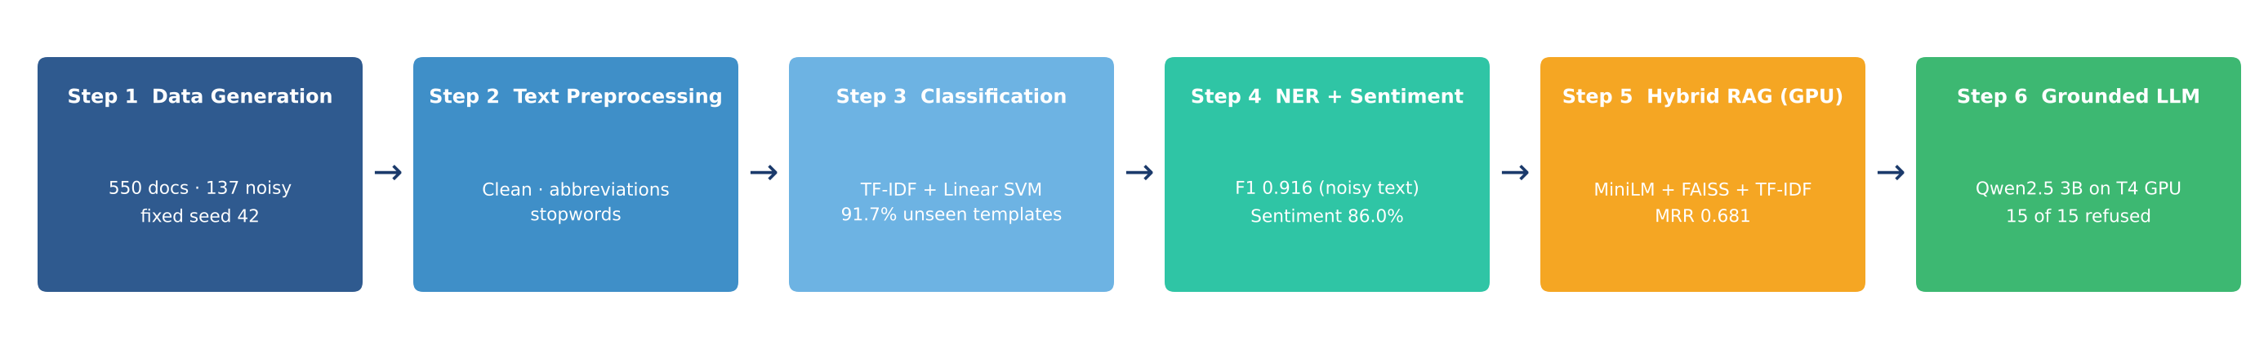
Figure 1: NLP Pipeline Architecture: Six-Step Document Intelligence Flow

5.1 Document Classification
Document classification is the basic problem of proactively deciding which category a document falls into: purchase order, supplier communication, maintenance report or general correspondence. Each document type has a different semantic vocabulary and structural profile, so downstream components need reliable classification to use the correct extraction patterns or retrieval strategies.
Five classification models were tested in the same scikit-learn pipeline (a TF-IDF vectorizer and then the classifier): Logistic Regression, Linear Support Vector Machine, Multinomial Naive Bayes, Random Forest and Gradient Boosting. Each was tested under three different protocols. The first is the usual measure, five-fold stratified cross-validation. The second is an unseen-template test, where models train on templates 0 through 6 and are tested on templates 7 and 8; this is the honest test, as the model has not seen those sentence structures. The third evaluates accuracy on the 137 noisy documents. The results are summarised in table 2 and figure 2.
Model | 5-Fold CV | Unseen Templates | Noisy Docs
Linear SVM (selected) | 100.0% | 91.7% | 100.0%
Logistic Regression | 100.0% | 86.2% | 100.0%
Naive Bayes | 99.6% | 86.2% | 99.3%
Random Forest | 100.0% | 82.6% | 100.0%
Gradient Boosting | 99.3% | 56.0% | 98.5%
Table 2: Classification Model Performance Comparison (550-document corpus, three evaluation protocols)

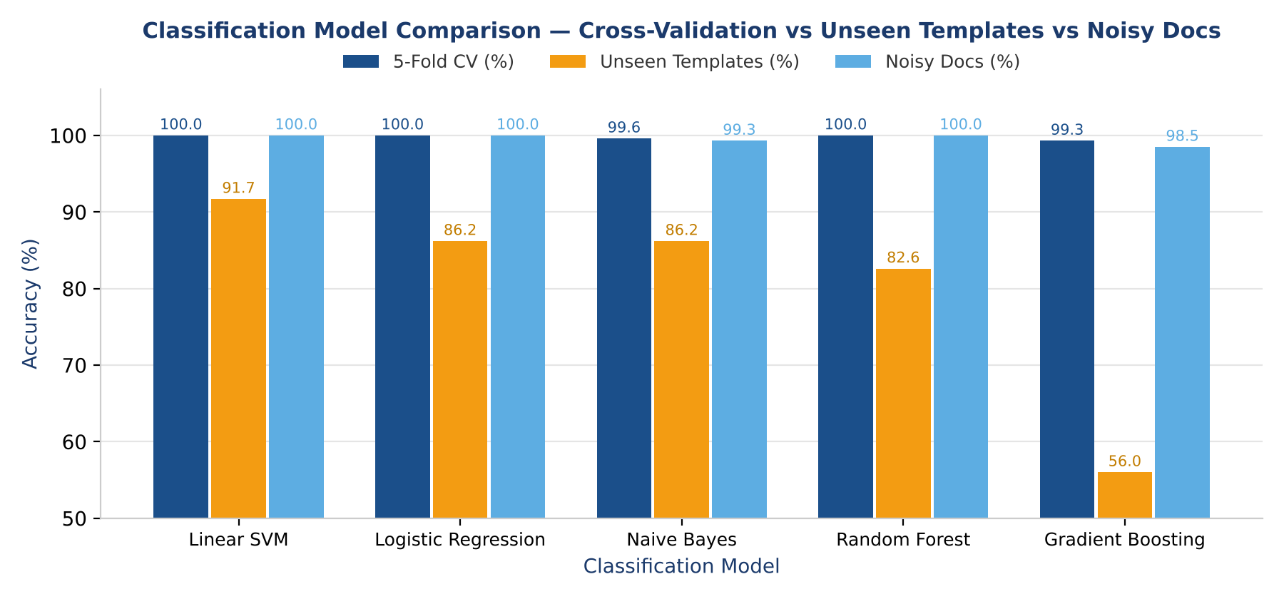
Figure 2: Classification Model Comparison: Cross-Validation vs Unseen-Template vs Noisy-Document Accuracy
All five models scored between 99.3% and 100% in cross-validation; however, the Linear SVM had the highest unseen-template accuracy (91.7%). Since the same templates occur in both training and test data, cross-validation on this corpus mostly assesses memorisation of template text, and a random 80/20 split also yielded 100%. The models are significantly separated by the unseen-template test: Gradient Boosting dropped to 56.0%, Random Forest to 82.6%, and Logistic Regression and Naive Bayes to 86.2%. This shows that the tree ensembles memorised template text rather than learning transferable vocabulary. Seven out of eighteen test papers were predicted to be supplier communication, making general correspondence the SVM's poorest class (recall 0.56). Since that class was designed to share supplier and component vocabulary with the other types, this is to be expected. The unseen-template figure is better planning guidance than the 100% cross-validation score because accuracy for real documents will rely on how closely they resemble the training data. Additionally, the SVM was chosen as the production contender because explainability is supported by its feature weights, which can be examined to reveal which words distinguish each class (Kowsari et al., 2019).

5.2 Named Entity Recognition
Named entity recognition transforms the classifier's output into structured intelligence by identifying and labelling the specific entities within each document. For procurement documents, the entities of interest are the part being ordered or repaired, the supplier, the quantity, the delivery date, the site, and the equipment concerned.
The NER module employs a hybrid architecture of regular expressions and gazetteer lookup. Regular expression patterns address entities with predictable structural forms: dates in several formats and quantities in several phrasings ("120 units", "310x", "qty: 145", "Ordering 275 gearbox GB 300 components"). Gazetteer lookup applies exact-match search against curated lists of known entities: nine supplier names, five UAE sites, six items of equipment, and fifteen-part descriptions. Urgency is detected separately by keyword rules (Section 5.3). Scoring against gold labels exposed one weakness during development: the first quantity pattern missed phrasings such as "Ordering 275 gearbox GB 300 components", and adding a third pattern raised clean quantity recall from 0.914 to 1.000.
Entity Type | Method | Clean F1 | Noisy Recall | Noisy F1
PART | Regex + gazetteer | 1.000 | 0.872 | 0.920
SUPPLIER | Gazetteer | 1.000 | 0.779 | 0.876
QUANTITY | Regex | 1.000 | 0.940 | 0.962
DATE | Regex | 1.000 | 0.974 | 0.987
SITE | Gazetteer | 1.000 | 0.782 | 0.878
EQUIPMENT | Gazetteer | 1.000 | 0.822 | 0.902
MICRO AVERAGE | Hybrid | 1.000 | 0.853 | 0.916
Table 3: NER Evaluation Against Gold Labels — Clean Text vs 137 Noisy Documents
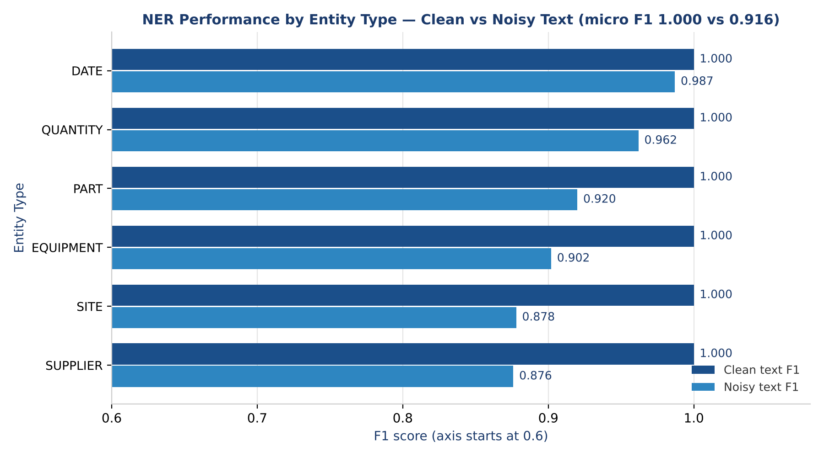
Figure 3: NER Performance by Entity Type: Clean vs Noisy Text (F1)

The NER module's precision, recall, and F1 of 1.000 for each of the six entity types on clean text are expected since all the names used to generate the data are contained in the gazetteers; this number should not be interpreted as actual performance. The noisy test on 137 documents yielded an interesting result: micro precision remained high at 0.989, while recall dropped to 0.853, resulting in an F1 of 0.916. Because exact matching cannot recover a malformed string, the technique seldom extracts incorrect entities but misses misspelt ones, such as "PartsPro Internat1onal", "Jebel Ali Free one", or "5orting Machine SM 3". Dates (0.974) and amounts (0.940) were the most resilient, but supplier (recall 0.779) and site (0.782) names suffered the most since these multi-word names are shattered by a single letter error. The degradation of rule-based extraction on noisy text is consistent with the arguments in Section 2.2, and fuzzy matching is motivated as the initial production enhancement.

5.3 Urgency and Sentiment Detection
The operational tone of procurement communications is addressed by urgency and sentiment detection, both implemented as transparent keyword rules. Supplier sentiment (positive, negative or neutral) is determined by counting indicator phrases: “confirmed” and “ahead of schedule” for positive, “delayed”, “on hold” and “backordered” for negative, and “being processed” for neutral. The share of matched indicators that belong to the winning class is reported as a confidence value. Purchase order urgency (ROUTINE, HIGH or CRITICAL) is determined from cues such as “production line halted”, “urgent” and “no rush”. Both modules were evaluated against gold labels: sentiment accuracy was 86.0% over 150 supplier communications, and urgency accuracy was 100% on both clean (150) and noisy (39) purchase orders. The urgency result should be read with care, because the generated documents contain exactly the cue phrases that the rules search for.
Urgency detection supports prioritisation. Procurement teams can order their workload by operational risk and not by queue position, because a purchase order with a critical urgency flag can be escalated automatically for faster processing. Negative supplier tone may also signal delays before they cause downtime. The 14 negative emails predicted as positive were all deliberately mixed cases, and the 7 neutral emails predicted as negative all contained the word “regret”, which is on the negative indicator list. The average confidence of 0.91 is higher than the 86.0% accuracy justifies, so it would need calibration before being shown to users.

5.4 Retrieval-Augmented Generation
The retrieval-augmented generation element transforms the 550 records of the dataset into a knowledge repository that personnel may interrogate in natural language, obtaining responses with source references rather than manually sifting through papers. It comprises three tiers: a retrieval tier featuring three rival retrievers, a refusal gate that prevents an answer when the documents lack support, and a GPU-implemented language model that formulates the answer based on the recovered documents.
Due to the briefness of the dataset, each gets indexed in its entirety along with the corresponding information. The trio of retrievers consists of a sparse TF-IDF index (3,000 features, utilising cosine similarity); a dense index comprising all-MiniLM-L6-v2 embeddings (384 dimensions) queried via FAISS; and a hybrid approach that integrates the two rankings through Reciprocal Rank Fusion (k = 60), favouring documents that are highly ranked by both without necessitating the adjustment of their disparate scoring systems (Cormack et al., 2009). The assessment of retrieval was conducted on 30 queries pertaining to components, vendors, locations, and apparatus, with relevance determined by the gold labels, utilising Hit@1, Hit@3, Mean Reciprocal Rank (MRR), and Precision@5 (Section 6.3).
Responses are produced using Qwen2.5-3B-Instruct (Qwen Team, 2024) utilising half precision on the Tesla T4 (6.3 GB of GPU memory, taking four to six seconds each response). The prompt includes solely the five most relevant documents, and the model is required to respond using these, citing them numerically, while otherwise stating, “Information not found in the available documents.” Three mechanisms constrain hallucination, the primary hazard of unfounded generation (Lewis et al., 2020; Ji et al., 2023). A refusal gate bypasses the model if the optimal dense similarity is beneath 0.53, a criterion derived from the data, where relevant enquiries achieved a minimum of 0.68 and irrelevant questions a maximum of 0.37. A grounding verification ensures that each entity in a response is present in the referenced documents, whereas a citation verification guarantees that every cited figure corresponds to a sourced document.
A unique function, process_document(), along with a Gradio web application, presents the entire workflow via three tabs: analysing an individual email or document (type, entities, urgency, sentiment, and analogous documents), batch uploading of .txt, .eml, or .csv files into a unified results table, and querying the documents with citations or denials. The demonstration processes plain-text emails and the unformatted content of .eml files, although it does not interface with a mailbox or access attachments.

6. Evaluation and Results
Every module was scored against the gold labels generated with the data, using precision, recall and F1 where ground truth exists and standard information retrieval metrics for retrieval. The section ends with a cross-component scorecard.

6.1 Classification Evaluation
The classification was evaluated under three protocols (Table 2). In five-fold cross-validation each model achieved between 99.3 and 100%, and an 80/20 random split also resulted in 100% for the Random Forest, because the same templates are present in both training and test data. The realistic result is the unseen-template accuracy: Linear SVM achieved 91.7% on templates 7 and 8, which were not utilized in training. On the 137 noisy documents it got 100%, because most discriminative vocabulary survives a few character errors. General correspondence had recall of 0.56, with 7 of 18 documents predicted as supplier communication, because this class was planned to share part and supplier vocabulary with the other types. Gradient Boosting demonstrates how a high cross-validation score can disguise weak generalization: 99.3% in cross-validation but only 56.0% on unseen templates.

6.2 NER, Urgency and Sentiment Evaluation
NER was scored against the gold entities stored with each document (Table 3). On clean text, precision, recall and F1 were all 1.000 across the six entity types. On the 137 noisy documents, micro precision was 0.989, micro recall 0.853 and F1 0.916. Date extraction was the most robust (F1 0.987), followed by quantity (0.962) and part (0.920), while equipment (0.902), site (0.878) and supplier (0.876) names were most affected, because one corrupted character defeats exact gazetteer matching. For example, “PartsPro Internat1onal” was missed for PartsPro International, and “Jebel Ali Free one” for Jebel Ali Free Zone. This motivates fuzzy matching as a production enhancement. Urgency detection reached 100% accuracy on both clean and noisy purchase orders, which reflects the explicit urgency phrases in the templates and should not be assumed for real documents. Sentiment accuracy over the 150 supplier communications was 86.0%. Of the 21 errors, 14 were negative emails predicted as positive, all of them deliberately mixed emails in which a positive phrase sits beside a negative one, and 7 were neutral emails predicted as negative because they contained the word “regret”. The average confidence of 0.91 is higher than the accuracy justifies.

6.3 RAG Retrieval Evaluation
Retrieval Method | Hit@1 | Hit@3 | MRR | P@5
TF-IDF (sparse) | 0.600 | 0.667 | 0.662 | 0.433
Dense (GPU + FAISS) | 0.433 | 0.800 | 0.597 | 0.340
Hybrid (RRF) | 0.567 | 0.767 | 0.681 | 0.440
Table 4: Retrieval Quality Metrics Across 30 Evaluation Queries (relevance taken from gold labels)
There is no single retriever that wins on all the metrics. Dense retrieval most often places a relevant document in the top three (Hit@3 0.800) but ranks it first less often (Hit@1 0.433) than TF-IDF (0.600). The hybrid method has the highest MRR (0.681) and Precision@5 (0.440), although its advantage over TF-IDF is small with only 30 queries. By document type, TF-IDF scored an MRR of 1.000 on maintenance queries and 0.812 on purchase orders, where exact part codes decide relevance, but only 0.173 on supplier communications, where dense retrieval scored 0.733 because supplier emails are worded in many ways. This is the vocabulary mismatch problem of sparse retrieval, and it agrees with Karpukhin et al. (2020), who found that dense retrieval helps most on reworded queries. The hybrid method scored 0.950 on maintenance, 0.703 on purchase orders and 0.388 on supplier communications.

6.4 Grounded Generation and Hallucination Tests
Generation was tested on 15 in-scope questions, 10 off-topic questions (for example a football result) and 5 in-domain but unanswerable questions (for example the price of a part that does not exist in the data). The last two groups test whether the system invents an answer when it should decline, the main ethical risk of generative models in daily operations. No in-scope question was wrongly refused, every answer was entity-grounded (100%) and citation precision was 86.7% (maintenance reports 0.933, supplier communications 0.900, purchase orders 0.767, where many near-identical orders exist). All 10 off-topic and all 5 unanswerable questions were refused (Table 5). The grounding check verifies entities but not the relationships between them, so a correct entity attached to the wrong order would not be caught.
Measure | Result
In-scope questions wrongly refused (n = 15) | 0.0%
Entity grounding of answers | 100.0%
Citation precision (cited documents truly relevant) | 86.7%
Off-topic questions refused (n = 10) | 100.0%
In-domain but unanswerable questions refused (n = 5) | 100.0%
Table 5: Grounded Generation and Hallucination Tests (Qwen2.5-3B-Instruct with refusal gate)

6.5 Pipeline Health Scorecard
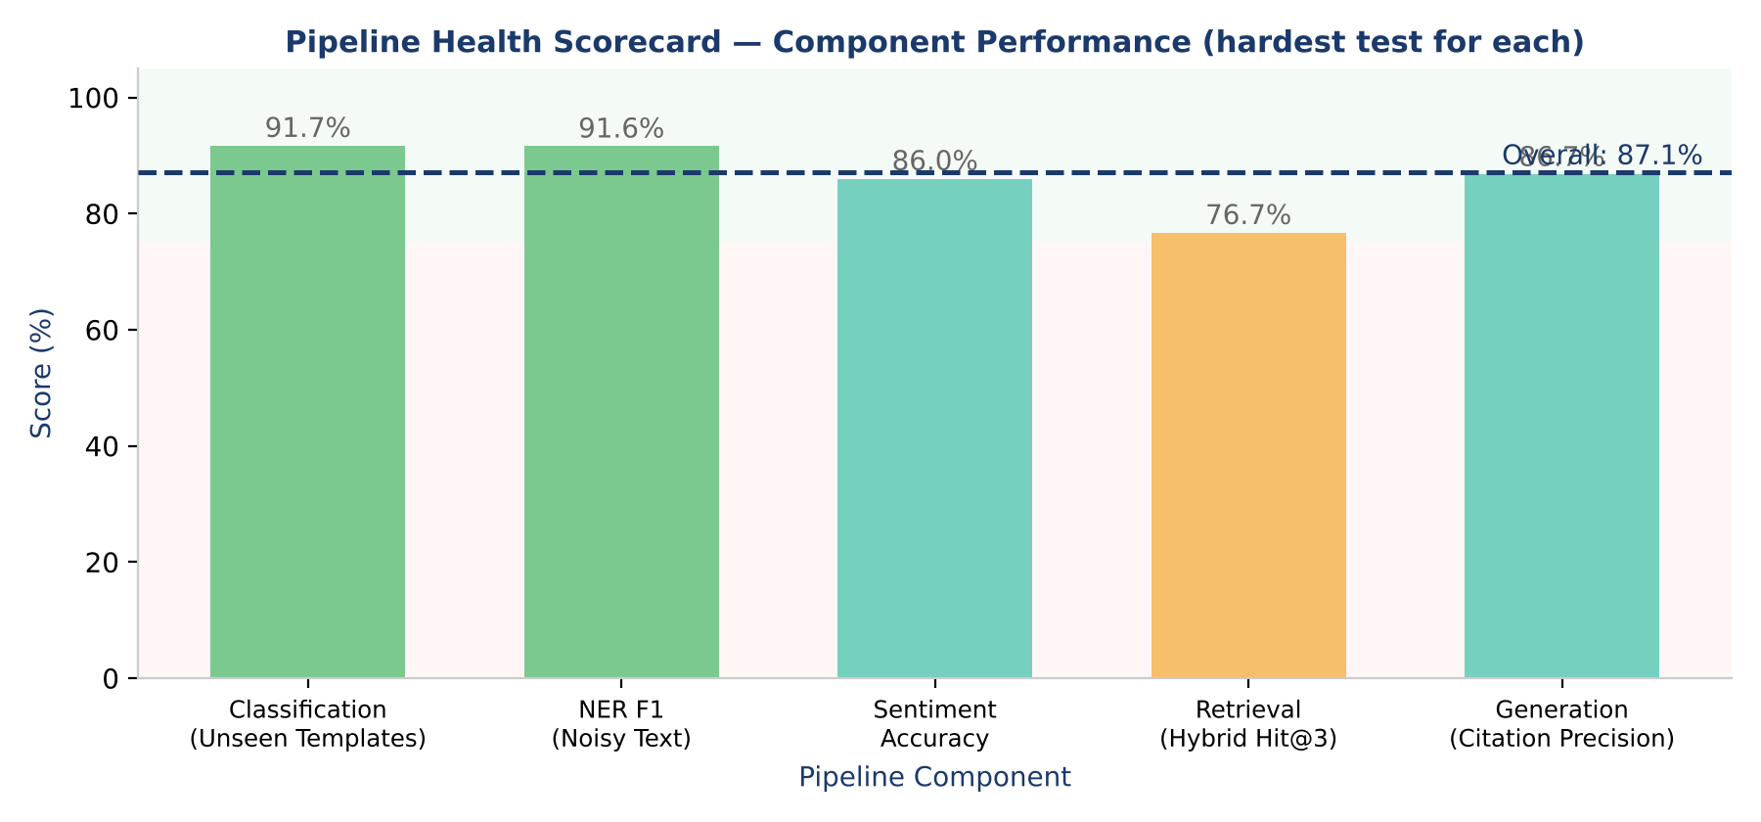
Figure 4: Pipeline Health Scorecard — Component Performance with Colour-Coded Grade Bands

Pipeline Component | Score | Weight | Assessment
Document Classification (Unseen Templates) | 91.7% | 25% | Good: linear SVM generalises; general correspondence is the weak class
Named Entity Recognition (Noisy F1) | 91.6% | 25% | Good: precision 0.989, but recall falls to 0.853 on noisy text
Sentiment Analysis (Accuracy) | 86.0% | 10% | Fair: mixed emails cause 14 errors; confidence is overstated
Retrieval (Hybrid Hit@3) | 76.7% | 20% | Fair: hybrid MRR 0.681; no single retriever wins on every query type
Grounded Generation (Citation Precision) | 86.7% | 20% | Good: all 15 off-topic or unanswerable questions refused
OVERALL PIPELINE | 87.1% | 100% | Good
Table 6: Pipeline Health Scorecard — Weighted Component Assessment (weights are the author's judgement)

7. Tool Stack and Platforms
The prototype was developed in Python with open-source tools. The development environment was Google Colab with its Tesla T4 GPU. Table 7 shows the full tool stack, separating the tools utilized in the present prototype from the production-ready alternatives identified for the upgrade path. This transparency is vital for both reproducibility and for the practical handoff from research prototype to production system.
Tool / Library | Role | Justification
scikit-learn | Prototype | TF-IDF vectorisation, five classification models, five-fold cross-validation, sparse retrieval. Industry-standard, well-documented, lightweight
NumPy and Pandas | Prototype | Seeded synthetic data generation, data handling, and computation of evaluation metrics
Regular Expressions (re module) | Prototype | High-precision pattern-based extraction of dates and quantities. Fully deterministic and easy to inspect
Google Colab (Tesla T4 GPU) | Prototype | Free GPU runtime that runs the embedding model and the language model. Shareable notebook that reproduces every result
PyTorch and Hugging Face Transformers | Prototype | GPU model execution in half precision. Runs Qwen2.5-3B-Instruct in 6.3 GB of GPU memory (Wolf et al., 2020)
sentence-transformers (all-MiniLM-L6-v2) | Prototype | 384-dimensional dense embeddings encoded on the GPU in 1.7 seconds for 550 documents
FAISS (CPU) | Prototype | Inner-product similarity index for dense retrieval. CPU is ample at 550 vectors; GPU indexes suit larger collections
Qwen2.5-3B-Instruct | Prototype | Instruction-tuned language model for grounded, cited answers. Fits a free T4 GPU in half precision
Gradio | Prototype | Web demo with email and document analysis, batch file upload, and a question-answering tab, launched from the notebook
GitHub | Prototype | Version control, well-commented code, and README for reproducibility. Supports submission requirements
Fine-tuned transformer NER (spaCy or Hugging Face) | Production | Replaces rules to close the noisy-text recall gap (0.853). Requires an annotated real-world corpus
Falcon LLM (TII UAE) | Production | UAE-developed open-source language model from the Technology Innovation Institute. Reinforces UAE 2030 alignment and data sovereignty
Table 7: Tool Stack : Prototype Implementation and Production Upgrade Pathway
The prototype employs conventional machine learning, where it works well (TF-IDF with linear models for classification and rules for structured entity extraction), and GPU-hosted transformer models were meaning matters (dense embeddings and answer generation). The design is based on one principle: interpretable, reproducible components come first, and larger models are introduced only where they provide a demonstrable value. The GPU is confirmed at notebook start-up (Figure 5), encoding the embeddings and running the language model, while the FAISS search runs on the CPU, which is sufficient at this corpus size. LangChain was not utilized since the retrieval and prompting phases are short enough to write explicitly, which keeps the logic visible. Qwen2.5-3B-Instruct was selected due to its ability to follow instructions properly and fit into the free T4 GPU. A natural update is the Falcon model from the UAE’s Technology Innovation Institute (Almazrouei et al., 2023). The Falcon model would serve the sovereignty and self-reliance goals of the UAE National AI Strategy 2031 and Operation 300bn (UAE Government, 2021).
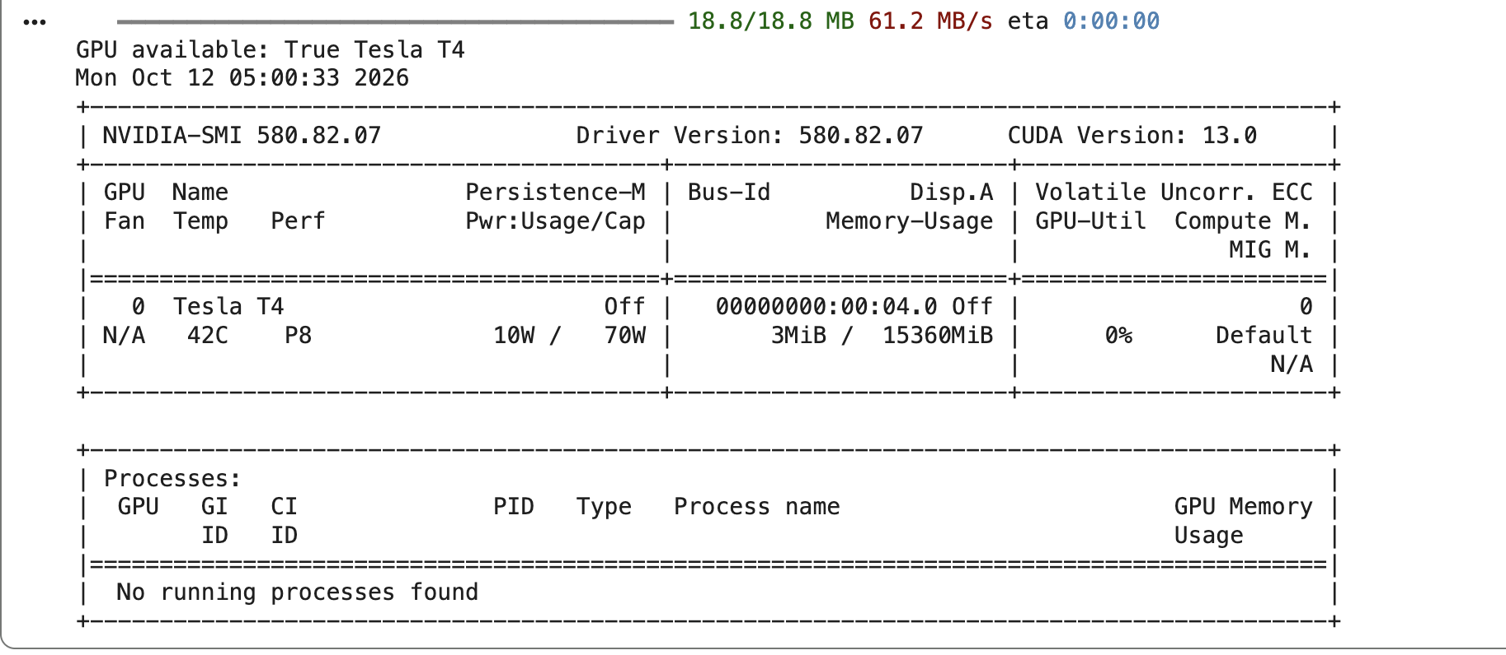
Figure 5: GPU Confirmation from the Notebook — Tesla T4, CUDA Available

8. Ethical Considerations and Mitigation Strategies
Procurement decisions really matter to money, operations and people. A misclassified invoice might delay a supplier’s payment, a biased entity extraction may penalize some suppliers, and a hallucinated answer may lead to an incorrect purchase order. These hazards informed the design of the system from the start, not added at the end.

8.1 Data Privacy and UAE PDPL Compliance
The UAE Personal Data Protection Law (PDPL), Federal Decree-Law No 45 of 2021, applies to any organisation that handles personal data in the UAE and imposes data protection obligations on them. Procurement documentation will commonly include names, email addresses and job titles of employees. The prototype bypasses the problem because all its data is synthetic and generated without any reference to a real person, so it’s not dealing with any sensitive or confidential information. A production system would require more. Email addresses and personal names would be disguised before being seen by any model, extracted personal entities would only be utilised for the procurement procedure they were collected for, and access control and audit logging would be introduced. Running a modest open language model on the organisation’s own infrastructure, rather than transferring documents to an outside service, also limits data exposure.

8.2 Bilingual Processing and Arabic Language Bias
In the UAE procurement communication is often bilingual, with technical English terminology used alongside Arabic organisational terms, supplier names and regulatory references. The prototype handles English only, so a document written mainly in Arabic would be classified wrongly, and its entities would be missed. This is more than a technical gap. Arabic documents from smaller local suppliers could be mishandled more often than English ones, which would work against UAE SMEs. The upgrade path covers this with multilingual sentence-transformer models (for example paraphrase-multilingual-MiniLM-L12-v2) and Arabic-adapted NER models, with results compared across languages to check that performance is even.

8.3 Supplier Fairness in Automated Classification
A classifier tends to do best on the documents it resembles most. If large suppliers write in a style close to the training data, documents from smaller suppliers may be misclassified more often, causing delays, wrong entities and possibly poor purchase decisions. The current system only partly addresses this. The unseen-template and noisy-text tests measure performance on wording the model has not memorised and on corrupted text, which is more honest than reporting the cross-validation score alone. In production, accuracy should also be tracked by supplier type and document origin so that unfair patterns show up early, in line with the responsible AI principles of Barredo Arrieta et al. (2020).

8.4 Hallucination Control and Human-in-the-Loop Oversight
Hallucination is the biggest ethical risk in the RAG component: an answer that sounds confident but is not supported by the retrieved documents. Because the prototype uses a generative model, the risk was tested directly. Four controls are in place: every answer must cite its source, a refusal gate stops the model when the best dense similarity falls below a threshold, a grounding check confirms that every entity in an answer appears in the cited documents, and a fixed reply (“Information not found in the available documents.”) is used when no answer is supported. In testing, all 10 off-topic and all 5 unanswerable questions were refused, no in-scope question was wrongly refused, entity grounding was 100% and citation precision was 86.7%. These results come from small test sets, and the threshold was set on the same queries, so they show that the controls work in principle but say little about real documents. The system is also built to keep people in charge of important decisions. It flags critical stock-outs, picks out urgent purchase orders and finds related supplier communications, but raising a purchase order, approving a payment or contacting a supplier always needs a person’s authorisation. This matches the emphasis on human oversight and explainability in the responsible AI literature (Ribeiro, Singh and Guestrin, 2016; Barredo Arrieta et al., 2020).

9. Value Proposition and Expected Output
The pipeline offers four kinds of business value that address the operational challenges outlined in Section 1.
The first is automated document triage. With 91.7% accuracy on templates it had never seen (and 100% in cross-validation and on noisy text), the Linear SVM could route most incoming purchase orders, supplier emails, maintenance reports and correspondence to the right workflow without manual review, with a person checking the uncertain cases. As an illustration only, since no time study was undertaken, saving 10 minutes of manual sorting on each of 200 documents a day would free more than 33 staff-hours per day.
The second is structured entity extraction. Six entity types (parts, suppliers, quantities, dates, sites and equipment) are extracted with an F1 of 1.000 on clean text and 0.916 on noisy text, turning unstructured text into a searchable, structured knowledge base. Part names can be matched against inventory records, supplier names against approved vendor lists, and quantities and delivery dates checked against contracted terms, without manual data entry.
The third is natural-language querying. With the hybrid retrieval and grounded generation layers, staff can ask questions such as “What is the status of bearing assembly orders?” or “Which site reported a breakdown involving the air filter AF 250?” and receive a cited answer in four to six seconds on the T4 GPU. If the documents do not contain the answer, the system declines instead of inventing one. This is expected to reduce the time to an answer from hours to under a minute.
The fourth is alignment with national industrial strategy. The prototype works on UAE-contextualised data (sites such as Jebel Ali Free Zone and KIZAD Industrial) and has an upgrade path to Arabic processing and to Falcon. It offers a replicable model for AI-enabled procurement that supports the aims of Operation 300bn.
Each upgrade is modular and can be added without altering the pipeline. Dense embeddings and a hybrid retriever are already in the prototype and complement TF-IDF instead of replacing it (hybrid MRR 0.681 against 0.662), so the next retrieval gain is likely to come from tuning the fusion weights per query type on a separate validation set. Fine-tuning a transformer on an annotated real corpus is the main route to better classification and NER, and fuzzy matching could close the noisy-text recall gap (0.853) in the meantime. These benefits are expected, not measured: no time-saving study has been done and the accuracy figures come from synthetic data, so a pilot on real, anonymised documents is the necessary next step.

10. Conclusion
A prototype was developed to interpret procurement paperwork for spare parts. Each document is classified by type, and part numbers, suppliers, sites and dates are extracted, urgent orders and tone of supplier emails are noted, and queries are answered with reference to the source document. The prototype was implemented in Google Colab on 550 synthetic records.
The classifier result explains why it is important to test on unseen data. The Linear SVM got 100% in cross-validation but only 91.7% on templates it has never seen before. 91.7% is taken as the realistic number as 100% mostly shows that the models can memorise the templates they were trained on. Entity extraction was F1 = 0.916 on noisy text. Its weak point is recall (0.853): some entities are missed, but what is extracted is almost always right. Keyword sentiment reached 86.0%. Hybrid retrieval achieves the best MRR (0.681); however, the difference between the retrievers is modest. The answer generator refused all 15 questions that should not be answered and refused none of the in-scope ones incorrectly. This is important since a faulty answer from a procurement tool could cost more than no answer.
The dataset is synthetic and produced from templates; thus, real performance should be lower. The test sets are tiny, and the rejection level was determined on the same queries that it was tested on. Extraction and sentiment are rule-based, so they don't catch language they haven't seen. The noise was created with character changes, so genuine scans would need OCR. The system also supports English exclusively.
Next is a trial on real anonymised UAE procurement documents with labelled data so that extraction can be learned rather than hand-written. In addition, the most helpful features would be Arabic-English embeddings, relation extraction to link suppliers, parts, orders and invoices, and a locally hosted Falcon model.

References.
Almazrouei, E. et al. (2023) 'The Falcon series of open language models', arXiv preprint arXiv:2311.16867.
Barredo Arrieta, A., Diaz-Rodriguez, N., Del Ser, J., Bennetot, A., Tabik, S., Barbado, A., Garcia, S., Gil-Lopez, S., Molina, D., Benjamins, R., Chatila, R. and Herrera, F. (2020) 'Explainable Artificial Intelligence (XAI): Concepts, taxonomies, opportunities and challenges toward responsible AI', Information Fusion, 58, pp. 82-115.
Cormack, G.V., Clarke, C.L.A. and Buettcher, S. (2009) 'Reciprocal rank fusion outperforms Condorcet and individual rank learning methods', in Proceedings of the 32nd International ACM SIGIR Conference on Research and Development in Information Retrieval, pp. 758-759.
Gao, Y., Xiong, Y., Gao, X., Jia, K., Pan, J., Bi, Y., Dai, Y., Sun, J. and Wang, H. (2023) 'Retrieval-augmented generation for large language models: A survey', arXiv preprint arXiv:2312.10997.
Ji, Z., Lee, N., Frieske, R., Yu, T., Su, D., Xu, Y., Ishii, E., Bang, Y.J., Madotto, A. and Fung, P. (2023) 'Survey of hallucination in natural language generation', ACM Computing Surveys, 55(12), article 248.
Johnson, J., Douze, M. and Jegou, H. (2019) 'Billion-scale similarity search with GPUs', IEEE Transactions on Big Data, 7(3), pp. 535-547.
Karpukhin, V., Oguz, B., Min, S., Lewis, P., Wu, L., Edunov, S., Chen, D. and Yih, W. (2020) 'Dense passage retrieval for open-domain question answering', in Proceedings of the 2020 Conference on Empirical Methods in Natural Language Processing (EMNLP), pp. 6769-6781.
Kowsari, K., Meimandi, K.J., Heidarysafa, M., Mendu, S., Barnes, L. and Brown, D. (2019) 'Text classification algorithms: A survey', Information, 10(4), p. 150.
Lample, G., Ballesteros, M., Subramanian, S., Kawakami, K. and Dyer, C. (2016) 'Neural architectures for named entity recognition', in Proceedings of the 2016 Conference of the North American Chapter of the Association for Computational Linguistics (NAACL), San Diego, CA, pp. 260-270.
Lewis, P., Perez, E., Piktus, A., Petroni, F., Karpukhin, V., Goyal, N., Kuttler, H., Lewis, M., Yih, W., Rocktaschel, T., Riedel, S. and Kiela, D. (2020) 'Retrieval-augmented generation for knowledge-intensive NLP tasks', in Advances in Neural Information Processing Systems (NeurIPS), 33, pp. 9459-9474.
Li, J., Sun, A., Han, J. and Li, C. (2022) 'A survey on deep learning for named entity recognition', IEEE Transactions on Knowledge and Data Engineering, 34(1), pp. 50-70.
Minaee, S., Kalchbrenner, N., Cambria, E., Nikzad, N., Chenaghlu, M. and Gao, J. (2021) 'Deep learning-based text classification: A comprehensive review', ACM Computing Surveys, 54(3), pp. 1-40.
Qwen Team (2024) 'Qwen2.5 technical report', arXiv preprint arXiv:2412.15115.
Reimers, N. and Gurevych, I. (2019) 'Sentence-BERT: Sentence embeddings using Siamese BERT-networks', in Proceedings of the 2019 Conference on Empirical Methods in Natural Language Processing (EMNLP-IJCNLP), pp. 3982-3992.
Ribeiro, M.T., Singh, S. and Guestrin, C. (2016) '"Why should I trust you?": Explaining the predictions of any classifier', in Proceedings of the 22nd ACM SIGKDD International Conference on Knowledge Discovery and Data Mining (KDD), San Francisco, CA, pp. 1135-1144.
Sun, C., Qiu, X., Xu, Y. and Huang, X. (2019) 'How to fine-tune BERT for text classification?', in China National Conference on Chinese Computational Linguistics (CCL), Kunming, China, pp. 194-206.
UAE Government (2021) UAE National AI Strategy 2031 and Fourth Industrial Revolution Strategy. Available at: https://u.ae/en/about-the-uae/strategies-initiatives-and-awards/strategies-plans-and-visions/government-services-and-digital-transformation/fourth-industrial-revolution (Accessed: October 2026).
Vaswani, A., Shazeer, N., Parmar, N., Uszkoreit, J., Jones, L., Gomez, A.N., Kaiser, L. and Polosukhin, I. (2017) 'Attention is all you need', in Advances in Neural Information Processing Systems (NeurIPS), 30, pp. 5998-6008.
Wang, W., Wei, F., Dong, L., Bao, H., Yang, N. and Zhou, M. (2020) 'MiniLM: Deep self-attention distillation for task-agnostic compression of pre-trained transformers', in Advances in Neural Information Processing Systems (NeurIPS), 33, pp. 5776-5788.
Wang, H., Li, J., Wu, H., Hovy, E. and Sun, Y. (2023) ‘Pre-trained language models and their applications’, Engineering, 25, pp. 51-65.
Wankhade, M., Rao, A.C.S. and Kulkarni, C. (2022) 'A survey on sentiment analysis methods, applications, and challenges', Artificial Intelligence Review, 55(7), pp. 5731-5780.
Wolf, T., Debut, L., Sanh, V., Chaumond, J., Delangue, C., Moi, A., Cistac, P., Rault, T., Louf, R., Funtowicz, M. and Brew, J. (2020) 'Transformers: State-of-the-art natural language processing', in Proceedings of the 2020 Conference on Empirical Methods in Natural Language Processing: System Demonstrations (EMNLP), pp. 38-45.

