AI-Powered Procurement and Spare Parts
Document Intelligence System

Aligned with UAE Industrial Strategy 2030

Assessment | NLP Solution Design
Student Name | Hala Sarhan
Student ID | 5080307
Course | MAAI 902: Natural Language Processing and Large Language Models
Lecturer | Dr. Pallavi Ranjan
Code Repository | https://github.com/halakhalid8991/MAAI902_Assessment2_NLP_Solution_Design_Hala_Sarhan
Prototype | Google Colab notebook on a Tesla T4 GPU (MAAI_902_Prototype.ipynb)

Abstract
This report presents the design and implementation of an NLP-driven document intelligence system for procurement and spare parts management, developed in alignment with the UAE Industrial Strategy 2030 and Operation 300bn. The system addresses a core operational challenge: the manual processing of heterogeneous procurement documents, including purchase orders, supplier emails, maintenance reports, and general correspondence, is time-consuming, inconsistent, and fails to capture the semantic richness embedded in unstructured text. The proposed pipeline is prototyped in Google Colab on a Tesla T4 GPU and works on a reproducible synthetic corpus of 550 documents across four document types, 137 of which carry OCR-style noise. It applies text preprocessing and TF-IDF feature extraction and compares five classification models, with a Linear Support Vector Machine selected as the best performer (100 per cent cross-validation accuracy, but 91.7 per cent on templates never seen in training). A hybrid named entity recognition module combining regular expressions and gazetteer lookup extracts six entity types and is scored against gold labels, achieving an F1 score of 1.000 on clean text and 0.916 on noisy text. A retrieval component compares sparse TF-IDF, dense MiniLM embeddings with a FAISS index (encoded on the GPU), and a hybrid Reciprocal Rank Fusion method, which reaches a Mean Reciprocal Rank of 0.681 over 30 evaluation queries. A grounded generation layer built on the Qwen2.5 3B Instruct language model answers questions with source citations and a calibrated refusal gate, and correctly refused all 15 off-topic or unanswerable test questions. Because the data are synthetic and template-based, the results demonstrate feasibility rather than real-world accuracy, and this limitation is stated throughout the report.

1. Introduction and Problem Definition
Procurement and spare parts management sit at the operational core of industrial enterprises across the Gulf Cooperation Council. Every day, procurement teams process hundreds of documents spanning purchase orders, supplier emails, maintenance reports, and general correspondence, each carrying critical information about costs, part numbers, delivery timelines, and supplier terms. In the UAE specifically, where the industrial and logistics sector is rapidly expanding under national initiatives such as Operation 300bn and the Fourth Industrial Revolution strategy, the sheer volume of this documentation has outgrown the capacity of manual review processes. The consequences are tangible: misclassified documents, missed reorder points, duplicated purchase orders, and delayed procurement decisions that ripple into production downtime and cost overruns.
The fundamental problem is not simply one of volume. It is a problem of semantic intelligence. Current enterprise resource planning systems excel at managing structured data, but they are largely blind to the meaning embedded in free-form procurement texts. An email that reads "URGENT: gearbox GB 300 stock at the Jebel Ali Free Zone site is critically low, please raise an emergency PO" contains actionable intelligence across at least five dimensions: part type, location, urgency level, required action, and implied supplier context. Extracting and acting on this information manually introduces latency, human error, and organisational knowledge bottlenecks that no spreadsheet can resolve.
Natural language processing offers a principled solution to this problem. By applying document classification, named entity recognition, sentiment and urgency analysis, and retrieval-augmented generation to the procurement document corpus, it becomes possible to automate the ingestion, categorisation, and intelligent querying of procurement information at scale. This project designs and implements precisely such a pipeline, using a reproducible synthetic dataset of 550 procurement documents covering purchase orders, supplier emails, maintenance reports, and general correspondence.
The system is designed with direct alignment to the UAE's national digital transformation agenda. Operation 300bn targets the growth of the UAE industrial GDP from AED 133 billion to AED 300 billion by 2031, demanding smarter supply chain intelligence as a foundational enabler. The UAE's Fourth Industrial Revolution Strategy explicitly prioritises AI-driven automation across government and enterprise operations (UAE Government, 2021). The Cabinet-approved UAE Electronic Invoicing System further signals an institutional readiness for document intelligence at the national level. This project contributes a working prototype that demonstrates how NLP can serve as the intelligence layer for next-generation procurement systems in the UAE industrial context.
The remainder of this report is structured as follows. Section 2 reviews the relevant academic literature. Section 3 describes the input data and its characteristics. Section 4 details the preprocessing and feature engineering approach. Section 5 presents the full pipeline architecture and implementation results across classification, named entity recognition, sentiment and urgency analysis, and retrieval-augmented generation. Section 6 provides a comprehensive evaluation. Sections 7 and 8 address the tool stack and ethical considerations respectively. Section 9 discusses the value proposition and expected outputs, and Section 10 concludes with the limitations of the work and a future research roadmap.

2. Literature Review
The academic foundations underpinning this project span four intersecting bodies of research: document classification, named entity recognition, retrieval-augmented generation, and the application of NLP to supply chain and procurement contexts. This section synthesises the most relevant scholarship across these domains.

2.1 Document Classification in Domain-Specific Contexts
Text classification has evolved considerably over the past decade, progressing from bag-of-words representations and support vector machines to transformer-based architectures that capture sequential and contextual dependencies with remarkable precision. Minaee et al. (2021) provide a comprehensive review of deep learning methods for text classification, surveying convolutional neural networks, recurrent architectures, and transformer variants across more than 40 benchmark tasks. Their findings confirm that while deep learning models achieve state-of-the-art performance on general corpora, classical models such as TF-IDF with Support Vector Machines remain highly competitive in domain-specific settings where labelled data is limited, an observation directly relevant to the procurement context addressed here.
Kowsari et al. (2019) extend this comparative analysis by systematically evaluating text classification algorithms across multiple dimensions, including feature representation, model complexity, and interpretability. Their work establishes that TF-IDF with bigram features and SVM classifiers achieves strong results on structured domain text, which is consistent with the near-perfect cross-validation scores obtained in this project, although the unseen-template results in Section 6.1 show how much of that score depends on template overlap. The interpretability advantage of linear classifiers, noted by Kowsari et al. (2019), is particularly valuable in procurement settings where audit trails and explainability are regulatory requirements.
For contexts involving pre-trained language models, Sun et al. (2019) demonstrate fine-tuning strategies for BERT across a range of text classification tasks, achieving significant gains over classical methods on semantically complex corpora. Vaswani et al. (2017) provide the foundational architecture that underpins these advances, introducing the self-attention mechanism that allows transformers to capture long-range dependencies in text, a capability especially useful for procurement emails where key information may span multiple paragraphs. Wang et al. (2022) subsequently survey pre-trained language model applications across engineering domains, confirming that transformer-based features substantially improve NER and classification accuracy in specialised technical contexts.

2.2 Named Entity Recognition for Technical and Procurement Domains
Named entity recognition has undergone a transformation from rule-based gazetteers and conditional random fields to neural architectures capable of learning entity boundaries from context alone. Li et al. (2022) survey deep learning methods for NER in a comprehensive IEEE Transactions on Knowledge and Data Engineering review, cataloguing the progression from BiLSTM-CRF models through to BERT-based token classification. Their analysis confirms that hybrid approaches combining learned representations with domain gazetteers consistently outperform either approach in isolation, a finding that motivates the hybrid architecture combining regular expressions and gazetteers adopted in this project.
Lample et al. (2016) established the neural architecture template that defines modern NER practice, demonstrating that bidirectional LSTM networks with CRF decoding capture both local context and global sequence constraints. Their character-level embeddings are particularly valuable for handling the part numbers and equipment model codes that define procurement entity types. Neural taggers do, however, require annotated training data, which is unavailable for this project. For well-defined identifiers, rule-based and gazetteer methods remain attractive because their behaviour is transparent and precise, but they degrade when text is corrupted, a pattern observed directly in the noisy-text evaluation in Section 6.2.
In practice, combining several inexpensive extraction signals, such as patterns, gazetteers, and context rules, is a common design where annotated data is scarce (Li et al., 2022). This layered approach informed the NER design in the present project, in which regular expressions, gazetteer lookup, and keyword rules each handle the entity types they are best suited to, and each is scored separately against gold labels.

2.3 Retrieval-Augmented Generation
Lewis et al. (2020) introduce the retrieval-augmented generation framework at NeurIPS, demonstrating that augmenting a language model with a non-parametric retrieval component over an external knowledge base substantially improves performance on knowledge-intensive tasks while reducing hallucination. The architecture they propose, consisting of a dense passage retriever and a sequence-to-sequence generator conditioned on retrieved passages, provides the conceptual template for the RAG component implemented in this project. The prototype implements this idea with three competing retrievers (sparse TF-IDF, dense MiniLM embeddings searched with FAISS, and a hybrid of the two) feeding the Qwen2.5 3B Instruct language model (Qwen Team, 2024), which generates the final answer from the retrieved documents.
Gao et al. (2023) extend this foundation with a comprehensive survey of RAG for large language models, distinguishing between naive, advanced, and modular RAG variants. They identify retrieval quality, as measured by Mean Reciprocal Rank and Hit@K, as the primary determinant of end-to-end system performance, and confirm that sparse retrieval methods such as BM25 and TF-IDF achieve competitive results relative to dense methods when domain vocabularies are stable and queries are keyword-rich, conditions that apply directly to structured procurement queries. Karpukhin et al. (2020) demonstrate that dense passage retrieval using bi-encoder architectures achieves substantially higher MRR than TF-IDF on open-domain question answering tasks. This is why the prototype implements and compares both approaches instead of assuming that one is superior (Section 6.3). Sentence embeddings (Reimers and Gurevych, 2019; Wang et al., 2020) make dense retrieval practical at small scale, Reciprocal Rank Fusion offers a simple way of merging sparse and dense rankings (Cormack et al., 2009), and FAISS provides efficient similarity search (Johnson et al., 2019). Generative models can nevertheless produce fluent statements that no source supports (Ji et al., 2023), which motivates the refusal gate and grounding checks described in Section 5.4.

2.4 NLP Applications in Supply Chain and Procurement
The intersection of NLP and procurement has attracted growing research attention, though the domain remains comparatively underserved relative to general NLP benchmarks. Pipelines that sequence classification, entity extraction, and retrieval are a common pattern in document intelligence systems (Li et al., 2022; Gao et al., 2023), and this is the structure adopted in the present project: each incoming document is typed, its entities are extracted, and related documents are retrieved to support the procurement decision.
Domain vocabulary also shapes preprocessing. Engineering part names, model codes, and abbreviations such as PO, ETA, and MOQ carry most of the meaning in procurement text, so the prototype expands domain abbreviations and preserves part codes intact before any modelling. Strong results from simple linear models on technical text (Minaee et al., 2021) reinforce the design decision to invest in careful preprocessing and honest evaluation before moving to more computationally demanding model architectures.
The broader context of responsible AI in supply chains is addressed by Barredo Arrieta et al. (2020), who survey explainable AI methods and their application in operational decision support. Their analysis of LIME and SHAP feature attribution is particularly relevant to the procurement context, where decisions affecting supplier selection, inventory management, and payment processing require auditability and transparency. Wankhade, Rao and Kulkarni (2022) complement this with a survey of sentiment analysis approaches, noting that urgency and sentiment detection in procurement communications, such as identifying escalating supplier concerns before they become contractual disputes, represents an important underexplored application domain.

3. Input Data Description
The pipeline operates on a synthetic corpus of 550 procurement documents generated in Python with a fixed random seed (42), so that every run of the notebook reproduces exactly the same data. Real procurement documents are commercially confidential, which is why synthetic data were used. The vocabulary nevertheless reflects industrial spare parts work, with 15 part types (for example hydraulic pump HP 200 and gearbox GB 300), nine suppliers, six items of equipment, and five UAE sites including Dubai Logistics Hub, Jebel Ali Free Zone, and KIZAD Industrial. Table 1 provides the composition of the corpus and the gold labels stored with each document.
Document Type | Records | Share | Typical Content | Gold Labels Stored
Purchase Order | 150 | 27.3% | Part, quantity, supplier, delivery date, priority tag | Entities, urgency level
Supplier Communication | 150 | 27.3% | Order status updates: confirmed, delayed, on hold | Entities, true sentiment
Maintenance Report | 150 | 27.3% | Equipment failure at a site and replacement part | Entities
General Correspondence | 100 | 18.2% | Mixed notes mentioning parts and suppliers | Entities
Total | 550 | 100% | 137 documents (about 25%) carry OCR-style noise | 4 document types
Table 1: Synthetic Procurement Corpus — Composition and Gold Labels

Each document type is generated from nine different templates, written with deliberately overlapping vocabulary: parts, suppliers, and purchase order references appear in several document types, so a classifier cannot identify a document type from a single keyword. Purchase orders carry a part, quantity, supplier, delivery date, and priority tag; supplier communications report order status such as confirmed, delayed, or on hold; maintenance reports describe an equipment failure at a site and the replacement part; and general correspondence mixes part and supplier mentions without a clear transactional purpose. Every document stores gold labels (document type, entity values, urgency level for purchase orders, and true sentiment for supplier communications), which allows all downstream modules to be scored with real precision, recall, and accuracy rather than judged by eye.
Three features of the data were designed to make the evaluation harder and more honest. First, each document records a template identifier, so that classifiers can be trained on templates 0 to 6 and tested on templates 7 and 8 that they have never seen, which separates genuine generalisation from memorisation of template wording. Second, approximately 15 per cent of supplier communications are deliberately hard cases containing both positive and negative signals (for example, express shipping arranged at no extra cost alongside a 15 per cent price increase), which tests the sentiment module on realistic ambiguity. Third, the corpus contains a mix of clean and noisy text, described below.
To simulate the character substitution errors common in scanned procurement documents, OCR-style noise (for example "Internat1onal" or "5orting Machine") was applied to 137 of the 550 documents, approximately 25 per cent of the corpus. The clean original text is retained alongside the noisy version, so each module can be scored on both. The limitation of this design should be stated plainly: text generated from templates is far more regular than real procurement documents, so all scores in this report are more optimistic than a live deployment would achieve. The unseen-template and noisy-text tests in Section 6 exist to narrow that gap, but they cannot close it.

4. Preprocessing and Embedding Techniques
Text preprocessing serves as the critical bridge between raw document content and the numerical representations required by machine learning models. The pipeline applies three cleaning operations designed to reduce noise while preserving the tokens that matter in procurement language, followed by two kinds of numerical representation: sparse TF-IDF vectors for classification and dense sentence embeddings for retrieval.
The first operation is text cleaning: conversion to lowercase, collapsing of repeated whitespace, and removal of special characters while retaining letters, digits, and basic sentence punctuation. Part codes such as "hp 200" and "gb 300" therefore survive intact, since they are the vocabulary through which procurement entities are expressed.
The second operation is abbreviation expansion. A domain map converts short forms into their full meaning, for example "po" to "purchase order", "eta" to "estimated time of arrival", "moq" to "minimum order quantity", "bom" to "bill of materials", and "cnc" to "computer numerical control", so that abbreviated and spelled-out versions of the same concept share one representation. The third operation removes common English stopwords while preserving domain terms. Importantly, entity extraction and sentiment analysis run on the original text rather than the cleaned text, because capitalisation, punctuation, and exact spelling carry information that those tasks need.
Feature extraction employs TF-IDF vectorisation inside a scikit-learn pipeline, using a maximum vocabulary of 5,000 features, unigram and bigram tokens, a minimum document frequency of 2, and a maximum document frequency of 95 per cent. Placing the vectoriser inside the pipeline means that it is fitted only on training data in every cross-validation fold; fitting it on the whole corpus first would leak test vocabulary into training and inflate accuracy. For retrieval, a separate sparse TF-IDF index with 3,000 features is built over each document's enriched text, and the choice of TF-IDF for the classifier is deliberate: it is lightweight, deterministic, and produces directly interpretable feature weights that facilitate debugging and audit.
Dense embeddings are the second representation. Each document, enriched with its extracted metadata, is encoded with the sentence-transformers model all-MiniLM-L6-v2, which maps text to 384-dimensional vectors that capture meaning rather than exact wording (Reimers and Gurevych, 2019; Wang et al., 2020). Encoding runs on the Tesla T4 GPU and takes 0.4 seconds for all 550 documents. The vectors are normalised and stored in a FAISS inner-product index, so that similarity equals cosine similarity. Keeping both representations is deliberate: sparse vectors match exact part codes best, while dense vectors match reworded questions best, and Section 5.4 combines them.

5. NLP Pipeline and Architecture
The pipeline consists of six sequential stages: synthetic data generation, text preprocessing, document classification, named entity recognition with sentiment and urgency analysis, hybrid retrieval-augmented generation with a language model, and evaluation. Figure 1 illustrates the full architecture with data flows between components. The embedding model and the language model run on the GPU; the remaining modules are lightweight and run on the CPU.
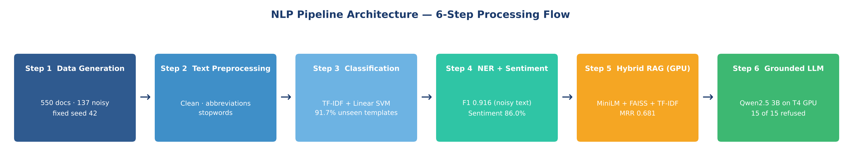
Figure 1: NLP Pipeline Architecture — Six-Step Document Intelligence Flow

5.1 Document Classification
Document classification addresses the fundamental challenge of automatically determining which category a given document belongs to: purchase order, supplier communication, maintenance report, or general correspondence. Without reliable classification, downstream components cannot apply the correct extraction patterns or retrieval strategies, because each document type carries a distinct semantic vocabulary and structural profile.
Five classification models were compared inside identical scikit-learn pipelines (a TF-IDF vectoriser followed by the classifier): Logistic Regression, a Linear Support Vector Machine, Multinomial Naive Bayes, Random Forest, and Gradient Boosting. Each was evaluated under three protocols. The first is stratified five-fold cross-validation, the standard measure. The second is an unseen-template test, in which models train on templates 0 to 6 and are tested on templates 7 and 8; this is the honest test, because the model has never met those sentence structures. The third measures accuracy on the 137 noisy documents. Table 2 and Figure 2 summarise the results.
Model | 5-Fold CV | Unseen Templates | Noisy Docs
Linear SVM (selected) | 100.0% | 91.7% | 100.0%
Logistic Regression | 100.0% | 86.2% | 100.0%
Naive Bayes | 99.6% | 86.2% | 99.3%
Random Forest | 100.0% | 82.6% | 100.0%
Gradient Boosting | 99.3% | 56.0% | 98.5%
Table 2: Classification Model Performance Comparison (550-document corpus, three evaluation protocols)

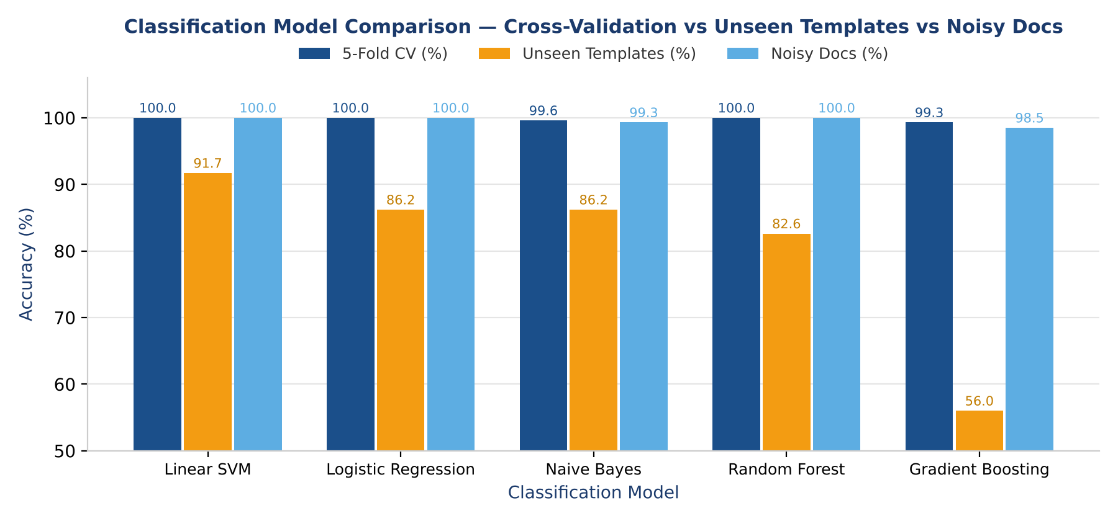
Figure 2: Classification Model Comparison — Cross-Validation vs Unseen-Template vs Noisy-Document Accuracy

The Linear SVM achieved the highest unseen-template accuracy at 91.7 per cent, while all five models scored between 99.3 and 100 per cent in cross-validation. This gap is the central finding. A random 80/20 split also returned 100 per cent, because the same templates appear in both the training and test partitions, so cross-validation on this corpus measures template memorisation as much as classification skill. The unseen-template test separates the models clearly: Logistic Regression and Naive Bayes fell to 86.2 per cent, Random Forest to 82.6 per cent, and Gradient Boosting to 56.0 per cent, indicating that the tree ensembles memorised template wording instead of learning transferable vocabulary. The Linear SVM generalised best, which agrees with the literature on linear models for sparse text (Kowsari et al., 2019).
The weakest class for the selected SVM on unseen templates is general correspondence, with a recall of 0.56: 7 of its 18 test documents were predicted as supplier communication. This is expected, because general correspondence was deliberately designed to share part and supplier vocabulary with the other types. In a production deployment processing real documents from many suppliers, accuracy would depend on how closely real documents resemble the training data, so the unseen-template result is a better planning figure than the 100 per cent cross-validation score. The linear SVM's interpretability advantage over ensemble methods was also a factor in its selection as the production-candidate model, as its feature weight vectors can be directly inspected to identify the discriminating vocabulary for each class, supporting explainability requirements.

5.2 Named Entity Recognition
Named entity recognition transforms the classifier's output into structured intelligence by identifying and labelling the specific entities within each document. For procurement documents, the entities of interest are the part being ordered or repaired, the supplier, the quantity, the delivery date, the site, and the equipment concerned.
The NER module employs a hybrid architecture of regular expressions and gazetteer lookup. Regular expression patterns address entities with predictable structural forms: dates in several formats and quantities in several phrasings ("120 units", "310x", "qty: 145", "Ordering 275 gearbox GB 300 components"). Gazetteer lookup applies exact-match search against curated lists of known entities: nine supplier names, five UAE sites, six items of equipment, and fifteen part descriptions. Urgency is detected separately by keyword rules (Section 5.3). Scoring against gold labels exposed one weakness during development: the first quantity pattern missed phrasings such as "Ordering 275 gearbox GB 300 components", and adding a third pattern raised clean quantity recall from 0.914 to 1.000.
Entity Type | Method | Clean F1 | Noisy Recall | Noisy F1
PART | Regex + gazetteer | 1.000 | 0.872 | 0.920
SUPPLIER | Gazetteer | 1.000 | 0.779 | 0.876
QUANTITY | Regex | 1.000 | 0.940 | 0.962
DATE | Regex | 1.000 | 0.974 | 0.987
SITE | Gazetteer | 1.000 | 0.782 | 0.878
EQUIPMENT | Gazetteer | 1.000 | 0.822 | 0.902
MICRO AVERAGE | Hybrid | 1.000 | 0.853 | 0.916
Table 3: NER Evaluation Against Gold Labels — Clean Text vs 137 Noisy Documents

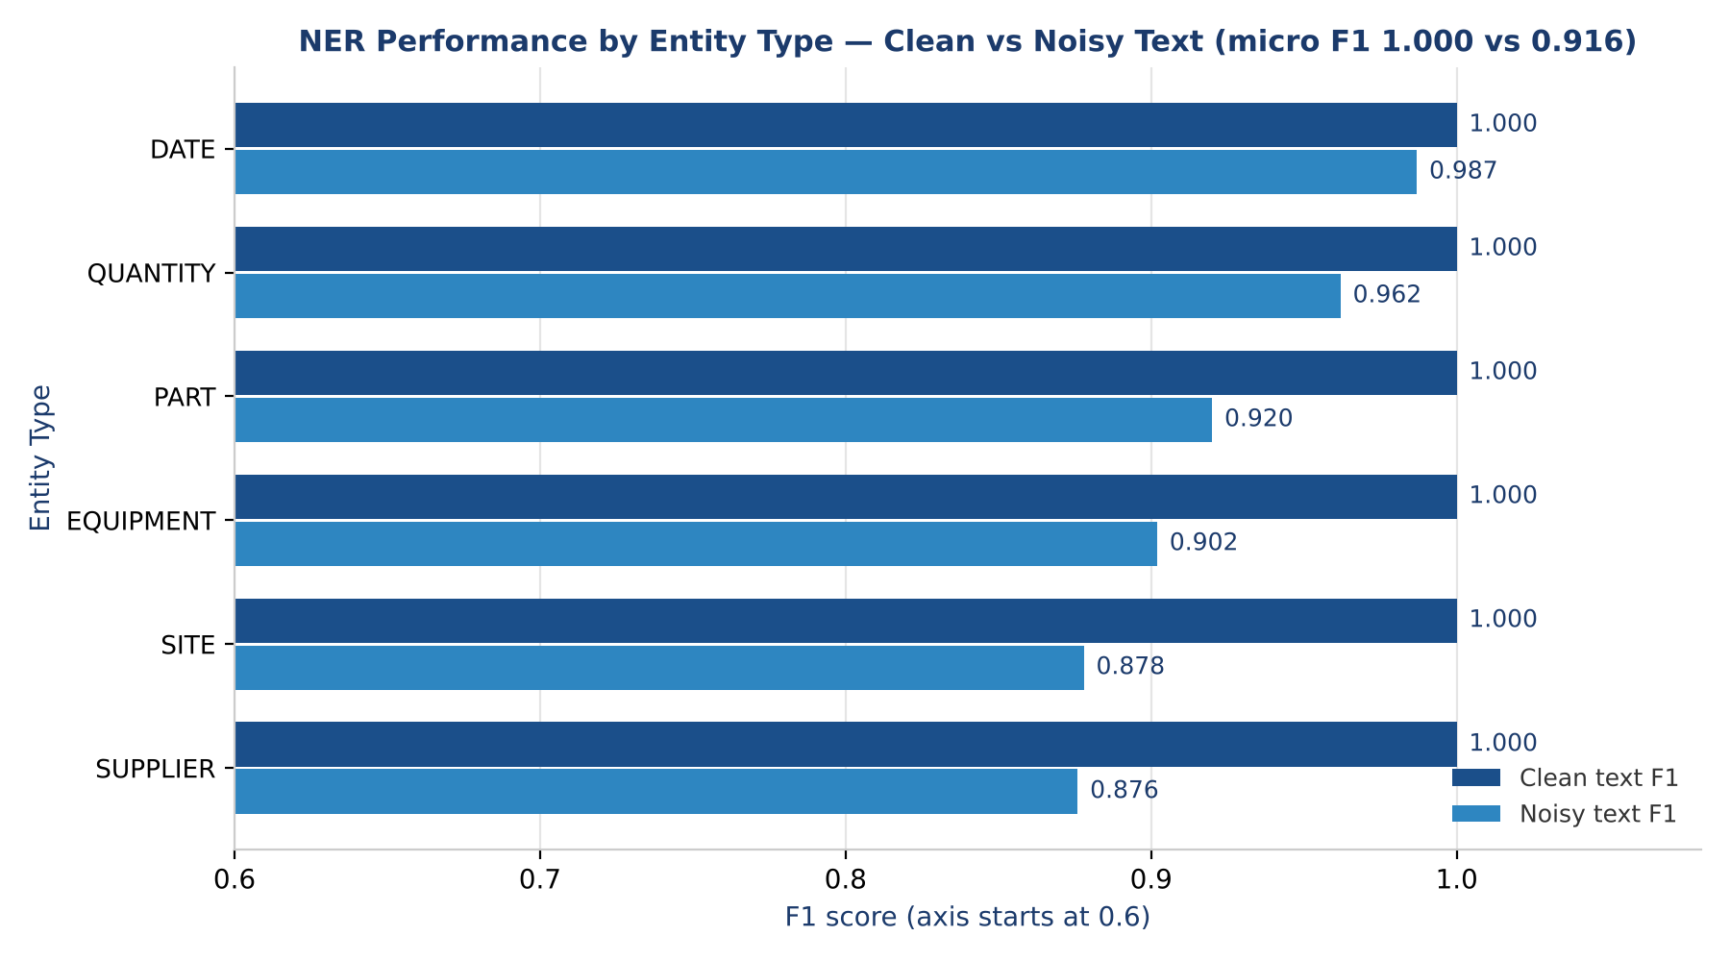
Figure 3: NER Performance by Entity Type — Clean vs Noisy Text (F1)

On clean text, the NER module achieved a precision, recall, and F1 of 1.000 for all six entity types, which is expected because the gazetteers contain every name used to generate the data; this figure should not be read as real-world performance. The informative result is the noisy test on 137 documents, where micro precision stayed high at 0.989 but recall fell to 0.853, giving an F1 of 0.916. The system therefore rarely extracts a wrong entity but misses misspelled ones, such as "PartsPro Internat1onal", "Jebel Ali Free one", or "5orting Machine SM 3", because exact matching cannot recover a corrupted string. Supplier (recall 0.779) and site (0.782) names suffered most, as these multi-word names are broken by a single character error, while dates (0.974) and quantities (0.940) were the most robust. This motivates fuzzy matching as the first production enhancement, and the degradation of rule-based extraction on noisy text is consistent with the discussion in Section 2.2.

5.3 Urgency and Sentiment Detection
Urgency and sentiment detection address the operational tone of procurement communications and are implemented as transparent keyword rules. Supplier sentiment (positive, negative, or neutral) is derived by counting indicator phrases, for example "confirmed" and "ahead of schedule" for positive, "delayed", "on hold", and "backordered" for negative, and "being processed" for neutral, with the share of the winning class reported as a confidence value. Purchase order urgency (ROUTINE, HIGH, or CRITICAL) is derived from cues such as "production line halted", "urgent", and "no rush". Both modules are scored against gold labels: urgency accuracy was 100 per cent on both clean and noisy purchase orders (n = 39), while sentiment accuracy was 86.0 per cent over 150 supplier communications.
The practical value of urgency detection lies in its ability to support procurement prioritisation. A purchase order carrying a critical urgency flag can be automatically escalated for expedited processing, enabling procurement teams to triage their workload by operational risk rather than chronological queue position. Sentiment detection adds an early warning for supplier problems: negative supplier tone surfaces delays before they become downtime. The sentiment errors were concentrated in the deliberately mixed emails (14 negative emails predicted as positive and 7 neutral emails predicted as negative), and the average reported confidence of 0.91 is higher than an accuracy of 86.0 per cent justifies, so the confidence value would need calibration before being shown to users.

5.4 Retrieval-Augmented Generation
The retrieval-augmented generation component transforms the document corpus into a queryable knowledge base, enabling procurement staff to ask natural language questions and receive grounded answers with source attributions rather than conducting manual document searches. The architecture consists of three layers: a retrieval layer with three competing retrievers, a refusal gate that stops the system answering when the documents do not support an answer, and a GPU-hosted language model that writes the answer from the retrieved documents.
Because documents in this corpus are short, each of the 550 documents is indexed whole, after being enriched with its extracted metadata. Three retrievers are implemented: a sparse TF-IDF index (3,000 features, cosine similarity); a dense index in which all-MiniLM-L6-v2 embeddings (384 dimensions) are computed on the GPU and searched with FAISS; and a hybrid method that merges the two rankings with Reciprocal Rank Fusion (k = 60), rewarding documents that both retrievers rank highly without having to calibrate their different score scales (Cormack et al., 2009).
System evaluation used 30 queries covering parts, suppliers, sites, and equipment across the searchable document types, with relevance defined automatically from the gold labels rather than judged by eye. Retrieval performance was measured with Hit@1, Hit@3, Mean Reciprocal Rank (MRR), and Precision@5, as reported in Section 6.3.
Answers are generated by Qwen2.5-3B-Instruct (Qwen Team, 2024), loaded in half precision on the Tesla T4 (6.3 GB of GPU memory, four to six seconds per answer). The prompt contains only the top five retrieved documents, and the model must answer from them, cite them by number, and otherwise reply "Information not found in the available documents." Three controls limit hallucination, which is the principal risk of generative systems operating without grounding (Lewis et al., 2020; Ji et al., 2023). A refusal gate skips the model entirely when the best dense similarity is below 0.53, a threshold chosen from the data: in-scope questions scored at least 0.68 and off-topic questions at most 0.37. A grounding check confirms that every entity in an answer appears in the cited documents, and a citation check confirms that every cited number points to a retrieved document. An end-to-end function, process_document(), and a Gradio web application expose the whole pipeline through three tabs: "Analyse an email / document", in which the user enters a subject, sender and body (or pastes a document) and receives the type, entities, urgency, sentiment and similar documents; "Batch upload", in which several .txt, .eml or .csv files are processed at once into a single results table; and "Ask the documents", which answers a question with citations or refuses. The demo accepts emails as plain text, with the subject joined to the body in the same format as the corpus, and a .eml file is read through its plain-text body, but it does not connect to a mailbox or read attachments.

6. Evaluation and Results
This section presents a systematic evaluation of the full pipeline across its principal NLP components: document classification, named entity recognition, sentiment and urgency analysis, retrieval, and grounded generation. Every module is scored against gold labels generated with the data. Where ground truth data is available, formal precision, recall, and F1 metrics are reported, and for retrieval quality, standard information retrieval metrics are used. The section concludes with a cross-component pipeline scorecard.

6.1 Classification Evaluation
Classification was evaluated under three protocols (Table 2). Under five-fold cross-validation, every model scored between 99.3 and 100 per cent, and a random 80/20 split also gave 100 per cent for the SVM, because the same templates appear in both training and test partitions. The honest figure is the unseen-template accuracy: the Linear SVM achieved 91.7 per cent on templates 7 and 8, which it had not seen during training. On the 137 noisy documents the SVM scored 100 per cent, showing that OCR-style character noise does little harm to a TF-IDF classifier, because most of the discriminating vocabulary survives a small number of character errors.
All of the SVM's errors on unseen templates fall in one class. General correspondence had a recall of 0.56, with 7 of 18 documents predicted as supplier communication, while the other three classes were classified perfectly. This is the most semantically challenging boundary in the corpus, since general correspondence was designed to share part and supplier vocabulary with the other types. The ranking of models also matters: Gradient Boosting reached 99.3 per cent in cross-validation but only 56.0 per cent on unseen templates, a clear example of how a high cross-validation score can hide poor generalisation.

6.2 NER, Urgency and Sentiment Evaluation
NER was scored against the gold entities stored with each document (Table 3). On clean text, precision, recall, and F1 were all 1.000 across the six entity types. On the 137 noisy documents, micro precision was 0.989, micro recall 0.853, and F1 0.916. Date extraction was the most robust (F1 0.987), followed by quantity (0.962) and part (0.920), while equipment (0.902), site (0.878), and supplier (0.876) names were the most affected, because a single corrupted character defeats exact gazetteer matching. Examples of misses include "PartsPro Internat1onal" for the supplier PartsPro International and "Jebel Ali Free one" for Jebel Ali Free Zone. This finding motivates the inclusion of fuzzy matching as a production enhancement.
Urgency detection on purchase orders reached 100 per cent accuracy on both clean and noisy documents (n = 39), which reflects the explicit urgency phrases in the templates and should not be assumed for real documents. Sentiment accuracy over the 150 supplier communications was 86.0 per cent. The 21 errors comprised 14 negative emails predicted as positive and 7 neutral emails predicted as negative, mostly from the deliberately mixed emails in which a positive phrase sits beside a negative one. The average confidence of 0.91 is higher than the accuracy justifies.

6.3 RAG Retrieval Evaluation
Retrieval Method | Hit@1 | Hit@3 | MRR | P@5
TF-IDF (sparse) | 0.600 | 0.667 | 0.662 | 0.433
Dense (GPU + FAISS) | 0.433 | 0.800 | 0.597 | 0.340
Hybrid (RRF) | 0.567 | 0.767 | 0.681 | 0.440
Table 4: Retrieval Quality Metrics Across 30 Evaluation Queries (relevance taken from gold labels)

No single retriever wins on every metric. Dense retrieval most often places a relevant document in the top three (Hit@3 of 0.800) but ranks the best document first less often (Hit@1 of 0.433) than TF-IDF (0.600). The hybrid method achieves the highest MRR (0.681) and the highest Precision@5 (0.440), making it the most robust choice, although its advantage over TF-IDF is small with only 30 queries. The breakdown by document type explains the pattern. TF-IDF scored an MRR of 1.000 on maintenance queries and 0.812 on purchase order queries, where exact part codes decide relevance, but only 0.173 on supplier communication queries, where dense retrieval scored 0.733 because supplier emails are worded in many different ways. This is the vocabulary mismatch problem inherent to sparse retrieval, and it agrees with the finding of Karpukhin et al. (2020) that dense retrieval helps most on reworded queries, while sparse retrieval remains strong on exact identifiers. The hybrid method scored an MRR of 0.950 on maintenance queries, 0.703 on purchase orders, and 0.388 on supplier communications.

6.4 Grounded Generation and Hallucination Tests
Generation was tested on 15 in-scope questions, 10 off-topic questions (for example a football result or a weather forecast), and 5 in-domain but unanswerable questions (for example the price of a part that does not exist in the data). The off-topic and unanswerable questions are deliberate: they test whether the system invents an answer when it should decline, which is the main ethical risk of using generative models in daily operations. No in-scope question was wrongly refused (0.0 per cent), every answer was entity-grounded (100 per cent), and citation precision was 86.7 per cent (maintenance reports 0.933, supplier communications 0.900, and purchase orders 0.767, where many near-identical orders exist). All 10 off-topic and all 5 unanswerable questions were refused (100 per cent), as shown in Table 5. The grounding check verifies entities but not the relationships between them, so a correct entity attached to the wrong order would not be caught.
Measure | Result
In-scope questions wrongly refused (n = 15) | 0.0%
Entity grounding of answers | 100.0%
Citation precision (cited documents truly relevant) | 86.7%
Off-topic questions refused (n = 10) | 100.0%
In-domain but unanswerable questions refused (n = 5) | 100.0%
Table 5: Grounded Generation and Hallucination Tests (Qwen2.5-3B-Instruct with refusal gate)

6.5 Pipeline Health Scorecard
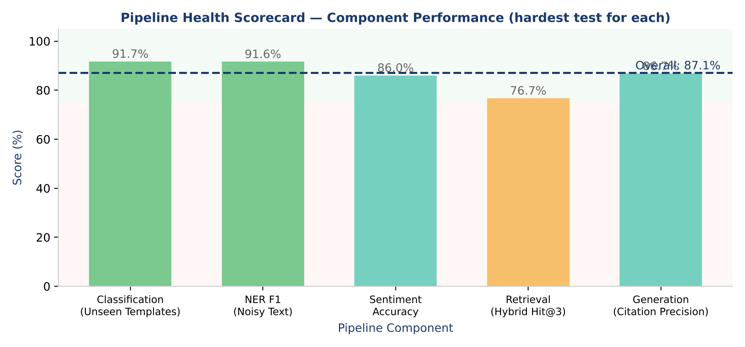
Figure 4: Pipeline Health Scorecard — Component Performance with Colour-Coded Grade Bands

Pipeline Component | Score | Weight | Assessment
Document Classification (Unseen Templates) | 91.7% | 25% | Good: linear SVM generalises; general correspondence is the weak class
Named Entity Recognition (Noisy F1) | 91.6% | 25% | Good: precision 0.989, but recall falls to 0.853 on noisy text
Sentiment Analysis (Accuracy) | 86.0% | 10% | Fair: mixed emails cause 21 errors; confidence is overstated
Retrieval (Hybrid Hit@3) | 76.7% | 20% | Fair: hybrid MRR 0.681; no single retriever wins on every query type
Grounded Generation (Citation Precision) | 86.7% | 20% | Good: all 15 off-topic or unanswerable questions refused
OVERALL PIPELINE | 87.1% | 100% | Good: each component scored on its hardest test, not its easiest
Table 6: Pipeline Health Scorecard — Weighted Component Assessment (weights are the author's judgement)

7. Tool Stack and Platforms
The prototype was implemented in Python using open-source libraries, with Google Colab and its Tesla T4 GPU as the development environment. Table 7 documents the complete tool stack, distinguishing between the tools used in the current prototype and the production-grade alternatives identified for the upgrade pathway. This transparency is important both for reproducibility and for the practical handoff from research prototype to production system.
Tool / Library | Role | Justification
scikit-learn | Prototype | TF-IDF vectorisation, five classification models, five-fold cross-validation, sparse retrieval. Industry-standard, well-documented, lightweight
NumPy and Pandas | Prototype | Seeded synthetic data generation, data handling, and computation of evaluation metrics
Regular Expressions (re module) | Prototype | High-precision pattern-based extraction of dates and quantities. Fully deterministic and easy to inspect
Google Colab (Tesla T4 GPU) | Prototype | Free GPU runtime that runs the embedding model and the language model. Shareable notebook that reproduces every result
PyTorch and Hugging Face Transformers | Prototype | GPU model execution in half precision. Runs Qwen2.5-3B-Instruct in 6.3 GB of GPU memory (Wolf et al., 2020)
sentence-transformers (all-MiniLM-L6-v2) | Prototype | 384-dimensional dense embeddings encoded on the GPU in 0.4 seconds for 550 documents
FAISS (CPU) | Prototype | Inner-product similarity index for dense retrieval. CPU is ample at 550 vectors; GPU indexes suit larger collections
Qwen2.5-3B-Instruct | Prototype | Instruction-tuned language model for grounded, cited answers. Fits a free T4 GPU in half precision
Gradio | Prototype | Web demo with email and document analysis, batch file upload, and a question-answering tab, launched from the notebook
GitHub | Prototype | Version control, well-commented code, and README for reproducibility. Supports submission requirements
Fine-tuned transformer NER (spaCy or Hugging Face) | Production | Replaces rules to close the noisy-text recall gap (0.853). Requires an annotated real-world corpus
Falcon LLM (TII UAE) | Production | UAE-developed open-source language model from the Technology Innovation Institute. Reinforces UAE 2030 alignment and data sovereignty
Table 7: Tool Stack — Prototype Implementation and Production Upgrade Pathway

The prototype combines classical machine learning where it is strong (TF-IDF with linear models for classification, and rules for structured entity extraction) with GPU-hosted transformer models where meaning matters (dense embeddings and answer generation). This reflects a deliberate design philosophy: use interpretable, reproducible components first, and introduce larger models only where they add value. GPU use is confirmed at notebook start-up (Figure 5): the GPU encodes the embeddings and runs the language model, while FAISS search runs on the CPU, which is appropriate at this corpus size. LangChain was not needed because the retrieval and prompting steps are short enough to write directly, which keeps the logic visible. The upgrade pathway to a Falcon LLM, developed by the UAE's Technology Innovation Institute (Almazrouei et al., 2023), remains particularly noteworthy from a national strategy perspective, as it would align with the sovereignty and self-reliance objectives of the UAE National AI Strategy 2031 and Operation 300bn (UAE Government, 2021). Qwen2.5-3B-Instruct was used in the prototype because it follows instructions well and fits on the free T4 GPU.
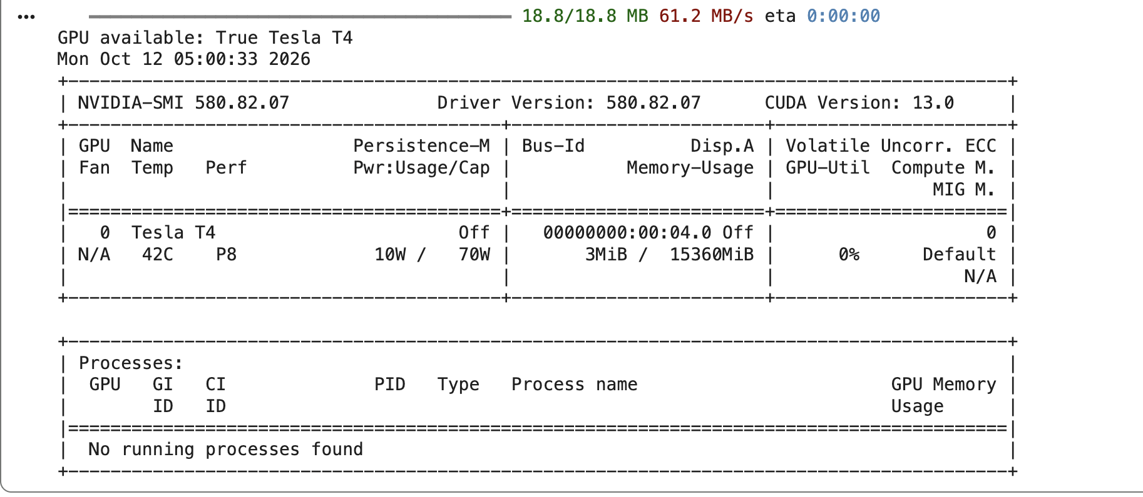
Figure 5: GPU Confirmation from the Notebook — Tesla T4, CUDA Available

8. Ethical Considerations and Mitigation Strategies
The deployment of AI systems in procurement and supply chain contexts raises a set of ethical obligations that extend beyond technical performance metrics. Procurement decisions carry real financial, operational, and human consequences: incorrect classification of an invoice can delay supplier payment; biased entity extraction can systematically disadvantage certain suppliers; a hallucinated RAG response can trigger an erroneous purchase order. The following considerations were embedded in the design of this system from the outset rather than treated as post-hoc compliance requirements.

8.1 Data Privacy and UAE PDPL Compliance
The UAE Personal Data Protection Law (PDPL), Federal Decree-Law No. 45 of 2021, establishes data protection obligations for organisations processing personal data in the UAE. In the procurement context, documents may contain personal identifiers including employee names, email addresses, and job titles. The prototype uses only synthetic data generated without reference to any real individual, so no personal or confidential information is processed and no privacy obligations arise from the prototype itself. A production deployment would add masking of email addresses and personal names before any model processing, apply purpose limitation so that extracted personal entities are stored and processed only for the procurement workflow for which they were collected, and add access control and audit logging. Running a small open language model on the organisation's own infrastructure, instead of sending documents to an external service, also limits data exposure.

8.2 Bilingual Processing and Arabic Language Bias
UAE procurement environments are inherently bilingual, with operational communications often mixing English technical vocabulary with Arabic organisational terms, supplier names, and regulatory references. The current prototype processes English-language documents exclusively, which introduces a systematic capability gap: procurement communications authored primarily in Arabic would not be correctly classified or have their entities extracted by the current pipeline. This is not merely a technical limitation but an equity concern, as Arabic-language documents from smaller local suppliers are statistically more likely to be mishandled, potentially introducing structural bias against UAE SMEs in the procurement process. The production upgrade path addresses this through multilingual sentence-transformer models (such as paraphrase-multilingual-MiniLM-L12-v2) and Arabic-adapted NER models, with evaluation protocols specifically designed to assess parity across language variants.

8.3 Supplier Fairness in Automated Classification
Automated document classification in procurement creates a risk of systematic supplier disadvantage. If the classification model performs better on documents from large, established suppliers whose documentation style resembles the training corpus, then smaller or less familiar suppliers whose documents use different formatting conventions may experience higher misclassification rates, leading to processing delays, incorrect entity extraction, and potentially erroneous purchase decisions. This risk is addressed in the current system through the unseen-template and noisy-text tests, which deliberately measure performance on wording the model has not memorised and on corrupted text, instead of reporting only the flattering cross-validation score. In production, ongoing monitoring of classification accuracy stratified by supplier type and document origin would be required to detect and address emergent supplier fairness issues, consistent with the responsible AI principles outlined by Barredo Arrieta et al. (2020).

8.4 Hallucination Control and Human-in-the-Loop Oversight
The most significant ethical risk in the RAG component is hallucination: the generation of confident-sounding but factually incorrect responses that are not grounded in the retrieved documents. The prototype uses a generative language model, so this risk is real, and it was tested directly. Mitigation strategies embedded in the design include mandatory source citation with every response, a refusal gate that stops the model from running when the best dense similarity falls below a calibrated threshold, a grounding check that every entity in an answer appears in the cited documents, and a fixed fallback response ("Information not found in the available documents."). In testing, all 10 off-topic and all 5 in-domain unanswerable questions were refused, no in-scope question was wrongly refused, entity grounding was 100 per cent, and citation precision was 86.7 per cent. These results come from small test sets, and the gate threshold was calibrated on the same queries, so they show that the controls work in principle rather than guaranteeing behaviour on real documents.
Beyond technical safeguards, the system is designed with a human-in-the-loop principle for all consequential procurement decisions. The pipeline outputs are framed as decision support rather than autonomous decision-making: the system flags critical stock-outs, identifies urgent purchase order requests, and surfaces related supplier communications, but all actions such as raising purchase orders, approving payments, and initiating supplier contact remain under human authorisation. This design choice aligns with the LIME-based explainability approach advocated by Ribeiro, Singh and Guestrin (2016) and with the broader responsible AI framework for high-stakes operational contexts described by Barredo Arrieta et al. (2020).

9. Value Proposition and Expected Output
The demonstrated pipeline delivers four categories of business value that directly address the operational challenges identified in Section 1.
The first is automated document triage. The Linear SVM's 91.7 per cent accuracy on templates it had never seen (and 100 per cent in cross-validation and on noisy text) means that a procurement team receiving a mixed batch of purchase orders, supplier emails, maintenance reports, and correspondence can route most documents to the appropriate workflow without manual review, with human checking for uncertain cases. As an illustration only, since no time study was run, for an organisation processing 200 procurement documents daily, a 10-minute reduction in manual sorting per document would represent a saving of more than 33 staff-hours per day.
The second is structured entity intelligence. The extraction of six entity types (parts, suppliers, quantities, dates, sites, and equipment), with an F1 of 1.000 on clean text and 0.916 on noisy text, transforms unstructured text into a searchable structured knowledge base. Part names can be matched against inventory records, supplier names reconciled against approved vendor lists, and quantities and delivery dates checked against contracted terms, all without manual data entry.
The third is natural language procurement querying. The hybrid retrieval and grounded generation layers enable procurement staff to query the document collection using plain English rather than constructing complex database queries. Questions such as "What is the status of bearing assembly orders?" or "Which site reported a breakdown involving the air filter AF 250?" are answered in four to six seconds on the T4 GPU with source citations, and the system declines to answer when the documents do not contain the information, instead of inventing a response. This is expected to reduce the time-to-insight for procurement decisions from hours to under a minute.
The fourth is the alignment with national industrial strategy. By demonstrating a working NLP pipeline for procurement intelligence that operates on UAE-contextualised data (UAE sites such as Jebel Ali Free Zone and KIZAD Industrial), is compatible with Arabic language processing in the production upgrade path, and has a clear upgrade path to Falcon LLM integration, this project contributes a replicable blueprint for AI-enabled procurement modernisation that directly supports Operation 300bn's objectives for smarter UAE industrial supply chains.
The upgrade trajectory from prototype to production is clearly defined. Dense embeddings and a hybrid retriever are already part of the prototype, and the results show that they complement rather than replace TF-IDF (hybrid MRR of 0.681 against 0.662 for TF-IDF alone), so the next retrieval gain is likely to come from tuning the fusion weights per query type on a separate validation set. Fine-tuning a transformer on an annotated real-world corpus is the main route to better classification and NER on real documents, with fuzzy matching addressing the noisy-text recall gap (0.853) in the interim. Each of these improvements is modular and can be incrementally deployed without redesigning the pipeline architecture. These benefits are expected rather than measured: no time-saving study was run and the accuracy figures come from synthetic data, so a pilot on real, anonymised documents is the necessary next step.

10. Conclusion
This report has presented the design, implementation, and evaluation of a six-stage NLP pipeline for procurement and spare parts document intelligence, developed in the context of the UAE's Industrial Strategy 2030. The system addresses a real and pressing operational challenge: the semantic richness of procurement documents is currently inaccessible to the automated systems that manage them. By combining document classification, hybrid named entity recognition, sentiment and urgency analysis, and retrieval-augmented generation, the pipeline transforms 550 synthetic procurement documents into an intelligent, queryable knowledge base, with its embedding and language models running on a Tesla T4 GPU.
The core performance results are encouraging but need careful interpretation. A Linear SVM reaches 100 per cent cross-validation accuracy but 91.7 per cent on templates it has never seen, which is the more honest figure. A hybrid rule-based NER module achieves an F1 of 1.000 on clean text and 0.916 on noisy text, with recall (0.853) as the weak point, and keyword sentiment reaches 86.0 per cent. Hybrid retrieval reaches an MRR of 0.681 over 30 queries, with sparse and dense methods complementing each other, and the Qwen2.5 3B Instruct generator with a calibrated refusal gate refused all 15 off-topic or unanswerable questions without wrongly refusing any in-scope question. The overall pipeline health score of 87.1 per cent, calculated from the hardest test for each component, represents a strong foundation for a pilot on real data.
The ethical framework embedded in the design, covering UAE PDPL compliance, bilingual fairness, supplier equity, hallucination control, and human-in-the-loop oversight, reflects an understanding that technical performance alone is insufficient for responsible AI deployment in high-stakes operational environments. The production upgrade trajectory, toward fine-tuned transformer models, a managed vector database, and a UAE-developed Falcon LLM, provides a concrete roadmap from prototype to enterprise-grade deployment that aligns with UAE AI sovereignty objectives.
The limitations of this work should be stated plainly. The data are synthetic and template-based, so real-world accuracy will be lower. The test sets are small (30 retrieval queries, 150 supplier communications, and 15 in-scope generation questions), so the differences between retrievers are not statistically conclusive. The refusal threshold was calibrated on the same queries it was later evaluated on. Rule-based extraction and keyword sentiment cannot handle unseen phrasing, and recall drops on noisy text. Noise was simulated by character edits, so real scanned documents would additionally need OCR. The system processes English only, and the grounding check cannot detect a wrong relationship between two correct entities.
Future research directions include annotation of a real-world UAE procurement document corpus to enable supervised NER model training, evaluation of Arabic-English bilingual embeddings for cross-language procurement query processing, and investigation of relation extraction methods that could map supplier-to-part-to-PO-to-invoice chains as a knowledge graph overlay on the existing pipeline architecture. These extensions would transform the current document intelligence system into a comprehensive procurement knowledge management platform aligned with the next generation of UAE smart industrial infrastructure.

References.
Almazrouei, E. et al. (2023) 'The Falcon series of open language models', arXiv preprint arXiv:2311.16867.
Barredo Arrieta, A., Diaz-Rodriguez, N., Del Ser, J., Bennetot, A., Tabik, S., Barbado, A., Garcia, S., Gil-Lopez, S., Molina, D., Benjamins, R., Chatila, R. and Herrera, F. (2020) 'Explainable Artificial Intelligence (XAI): Concepts, taxonomies, opportunities and challenges toward responsible AI', Information Fusion, 58, pp. 82-115.
Cormack, G.V., Clarke, C.L.A. and Buettcher, S. (2009) 'Reciprocal rank fusion outperforms Condorcet and individual rank learning methods', in Proceedings of the 32nd International ACM SIGIR Conference on Research and Development in Information Retrieval, pp. 758-759.
Devlin, J., Chang, M.W., Lee, K. and Toutanova, K. (2019) 'BERT: Pre-training of deep bidirectional transformers for language understanding', in Proceedings of the 2019 Conference of the North American Chapter of the Association for Computational Linguistics (NAACL), Minneapolis, MN, pp. 4171-4186.
Gao, Y., Xiong, Y., Gao, X., Jia, K., Pan, J., Bi, Y., Dai, Y., Sun, J. and Wang, H. (2023) 'Retrieval-augmented generation for large language models: A survey', arXiv preprint arXiv:2312.10997.
Ji, Z., Lee, N., Frieske, R., Yu, T., Su, D., Xu, Y., Ishii, E., Bang, Y.J., Madotto, A. and Fung, P. (2023) 'Survey of hallucination in natural language generation', ACM Computing Surveys, 55(12), article 248.
Johnson, J., Douze, M. and Jegou, H. (2019) 'Billion-scale similarity search with GPUs', IEEE Transactions on Big Data, 7(3), pp. 535-547.
Karpukhin, V., Oguz, B., Min, S., Lewis, P., Wu, L., Edunov, S., Chen, D. and Yih, W. (2020) 'Dense passage retrieval for open-domain question answering', in Proceedings of the 2020 Conference on Empirical Methods in Natural Language Processing (EMNLP), pp. 6769-6781.
Kowsari, K., Meimandi, K.J., Heidarysafa, M., Mendu, S., Barnes, L. and Brown, D. (2019) 'Text classification algorithms: A survey', Information, 10(4), p. 150.
Lample, G., Ballesteros, M., Subramanian, S., Kawakami, K. and Dyer, C. (2016) 'Neural architectures for named entity recognition', in Proceedings of the 2016 Conference of the North American Chapter of the Association for Computational Linguistics (NAACL), San Diego, CA, pp. 260-270.
Lewis, P., Perez, E., Piktus, A., Petroni, F., Karpukhin, V., Goyal, N., Kuttler, H., Lewis, M., Yih, W., Rocktaschel, T., Riedel, S. and Kiela, D. (2020) 'Retrieval-augmented generation for knowledge-intensive NLP tasks', in Advances in Neural Information Processing Systems (NeurIPS), 33, pp. 9459-9474.
Li, J., Sun, A., Han, J. and Li, C. (2022) 'A survey on deep learning for named entity recognition', IEEE Transactions on Knowledge and Data Engineering, 34(1), pp. 50-70.
Minaee, S., Kalchbrenner, N., Cambria, E., Nikzad, N., Chenaghlu, M. and Gao, J. (2021) 'Deep learning-based text classification: A comprehensive review', ACM Computing Surveys, 54(3), pp. 1-40.
Qwen Team (2024) 'Qwen2.5 technical report', arXiv preprint arXiv:2412.15115.
Reimers, N. and Gurevych, I. (2019) 'Sentence-BERT: Sentence embeddings using Siamese BERT-networks', in Proceedings of the 2019 Conference on Empirical Methods in Natural Language Processing (EMNLP-IJCNLP), pp. 3982-3992.
Ribeiro, M.T., Singh, S. and Guestrin, C. (2016) '"Why should I trust you?": Explaining the predictions of any classifier', in Proceedings of the 22nd ACM SIGKDD International Conference on Knowledge Discovery and Data Mining (KDD), San Francisco, CA, pp. 1135-1144.
Sun, C., Qiu, X., Xu, Y. and Huang, X. (2019) 'How to fine-tune BERT for text classification?', in China National Conference on Chinese Computational Linguistics (CCL), Kunming, China, pp. 194-206.
UAE Government (2021) UAE National AI Strategy 2031 and Fourth Industrial Revolution Strategy. Available at: https://u.ae/en/about-the-uae/strategies-initiatives-and-awards/strategies-plans-and-visions/government-services-and-digital-transformation/fourth-industrial-revolution (Accessed: October 2026).
Vaswani, A., Shazeer, N., Parmar, N., Uszkoreit, J., Jones, L., Gomez, A.N., Kaiser, L. and Polosukhin, I. (2017) 'Attention is all you need', in Advances in Neural Information Processing Systems (NeurIPS), 30, pp. 5998-6008.
Wang, W., Wei, F., Dong, L., Bao, H., Yang, N. and Zhou, M. (2020) 'MiniLM: Deep self-attention distillation for task-agnostic compression of pre-trained transformers', in Advances in Neural Information Processing Systems (NeurIPS), 33, pp. 5776-5788.
Wang, Z., Shao, J., Wen, X., Wu, H. and Zhang, J. (2022) 'Pre-trained language models and their applications', Engineering, 25, pp. 51-65.
Wankhade, M., Rao, A.C.S. and Kulkarni, C. (2022) 'A survey on sentiment analysis methods, applications, and challenges', Artificial Intelligence Review, 55(7), pp. 5731-5780.
Wolf, T., Debut, L., Sanh, V., Chaumond, J., Delangue, C., Moi, A., Cistac, P., Rault, T., Louf, R., Funtowicz, M. and Brew, J. (2020) 'Transformers: State-of-the-art natural language processing', in Proceedings of the 2020 Conference on Empirical Methods in Natural Language Processing: System Demonstrations (EMNLP), pp. 38-45.

