ece 558 - final project ueb blackjack

PSU Winter 2015

By Hussein AlAmeer & Tu Truong

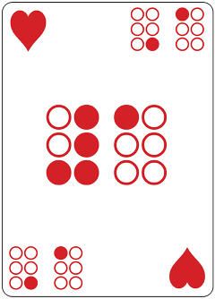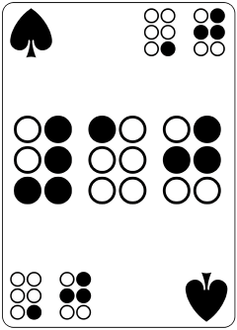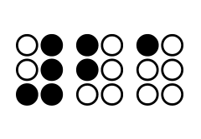

# 

# This app contains 4 Activities and 3 Fragments.

1. MainActivity Activity
   1. ListView that redirects the user to 3 other activities
      1. LearnBraille Activity ViewPager
         1. LearnBrailleFragment
            1. Swipes through note cards

UEB Numbers

UEB Capital Letter & Capital Word

UEB Alphabet A-N

UEB Alphabet M-Z

* + 1. Play BlackJack Activity
       1. PlayBlackJackStart Fragment
          1. Shows the game layout and a start button that switches to the PlayBlackJackGame Fragment.
       2. PlayBlackJackGame Fragment
          1. The Black Jack Game

Player is dealt 2 cards, Dealer is dealt Right card.

If Player Has a BlackJack

Player Wins

Player Can Hit

If Player gets 21

Player Stands

If Player gets < 21

Update Totals and Wait for Player’s next choice

If Player gets > 21

Player Busts and Loses

Player Can Stand

Deal the Dealer’s Second Card

Continue Dealer’s cards until…

Dealer Gets > 21

Dealer Total > Player Total

Dealer Gets total > 17

Player Can Start Over

Replace PlayBlackJackGame Fragment with itself

Player Can Reveal Numbers

Display the current Dealer and Player Current Cards and Totals.

* + 1. About Activity
       1. Displays Credit to Hussein and Tu
       2. Displays Credit to <http://developer.android.com/>

# 

5th Question

Start fragment

Question fragment

End fragment

4 Questions

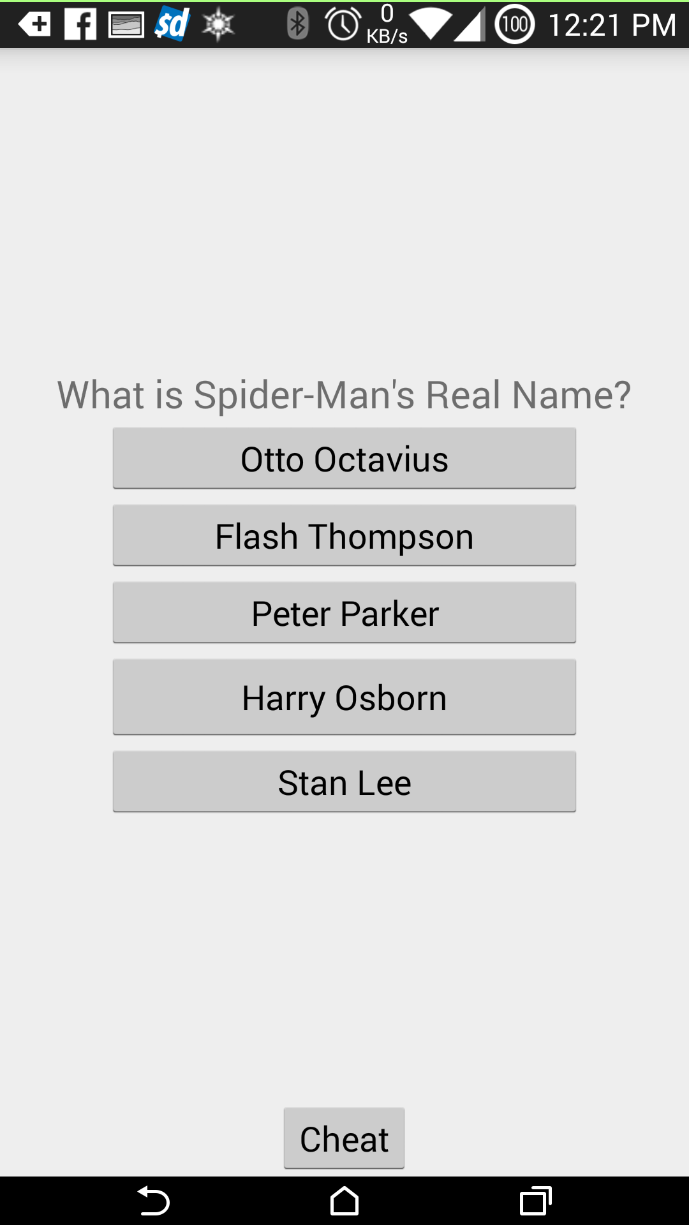

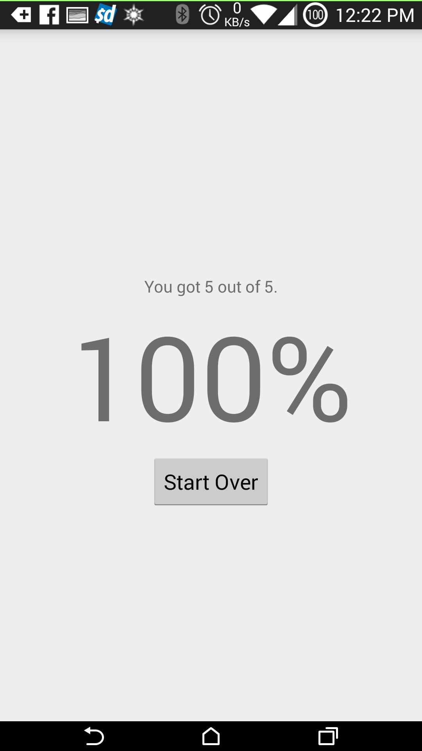

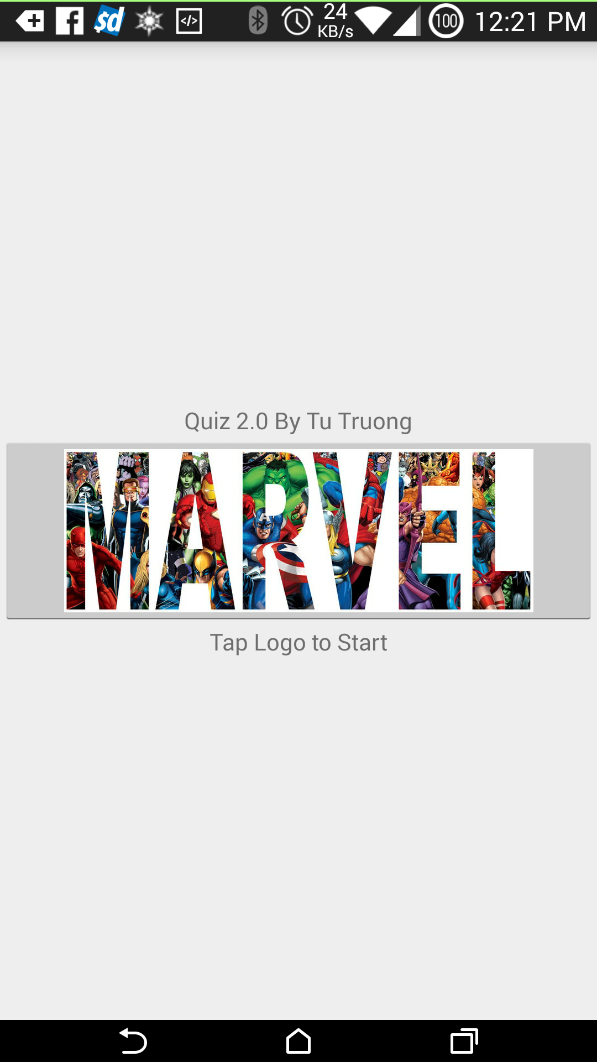

Main Activity

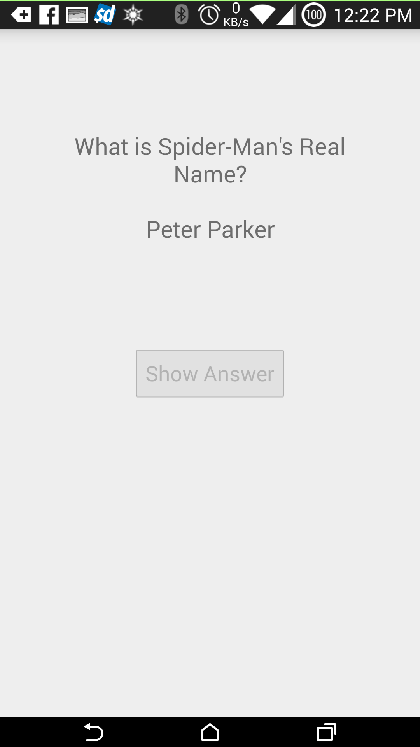

STATE AFTER

the user has cheated

STATE BEFORE

the user has cheated

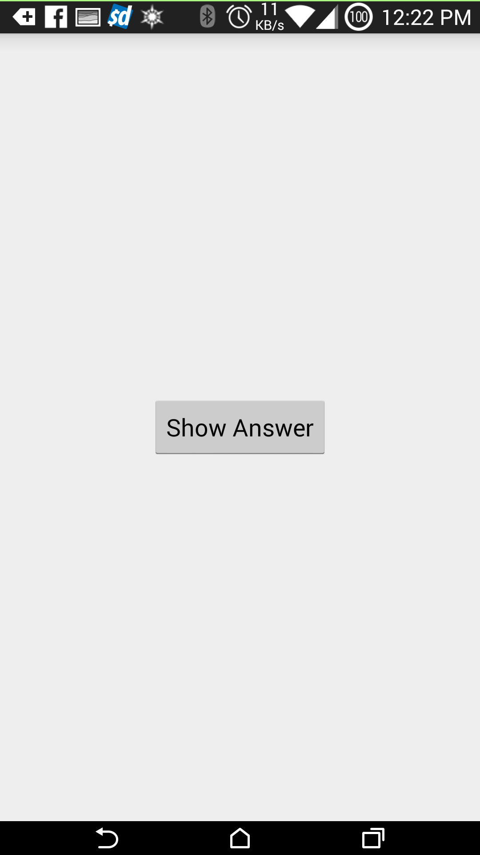

**Fax** [Fax]

[Website]

asdas

Cheat

fragment

cheated

d