Design Task

* The system to be designed is considered as safety critical system as it is a health monitoring system, that’s why we need to sample the data faster than the HW capabilities , to avoid loss of data and make system as responsive as possible.

* I have designed 3 different designs, the first one consists of 5 Tasks with overall CPU load= 78%,the second one consists of 4 Tasks with same CPU load, the last one consist of 3 tasks with higher CPU load=90% .
* What is best about design 1 is that every task is independent over other tasks as every sensor is in an individual task, but for the last design, the tasks are abstracted where I grouped all sensors in one task .

Design 1

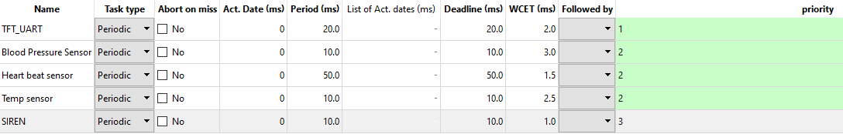

Tick rate = 10 MS

Hyper Period = 100 MS

CPU Load = 78%

Verification using SIMSO

Gantt Chart

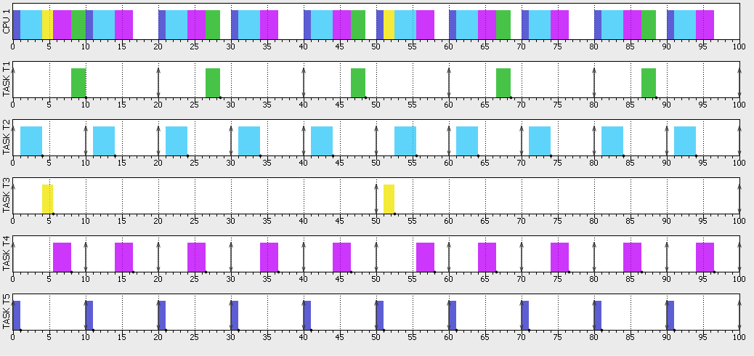

Design 3

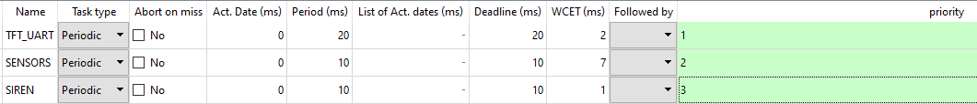

Tick rate = 10 MS

Hyper period =20 MS

CPU Load =90%

Verification Using SIMSO

Gantt Chart

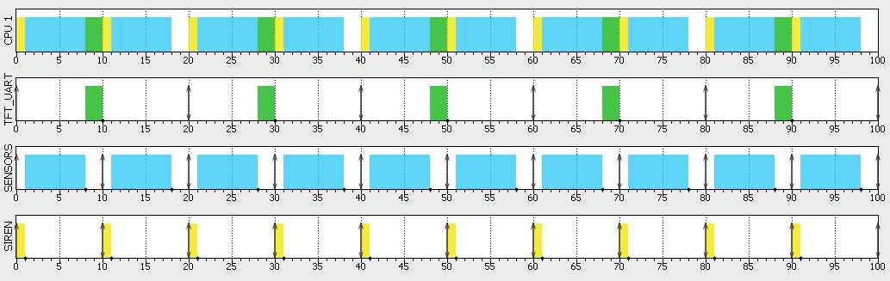

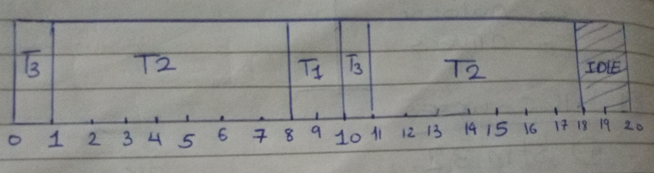

I have chosen the periodicity of

* TFT_UART : with analogy to button debouncing .
* SENSORS : tried to apply Nyquist Rule fs >= 2fmax .
* SIREN : to be fast enough with the data read and alert the system .