Implementing EDFscheduler in FreeRTOS

Implementation is based on thesis from Regensburg University of Applied Sciences,

under supervision of Eng / Khaled Hossam El-Dein .

Task Set

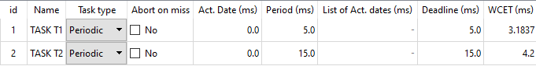

Verify the system schedulability

1. Analytical method

Using Time demand analysis method

T1

W(1) =3.184 +0 =3.184

.

.

.

W(5) =3.184 +0 =3.184

W(5) < 5 T1 is schedulable

T2

W(1) =4.24 + roundup(1/5)\*3.184 = 6.368

.

.

W(6) =4.24 + roundup(6/5)\*3.184 = 10.608

.

.

W(11) =4.24 + roundup(11/5)\*3.184 =13.792

.

.

W(15) =4.24 + roundup(15/5)\*3.184 =13.792

W(15) < 15 T2 is T2 is schedulable

1. Using Offline simulator

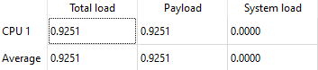

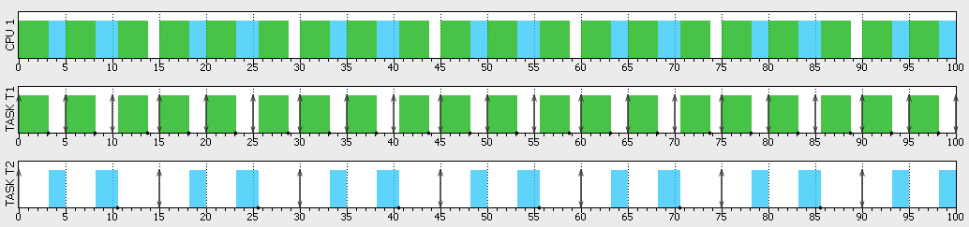

1. Using Runtim-Analysis

