**Calculate the Urm**

* U = (2.5/5)+(4.5/15)+(3.5/20) =0.975
* Urm=3(2^(1/3)-1)=0.78
* Since U> Urm , therefore the system is not schedulable

**Calculate the time demand analysis**

* Task 1
* W(1)=2.5+0=2.5
* W(2)=2.5+0=2.5
* W(3)=2.5+0=2.5
* W(4)=2.5+0=2.5
* W (5)=2.5+0=2.5 <5 Conclusion : Task1 is Schedulable
* Task 2
* W(1) =4.5 +roundup(1/5)*2.5 = 7
* W(6) =4.5 +roundup(6/5)*2.5 = 9.5
* W(11) =4.5 +roundup(11/5)*2.5 = 12
* W(15) =4.5 +roundup(15/5)*2.5 = 12 < 15 Conclusion : Task2 is Schedulable
* Task 3
* W(1)=3.5+Roundup(1/5)*2.5+Roundup(1/15)*4.5= 10.5
* W(6)=3.5+Roundup(6/5)*2.5+Roundup(6/15)*4.5= 13
* W(11)=3.5+Roundup(11/5)*2.5+Roundup(11/15)*4.5= 15.5
* W(16)=3.5+Roundup(16/5)*2.5+Roundup(16/15)*4.5= 22.5
* W(20)=3.5+Roundup(20/5)*2.5+Roundup(20/15)*4.5= 22.5 > 20

**Conclusion : T3 is not schedulable**

**Task Modeling using SIMSO**

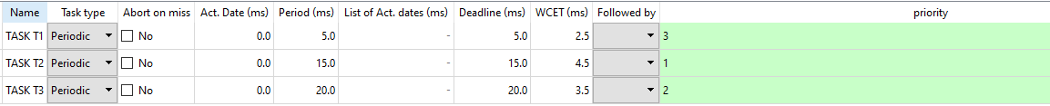

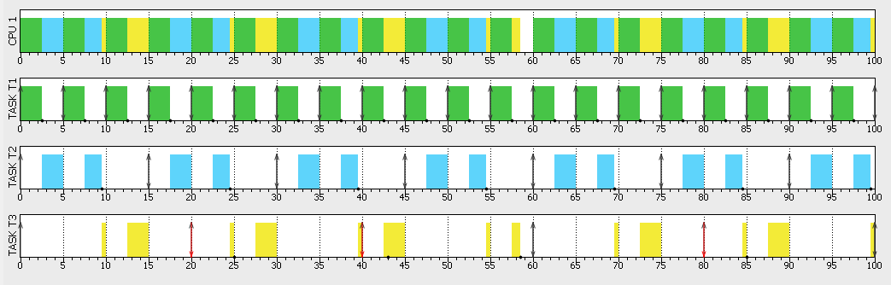

**It is crystal clear that task3 misses its deadline causing the system to be not schedulable .**