

Race me

Hela Sukkar, Q13764691, CGP600, AE2



January 5, 2018

Contents

Some of the errors: 1

# Some of the errors:

1. Adding input on 16/12/2017

After adding the input code and testing if the player was able to move the car with the (w, s, a, d) buttons, it didn’t work on the first time and I was receiving Theas errors, and later that day after trying many things, I remembered I didn’t add the libraries.

The problem was solved by adding the library in property inker.

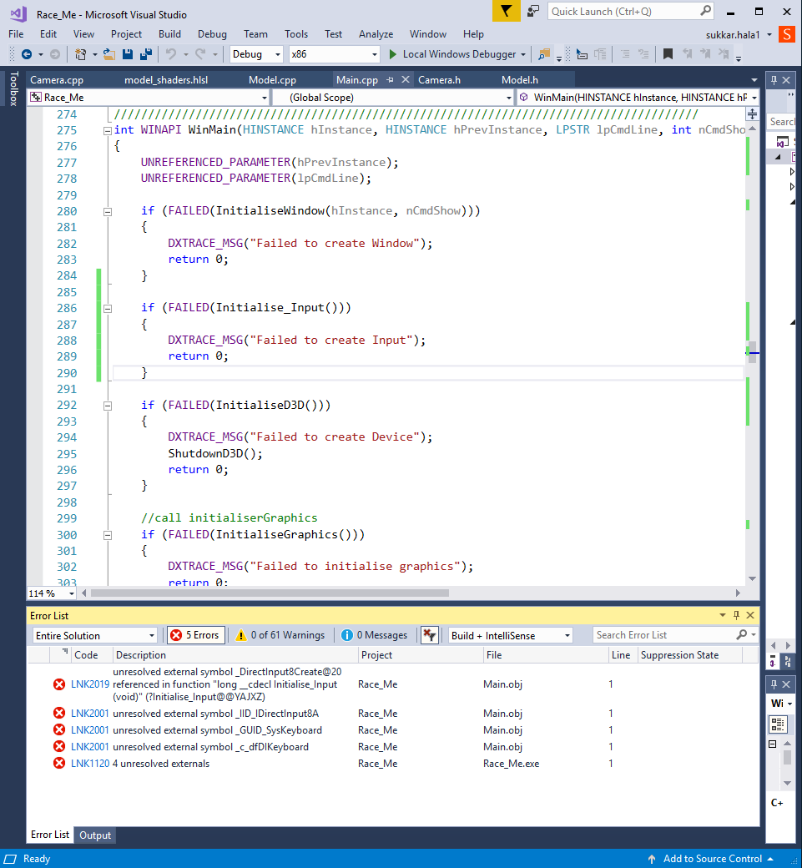

1. Loading model 16/12/2017

After adding the and loading the finished object in the game, then trying to start the game I started getting this error and the game was not loading and I was getting this error.

After reading the code and looking on the header and the .cpp files I realised I didn’t add the Initialise Graphics in winmain.

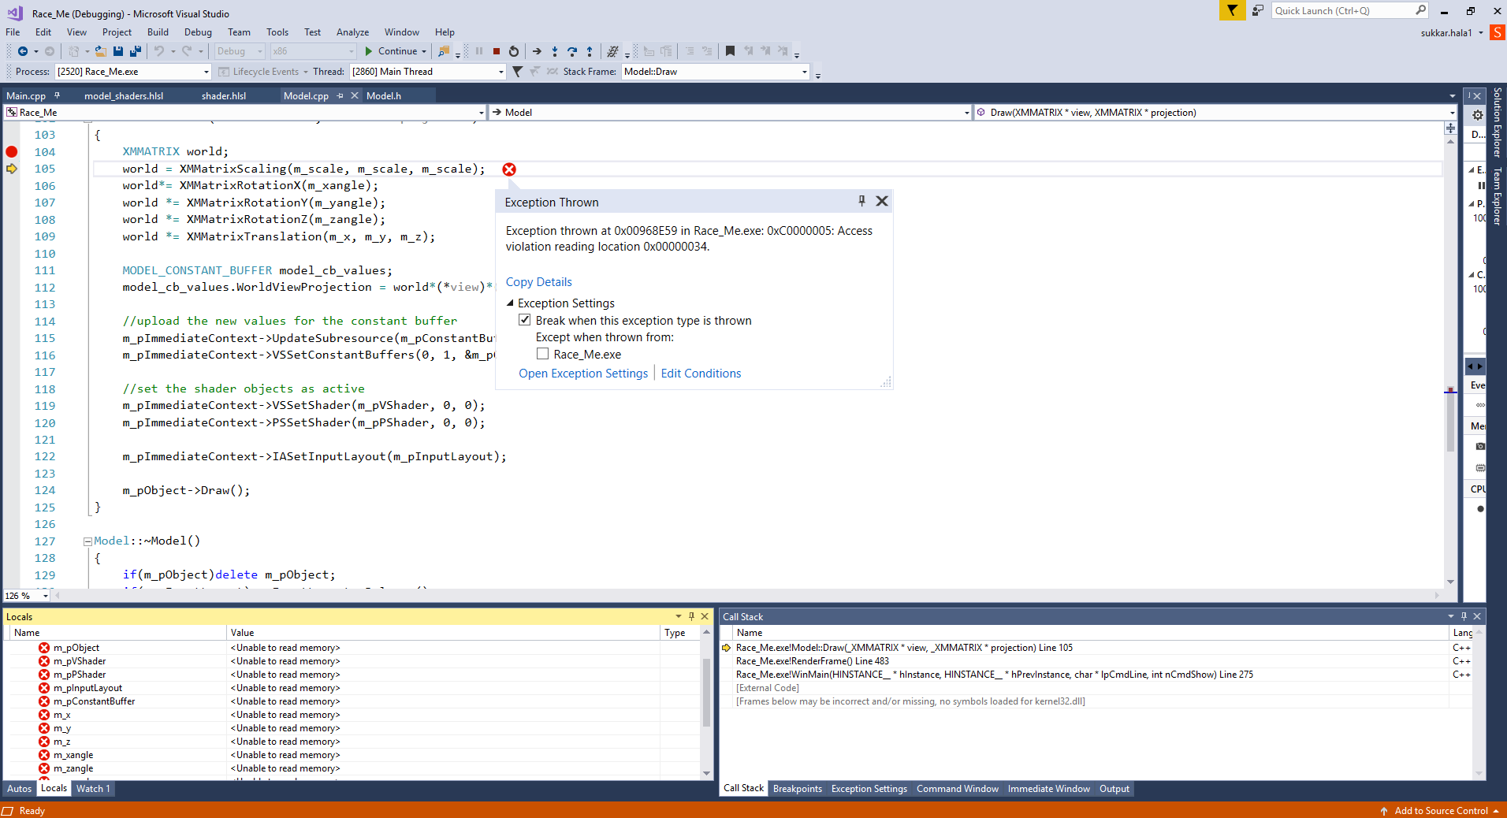

1. Adding the camera 17/12/2017

After adding the camera header and the .cpp file and then testing if the camera work I was getting this error and the game was not starting.

The code looked correct and the files where right and still the game didn’t compile.

After asking my friends and looking into it closely I realised that in the main ->release I deleted the camera then I deleted the input which gave an error because the game was deleting the keyboard input and after that deletes the camera and the gave the error.

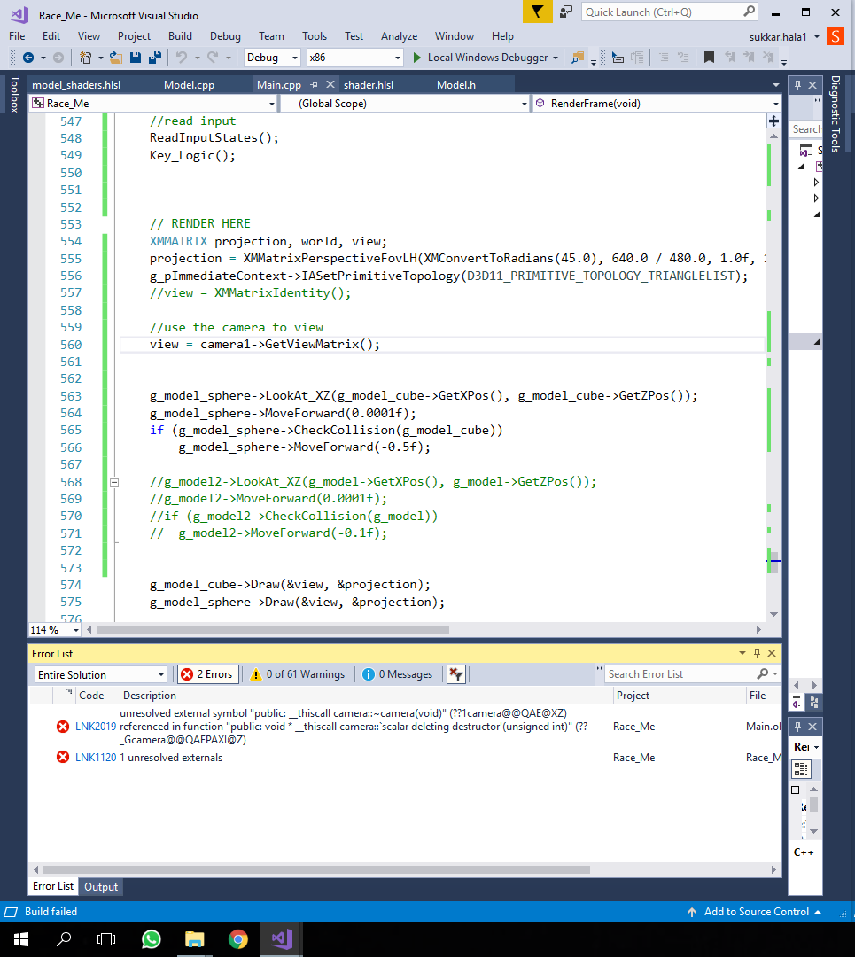

1. The object was not rotating 18/12/2017

After a while I discovered that the player and the AI are not rotating I red the code one more time to realise that in the world view matrix the order was wrong which made the objects don’t rotate when the player treys to.

1. One of the problems I couldn’t solve was changing the view from player camera to AI camera when the player presses (q, e), even though both cameras are working and to change the view I must do that in code.