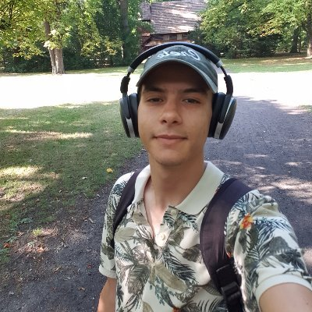

**Hicham Mellouki**

**Email Address:** hichammellouki@gmail.com

**Phone Number:** 06.26.53.81.54

**Education**

* 2010-2016 : Bac, Abou El Khayr High School
* 2016-2019 : Mohammed First University, Oujda

**Experience**

* 2019: Web developer
* 2020: Volunteer

**Hobbies**

Running - Travel - Reading