Laboratory 3 – Motor Control using Semiconductor Sensor, BJTs

Circuits, and Diode Rectifier

Ratthamnoon Prakitpong (63205165)

L2B

04/03/2019

No Lab Partner

**Task 1:**

We had to assemble this circuit for task 1.

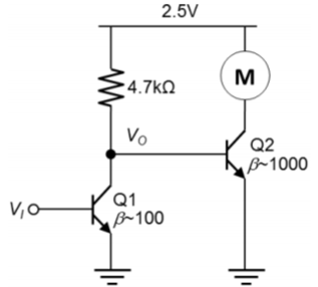

Figure 1.0: Circuit for Task 1

**Task 1.1:**

These are the observations to Vo:

|  |  |
| --- | --- |
| Vi (V) | Vo (V) |
| 0 | 2.5154 |
| 0.7 | 0.02639 |

Table 1.1: Task 1.1 Observation

This is consistent to the behaviour of a BJT. When Vi is low, BJT is cut off and acts like a short circuit, preventing current flow. This results in Vo being Vcc (~2.5V). When Vi is high, BJT is saturated and acts like an open circuit. This results in Vo being Vcc - i*R (~0), or in other word, Vo being grounded. BJT acts like a switch.

**Task 1.2:**

Motor spin at Vi = 0V, and don’t spin at Vi = 0.7V. This makes sense since at Vi = 0V, Vo is high and Q2 become saturated. Q2 lets current flow through the motor has current to power it. When Vi = 0.7V, Vo is low and Q2 becomes cut off. Q2 doesn’t let current flow through so the motor is not powered. BJT acts like a switch.

**Task 2:**

We had to assemble this circuit for Task 2:

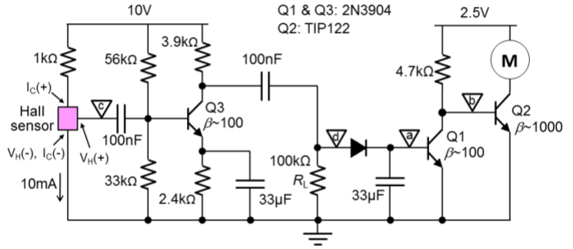

Figure 2.0: Circuit for Task 2

**Task 2.1:**

The sensor was checked and there was an approximately 10mA flowing through Ic(+) to Ic(-).

**Task 2.2:**

After point C was disconnected, these are observed when Vi was varied:

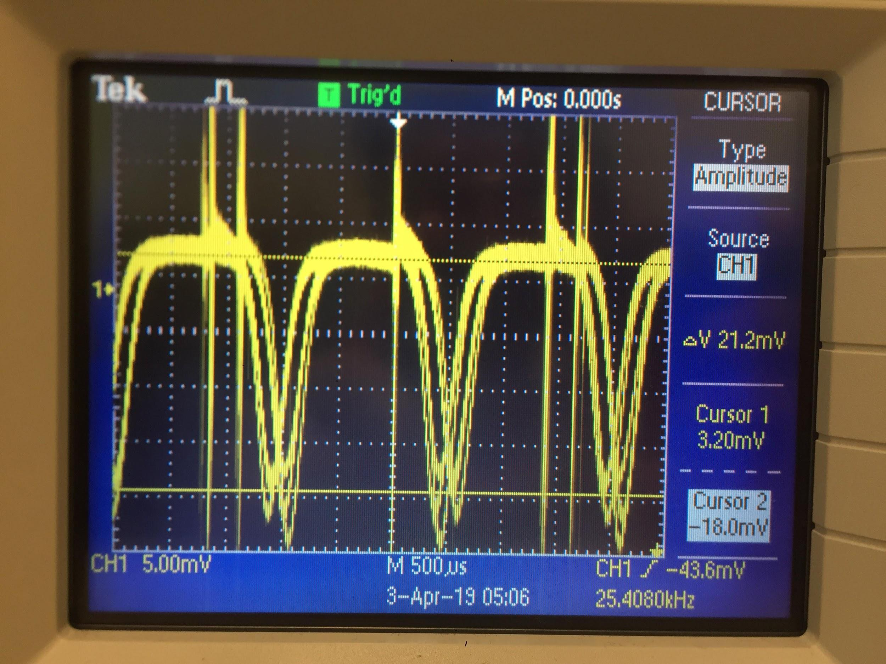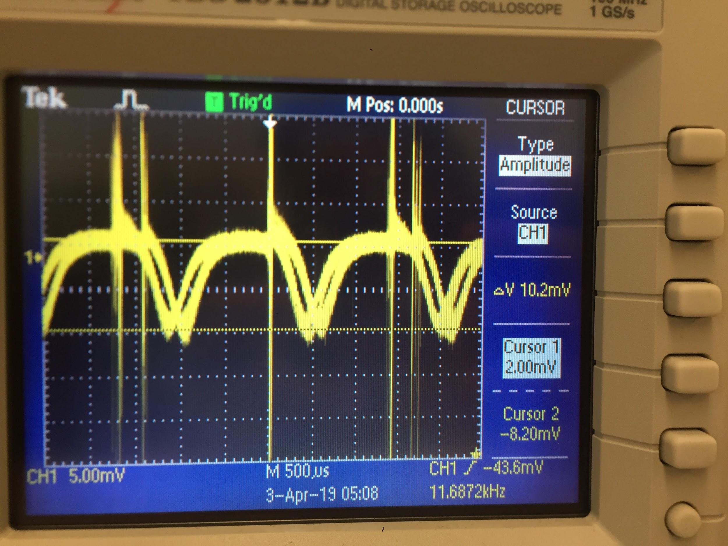

Figure 2.2.1: Waveform at Distance ~2mm; Figure 2.2.2: Waveform at Distance ~5mm

|  |  |
| --- | --- |
|  | VH(+) (mV) |
| 2mm | 21.2 |
| 5mm | 10.2 |

Table 2.2: Task 2.2 Observation

The fact that there was an oscillation in the signal makes sense since sensor signal comes from the rotating magnets attached to the motor. The farther the distance, the weaker input the sensor has, the weaker signal it is able to generate (comparing 21.2mV at ~2mm to 10.2mV at ~5mm).

**Task 2.3:**

After point C was reconnected and point D was disconnected, these were observed:

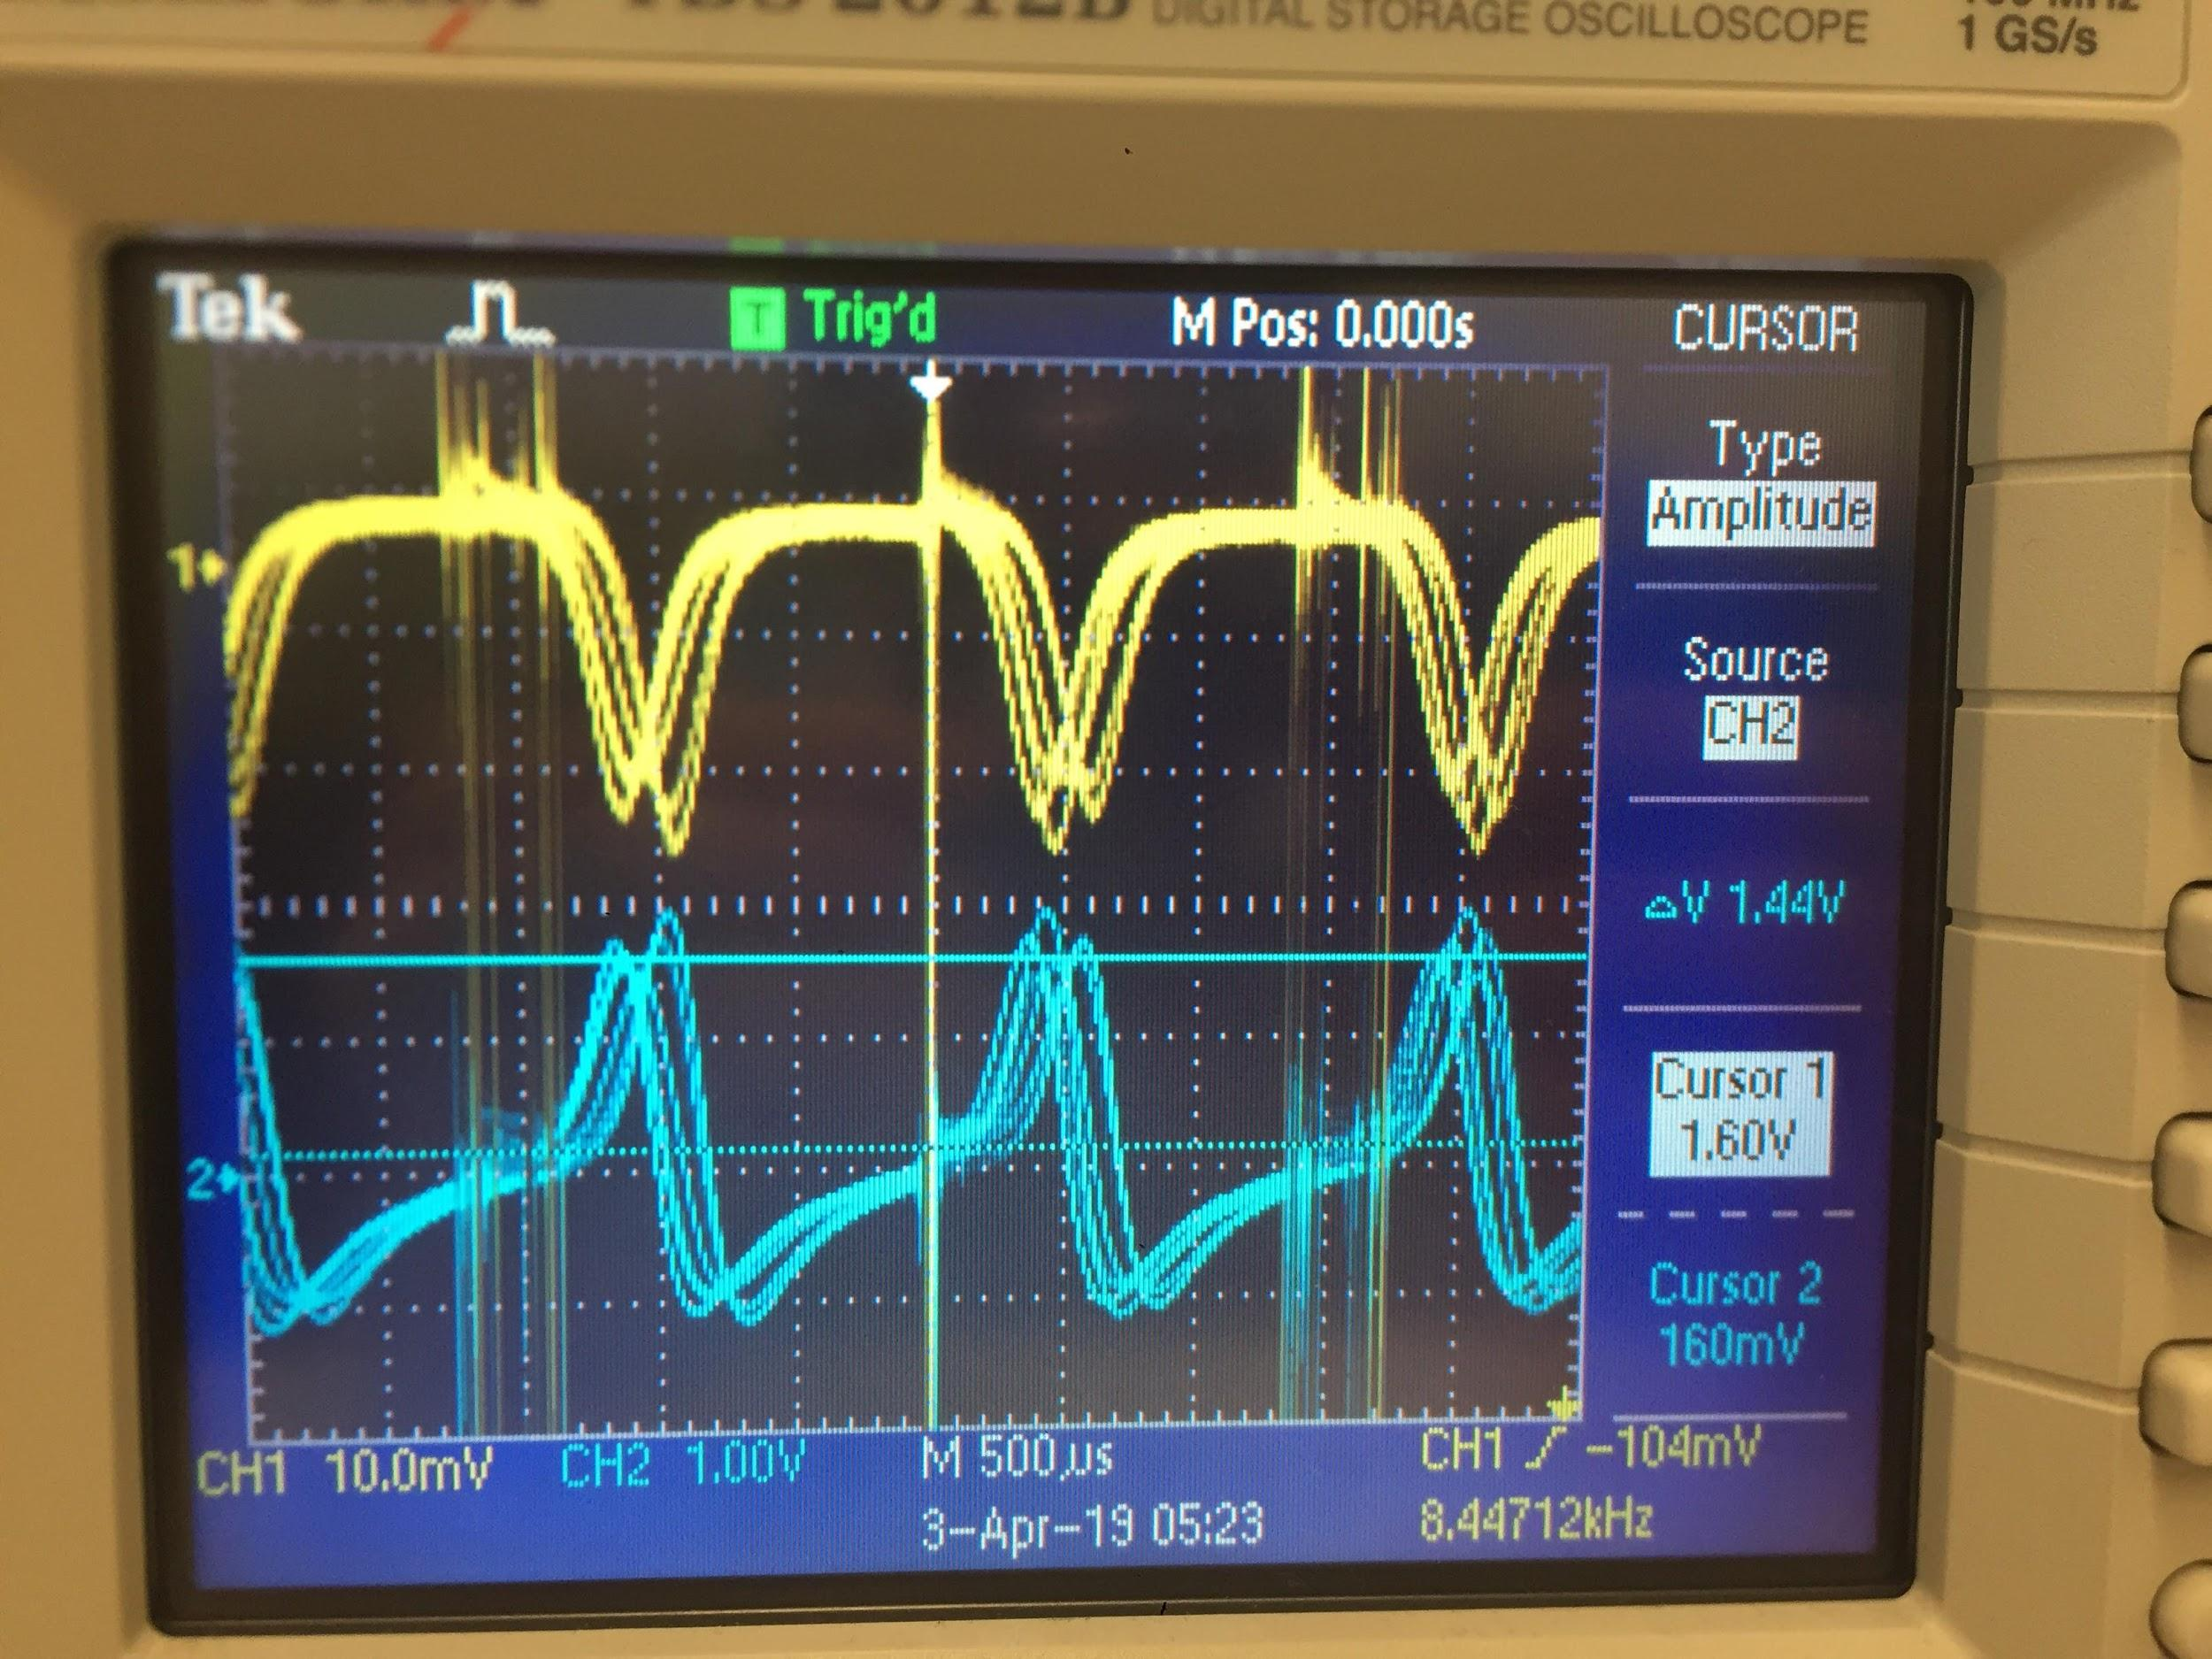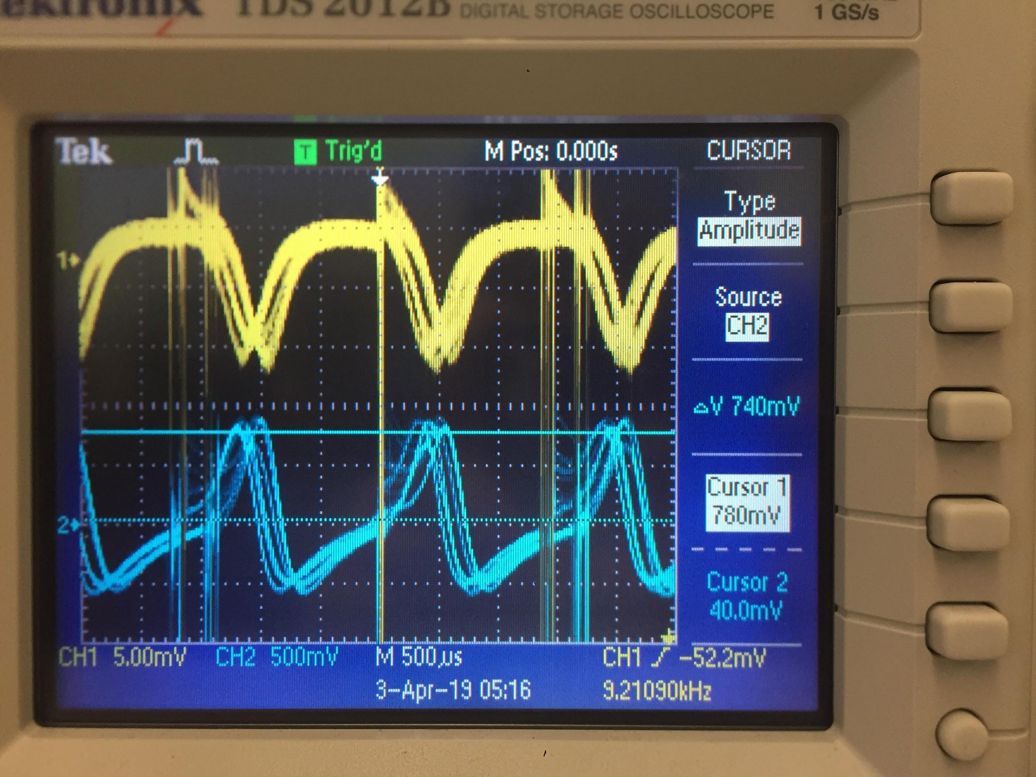

Figure 2.3.1: Waveforms at Distance ~2mm; Figure 2.3.2: Waveforms at Distance ~5mm

|  |  |  |  |  |
| --- | --- | --- | --- | --- |
|  | VH(+) (mV) | V-RL (mV) | IC (mA) | Av |
| 2mm | 19.2 | 1440 | 1.218 | -75 |
| 5mm | 10.2 | 740 | 1.218 | -72.5 |

Table 2.3: Task 2.3 Observations and Calculation

V-RL was obtain from the waveform, where noise (where corresponding VH(+) looks like plateau) was removed. Ic makes sense to remain the same, since it gm is a function of Ic (where gm = Ic/Vt), and Av is dependent on gm, and Av remains constant in this experiment.

From Lab 3, the beta value is 93.2319. In this case, Av can be calculated as shown here:

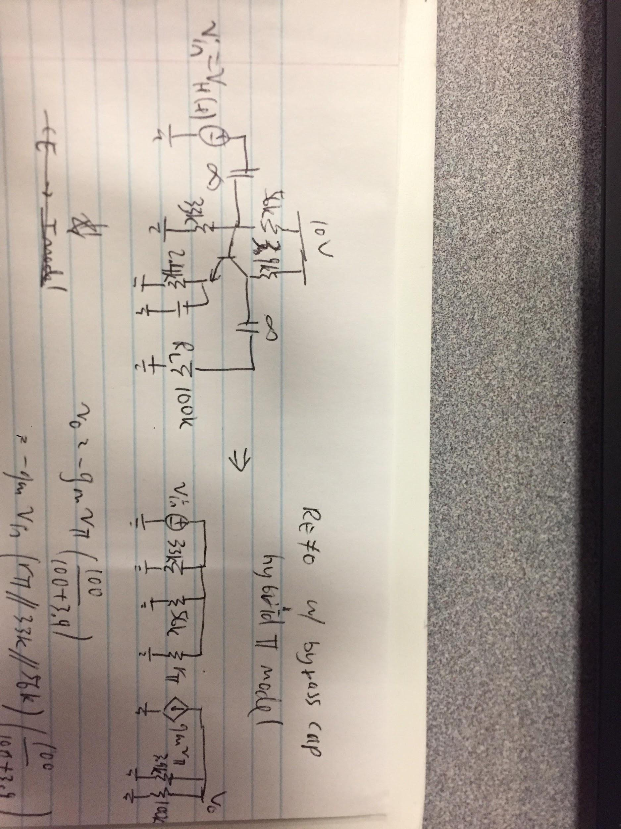

Figure 2.3: Small Signal Equivalent Circuit for Av Calculation

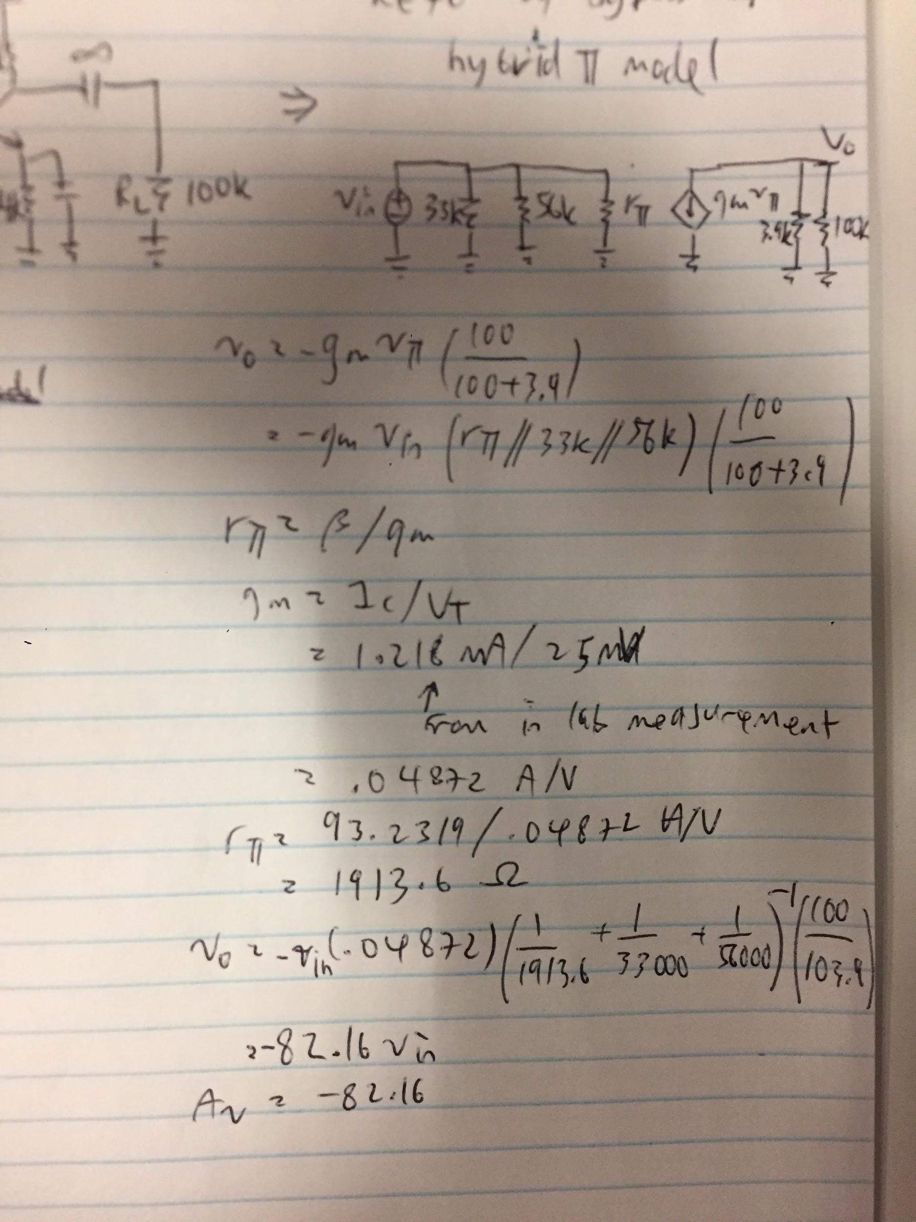

Calculation 2.3.1: Theoretical Av Calculation

Theoretical Av is -82.16, which is approximately 10% from the farther measured number:

% Accuracy = (theoretical - real)/theoretical = (82.16 - 72.5)/82.16 = 11.75%

Calculation 2.3.2: Task 2.3 Verification Calculation

While not the most accurate, the measurement is within a close enough range to the theoretical value to be acceptable.

**Task 2.4:**

After reconnecting point D and leaving point A disconnected, these are observed:

|  |  |
| --- | --- |
|  | Va-rectified (V) |
| 2mm | 2.17 |
| 5mm | 0.892 |

Table 2.4: Task 2.4 Observation

Va is measured at 33uF capacitor. Since the diode and the capacitor is parallel to the RL, and assuming diode resistance is small, it would make sense if Va changes proportional to V-RL. Comparing Va-rectified in Table 2.4 to V-RL observation in Table 2.3, where Va and V-RL at 2mm are higher than and changes by a similar value to Va and V-RL at 5mm, our theoretical discussion makes sense.

Note that values of Va-rectified in Table 2.4 and V-RL observation in Table 2.3 may not make perfect sense if calculated. This is due to an error in the sensor assembly, and the sensor had to be swapped out in between Task 2.3 and 2.4.

**Task 2.5:**

After reconnecting point A, the circuit is completed and these are observed:

|  |  |
| --- | --- |
|  | Va-rectified (V) |
| 2mm | 0.638 |
| 5mm | 0.467 |

Table 2.5: Task 2.5 Observation

The motor spin slowly when the plate (where the sensor is attached) is near, and fast when the plate is far. This makes sense according to the mechanism we have assembled.

The mechanism consist of many parts. At point C, the sensor converts its distance from spinning magnets to low voltage, oscillating signal (Task 2.2). At point D, BJT Q3 acts as a switch that inverts and amplified the small signal, and outputs it to V-RL (Task 2.3). At point A, the amplified signal is rectified so it can be input to control Q1 (Task 2.4). At point B, Q1 receives the rectified signal and switches between saturated/cut off mode to act like a switch, outputting high signal when receiving low signal, and vice versa (Task 1.1). Finally, Q2 receives output from Q1 and uses that to turn the motor on and off (Task 1.2).