Calculations and Discussions:

Task 1:

*Record the measured data directly into the Spreadsheet file. Calculate the average inductance and also record it in your Lab Report in Table 6 with Motor Parameters.*

Using the equation:

$Z = r + jωL$

$L =\frac{\sqrt{Z^{2} - r^{2} }}{ω}$

$L(average) =\frac{ \sum^{n}{}L}{n}$

Eq. 1: Average L calculations

Using these measurements:

|  |  |  |
| --- | --- | --- |
| Angle turn (deg) | Z (ohms) | Angle (deg) |
| 0 | 35.162 | 18.67 |
| 1 | 34.955 | 18.713 |
| 2 | 34.894 | 18.414 |
| 3 | 34.864 | 18.217 |
| 4 | 34.891 | 18.138 |
| 5 | 34.768 | 18.622 |
| 6 | 34.817 | 18.609 |
| 7 | 34.865 | 18.893 |
| 8 | 34.861 | 18.869 |
| 9 | 34.816 | 18.659 |
| 10 | 34.732 | 18.446 |
| 11 | 34.76 | 18.701 |
| 12 | 34.808 | 18.651 |
| 13 | 34.814 | 18.866 |
| 14 | 34.846 | 18.859 |
| 15 | 34.753 | 18.956 |

Table 1: L measurements

|  |
| --- |
| R (ohms) |
| 31.934 |
| f (Hz) |
| 20 |
| w (rad/s) |
| 125.6637061 |
| V |
| 10 |

Table 2: Other measurements needed to calculate for L

|  |  |
| --- | --- |
| Angle turn (deg) | L (H) |
| 0 | 0.2798103054 |
| 1 | 0.2781630518 |
| 2 | 0.2776776292 |
| 3 | 0.2774388968 |
| 4 | 0.277653756 |
| 5 | 0.2766749531 |
| 6 | 0.2770648827 |
| 7 | 0.2774468545 |
| 8 | 0.2774150236 |
| 9 | 0.2770569249 |
| 10 | 0.2763884742 |
| 11 | 0.2766112911 |
| 12 | 0.276993263 |
| 13 | 0.2770410094 |
| 14 | 0.2772956573 |
| 15 | 0.2765555869 |

Table 3: Calculated L for each turn angle

|  |
| --- |
| L_avg (H) |
| 0.2773304725 |
| Tau (H/ohm) |
| 0.008684489024 |
| Flux const. (VH/ohms) |
| 0.08684489024 |

Table 4: Average L and other relevant calculations

Task 2:

*Do all of the half steps appear to be equally spaced? What happens to the direction of rotation when the polarity of one of the phase connections is reversed by plugging the cables in the other way? What if both phases are reversed? You will need to answer these questions in your report.*

They do not appear to be equally spaced. The steps where both windings are energized seems to have larger steps than the steps where only one winding was energized.

When one phase is reversed, the direction of rotation reversed. However, when both windings are reversed, direction of rotation is the same as when both windings are not reversed.

Task 3:

*Stop the motor and set the speed back to about 5 cycles/s. Attach the Mass Clamp to the Torque Arm and repeat part 3). How does the additional mass affect the maximum speed? Could you observe an electro-mechanical resonance (oscillatory vibrations) in the Torque Arm?*

Maximum speed decreases from when there was no mass clamp, from 73 cycles/s to 53 cycles/s. To observe electro-mechanical resonance, you have to put your hand on to jig and feel for when the vibration is the largest. When you increase the speed, the vibration increases, so if you increase the speed until the vibration decrease a little bit, decreasing the speed back a little bit will get you to maximum vibration.

*How do you think it might be possible to drive the given stepper motor at even higher speeds than in step 4)?*

Assuming the question references step 4 because the same amount of mass has to be attached to the motor shaft.

Power equation is:

$P = ωT =iv$

Equation 2: Power equation

Speed is proportional to power, so keeping the same motor, if you increase the voltage, the speed should increase. Additionally, you could also decrease the torque while keeping the same power to increase speed. To decrease torque, attach the mass as close to motor shaft as possible to decrease the moment arm, hence decreased torque. Another way to decrease torque is to decrease the mass.

Task 4:

*Set the speed back to about 5 cycles/s. Run the Stepper Motor in this Micro-Stepping mode by clicking the “RUN/STOP” button on the bottom right. Is the rotation smooth? Does the rotation appear to be truly steady throughout the micro-step cycle or not?*

The rotation feels smoother than the larger steps used previously, since the step increments are extremely small.

It does not feel truly steady since the two windings are energized by sin and cos graphs, respectively, some steps has larger increments between it and the previous step. Additionally, most steps has different energy between two windings, the difference makes it not feel truly steady (similar to task 2 where steps with both energized windings are larger than only one winding energized).

*Slowly increase the rotor speed until the motor loses lock and record this speed in the corresponding column of Table 4. How does this speed compare with that found in Task 3? Is the maximum speed higher or lower than with Full-Stepping? You will need to answer this question in your report.*

Maximum speed decreased from 90 cycles/s to 83 cycles/s compared to task 3, full step with both windings energized. The drop is smaller compared to the drop when only one winding is energized (90 cycles/s to 79 cycles/s compared to 90 cycles/s to 83 cycles/s).

*Stop the motor and set the speed back to about 5 cycles/s. Attach the Mass Clamp to the Torque Arm and repeat step 3). Record the maximum speed in the corresponding column of Table 4. How does the additional mass affect the maximum speed? Did you observe an electro-mechanical resonance in the Torque Arm? You will need to answer this question in your report.*

The mass significantly reduced the maximum speed, reducing from 83 cycles/s to 63 cycles/s. Resonance was still observed, but it decreased from around 20-25 cycles/s to 15-20 cycles/s. This is larger compared to resonance of 5 cycles/s with mass clamp, both windings energized.

Task 5:

*How does the additional mass affect the electromechanical resonance?*

Additional mass decreased resonance frequency when both one and both windings are energized. With one winding energized, resonance frequency decreased from 15 cycles/s to 5 cycles/s. The numbers are the same with both windings energized.

Task 6A-1:

*Plot the inductance of the motor winding as a function of angular position. Does the inductance change significantly? Based on this result, would you say that the variable reluctance effect plays a large or small effect in this particular motor?*

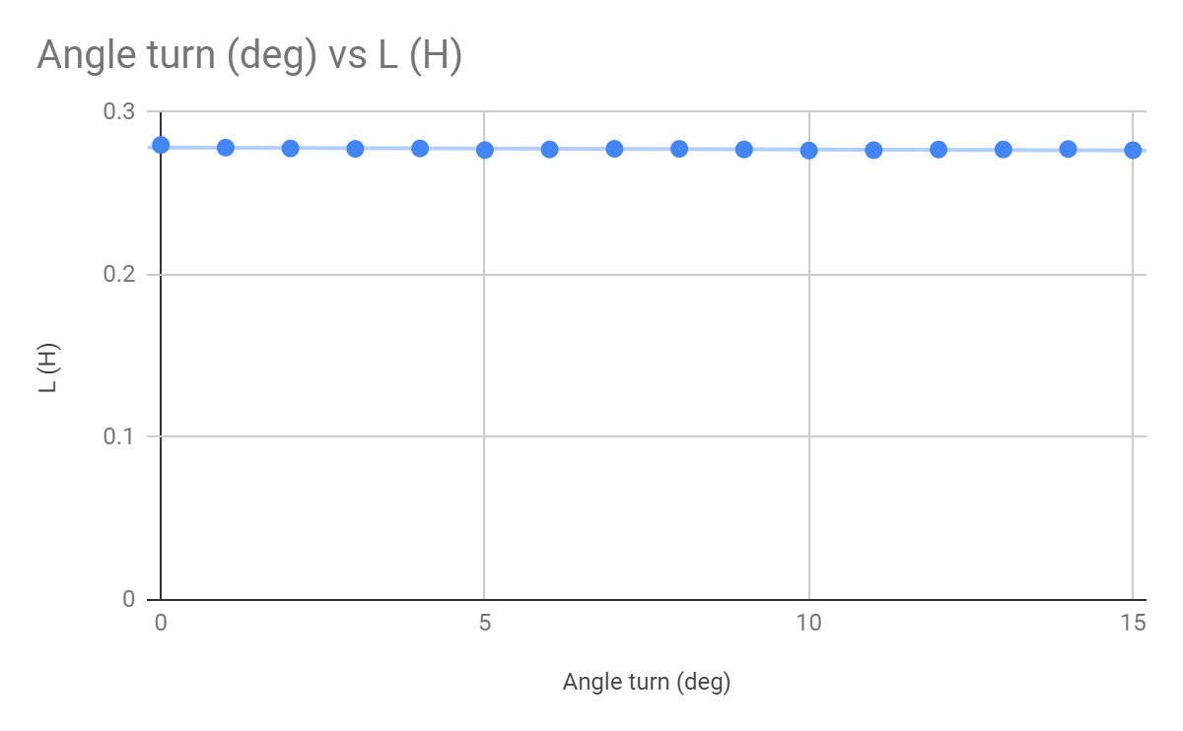

Figure 1: Angular position (deg) vs L (H)

Looking at the plot, the inductance does not change significantly with the angle. The best fit line is a horizontal line. Hence, we can conclude that variable reluctance does not play a significant role in this motor and the average value of inductance can be used in calculations.

Task 6A-2:

*Plot the motor torque curves as a function of angular position. Superimpose/show Phase A, Phase B, and Phases A+B all on the same plot.*

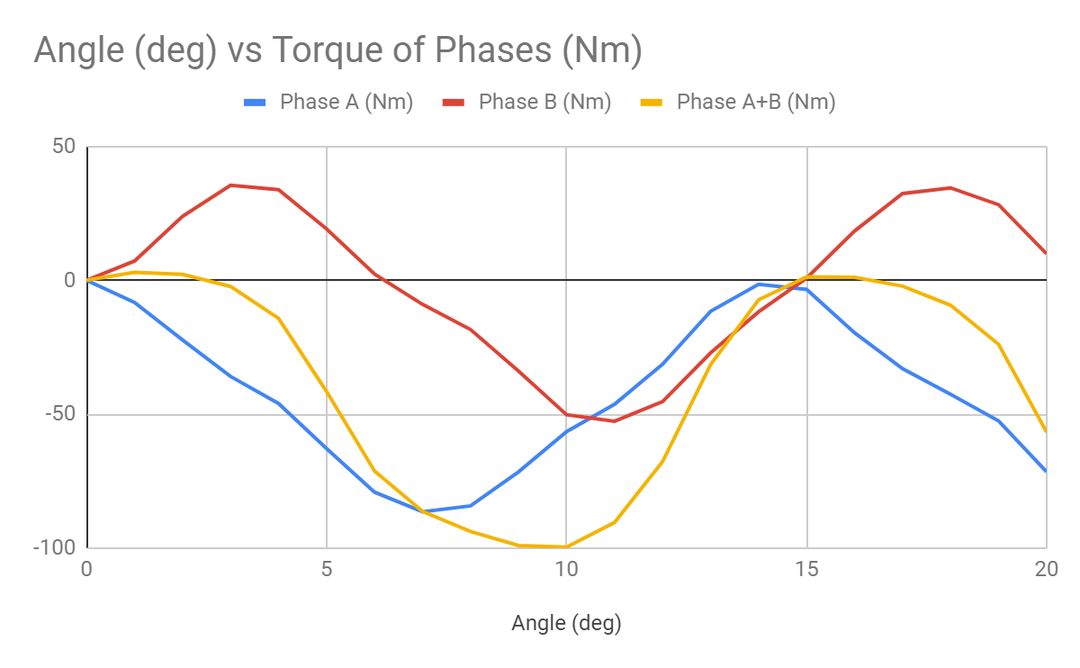

Figure 2: Angle (deg) vs Torque of Phase A, B, A+B (Nm)

Approximately, the sum of phase A and phase B plot results in phase A+B plot.

Task 6A-3:

*Verify that the measured torque curve for A+B corresponds to the expected value calculated from adding the torque from A and from B energized. Included this plot on a separate figure (or subplot) below the previous plot.*

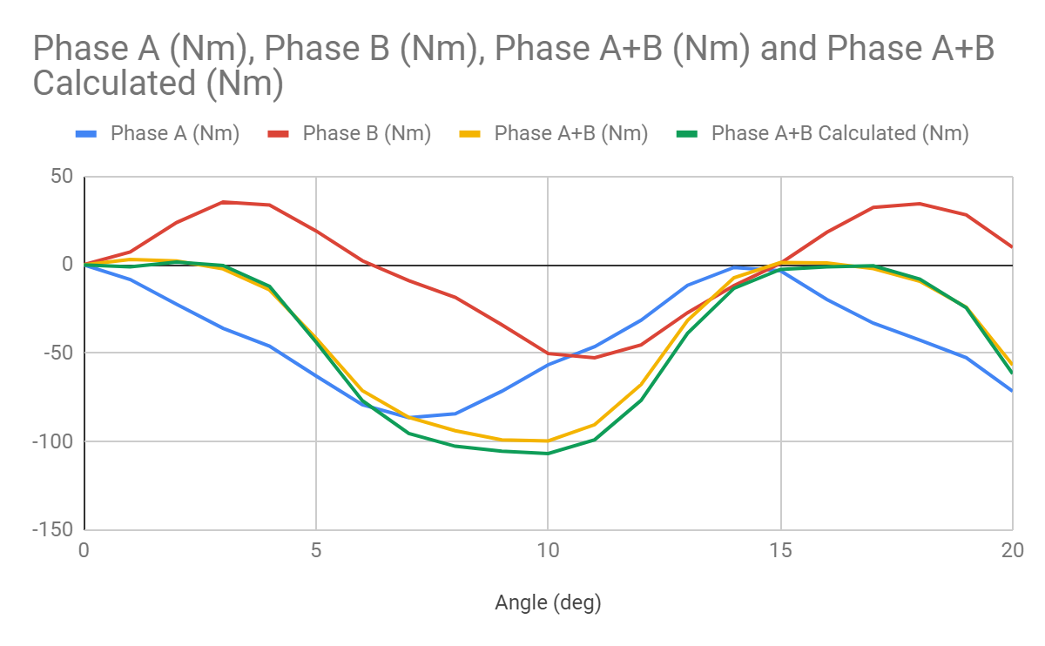

Figure 3: Angle (deg) vs Torque of Phase A, B, A+B (Nm) with sum of Phase A and Phase plotted as Phase A+B Calculated

As shown in Figure 3, the theory that phase A+B is the sum of phase A and phase B is verified. The phase A+B plot and phase A+B calculated plot overlay on top of each other very precisely.

Task 6A-4:

*Based on your plots in steps 2 and 3 you should be able to calculate the step length SL , number of rotor teeth NRT , and the PM flux constant m.*

SL = $\frac{[Degrees per Torque period]}{[number of teeth per torque period]}=\frac{{15}^{∘}}{4}={3.75}^{∘}$

$N_{RT}$ = $\frac{{360}^{∘}}{SL}=\frac{{360}^{∘}}{3.75}= 96$

$λ_{m}=Torque_{pp}[Phase A + B] = 100 Nm$

Task 6A-5:

*Complete Table 6 to characterize your previously “unknown” stepper motor. Clearly indicate how you found the numbers.*

Task 6B-1:

*Provide briefly answers to all the questions you were asked in Tasks 1-5.*

They are above.

Task 6B-2:

*Calculate the theoretical resolution of your 40 position micro-step routine. Given your observations of the rotating Torque Arm while micro-stepping, do you think the actual position accuracy is as good as your predicted resolution? Is it possible to do the microstepping so that the actual resolution is this good? Explain your answer.*

The 40 position micro-step routine divides the 3.6 degree step length by a factor of ten to result in a theoretical resolution of 0.36 degrees. We do not think the actual stepping resolution was this precise because the difference in potential from one step to the other may not always be large enough to overcome the initial friction of the rotor. If this were to happen, the proceeding micro-step would likely compensate for the non-actuated step resulting in a movement greater than theoretical resolution.

We could increase the actual resolution to achieve 0.36 degree precision by decreasing static friction about the rotor or increasing the voltage supplied to the windings. Alternatively we could build a stepper motor that is larger with more teeth or use a stronger permanent magnet to achieve higher precision.