#1

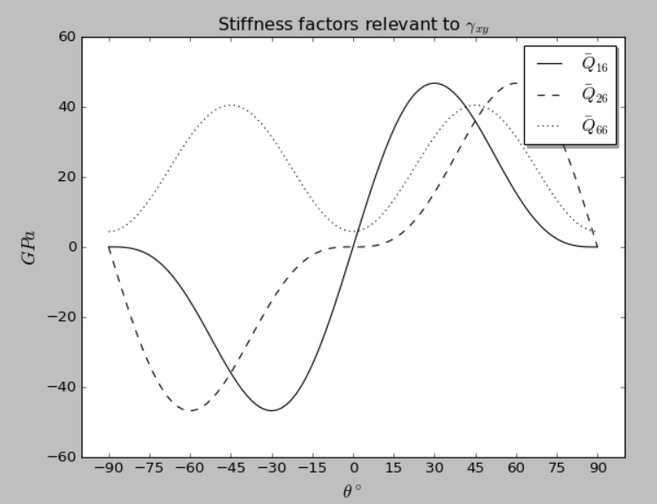

#3

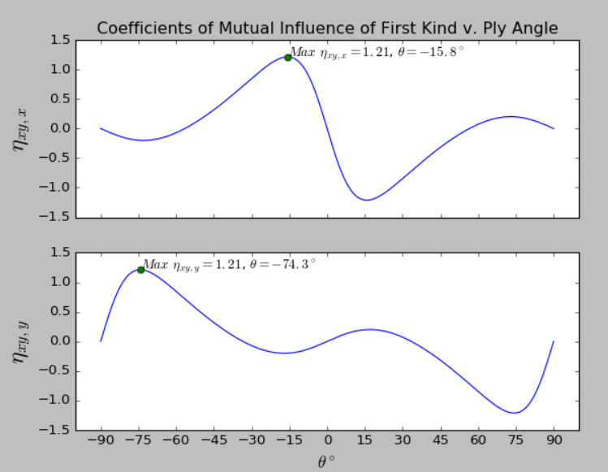

Both coefficients show symmetry about *ϴ=0ᵒ,* in which the sign of the coefficient has flipped. Each coefficient also has a maximal value of 1.21, and knowing about the symmetry, each coefficient will have its maximum value 90ᵒ away from the minimum value of the other coefficient. will have its minimum value of -1.21 at 15.8ᵒ, 90ᵒ away from  max at -74.3ᵒ.