**#1**

* The new tensile modulus goal is 150% of the previous composite, resulting in Erandom of 1.875 *10^6 psi.
* First need to find the volume fractions from the mass fraction of 20%
* Use Halpin-Tsai equations modified for discontinuous fiber to find E1 and E2
* Substitute in Tsai and Pagano equation for Randomly oriented discontinuous fiber
* Now have an equation with **fiber lengt**h as single variable
* Set 3/8*E1 + 5/8*E2 – Erandom = 0 and solve for **fiber length**

*-1511576.3149403 + 150000.0*(33717.0263788969*l_f/(3333.33333333333*l_f + 75.0) + 1)/(1 - 10.1151079136691/(3333.33333333333*l_f + 75.0)) = 0*

* The graph shows the minimum fiber length that will achieve the desired tensile modulus

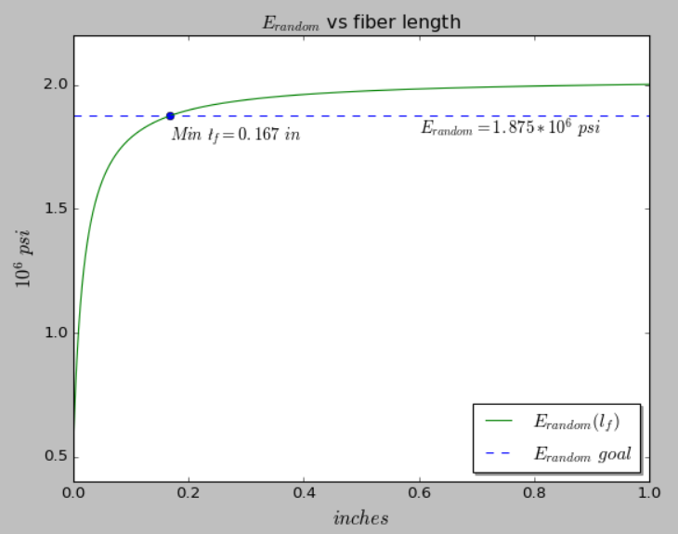

**#2**

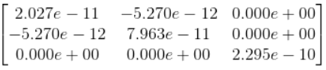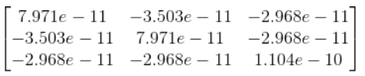

Assuming plane stress for the thin lamina.  is the same as  since no rotation has occurred.

has introduced coupling between tensile and shear components since are non-zero. We also see that the two tensile modulus values have become equal at 45ᵒ.

**#3**

Ex/E1 = 1/(E1*n**4/E2 + m**4 + m**2*n**2*(-2*v12 + (2*v12 + 2)/R))

Solved with algebraic system, see code #3 (includes assumptions about properties)

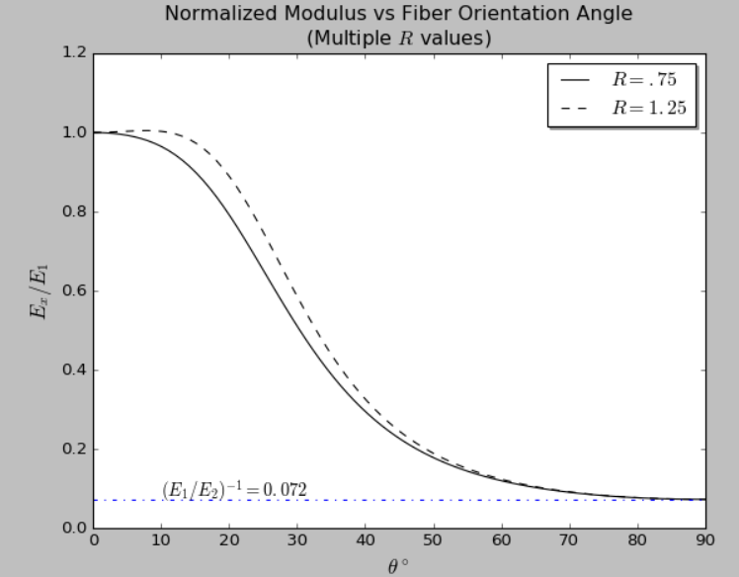

We can see that higher values of R result in equal or higher tensile modulus values across all orientation angles. As expected, both normalized modulus are 1 at 0ᵒ, since no transformation has occurred yet, so it is equivalent to E1/E1. Additionally, we see that Ex/E1 approaches E2/E1 as theta goes to 90ᵒ, which occurs since E1 and E2 are 90ᵒ apart.