#1

a)

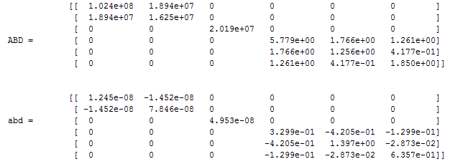

b)

$${\overline{υ}}_{xy}=1.1658$$

c) Very high effective Poisson’s ratio, strain in the transverse direction will be much higher than in the axial direction. This is the benefit of composites since most base materials have an upper limit of .5 for their Poisson’s ratio.

Source for common values: <https://www.engineeringtoolbox.com/poissons-ratio-d_1224.html>

d)

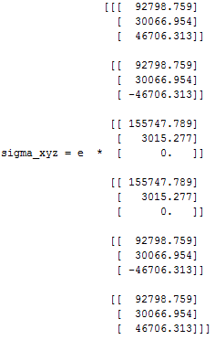

#3

