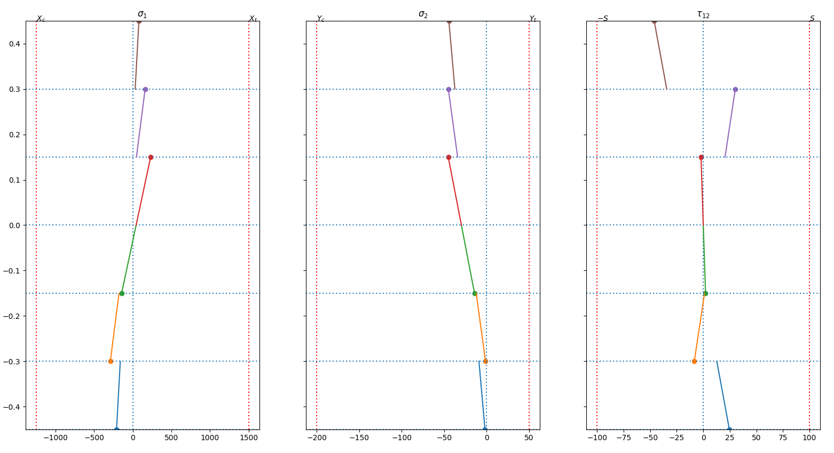

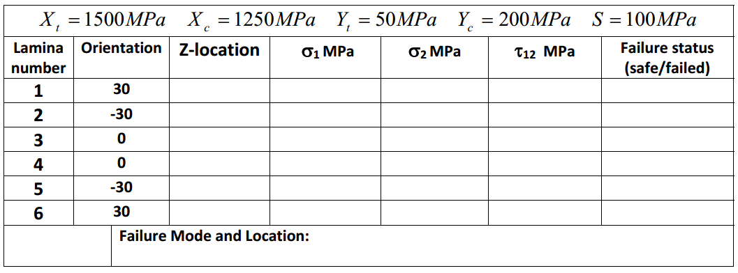

#2

Mx= -73.34 / 25.44 (Nm/m) in (30) ply at Z=-0.450mm

Mx= -103.37 / 24.80 (Nm/m) in (-30) ply at Z=-0.300mm

Mx= -164.14 / 45.53 (Nm/m) in (0) ply at Z=-0.150mm

Mx= -45.53 / 164.14 (Nm/m) in (0) ply at Z=0.150mm

Mx= -24.80 / 103.37 (Nm/m) in (-30) ply at Z=0.300mm

Mx= -25.44 / 73.34 (Nm/m) in (30) ply at Z=0.450mm

--------------------

FPF from -Mx=-24.80 (Nm/m) in (-30) ply at Z=0.300mm

FPF from Mx=24.80 (Nm/m) in (-30) ply at Z=-0.300mm