i)

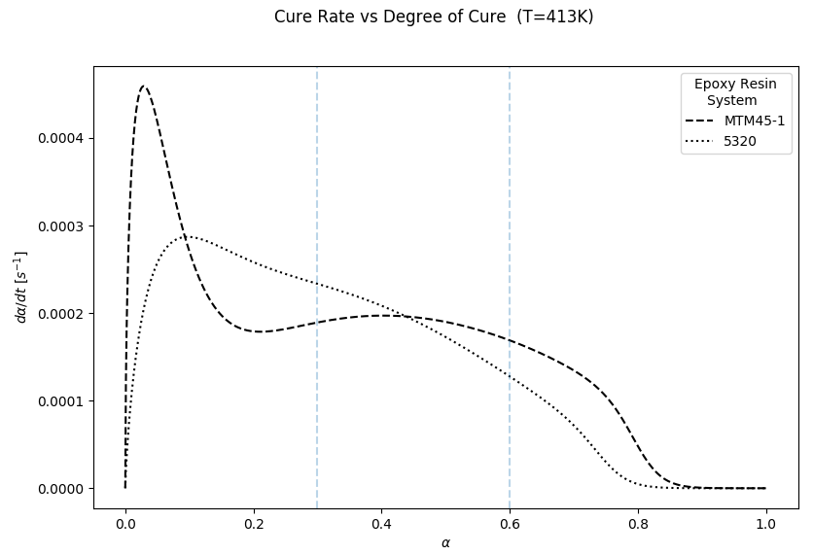

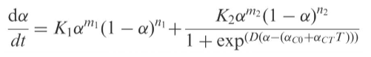

$K_{1}=A_{1}\exp\left(\frac{-E_{A1}}{RT}\right)$ $K_{2}=A_{2}exp⁡\left(\frac{-E_{A2}}{RT}\right)$

ii)

**0-.3**: This represents the activation dominated stage of the resin systems, in which the rate of cure starts out very quickly then would tend to zero if the diffusion portion were not considered. MTM45-1 experiences a very high rate of cure in this region, where as 5320 starts out much slower, but its activation period last slightly longer.

**.3-.6**: This is the diffusion dominated stage of the cure cycle. 5230 experiences a higher max cure rate sooner during the diffusion period, but this does not last as long as the diffusion stage experienced by MTM45-1 which starts later in its cure cycle.

**>.6**: This is the exponential asymptote that is reached towards the end of the cure cycle. Here it shows how the rate of cure will eventually go to zero for each resin system. However, we see that MTM45-1 maintains a higher cure rate in this region so it would be more feasible to bring this resin system to a higher degree of cure than 5320.