

**Microsoft Dynamics NAV:**

**Labour Hire**

**Role-Tailored Client (RTC)**

**Training:**

***Internal Payroll Process***

(This is hidden text) Select All (Ctrl-A) of the document, then press F9 to update the auto-fields.

|  |  |
| --- | --- |
| **Prepared By:** | Robyn Dumbleton |
| **Updated By** | Andrea Halbert |
| **Version:** | 3.0 |
| **Date Updated:** | **12th February 2018** |
| **Status:** | **Release** |

(This is hidden text) Use Alt+1 for Heading1, Alt+2 for Heading2 and Alt+N for Normal style

**REVISION HISTORY**

*This document is under version control.*

| **Version No.** | **Reason for Update** | **Date Issued** |
| --- | --- | --- |
|  |  |  |
| 1.0 | NAV2009 Role-Tailored Client | 01/07/2012 |
| 1.1 | NAV2013 RTC Screenshots added + reformatted | 21/03/2013 |
| 2.0 | NAV2016 RTC Updates | 23/02/2016 |
| 3.0 | NAV2017 RT Updates | 12/02/2018 |
|  |  |  |

**REFERENCE DOCUMENTS**

*This document is under version control*

| **Version No.** | **Document Title** | **Date Issued** |
| --- | --- | --- |
|  |  |  |
|  |  |  |
|  |  |  |
|  |  |  |
|  |  |  |
|  |  |  |

**DOCUMENT INSTRUCTIONS**

*This document is under version control*

| **Field Type** | **Description** | **Example** |
| --- | --- | --- |
|  |  |  |
| MENU PATHS | Menu paths are bold & highlighted in blue | **Departments/Labour Hire** |
| ACTIONS | Actions are bold & highlighted in red | **Actions Button>Functions>Post** |
|  |  |  |
|  |  |  |
|  |  |  |

**TABLE OF CONTENTS**

1 Introduction 5

2 Internal Payroll Processing Overview 6

3 Process Summary: 7

3.1 Entering New Employees 7

3.2 Processing Pays 9

4 Pay Process Detail 11

4.1 Entering New Employees – Human Resources Module 11

4.1.1 Edit: Employee Card 11

4.2 Entering New Employees – Payroll Module 12

4.2.1 Edit: Payroll Employee Card 13

4.2.2 Payroll Employee Card – Pay Dissections 16

4.2.3 Payroll Employee Card – Pay Rates 18

4.2.4 Payroll Employee Card – Gross / Allowances 18

4.2.5 Payroll Employee Card – Deductions 20

4.2.6 Payroll Employee Card – Superannuation 21

4.2.7 Payroll Employee Card – Leave Accruals 22

4.2.8 Payroll Employee Card – On Cost Transactions 23

5 Payroll Processing 26

5.1 Payroll Processing – Pay Journals 26

5.2 Payroll Processing – Enter any leave adjustments 26

5.3 Payroll Processing – Calculate Pays 27

5.4 Payroll Processing – Entry Validation Reports 28

5.5 Payroll Processing – Uncalculating Pays 29

5.6 Payroll Processing - Create Bank Transfer File 29

5.7 Payroll Processing - Post and Print Pay Advices 31

5.8 Payroll Processing - Close Pay Periods 34

# Introduction

This document has been prepared as a training manual for users of the Dynamics NAV 2017 Labour Hire Suite module.

This document will contain information relating to Internal Payroll Processing encompassing the following sections:

* Entering New Employees
  + Employee Card
  + Payroll Employee Card
* Processing Pays
  + Pay Journals
  + Enter Leave Adjustments
  + Calculating Pays
  + Entry Validation Reports
  + Un-calculating Pays
  + Creating a Bank Transfer File
  + Post and Print Pay Advices
  + Close Pay Period

# Internal Payroll Processing Overview

All internal staff will be entered into the Human Resources and Payroll modules of Dynamics NAV.

An overview of the payroll process flow is below.

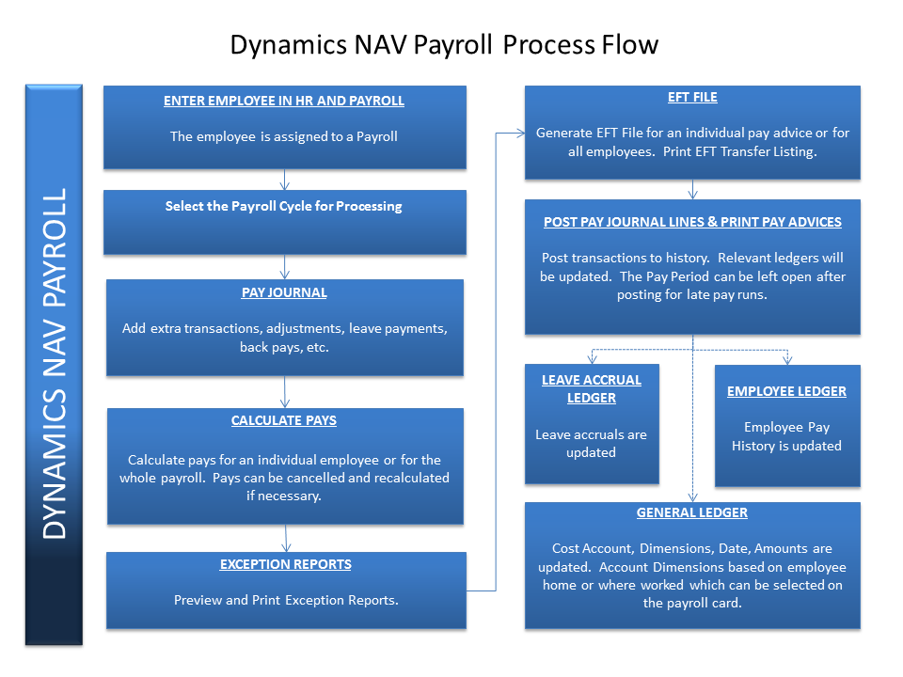

# Process Summary:

## Entering New Employees

1. Receive employee application and relevant details to enter into Dynamics NAV.
2. Enter new employee information into the Human Resources module. To access the Employee Maintenance task, go to the following menu:

Departments/Payroll/Employee Maintenance/Employees

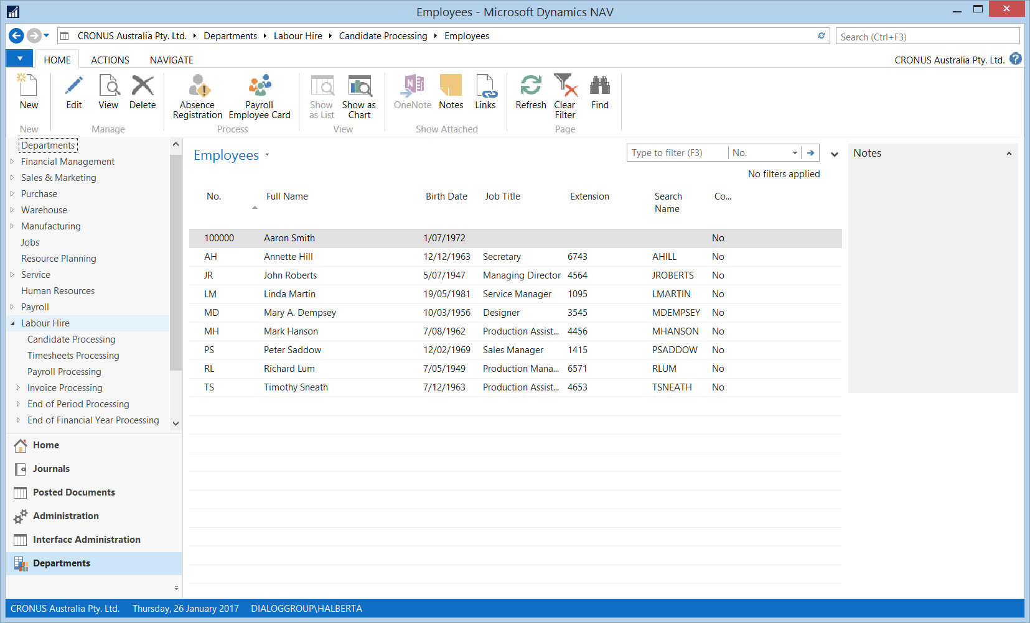

* Enter the new employee into the Payroll module. To access the Employee Maintenance task Click the “Payroll Employee Card” button or go to the following menu:

Departments/Payroll/Employee Maintenance/Payroll Employees

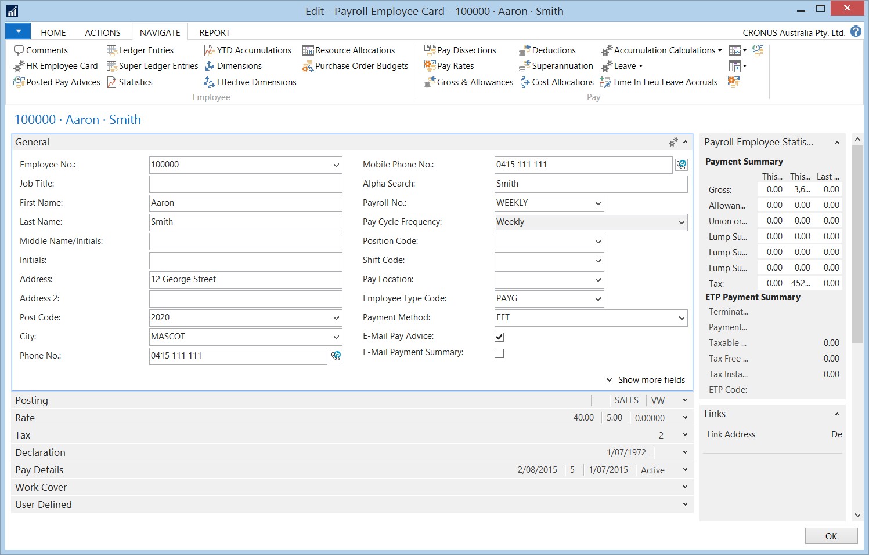

* Enter in Bank Details. To access the Bank Details task, Click the “Pay Dissections” task icon.
* Enter in Pay Rates in as an hourly rate. To access the Bank Details task, Click the “Pay Rates” task icon.
* Enter in Permanent Pay and Allowances. To access the Pay and Allowances task, Click the “Gross & Allowances” task icon.
* Enter in Permanent Deductions. To access the Deductions task, Click the “Deductions” task icon.
* Enter in Superannuation Fund. To access the Superannuation task, Click the “Superannuation” task icon.
* Enter in Employer On Costs such as Payroll Tax. To access the Employer On Costs task, Click the “Accumulation Calculations” and select the “Employer On Costs” task icon.
* Review and Add new leave accrual types such as Annual Leave , Sick Leave and Long Service Leave. To access the Leave Accrual task, Click the “Accruals” task icon.
* After you have completed these steps, you are then ready to process pays.

## Processing Pays

* Receive timesheets including Leave and /or pay adjustments for employees.
* Go into Departments/Payroll/Payroll Processing/Payroll Selection and select the payroll you wish to work in (note this is optional).

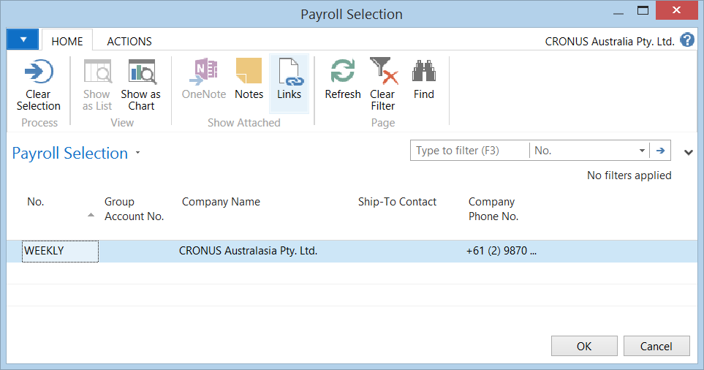

* Go into Departments/Pay Journal/Pay Processing/Pay Journal and enter in the leave adjustments. After completing entering adjustments, select the “Calculate Pays” function.

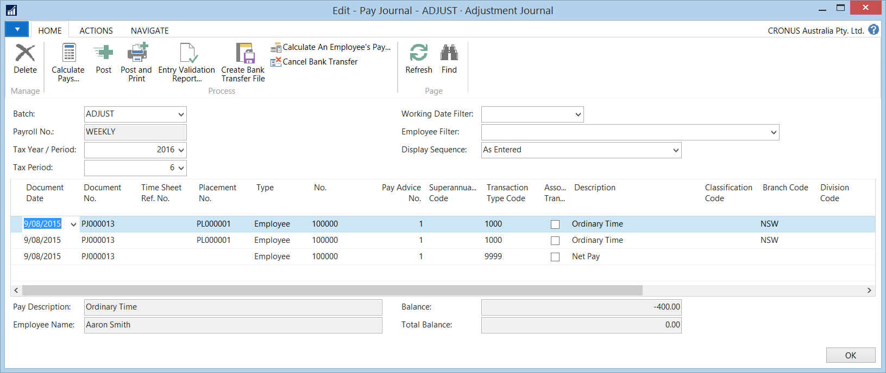

* In the Pay Journal - Select “Calculate Pays” to calculate your pays and “Enter the Pay Date“ and select “OK”.
* Then run the “Entry Validation Report” , select print preview to check for errors and warnings on the screen, when all clear, Print.
* Then select “Create Bank Transfer File” to create an EFT file. This can be saved to a file path. A *“Bank Transfer Listing”* report will print automatically at this stage. This should be filed with the *“Entry Validation Report”.*
* Then select “Post”. This will post the pays into the payroll history areas and print payslips.

After posting of the journal has occurred, you will be asked if you want to close the pay period. You can leave this open if there are and additional adjustments that may need to be processed in this period, otherwise, you can close the period, ready for the next period.

# Pay Process Detail

## Entering New Employees – Human Resources Module

To access the Employee Maintenance task, go to the following menu:

**Departments/Payroll/Employee Maintenance/Employees**



Click on the “New” button. The cursor will be on the ‘Employee No’ on the General Tab. Press ‘OK’, NAV will allocate the New Employee number. Proceed to complete the following details.

### Edit: Employee Card

| **Field Name** | | **Description** | | |
| --- | --- | --- | --- | --- |
| ***GENERAL FASTTAB*** | | | | |
| Job Title | | Enter the Person’s Job Title | | |
| First Name | | Enter the Employee’s First Name | | |
| Last Name | | Enter the Employee’s Last Name | | |
| Address | | Enter in the Employee’s Address Details. | | |
| Post Code / City | | Enter in the Employee’s Post Code e.g. 2000. | | |
| Sate / Country Code | | Enter in ‘AUS’ | | |
| Phone Number | | Enter in the employee’s home phone number if known. | | |
| Gender | | Select ‘Male’ or ‘Female’ | | |
| Marital Status | | If the Marital Status is known, select the appropriate code from the drop down arrow. | | |
| ***COMMUNICATION FASTTAB*** | | | | |
| Extension | | | Enter the employee’s work extension number if applicable. | |
| Mobile Phone No | | | Enter the employee’s mobile phone number if applicable | |
| Phone No. | | | The employee’s phone number will default if entered on the General Tab | |
| E-mail | | | Enter the employee’s email address. This will be required if intending on emailing the employee’s pay advice | |
| ***ADMINISTRATION FASTTAB*** | | | | |
| Employment date | | | | Enter the employee’s employment or start date. This field is a mandatory field, if nothing is entered will cause issues when calculating pays. |
| Status | | | | This will default to ‘Active’ |
| ***PERSONAL FASTTAB*** | | | | |
| Birth Date | Enter the employee’s birth date | | | |
| **Click** “OK” once you have completed all fields required. | | | | |

## Entering New Employees – Payroll Module

After employees are entered into the Human Resources module they are then entered into the Payroll module. All employee maintenance such as applications, updates to pay details, bank details and tax information is maintained on the Payroll Employee Card.

To access the Employee Maintenance task Click the “Payroll Employee Card” button or go to the following menu:

Departments/Payroll/Employee Maintenance/Payroll Employees

Click on the “New” button.

On the Payroll Employee Card go to the Employee No and from the Employee List select the employee you wish to continue entering on Payroll and proceed to complete the following details:

Once the New Employee has been selected ‘Press Enter’ and the information that was entered into the Human Resources Employee Card will default to the relevant fields in the Payroll Employee Card.

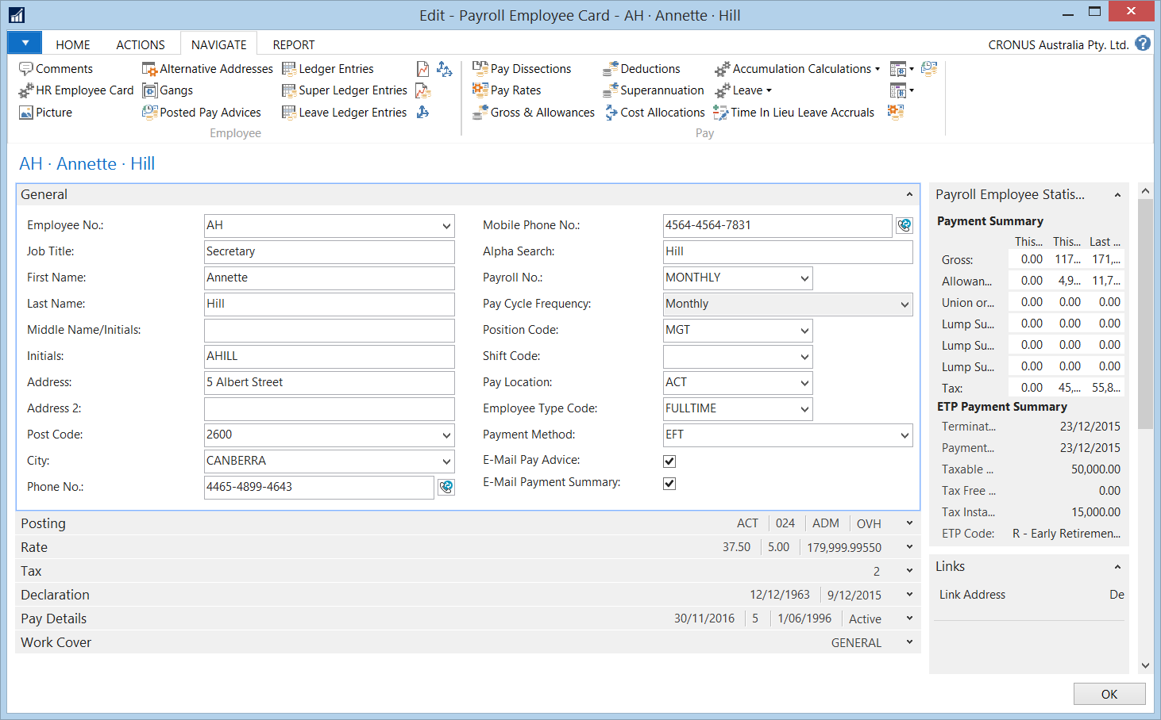

### Edit: Payroll Employee Card

| **Field Name** | **Description** |
| --- | --- |
| ***GENERAL FASTTAB*** | |
| Payroll No | Select the appropriate Payroll No. from the “ArrowDown”. You will receive a message requesting whether you want to change the Employee to the Payroll No. you have selected. Click ‘Yes’ |
| Emp Type Code | Select the Employee Type Code from “ArrowDown”. |
| Payment Method | Confirm the Payment Method has been changed to ‘EFT’. This will default to the Defaults on the Payroll Setup Card. |
| Email Pay Advice | If Pay advices will be sent via email, check this field. The employee’s email address must be entered in the Human Resources field, otherwise you will not be able to email the pay advice. |
| Email Payment Summaries | If Payment Summaries will be sent via email, check this field. The employee’s email address must be entered in the Human Resources field, otherwise you will not be able to email the pay advice. |
| Timesheet Reminder | The Timesheet Reminder field will default to ‘Yes’. Uncheck this field. |
| ***POSTING FASTTAB - The Posting Tab determines where and what information will be posted to the GL Accounts.*** | |
| Branch Code | Select the relevant Branch Code from the “ArrowDown”. |
| Global Dimension 1 &2 | Select the relevant Dimension Codes from the “ArrowDown”. This will usually be the same as the Branch Code. |
| ***RATE FASTTAB - There is nothing that needs to be completed on this tab, as the pay rates are later entered in the Pay Rates area.*** | |
| ***TAX FASTTAB*** | |
| Tax Scale No | The Tax Scale No. will default from the Payroll setup card and can be overridden. |
| HELP Debt | Select this field if advised on the declaration form. |
| Student Loan ( SFSS ) | Select his field if advised on the declaration form. |
| Fixed Tax Rate Applicable | This Field needs to be selected and ticked. |
| Fixed Tax Rate Valid Until Date | The Valid Until Date will be supplied from the ATO and needs to be entered in this field. |
| Fixed Tax Rate | The ATO will supply a letter detailing the fixed Tax rate amount. |
| G.S.T. Exempt | This relates to the setup of an Incorporated Company and if this is required, it needs to be ticked. |
| Fringe Benefits Amount | This field needs to be entered for reporting on the PAYG Payment Summary. |
| Inc. Company Tax Inv.Not Req | This relates to the setup of an Incorporated Company and if this is required, it needs to be ticked. |
| ***DECLARATION FASTTAB - If you have an Employment Declaration form for your employee, check the fields as per this form if you intend on remitting your employment declarations electronically to the ATO.*** | |
| Resident | Select this field if advised on the Declaration Form. |
| Tax Free Threshold Claimed | Select this field if advised on the Declaration Form. |
| HELP Debt | Select this field if advised on the Declaration Form. |
| Student Loan | Select this field if advised on the Declaration Form. |
| Claim Pension Rebate | Select this field if advised on the Declaration Form. |
| Use TFN for Superannuation | Select this field if advised on the Declaration Form. |
| Rebate Amount Claimed | Select this field if advised on the Declaration Form. |
| A.B.N. | This relates to the setup of an Incorporated Company and needs to be entered – the format of this field is 11 characters. |
| Incorporated Company Name | This relates to the setup of an Incorporated Company and will need to be entered. |
| Tax.File No | Enter the employee’s Tax File No. the format for this field is a maximum of 9 characters. |
| Birth Date | This field will populate from the HR Employee card. |
| Date Declaration Signed | Enter in the Date Declaration Signed from the Employment Declaration form. |
| Payee Signature | If the employee has signed the Employment Declaration form, check this field. |
| Declaration Lodged | This field will be populated with a date once the Declaration File Generation has been processed. |
| ***PAY DETAILS FASTTAB - There is nothing that needs to be completed on this tab, as the pay details are populated from the history ledgers.*** | |
| ***WORK COVER FASTTAB - This tab is only required if the employee has been setup as an Incorporated Company.*** | |
| Workers Comp Policy No. | The “Workers Comp Policy No” is used to record a Contractors policy number. |
| Workers Comp Insurer | The “Workers Comp Insurer” is used to record the name of the Contractors Workers Comp Insurer. |
| Policy Expiration Policy | The “Policy Expiration Date” is used to record the expiry date of the policy. |

### Payroll Employee Card – Pay Dissections

Employee Bank accounts are entered in the Pay Dissections area.

Access this task by clicking the“Pay Dissections”task icon.

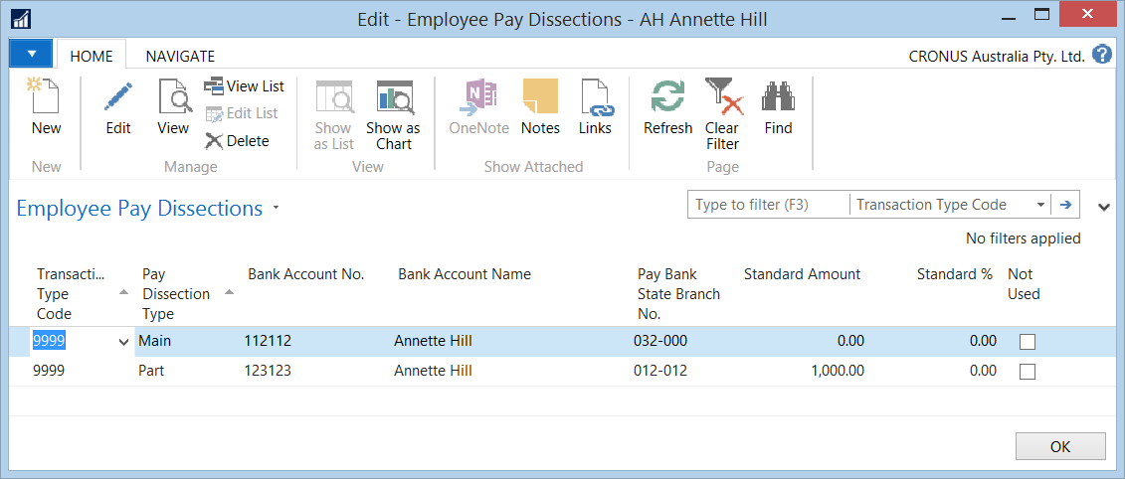

| **Field Name** | **Description** |
| --- | --- |
| Transaction Type Code | Transaction Type Code 9999 will default in this field. |
| Pay Dissection Type | There are 2 types of dissections:   * Main – Used to identify the main bank account * Part – Used to identify additional bank accounts |
| Bank Account No. | Enter the employee’s bank account number. This field has a limit of 9 characters which should be entered as follows: 123456789 |
| Bank Name | This will default to the employee’s name and can be overridden accordingly |
| EFT Bank No. | Enter in the employee’s BSB no. This field has a limit of 7 characters which should be entered as follows: 032-170 |
| Standard Amount / Standard % | If the employee has nominated an additional account, enter in the Amount or the Percentage as nominated by the employee. |
| **Click** “OK” once you have completed all fields required. | |

### Payroll Employee Card – Pay Rates

Enter in Pay Rates in as an hourly rate. To access the Employee Pay Rates task, click the “Pay Rates” task icon.

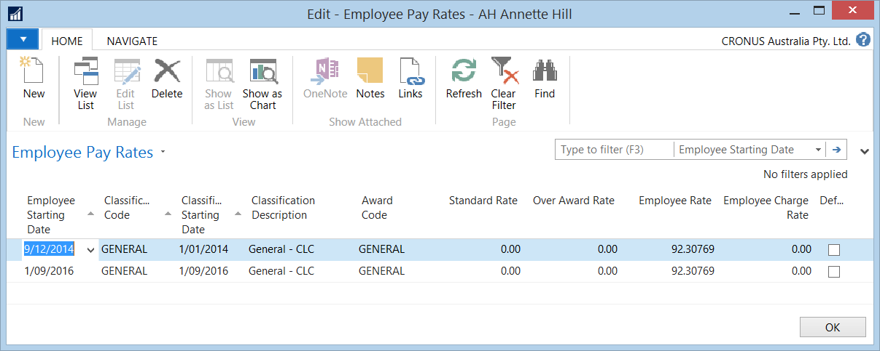

| **Field Name** | **Description** |
| --- | --- |
| Employee start Date | This field should default to the Employee’s Start Date |
| Classification Code | Click on the Arrow Up Button and select from the list – system created. |
| Employee Rate | Enter in the Employee’s rate as an hourly amount. |
| **Click** “OK” once you have completed all fields required. | |

After you have updated the rate and you click on the Rate Tab, the rate should be updated accordingly. ( This will only be updated if the Pay Period is after the Employee’s Start Date ).

### Payroll Employee Card – Gross / Allowances

It is assumed that Internal Employees are ‘Auto Paid’. To automatically generate hours, Ordinary / Normal Time should be set up as a permanent occurrence. The same applies if the employee is to receive an allowance on a permanent basis.

To access the Pay and Allowances task, Click the “Gross & Allowances” task icon. 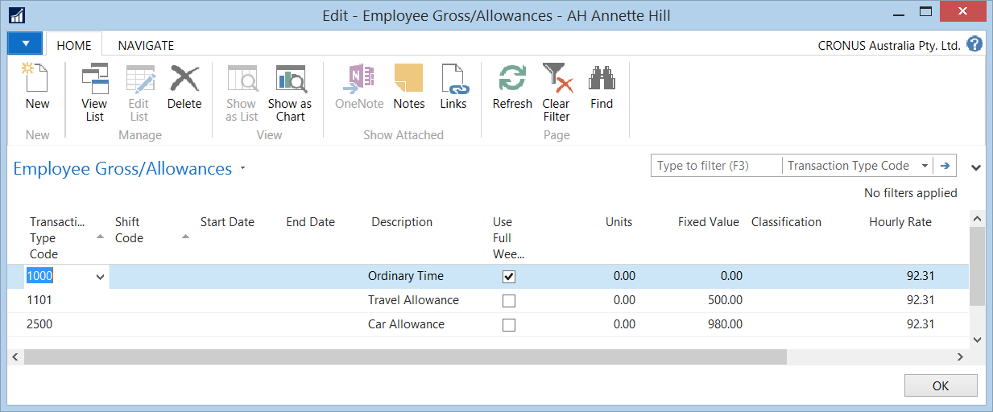

| **Field Name** | **Description** |
| --- | --- |
| Transaction Type Code | Select the Transaction Type Code from the “ArrowDown” e.g. Normal Time or a Permanent Allowance. |
| Start Date | Enter in a Start Date of when the Allowance transaction should commence. If this is for Ordinary of Normal Hours there is no need to enter in a Start Date. |
| Description | The Description will default from the Transaction. You can override the description should you require a user defined description to print on the Pay Advice. This will save using duplicate codes. |
| Units | Enter in the number of units required to be generated. For Ordinary / Normal Time type transactions you can enter in the number of hours per the pay period. |
| Fixed Value | Enter in the Fixed Value for allowance type transaction if required. |
| Hourly Rate | This will default from the Pay Rate table for Ordinary / Normal Time type transactions |
| Pay Value | This will be the sum of the Units field * Hourly Rate field |
| Not Used | The Not Used field is used to suppress the permanent transaction for a single pay only. When the pay period is closed on a payroll, this flag is then removed and ready to be generated for the next period. |
| **Click** “OK” once you have completed all fields required. | |

### Payroll Employee Card – Deductions

The Deductions Area is used to setup permanent deductions.

To access the Deductions task, Click the “Deductions” task icon.

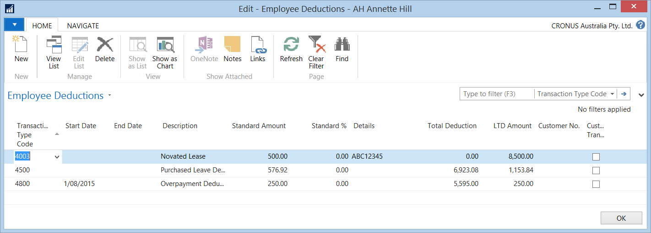

| **Field Name** | **Description** |
| --- | --- |
| Transaction Type Code | Select the Transaction Type Code from the “ArrowDown”. |
| Priority | If there are a number of deductions, you can select the order in which they are deducted, by entering 1,2,3, etc. for each transaction type. |
| Start Date | Enter in a Start Date of when the Allowance transaction should commence. If this is for Ordinary or Normal Hours there is no need to enter in a Start Date. |
| Description | The Description will default from the Transaction. You can override the description should you require a user defined description to print on the Pay Advice. This will save using duplicated codes. |
| Standard Amount / Standard % | Enter in a Standard Amount or Standard % of the deduction. |
| Details | Enter in a Reference number for the deduction |
| Total Deduction | If the Deduction is to cease as soon as it reaches a certain amount, enter in this amount here. |
| LTD Amount | This field is a sum of all the deductions to date. |
| Not Used | The Not Used field is used to suppress the permanent transaction for a single pay only. When the pay period is closed on a payroll, this flag is then removed and ready to be generated for the next period. |
| **Click** “OK” once you have completed all fields required. | |

### Payroll Employee Card – Superannuation

To access the Superannuation task, Click the “Superannuation” task icon.

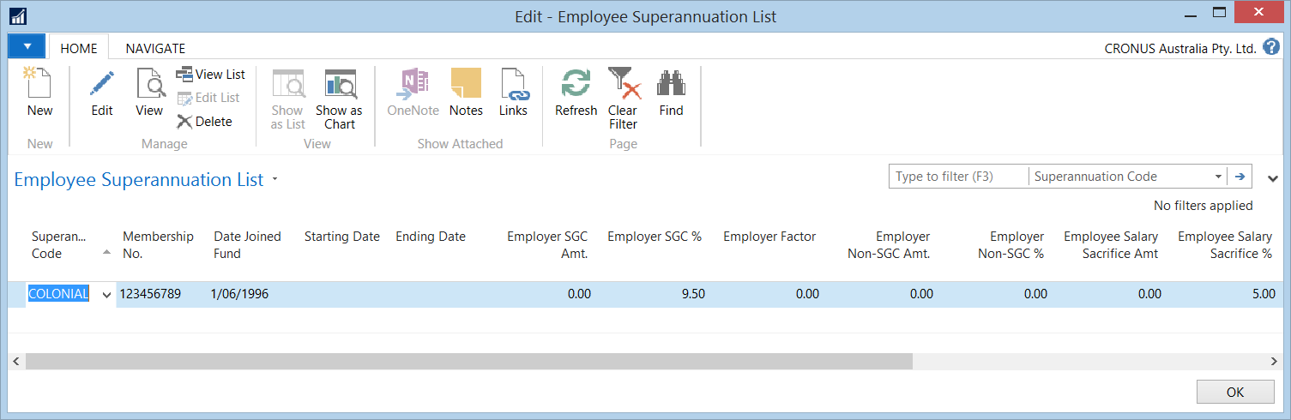

| **Field Name** | **Description** |
| --- | --- |
| Superannuation Company Code | Select the Superannuation Company code from the “ArrowDown”. |
| Membership No. | Enter in the Membership No. if known |
| Date Joined Fund | The ‘Date Joined Fund’ date will default to the Employee’s start date. If this date differs from the Employee start date, enter in the stat date for the Superannuation Fund. |
| Employer Standard % | The employer standard percentage will default to the value setup on the Superannuation Company card. |
| **Click** “OK” once you have completed all fields required. | |

#### **Superannuation - Employee Choice ( Changing Superannuation Funds )**

Changing Superannuation funds - enter an end date on the old fund and change the 9.5% to zero amount.

Then on the next line Add the new fund with the current month in the start date, then add the employer standard 9.5%.

If you are updating the employee’s Superannuation fund and your organisation is calculating Employer liabilities using On Costs, you must ensure that you update the Superannuation Code on the Superannuation On Cost transaction type. (Reference 4.2.8 - Payroll Employee Card – On Cost Transactions.

### Payroll Employee Card – Leave Accruals

Dependent upon what is setup on the Payroll (Pay Cycles) card, will depend upon whether the leave accruals will default to the Payroll Employee card when the employee is assigned to the Payroll.

To access the Leave Accrual task, Click the “Accruals” task icon. A list of the Leave Accruals for the employee will appear for viewing purposes.

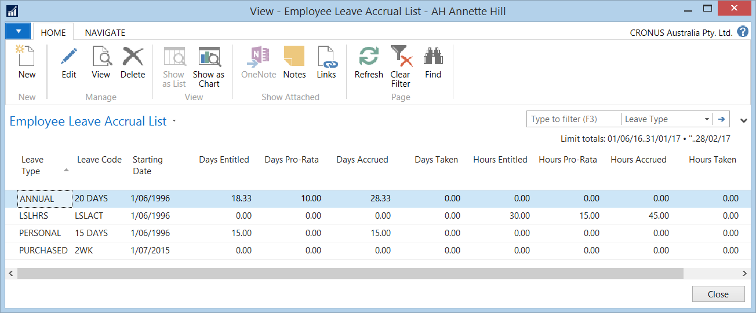

If you wish to create or add a new Leave Accrual, click on the “New” icon.

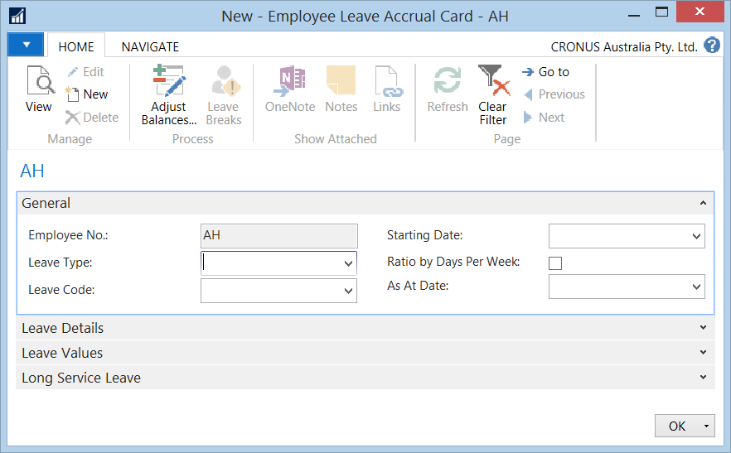

| **Field Name** | **Description** |
| --- | --- |
| Leave Type | Select the Leave Type code from the “ArrowDown”. |
| Leave Code | Select the appropriate Leave Code from the “ArrowDown”. |
| Start Date | The ‘Starting Date’ will default to the employees start date. This date is the Employee leave Accrual Start Date. |
| **Click** “OK” once you have completed all fields required. | |

### Payroll Employee Card – On Cost Transactions

If your organisation has chosen to calculate On Cost transactions, you will need to add in the relevant On Cost Transactions so that they are generated during the calculation of pays.

You access Employer On Costs from the Payroll Employee Card by clicking on the “Accumulation Calculations/” on the “Navigate” ribbon.

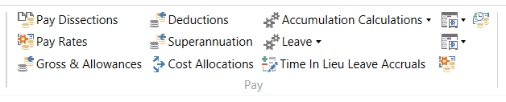

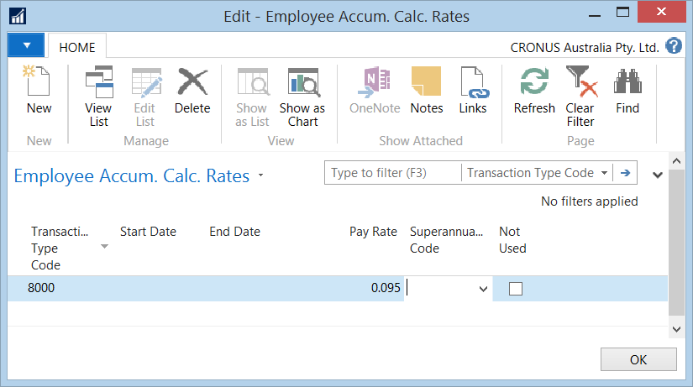

| **Field Name** | **Description** |
| --- | --- |
| Transaction Type Code | Select the Transaction Type code from the “ArrowDown”. |
| Start Date | The “Start Date” field is used to specify the date at which the On Cost transaction is to commence. |
| End Date | The “End Date” field is used to specify the date at which the On Cost transaction is to end. |
| Pay Rate | The “Pay Rate” field is used to retain the calculation rate of the On Cost transaction. This amount entered into this field should be expressed in decimal format. E.g. If the value is 9%, it should be entered as 0.09. |
| Superannuation Code | The “Superannuation Code” field is used to nominate the Contractor’s Superannuation code. This is only applicable if this On Cost transaction relates to the SGC accrual. |
| Not Used | If this field is ticked the Pay Transaction Type is not applied to the “current” pay period only.  The flag will be reset for the next pay period. |
| **Click “**OK” **after you have completed your selection.** | |

# Payroll Processing

## Payroll Processing – Pay Journals

To access the Pay Journals task, go to the following menu:

**Departments/Pay Journal/Pay Processing/Pay Journal**

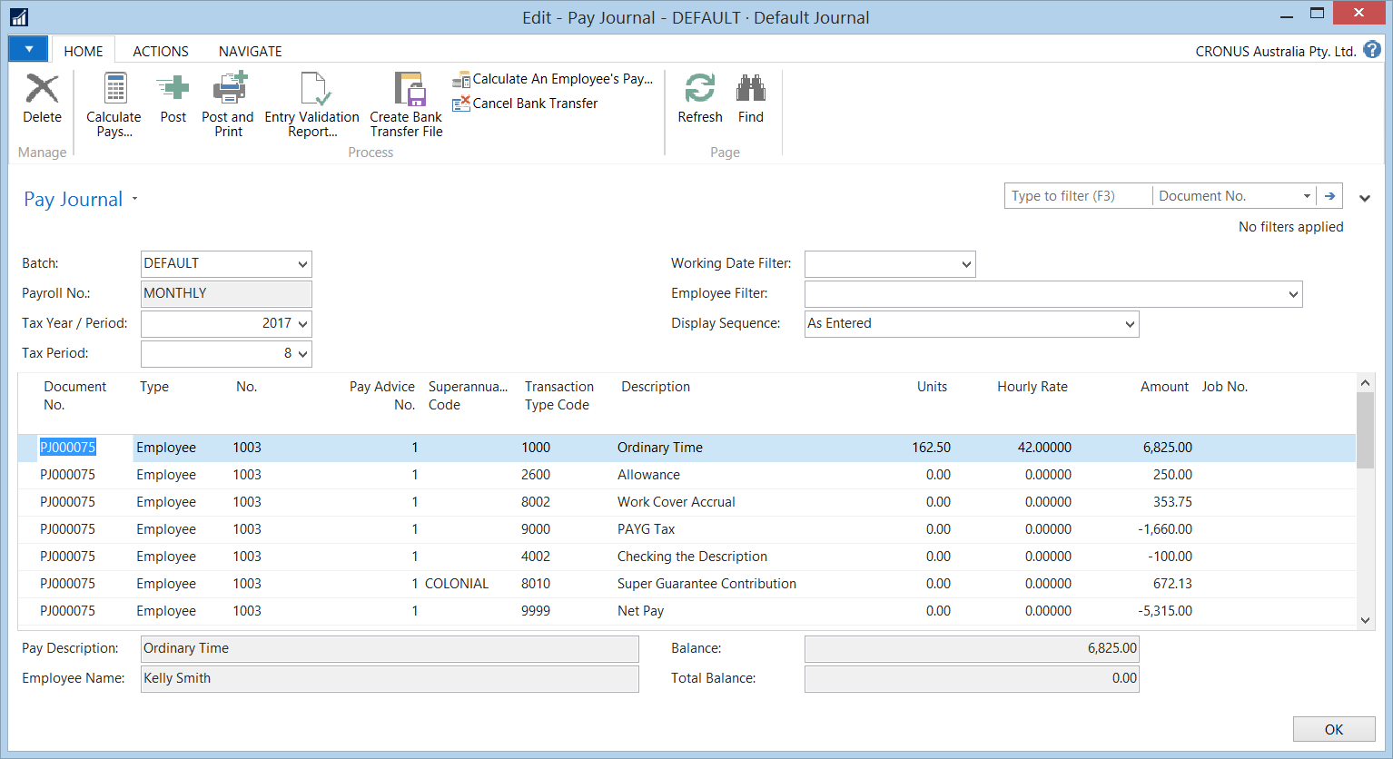

## Payroll Processing – Enter any leave adjustments

In the “Pay Journal” section enter in any leave taken for auto paid employee.

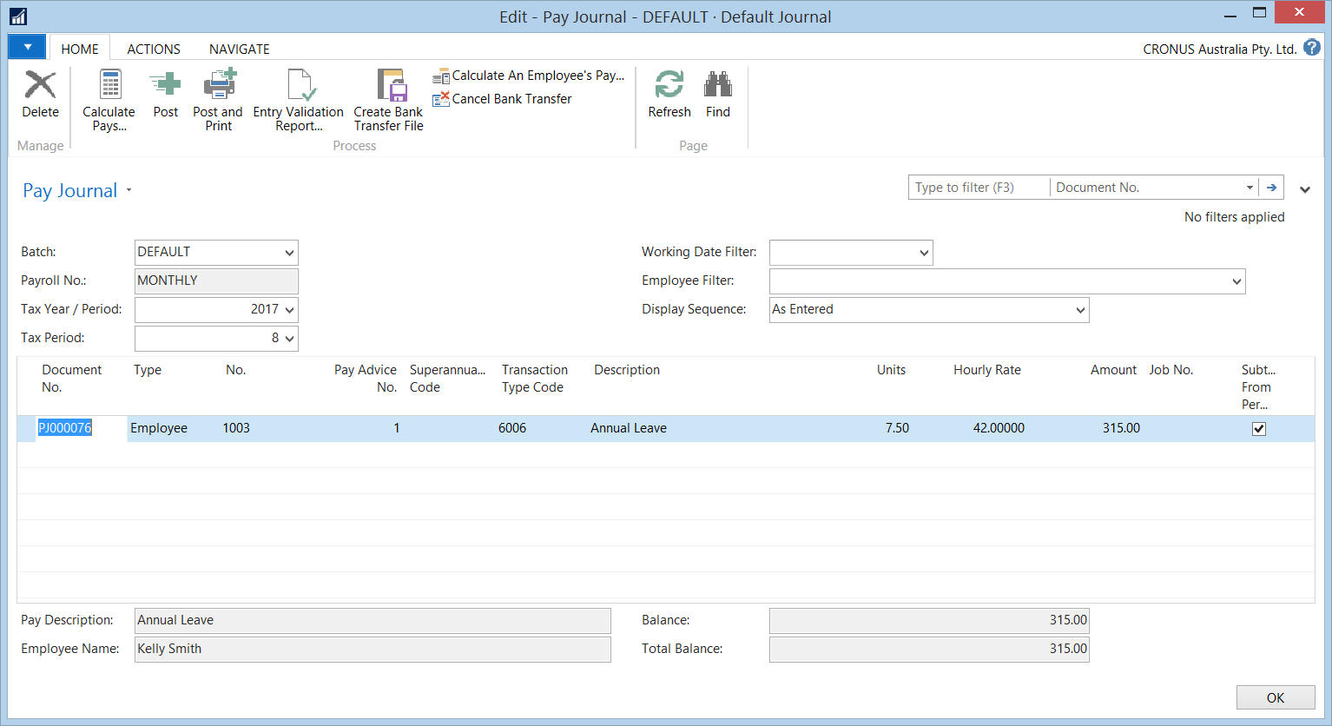

To enter leave against a specific employee, at a minimum the following fields should be populated:

| **Field Name** | **Description** |
| --- | --- |
| No. | Select the Employee’s No. from the “ArrowDown”. |
| Transaction Type Code | Enter or select the Transaction Type code for the Leave Type from the “ArrowDown”. |
| From Date | Enter in the Start Date of the absence in this field. (**You will need to update your display settings if this field is not displaying) |
| To Date | Enter in the End Date of the absence in this field. (**You will need to update your display settings if this field is not displaying) |
| Units | Enter in the No. of Hours in this field. |
| Subtract From Permanent Hours | This field will automatically default from the setup of the Pay Transaction Type card.  If the field is ticked, the value of this leave transaction will be deducted from the Employee’s standard auto-pay.  If the field is not ticked, the value of this leave transaction will be paid in addition to the Employee’s standard auto-pay. |
| **After entering your leave/temporary adjustments, the auto-pays can be calculated.** | |

## Payroll Processing – Calculate Pays

In the Pay Journal - Select “Calculate Pays” to calculate your pays and “Enter the Pay Date“ and select “OK”.

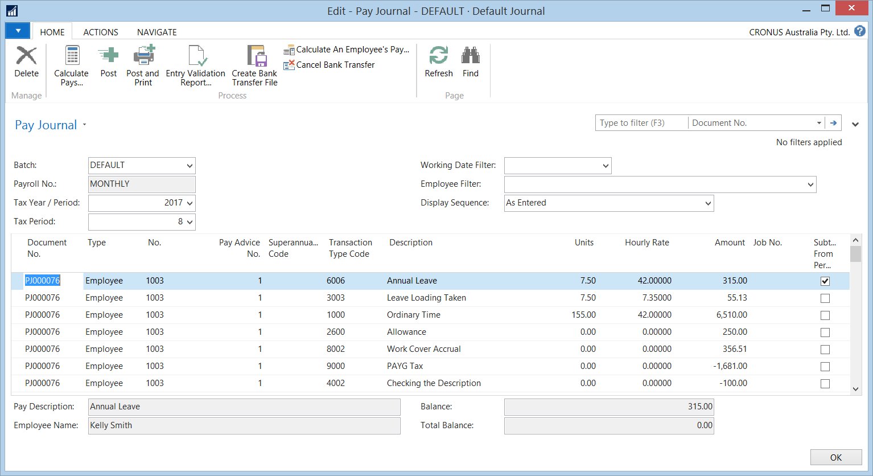

During this process any permanent hours and deductions, leave accruals, tax and superannuation is generated.

**Please note** : Pays can be calculated by individual or by all employees.

## Payroll Processing – Entry Validation Reports

Once pays have been calculated, the Entry Validation report has to be printed. You can preview the report online first for any errors or warnings which need to be fixed before proceeding to the next step. To run click on the “Entry Validation report” task.

Select Print Preview to check for errors and warnings on the screen, when all clear, Print.

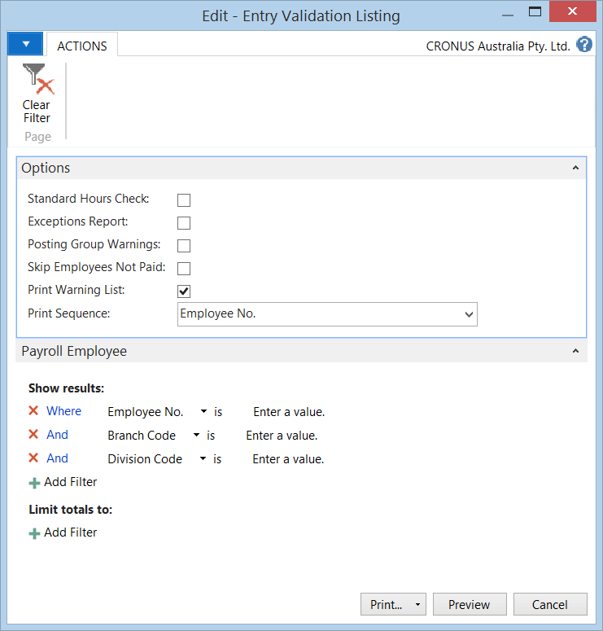

If errors are found on the Entry Validation Report, the individual’s pay can be fixed by uncalculating the pay. Please see the next step for “uncalculating Pays”.

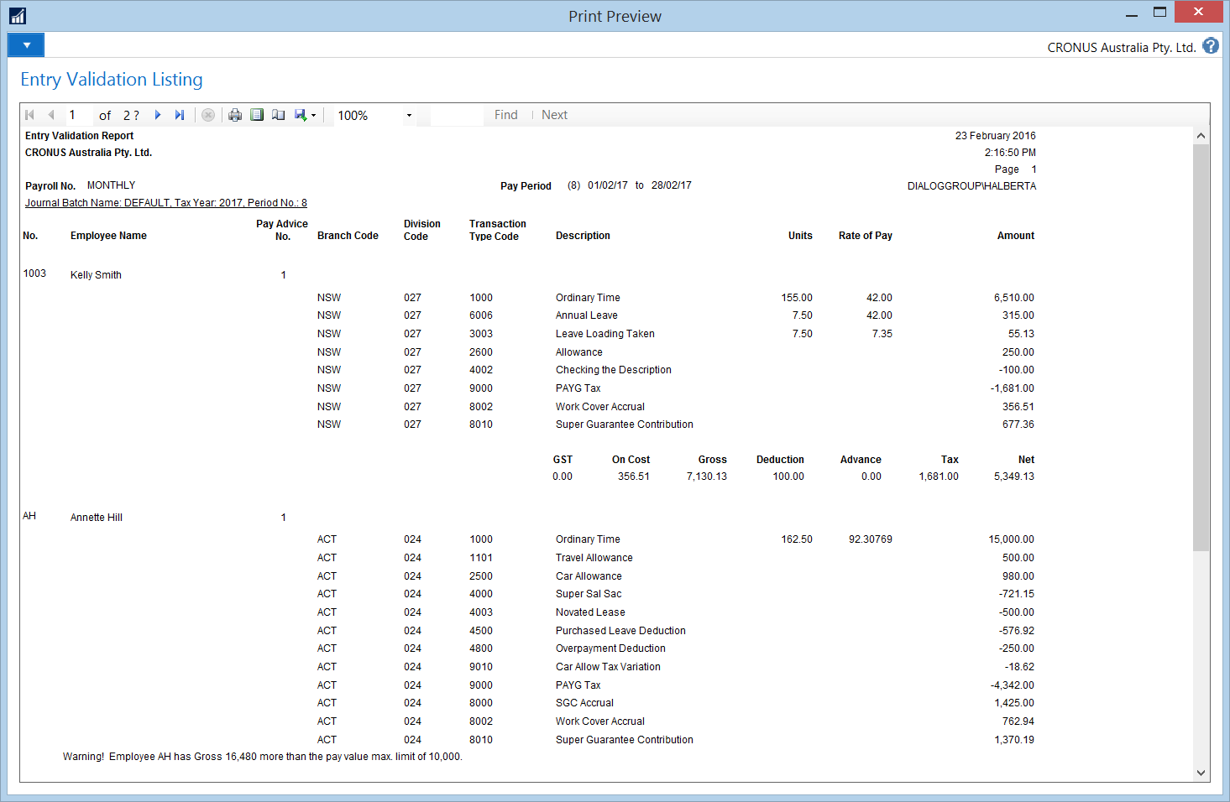

## Payroll Processing – Uncalculating Pays

Pays can be uncalculated for individual employees or for all employees within the Pay Journal. To “uncalculate” the pays, open the Actions Tab and click on “Cancel Calculated Pays”

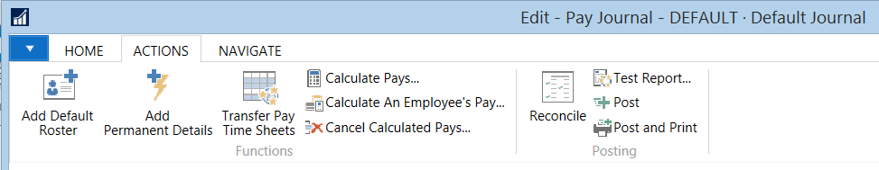

## Payroll Processing - Create Bank Transfer File

When the Entry Validation report has been checked and found to be correct, run the create bank transfer file process. To run the process click on the “Create Bank Transfer File” icon. The file can be saved to a network.

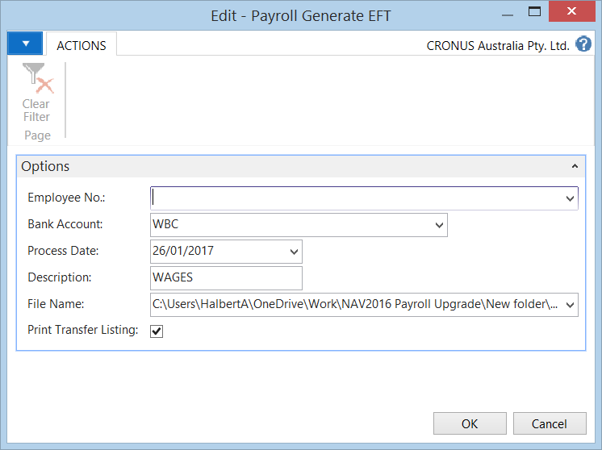

| **Field Name** | **Description** |
| --- | --- |
| Employee No. | You can create a bank transfer file for one employee by nominating the Employee’s number from the AssistButton.  Otherwise leave it blank to create a bank file for all employees. |
| Bank Account | The Bank Account attached to the Payroll will default from the Payroll Card.  Otherwise you can click on the AssistButton if you wish to nominate another Bank Account. |
| Process Date | This will be the “Processing Date” when the file will be processed by the Bank.  The date should be today’s date or greater. |
| Description | Enter in a Description for the file. |
| File Name | You can specify where you would like to save the file by clicking on the AssistButton.  You must ensure that you save the file with an .aba extension. |
| Print Transfer Listing | This field will automatically be selected and will provide you with an option to Print or Preview the Bank Transfer Listing Report.  (*If you do not print this report, it can be re-printed at a later stage). |
| **Click** “OK” once you have completed all fields required. | |

Pay advices are automatically flagged as paid. If for any reason you need to re-run the transfer again, run the “Cancel Bank Transfer” process and redo.

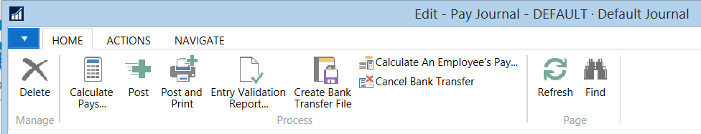

## Payroll Processing - Post and Print Pay Advices

When each batch of pays has been processed, they should be posted. This clears them from the Pay Journal area and writes the data to the employee pay history ledgers.



After you nominate the “Post” option, a “Print Pay Advice” message will appear as part of the posting process.

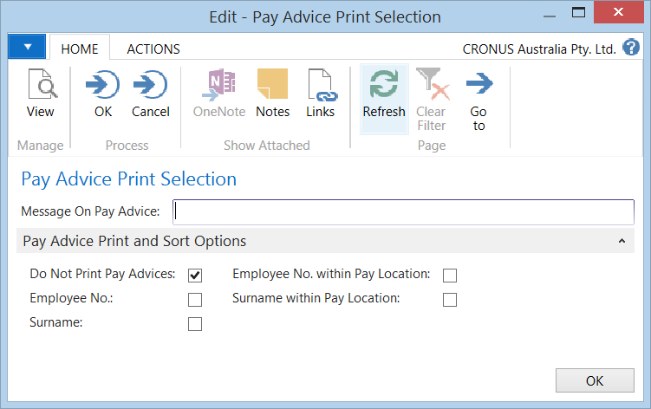

To print or reprint payslips, go to the following menu:

Departments/Payroll/Payroll Processing/ Print Pay Advices

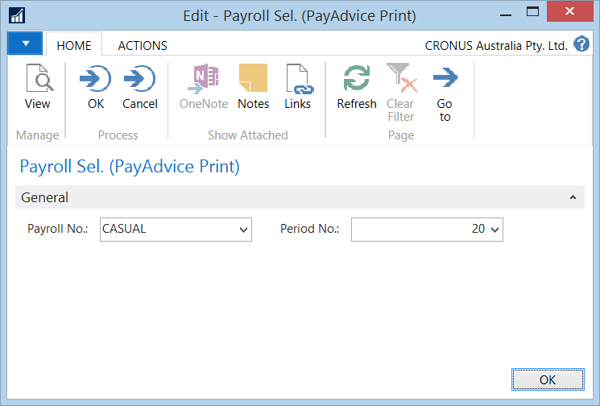

| **Field Name** | **Description** |
| --- | --- |
| Payroll No. | From the AssistButton, nominate the Payroll you wish to re-print pay advices for. |
| Period No. | From the AssistButton, nominate the Period No. you wish to re-print the pay advices for. |
| **Click** “OK” once you have completed all fields required. | |

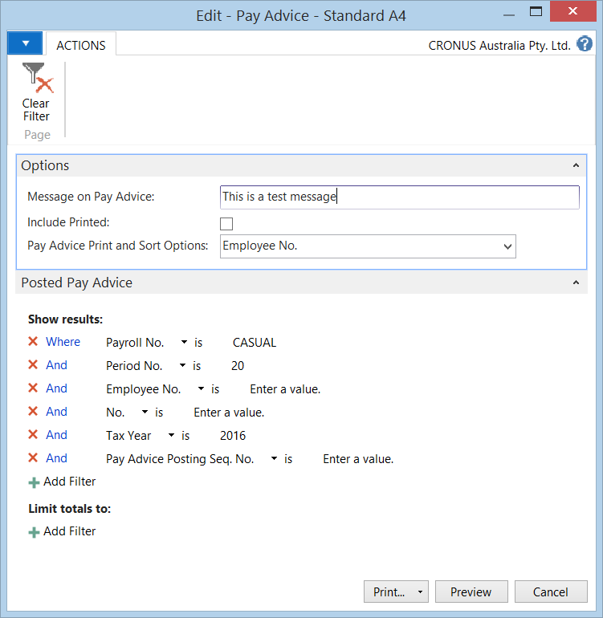

To email payslips, go to the following menu:

Departments/Payroll/Payroll Processing/ E-Mail Pay Advices

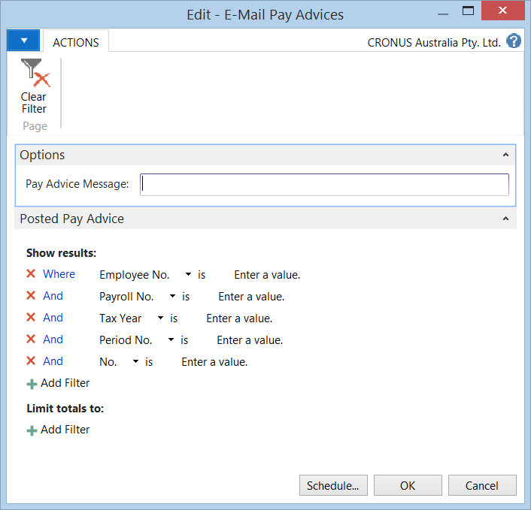

| **Field Name** | **Description** |
| --- | --- |
| ***OPTIONS FASTTAB*** | |
| Pay Advice Message | Complete this field if you wish to have a pay advice message printed on the emailed pay advices. |
| ***POSTED PAY ADVICE FASTTAB*** | |
| Employee No. | From the AssistButton, select the Employee No. otherwise leave this blank to generate email pay advices for all. |
| Payroll No. | From the AssistButton, select the Payroll No. otherwise leave this blank to generate email pay advices for all. |
| Tax Year | From the AssistButton, select the Tax Year otherwise leave this blank to generate email pay advices for all. |
| Period No. | From the AssistButton, select the Period No. otherwise leave this blank to generate email pay advices for all. |
| No. | From the AssistButton, select the No. (which relates to the Pay Advice No.) otherwise leave this blank to generate email pay advices for all. |
| **Click** “OK” once you have completed all fields required. | |

## Payroll Processing - Close Pay Periods

You can close the pay period independently if you choose not to close the pay period at the time of posting the payroll. To Close Pay periods, go to the following menu:

Departments/Payroll/Periodic Activities/Periodic Maintenance/ Close Pay Periods

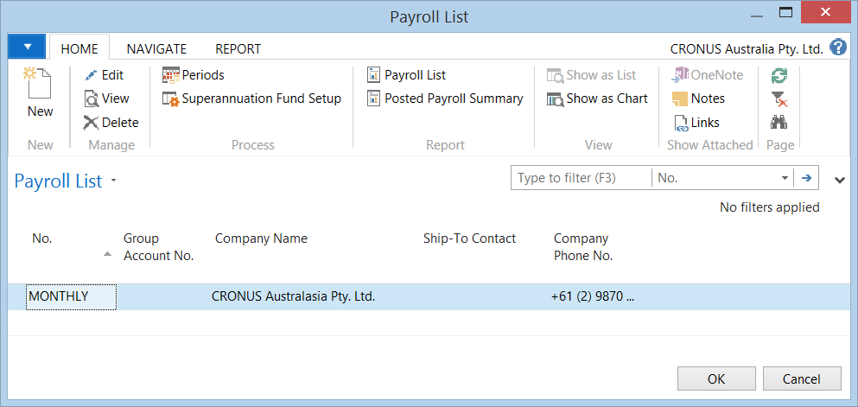

Select the Payroll No and press “OK’. Then select the Pay Period by the ticking the ‘Closed and Date Locked’ columns to close the pay period.